CALGARY SAFETY CONSULTANTS

Respectful Workplace Harassment and Violence Prevention Training
Student Reference Guide
Modules One Two Three and Four
This guide brings together the four modules of the Respectful Workplace Harassment and Violence Prevention Training program. Use it during training and afterward to review key concepts, connect the lessons to workplace procedures, and record practical notes.
01 | Respectful Workplace Foundations
02 | Workplace Harassment Prevention and Response
03 | Workplace Violence Prevention and Response
04 | Recovery Support and Continuous Improvement

STUDENT DETAILS
Name ________________________________________________
Date ____________________ Facilitator ____________________________________
GENERAL NOTES

Contents
Module One 3
Foundations of a Respectful Workplace 4
Shared Responsibility & the Internal Responsibility System (IRS) 14
Workplace Culture & Psychological Safety 21
Behaviour, Attitude & Mindset 30
Module Two 43
What Is Workplace Harassment? 44
Preventing Harassment in the Workplace 58
Prevention Policies, Programs & Plans 68
Responding to Workplace Harassment 80
Module Three 93
Understanding Workplace Violence 94
Preventing and Controlling Workplace Violence 109
Violence Prevention Plans Policies and Procedures 126
Responding to Workplace Violence 139
Module Four 153
Restoring the Workplace After an Incident 154
Supporting Affected Persons 164
Supporting the Workplace as a Whole 174
Sustaining Prevention and Moving Forward 187
Appendix Handouts and Templates 202

GENERAL NOTES

STUDENT REFERENCE GUIDE

Module One
Respectful Workplace Harassment and Violence Prevention Training
How to use this guide
This portrait reference guide follows the original Module One lesson and slide sequence. Each compact slide entry includes the PowerPoint visual, the lesson explanation, practical points to remember, and a line for notes. Every page also includes a general notes area.
Use the guide during training to record examples and questions. After training, return to the lesson overviews and summaries when you need to review responsibilities, reporting expectations, safe response options, or respectful communication practices.
Module roadmap
LESSON 01 | Foundations of a Respectful Workplace  Respect | Responsibilities | Psychological health and safety
LESSON 02 | Shared Responsibility & the Internal Responsibility System (IRS)  Roles | Rights | Reporting | Follow-through
LESSON 03 | Workplace Culture & Psychological Safety  Voice | Respect | Reporting | Follow-through
LESSON 04 | Behaviour, Attitude & Mindset  Words | Cues | Awareness | Self-regulation
Important: This guide supports the training. Follow the legislation, workplace policies, procedures, reporting routes, and emergency directions that apply to your workplace.
GENERAL NOTES

MODULE ONE / LESSON 01

Foundations of a Respectful Workplace
Respect | Responsibilities | Psychological health and safety
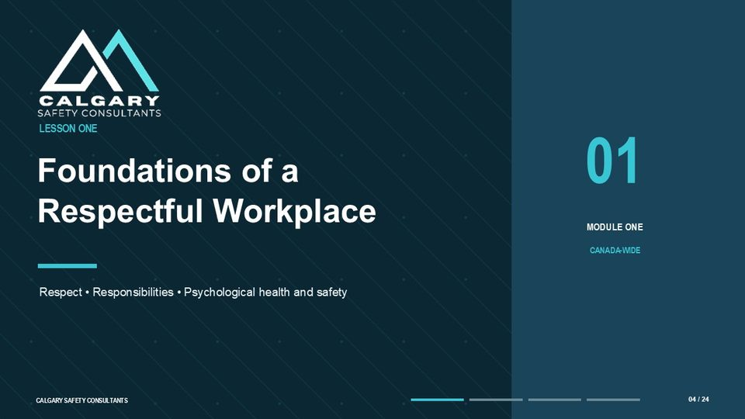
Lesson overview
A respectful workplace is created through everyday decisions and interactions. It is visible in how people communicate, listen, explain expectations, respond to questions, address mistakes, and follow through when a concern is raised. Respect does not require everyone to agree. It requires disagreement, feedback, correction, and decision-making to be handled without humiliation, intimidation, discrimination, or retaliation.
This lesson also introduces the prevention framework behind respectful workplace practices. The exact legal requirements depend on the jurisdiction and the workplace, but the shared approach is to identify risks, establish controls, train people, provide reporting routes, respond appropriately, and review whether the controls work. Psychological health and safety is part of this system because behaviour and work conditions can affect concentration, communication, confidence, participation, and mental well-being.
By the end of this lesson you should be able to
• Describe what respectful conduct looks like in ordinary workplace interactions.
• Explain why respect supports psychological health, communication, reporting, and reliable performance.
• Recognize that the governing occupational health and safety requirements depend on the applicable jurisdiction.
• Distinguish the general responsibilities of employers and workers.
• Explain why reporting and follow-through are essential parts of prevention.
GENERAL NOTES

LESSON 01 • SLIDE 01 OF 24    Notes __________________ | Respectful Workplace: Harassment and Violence Prevention Training  In this lesson, we will build the foundation for understanding respectful conduct, harassment and violence prevention, and the connection between respectful behaviour, psychological health, and workplace safety. The purpose is not only to define respectful behaviour, but to show how everyday communication, reporting, supervision, and follow-through influence whether people feel safe enough to participate and raise concerns. This course is written as a Canada-wide foundation.  That means the general prevention principles apply broadly, but the exact legal definitions, investigation requirements, reporting steps, timelines, and documentation obligations may differ depending on whether the workplace is federally regulated or regulated by a province or territory. Throughout the training, use the law, policy, and procedure that apply to your workplace.  KEY POINTS  • Respectful Workplace  • Harassment and Violence Prevention Training

LESSON 01 • SLIDE 02 OF 24    Notes __________________ | Respect starts with everyday behaviour.  Respect starts with everyday behaviour. A respectful workplace is shaped by how people communicate, listen, make decisions, give feedback, and respond when something goes wrong. It is visible in ordinary moments: how a supervisor answers a question, how a team handles disagreement, how concerns are received, and whether people are treated fairly when work becomes busy or stressful. Respect does not mean every conversation is easy, and it does not mean everyone must agree.  It means people are expected to remain professional, avoid conduct that humiliates, intimidates, threatens, or isolates others, and deal with concerns in a way that protects dignity and safety. As we move through this lesson, think about how these behaviours show up in your own workplace.  KEY POINTS  • How people communicate, listen, decide, and respond shapes the workplace.

LESSON 01 • SLIDE 03 OF 24  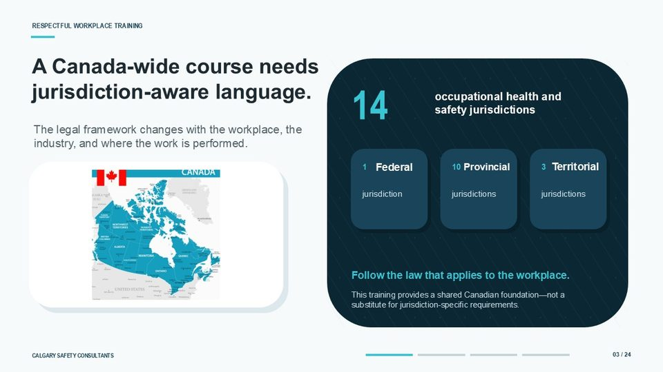  Notes __________________ | A Canada-wide course needs jurisdiction-aware language.  A Canada-wide course needs jurisdiction-aware language. Canada has fourteen occupational health and safety jurisdictions: one federal jurisdiction, ten provincial jurisdictions, and three territorial jurisdictions. The legal framework that applies to a workplace can depend on where the work is performed, the type of organization, the industry, and the specific role or relationship of the workplace parties involved.  This matters because harassment and violence prevention requirements are not identical across Canada. The general goal is prevention, but the definitions, reporting processes, investigation requirements, worker participation expectations, and documentation rules may vary. For that reason, this training provides a shared Canadian foundation. It is not a substitute for confirming the jurisdiction-specific requirements that apply to your workplace.  KEY POINTS  • occupational health and safety jurisdictions  • The legal framework changes with the workplace, the industry, and where the work is performed.  • Territorial  • Federal

GENERAL NOTES

LESSON 01 • SLIDE 04 OF 24  Notes __________________ | LESSON ONE: Foundations of a Respectful Workplace  We will focus on three connected themes: respect, responsibilities, and psychological health and safety. First, we will describe what a respectful workplace looks like in practical terms. Next, we will review the general occupational health and safety framework that supports harassment and violence prevention across Canada. Finally, we will connect respectful conduct to psychological health, worker participation, reporting, and employer response.  The key point for this lesson is that respectful behaviour is not separate from safety. It is part of how a workplace prevents harm, receives information early, and responds before concerns become more serious.  KEY POINTS  • Foundations of a Respectful Workplace  • Respect • Responsibilities • Psychological health and safety

LESSON 01 • SLIDE 05 OF 24  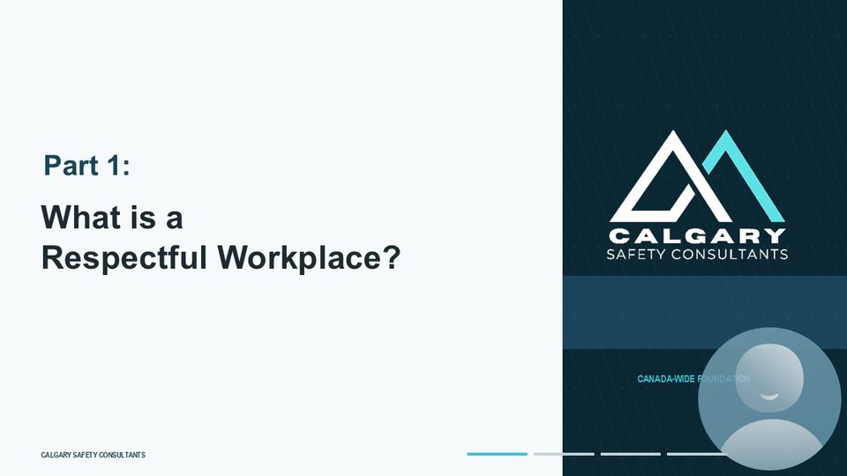  Notes __________________ | Part 1: What is a Respectful Workplace?  Part One asks a simple but important question: what is a respectful workplace? A respectful workplace is not created only by a policy statement, a poster, or an annual training record. It is created through repeated behaviour. Workers, supervisors, managers, contractors, and other workplace parties all influence the tone of the workplace through their words, decisions, and actions. In this section, we will look at respect as something practical and observable.  We are interested in how people are treated during normal work, during disagreement, during pressure, and when concerns are raised. That is where respectful workplace expectations become real.  KEY POINTS  • What is a Respectful Workplace?

LESSON 01 • SLIDE 06 OF 24  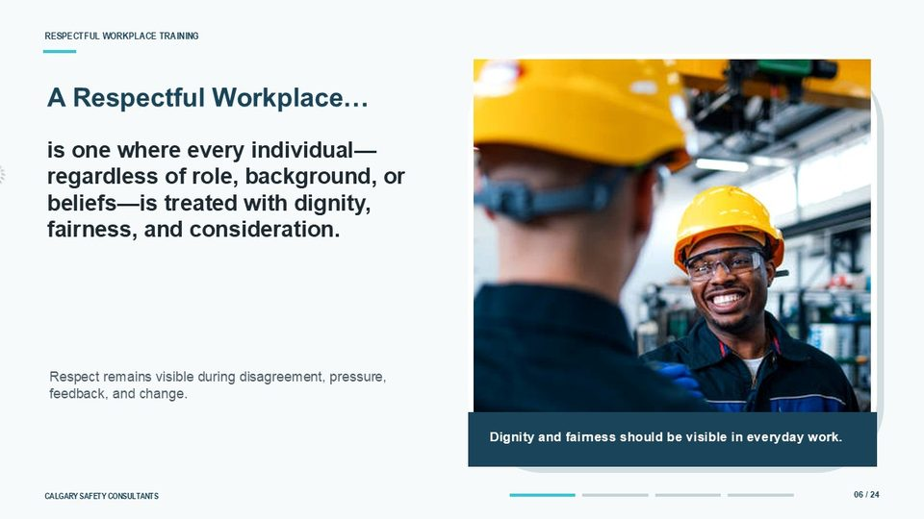  Notes __________________ | A Respectful Workplace…  A respectful workplace is one where every individual is treated with dignity, fairness, and consideration, regardless of their role, background, or beliefs. Dignity means recognizing that each person has basic worth and should not be humiliated, belittled, threatened, or excluded. Fairness means expectations are applied consistently, concerns are considered seriously, and people have a reasonable opportunity to be heard.  Consideration means thinking about how our words, actions, timing, tone, and decisions may affect others. Respect is especially important during disagreement, pressure, feedback, and change. Those are the moments when workplace behaviour is tested. A respectful workplace does not avoid difficult conversations; it handles them in a way that protects people, supports clarity, and maintains professional conduct.  KEY POINTS  • is one where every individual—regardless of role, background, or beliefs—is treated with dignity, fairness, and consideration.  • is one where every individual—regardless of their role, background, or beliefs—is treated with dignity, fairness, and consideration.  • DIGNITY  • FAIRNESS

GENERAL NOTES

LESSON 01 • SLIDE 07 OF 24  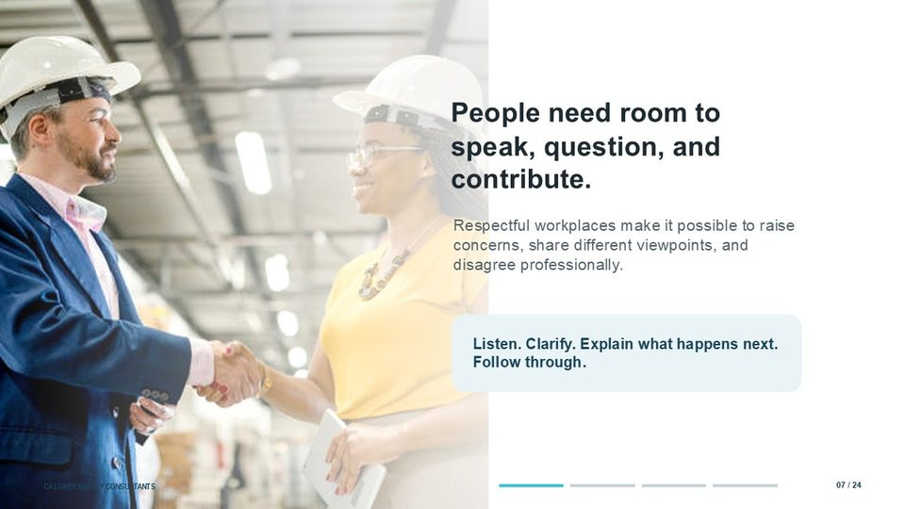  Notes __________________ | People need room to speak, question, and contribute.  People need room to speak, question, and contribute. In a respectful workplace, workers can raise concerns, ask questions, share different viewpoints, and disagree professionally without being ridiculed, ignored, punished, or treated as a problem. That does not mean every suggestion will be accepted, and it does not remove accountability. It means the concern is heard, clarified, and handled through an appropriate process. Supervisors and managers play an important role here.  They can support respectful communication by listening first, asking clarifying questions, explaining what happens next, and following through on commitments. When people see that their concerns are handled fairly, they are more likely to speak up early, before issues become more serious.  KEY POINTS  • Respectful workplaces make it possible to raise concerns, share different viewpoints, and disagree professionally.  • Listen. Clarify. Explain what happens next. Follow through.

LESSON 01 • SLIDE 08 OF 24  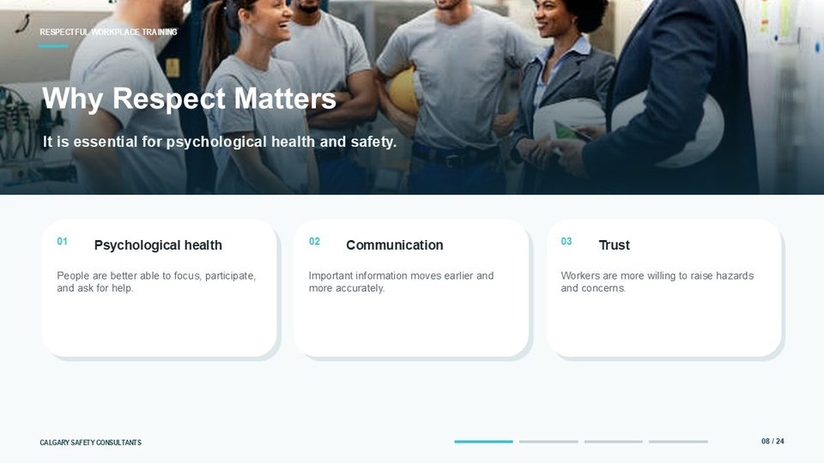  Notes __________________ | Why Respect Matters  Respect matters because it is essential for psychological health and safety. When people are treated respectfully, they are better able to focus, participate, ask for help, and share important information. Respect supports communication because people are more willing to clarify instructions, question unsafe conditions, and correct misunderstandings before they affect the work.  Respect also builds trust, and trust is one of the reasons workers choose to report hazards, harassment, violence, near misses, and other concerns. The implication is practical. Respectful conduct is not just a personal preference or a culture statement. It affects whether the workplace identifies problems early, whether workers participate in prevention, and whether the organization can control risk before harm occurs.  KEY POINTS  • It is essential for psychological health and safety.  • Psychological health  • Communication  • Trust

LESSON 01 • SLIDE 09 OF 24    Notes __________________ | Respect supports reliable performance.  Respect supports reliable performance. Clearer communication reduces friction and helps teams coordinate work before issues escalate. When workers feel able to ask questions and clarify expectations, fewer assumptions are made. When supervisors respond professionally, concerns are less likely to turn into conflict, grievances, absenteeism, turnover, or operational disruption. Respectful workplaces tend to have fewer avoidable conflicts, stronger teamwork, and more reliable work.  This is where psychological health and business performance connect. A respectful environment can improve productivity because people spend less energy managing interpersonal tension and more energy performing the work safely, accurately, and consistently.  KEY POINTS  • Clearer communication reduces friction and helps teams coordinate work before issues escalate.  • FEWER CONFLICTS  • STRONGER TEAMWORK  • MORE RELIABLE WORK

GENERAL NOTES

LESSON 01 • SLIDE 10 OF 24  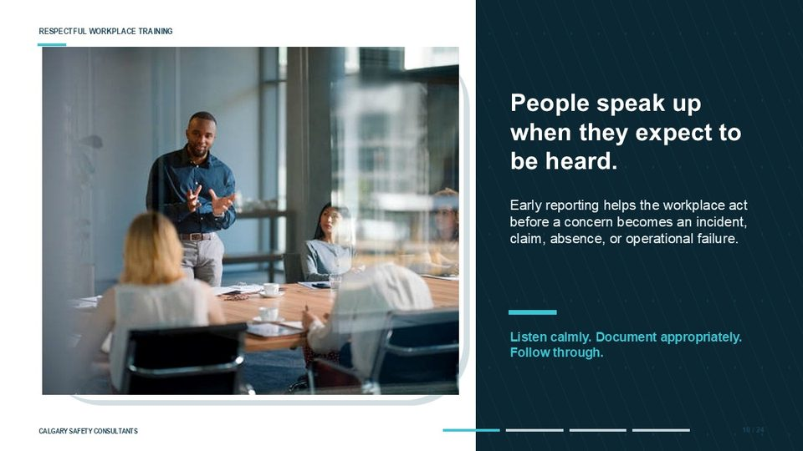  Notes __________________ | People speak up when they expect to be heard.  People speak up when they expect to be heard. Early reporting helps the workplace act before a concern becomes an incident, claim, absence, complaint, or operational failure. Workers may notice warning signs before management does. They may see changes in behaviour, escalating conflict, threats, near misses, workload pressures, or hazards that have not been captured in a formal assessment. For reporting to work, the response matters.  Supervisors should listen calmly, avoid blame or ridicule, document the concern appropriately, and explain what action will happen next. They should also follow through. If workers report concerns and nothing changes, trust drops and future reporting becomes less likely.  KEY POINTS  • Early reporting helps the workplace act before a concern becomes an incident, claim, absence, or operational failure.  • Listen calmly. Document appropriately. Follow through.

LESSON 01 • SLIDE 11 OF 24    Notes __________________ | Part 2: OH&S Legislation Overview  Part Two provides an overview of occupational health and safety legislation. The exact legal requirements depend on the jurisdiction, but the shared objective is prevention. Occupational health and safety laws are intended to help workplaces identify hazards, establish controls, communicate expectations, train workers, and respond when concerns or occurrences are reported.  For respectful workplace, harassment, and violence prevention, legislation provides the structure for employer duties, worker duties, reporting, investigation or resolution, confidentiality, recordkeeping, and review. The details may differ, but the prevention purpose remains consistent: identify the risk, take appropriate action, and protect workers from harm.  KEY POINTS  • OH&S Legislation Overview

LESSON 01 • SLIDE 12 OF 24  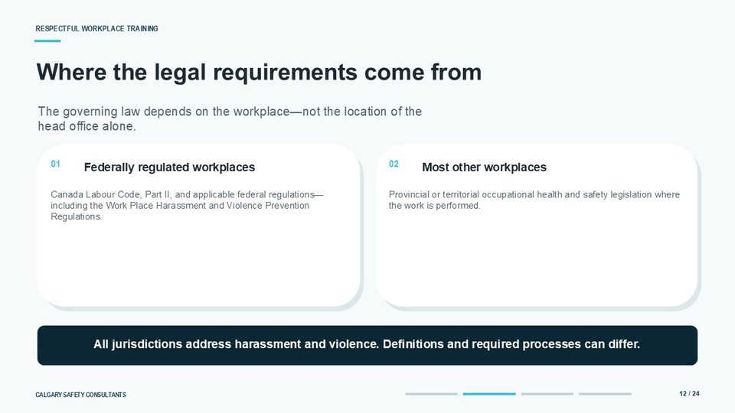  Notes __________________ | Where the legal requirements come from  Legal requirements come from the law that applies to the workplace, not from the location of the head office alone. Federally regulated workplaces are governed by the Canada Labour Code, Part Two, and applicable federal regulations, including the Work Place Harassment and Violence Prevention Regulations. Most other workplaces are governed by the occupational health and safety legislation of the province or territory where the work is performed.  All Canadian jurisdictions address harassment and violence, but they may use different definitions and require different processes. Employers should not assume that one policy, one timeline, or one investigation process automatically satisfies every jurisdiction. The correct approach is to confirm the applicable law, align the workplace procedure to that law, and make sure workers and supervisors understand the process they are expected to use.  KEY POINTS  • The governing law depends on the workplace—not the location of the head office alone.  • Federally regulated workplaces  • Most other workplaces  • Canada Labour Code, Part II, and applicable federal regulations—including the Work Place Harassment and Violence Prevention Regulations.

GENERAL NOTES

LESSON 01 • SLIDE 13 OF 24  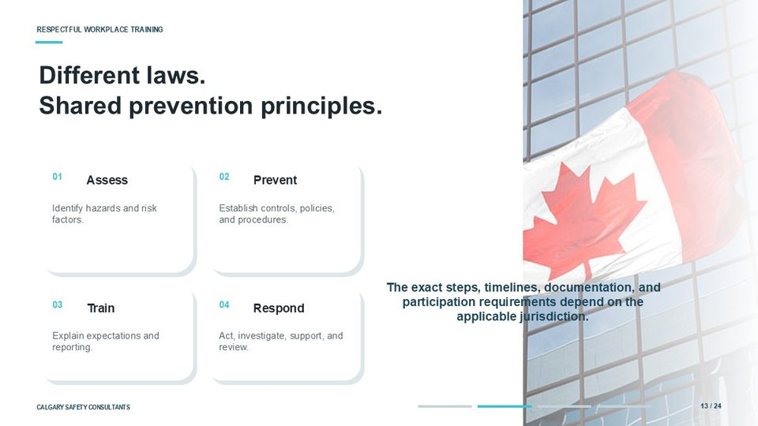  Notes __________________ | Different laws. Shared prevention principles.  Different laws can still share common prevention principles. Across Canada, harassment and violence prevention generally involves four practical steps. First, assess the workplace by identifying hazards, risk factors, and conditions that may contribute to harmful behaviour. Second, prevent harm by establishing controls, policies, reporting procedures, and safe work expectations. Third, train workers and supervisors so they understand what is expected, how to report, and how the process works.  Fourth, respond when concerns or occurrences arise by taking action, investigating or resolving as required, supporting affected people, and reviewing whether the controls are working. The exact steps, timelines, documentation, and participation requirements depend on the applicable jurisdiction. The principle is consistent: prevention has to be active, practical, and connected to how the workplace actually operates.  KEY POINTS  • Assess  • Prevent  • Identify hazards and risk factors.  • Establish controls, policies, and procedures.

LESSON 01 • SLIDE 14 OF 24    Notes __________________ | Employer Responsibilities  Employer responsibilities are a central part of prevention. Employers must take the measures required by the applicable jurisdiction to protect workers from physical and psychological harm. In practice, that means assessing risk, implementing controls, providing information and training, establishing reporting and response processes, and taking appropriate action when harassment, violence, threats, or related concerns are reported. Exact duties vary by jurisdiction and by workplace role.  In some situations, supervisors, owners, contractors, constructors, prime contractors, or other workplace parties may also have defined responsibilities. The practical expectation is that the employer’s prevention system must work in real operations, not only on paper. Workers need to know how to report, supervisors need to know how to respond, and the organization needs to complete corrective actions when they are required.  KEY POINTS  • Take the measures required by the applicable jurisdiction to protect workers from physical and psychological harm.  • ASSESS RISK  • IMPLEMENT CONTROLS  • TRAIN

LESSON 01 • SLIDE 15 OF 24  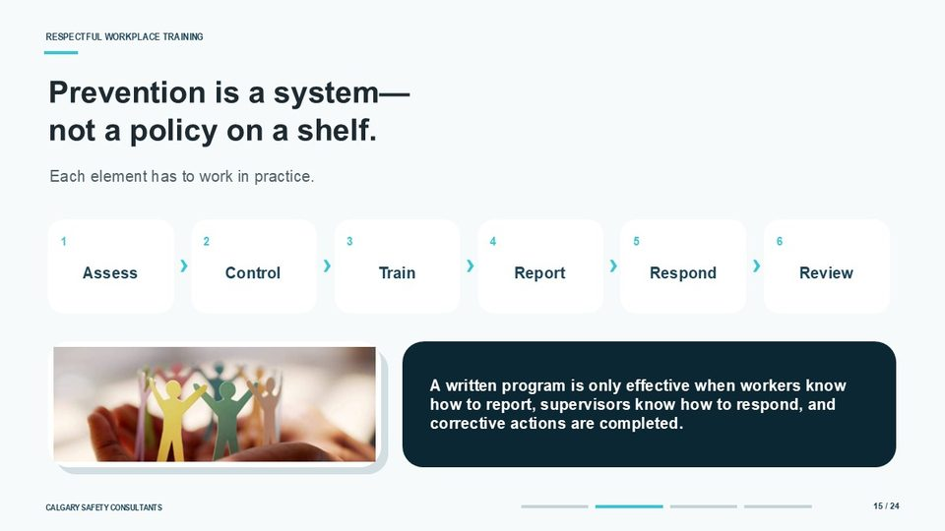  Notes __________________ | Prevention is a system— not a policy on a shelf.  Prevention is a system, not a policy on a shelf. Each element has to work in practice. The system begins with assessment, where the workplace identifies hazards and risk factors. It continues through controls, where policies, procedures, staffing, supervision, physical safeguards, and communication methods are put in place. Training then explains expectations and gives workers and supervisors the knowledge they need to act. Reporting gives people a way to bring concerns forward.  Response ensures the organization acts, investigates or resolves as required, supports affected people, and controls risk. Review confirms whether the system is effective and whether improvements are needed. A written program is only effective when workers know how to report, supervisors know how to respond, and corrective actions are completed. If any part of the system breaks down, prevention becomes weaker.  KEY POINTS  • Each element has to work in practice.  • Assess  • Control  • Train

GENERAL NOTES

LESSON 01 • SLIDE 16 OF 24  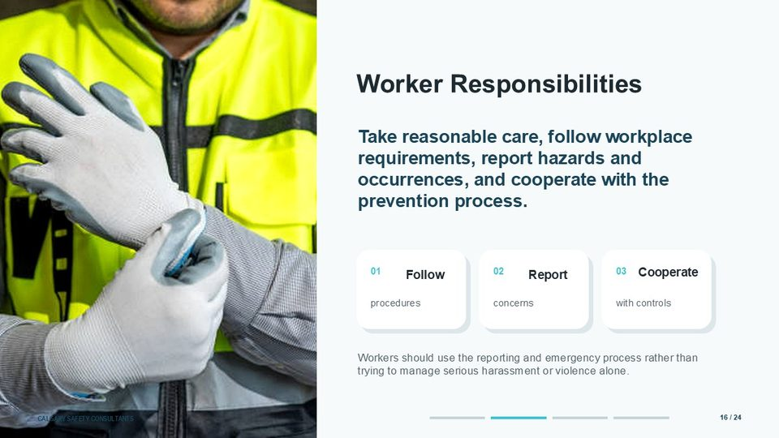  Notes __________________ | Worker Responsibilities  Workers also have responsibilities. Every employee is expected to take reasonable care to protect their own health and safety and the health and safety of their coworkers. In a respectful workplace prevention system, that includes following workplace procedures, reporting hazards and concerns, cooperating with controls, and participating in the process when required. Workers should not try to manage serious harassment, violence, threats, or immediate danger alone.  They should use the reporting process established by the workplace and follow the emergency procedure when there is an immediate threat. Reporting is not about creating conflict. It is about giving the organization the information it needs to prevent harm, protect people, and take the next required step.  KEY POINTS  • Take reasonable care, follow workplace requirements, report hazards and occurrences, and cooperate with the prevention process.  • Every employee is expected to take reasonable care to protect their own health and safety—and that of their coworkers.  • Follow  • Report

LESSON 01 • SLIDE 17 OF 24  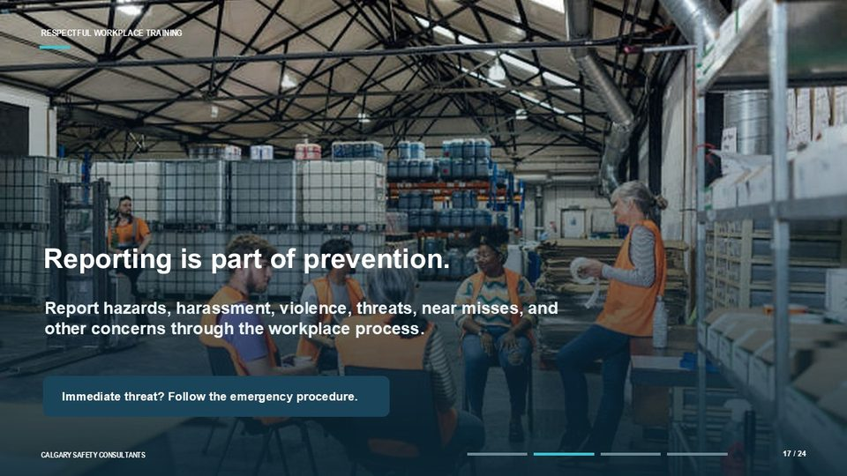  Notes __________________ | Reporting is part of prevention.  Reporting is part of prevention. Workers should report hazards, harassment, violence, threats, near misses, and other concerns through the workplace process. A good report focuses on factual information: what happened, who was involved, when and where it happened, who may have witnessed it, whether anyone is at immediate risk, and what support or control may be needed right away.  Supervisors should know how reports are received, who needs to be notified, what interim steps may be required, and how confidentiality will be protected as required by the applicable process. When there is an immediate threat, follow the emergency procedure. That may include leaving the area, contacting a supervisor or designated person, activating workplace emergency response, or calling emergency services when required.  KEY POINTS  • Report hazards, harassment, violence, threats, near misses, and other concerns through the workplace process.  • Immediate threat? Follow the emergency procedure.

LESSON 01 • SLIDE 18 OF 24  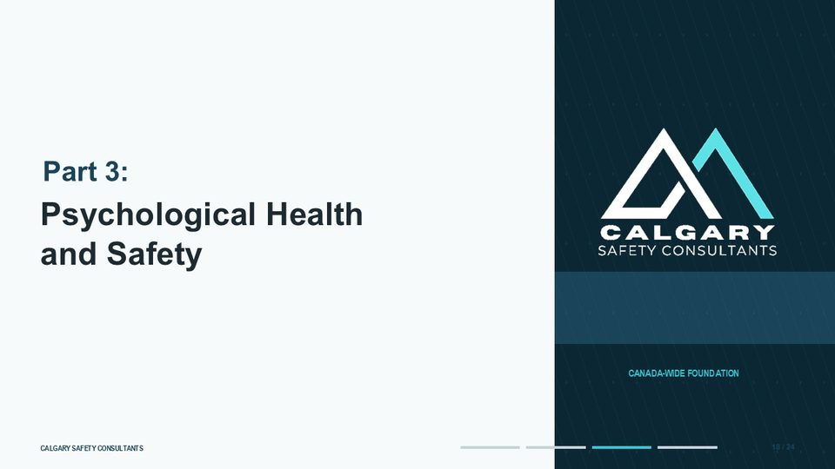  Notes __________________ | Part 3: Psychological Health and Safety  Part Three focuses on psychological health and safety. This part connects respectful workplace expectations to how work affects mental well-being, concentration, communication, and the ability to perform work safely. Psychological health and safety does not mean every workplace interaction will be comfortable or that normal performance management disappears.  It means the workplace should consider how behaviour, workload, communication, support, and exposure to harassment or violence can create harm or increase risk. As we move through this section, pay attention to the connection between conduct and consequence. Harmful behaviour can affect people, but it can also affect reporting, teamwork, attendance, claims, and operational reliability.  KEY POINTS  • Psychological Health and Safety

GENERAL NOTES

LESSON 01 • SLIDE 19 OF 24  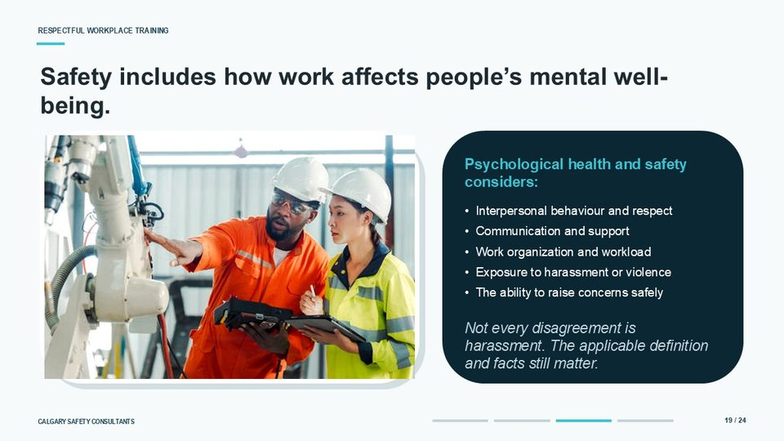  Notes __________________ | Safety includes how work affects people’s mental well-being.  Safety includes how work affects people’s mental well-being. Psychological health and safety considers interpersonal behaviour and respect, communication and support, work organization and workload, exposure to harassment or violence, and the ability to raise concerns safely. These factors matter because they can affect concentration, decision-making, participation, and the willingness to report hazards or ask for help. At the same time, not every disagreement is harassment.  Workplaces still need to assess the facts, the context, the applicable legal definition, and the workplace procedure. A fair process should distinguish between respectful disagreement, reasonable work direction, performance management, conflict, harassment, violence, bullying, or other harmful conduct. The goal is to assess the issue properly and respond in a way that protects people and supports safe work.  KEY POINTS  • Psychological health and safety considers:  • • Interpersonal behaviour and respect • Communication and support • Work organization and workload • Exposure to harassment or violence • The ability to raise concerns safely  • Not every disagreement is harassment. The applicable definition and facts still matter.

LESSON 01 • SLIDE 20 OF 24  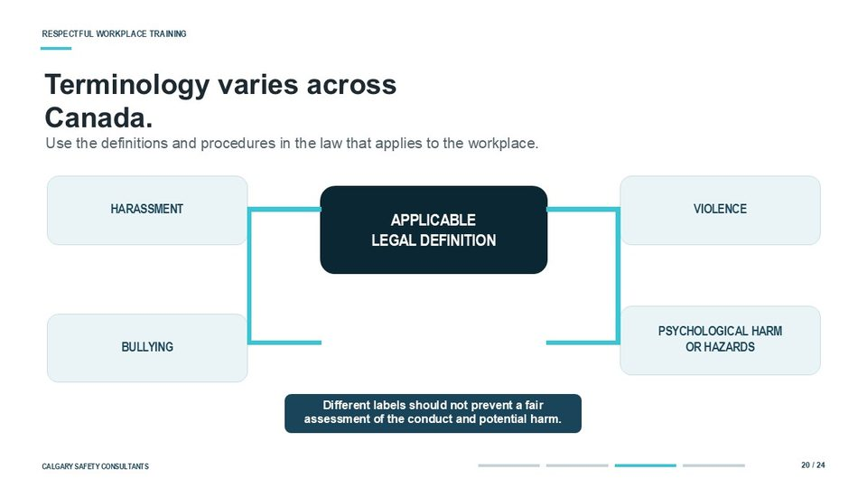  Notes __________________ | Terminology varies across Canada.  Terminology varies across Canada. Different jurisdictions may use different labels, including harassment, violence, bullying, psychological harm, or psychological hazards. The words may differ, but the practical responsibility remains: use the definitions and procedures in the law that applies to the workplace, and assess the conduct and potential harm fairly.  This is important because a concern should not be dismissed simply because a worker used a different term than the legislation or the company procedure. Someone may say they are being bullied, harassed, threatened, intimidated, targeted, or psychologically harmed. The organization still needs to look at the facts, apply the correct definition, consider the risk, and follow the appropriate reporting, response, or investigation process.  KEY POINTS  • Use the definitions and procedures in the law that applies to the workplace.  • HARASSMENT  • VIOLENCE  • APPLICABLE LEGAL DEFINITION

LESSON 01 • SLIDE 21 OF 24  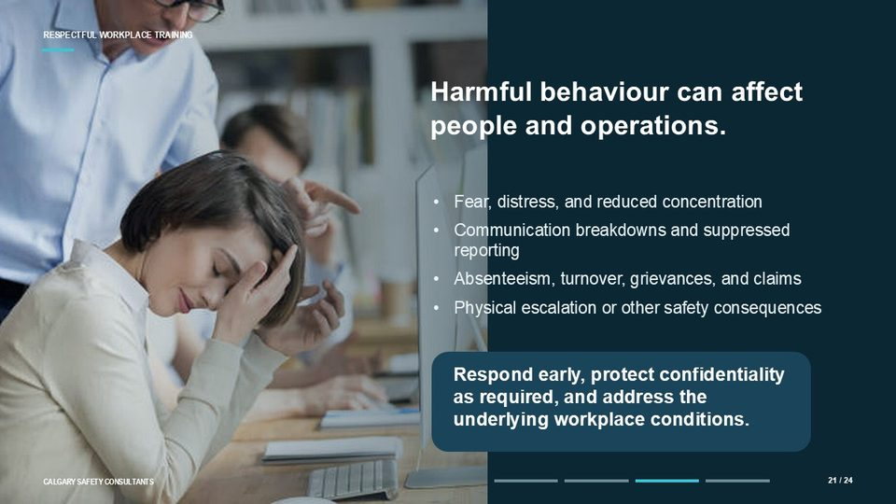  Notes __________________ | Harmful behaviour can affect people and operations.  Harmful behaviour can affect people and operations. For individuals, harmful behaviour may contribute to fear, distress, reduced concentration, loss of confidence, and a reduced ability to participate. For the organization, the same behaviour can lead to communication breakdowns, suppressed reporting, absenteeism, turnover, grievances, claims, and physical escalation or other safety consequences. The earlier the workplace responds, the more opportunity it has to control the risk.  A respectful response should protect confidentiality as required, avoid retaliation, support affected people, use the workplace process, and address the underlying conditions that allowed the concern to develop. If the organization treats the issue only as a personal disagreement, it may miss the broader workplace factors that need to be corrected.  KEY POINTS  • Fear, distress, and reduced concentration Communication breakdowns and suppressed reporting Absenteeism, turnover, grievances, and claims Physical escalation or other safety consequences  • Respond early, protect confidentiality as required, and address the underlying workplace conditions.

GENERAL NOTES

LESSON 01 • SLIDE 22 OF 24    Notes __________________ | Part 4: Bringing it all Together  Part Four brings the lesson together. A respectful workplace combines clear expectations, practical prevention controls, accessible reporting, employer response, worker cooperation, supervisor follow-through, and compliance with the law that applies to the workplace. It is not enough to say that respect is important. People need to know what respectful conduct looks like, how to raise a concern, and what the organization will do when a concern is reported.  This final section will review the key points and give you a short knowledge check to confirm the main ideas from Lesson One.  KEY POINTS  • Bringing it all Together

LESSON 01 • SLIDE 23 OF 24  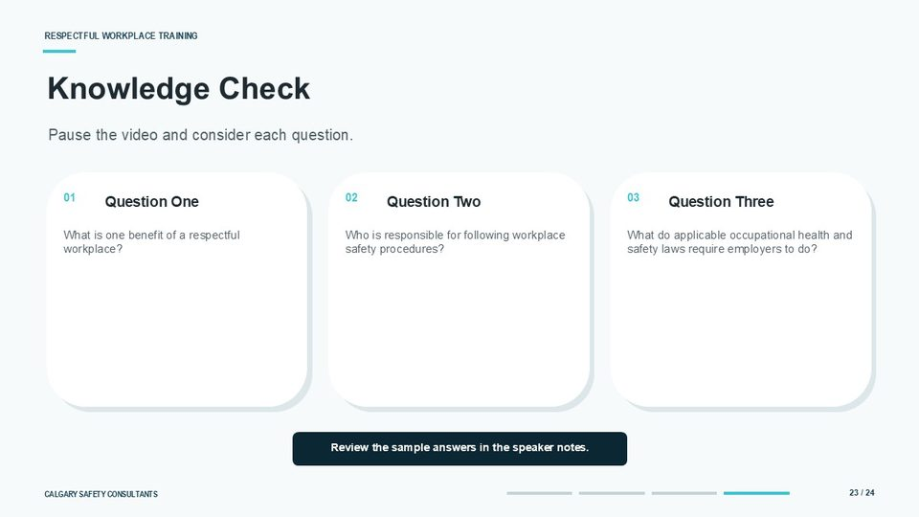  Notes __________________ | Knowledge Check  This is the knowledge check for Lesson One. Question one: what is one benefit of a respectful workplace? A good answer is that respect supports psychological health and safety, clearer communication, stronger trust, better teamwork, and more reliable performance. Any of those benefits would be appropriate. Question two: who is responsible for following workplace safety procedures? The answer is that every worker must follow the procedures and requirements that apply to their role.  Employers, supervisors, workers, and other workplace parties may have different duties, but everyone contributes to prevention. Question three: what do applicable occupational health and safety laws require employers to do?  The exact requirements vary by jurisdiction, but employers generally need to assess hazards and risk factors, implement controls, provide training, establish reporting and response processes, and investigate or resolve occurrences as required by the law that applies to the workplace.  KEY POINTS  • Pause the video and consider each question.  • What is one benefit of a respectful workplace? Who is responsible for following safety procedures? What does the OH&S Act require of employers?  • Question One  • Question Two

LESSON 01 • SLIDE 24 OF 24  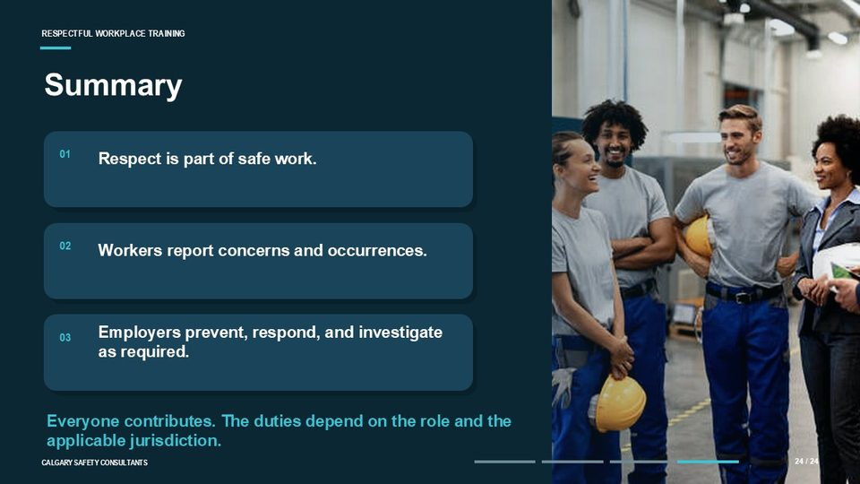  Notes __________________ | Summary  To summarize Lesson One, respect is part of safe work. Workers report concerns and occurrences through the workplace process. That includes hazards, harassment, violence, threats, near misses, and other conditions that may affect health and safety. Reporting gives the organization the information it needs to act before the concern becomes more serious. Employers prevent, respond, and investigate as required.  That means identifying risk, implementing controls, training workers and supervisors, responding to reports, protecting confidentiality as required, and reviewing whether preventive measures are effective. Everyone contributes, but the duties depend on the role and the applicable jurisdiction. A respectful workplace makes expectations clear, receives concerns professionally, follows through on required action, and treats people with dignity, fairness, and consideration.  This concludes Module One, Lesson One: Foundations of a Respectful Workplace.  KEY POINTS  • Respect is part of safe work.  • The most important thing: Worker need to report Employers need to investigate.  • Workers report concerns and occurrences.  • Employers prevent, respond, and investigate as required.

GENERAL NOTES

LESSON 01 SUMMARY
Foundations of a Respectful Workplace
The following points bring the lesson together. Use them to review the main prevention message and connect it to the procedures and expectations in your workplace.
01 | Respect is a safety condition as well as a standard of conduct. People are more likely to ask questions, share information, report concerns, and participate in problem-solving when they expect to be heard and treated fairly.
02 | A respectful workplace protects dignity, fairness, and consideration while still allowing supervision, performance management, disagreement, and difficult decisions. The standard is professional and fair behaviour, not the absence of every uncomfortable conversation.
03 | Legal terminology and procedures vary across Canada. Workers and employers must use the definitions, reporting routes, investigation requirements, and protective measures that apply to their workplace and jurisdiction.
04 | Prevention is a working system: assess risks, establish controls, train people, receive reports, respond, correct problems, and verify that corrective actions are effective. A policy has limited value if people do not know how to use it.
05 | Workers support prevention by following procedures, treating others respectfully, reporting hazards and occurrences, cooperating with workplace processes, and seeking immediate help when safety is at risk. Employers remain responsible for leading and resourcing the prevention system.
Reflection and application
• Where does a worker report a harassment, violence, threat, or near-miss concern in this workplace?
• What immediate emergency steps apply if there is a threat to safety?
• What does respectful disagreement look and sound like in my role?
________________________________________________________________________________
________________________________________________________________________________
GENERAL NOTES

MODULE ONE / LESSON 02

Shared Responsibility & the Internal Responsibility System (IRS)
Roles | Rights | Reporting | Follow-through
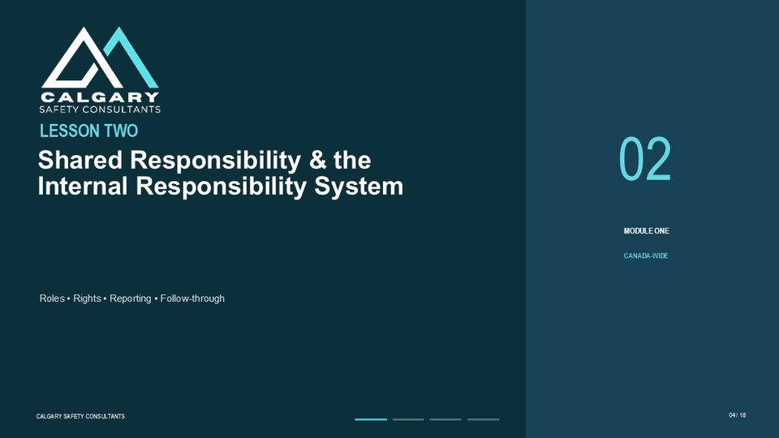
Lesson overview
The Internal Responsibility System, often called the IRS, is the practical idea that everyone participates in workplace health and safety within the authority and responsibilities of their role. Employers establish and resource the system. Supervisors translate requirements into day-to-day direction, monitoring, and response. Workers follow procedures, report concerns, participate, and provide information about the work.
Shared responsibility does not mean identical responsibility. The employer has broader duties to assess risk, establish policies and procedures, provide training, investigate or otherwise address concerns, and verify that corrective measures work. The IRS succeeds when information moves through clear reporting routes and the workplace closes the loop with fair response, appropriate communication, and follow-through.
By the end of this lesson you should be able to
• Describe the Internal Responsibility System as a workplace partnership.
• Identify the different roles of employers, supervisors, workers, and workplace health and safety representatives or committees.
• Recognize the rights to know, participate, and refuse dangerous or unsafe work under the applicable process.
• Explain how early reporting and response prevent escalation.
• Describe what it means to close the loop after a concern is reported.
GENERAL NOTES

LESSON 02 • SLIDE 01 OF 15  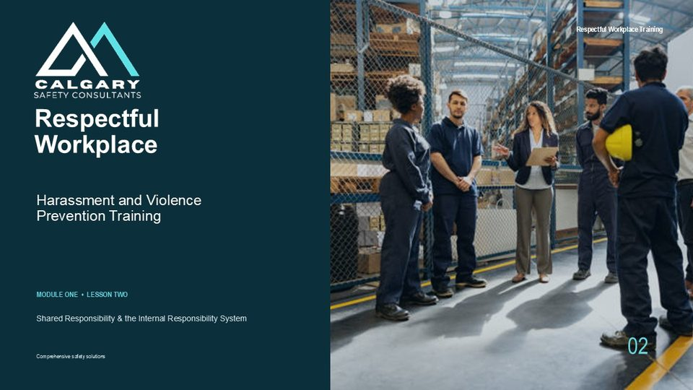  Notes __________________ | Respectful Workplace: Harassment and Violence Prevention Training  Lesson Two focuses on shared responsibility and the Internal Responsibility System, commonly called the IRS. The IRS is the underlying philosophy of occupational health and safety legislation across Canadian jurisdictions. It recognizes that workplace health and safety improves when employers, supervisors, workers, committees, representatives, and other workplace parties participate within their roles. This lesson uses Canada-wide language.  The exact duties, definitions, reporting processes, and legal tests depend on whether the workplace is federally, provincially, or territorially regulated. The applicable law and the organization’s current procedures always take precedence.  KEY POINTS  • Respectful Workplace  • Harassment and Violence Prevention Training  • Shared Responsibility & the Internal Responsibility System

LESSON 02 • SLIDE 02 OF 15  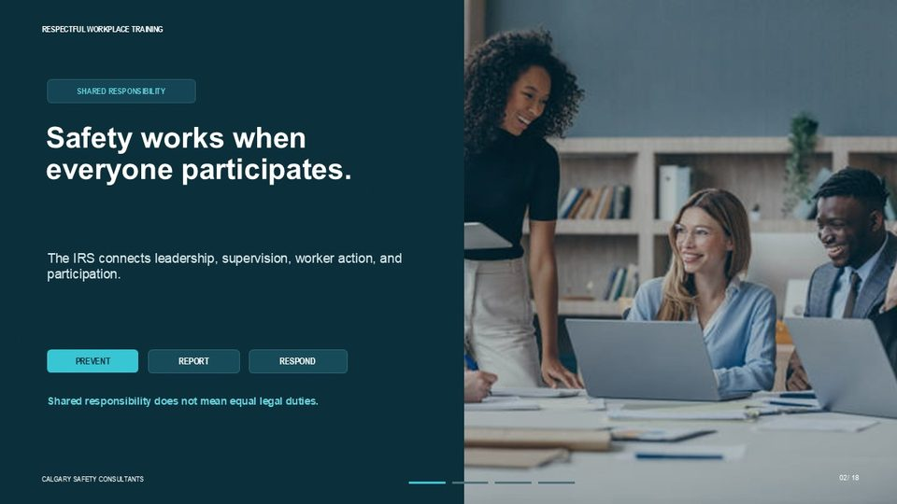  Notes __________________ | Safety works when everyone participates.  Safety systems work best when information moves quickly and people act before a concern becomes an incident. Employers establish and resource the system. Supervisors communicate expectations and respond to issues. Workers follow procedures, report hazards and inappropriate conduct, and participate in prevention. Committees or representatives provide a joint forum for reviewing concerns and recommending improvements. Shared responsibility does not mean that every party has the same legal duty.  It means each party contributes, while the employer retains the authority and accountability assigned by the applicable legislation.  KEY POINTS  • SHARED RESPONSIBILITY  • The IRS connects leadership, supervision, worker action, and participation.  • PREVENT  • REPORT

LESSON 02 • SLIDE 03 OF 15  Notes __________________ | LESSON TWO: Shared Responsibility & the Internal Responsibility System (IRS)  Lesson Two explains how the Internal Responsibility System supports a respectful and safe workplace. By the end of the lesson, learners should be able to describe the IRS, identify the general roles of employers, supervisors, and workers, recognize the three basic worker rights, and explain why reporting must be followed by fair response and corrective action.  We will also emphasize an important limit: worker participation never removes the employer’s duty to establish and maintain an effective prevention system.  KEY POINTS  • Shared Responsibility & the Internal Responsibility System  • Roles • Rights • Reporting • Follow-through

GENERAL NOTES

LESSON 02 • SLIDE 04 OF 15  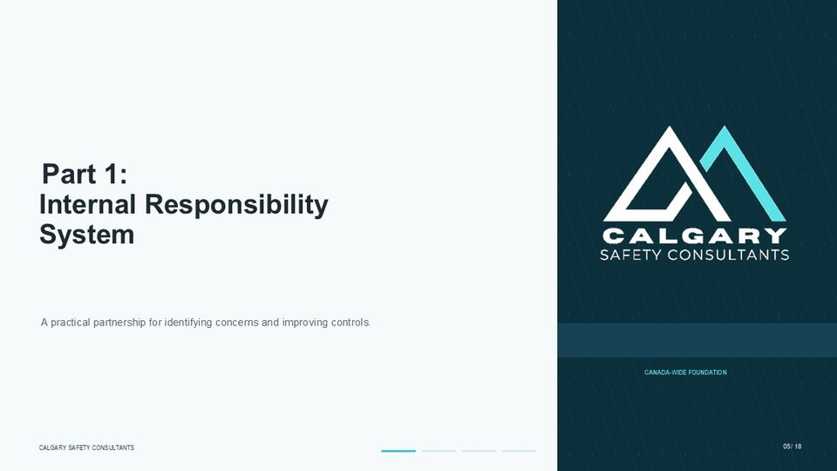  Notes __________________ | Part 1: Internal Responsibility System  Part One begins with the Internal Responsibility System itself. Think of the IRS as a practical operating model rather than a slogan. Hazards and workplace concerns are most likely to be controlled when the people closest to the work can identify problems, the supervisor can respond, and the employer provides the authority, resources, and system needed to correct them.  KEY POINTS  • Internal Responsibility System  • A practical partnership for identifying concerns and improving controls.

LESSON 02 • SLIDE 05 OF 15  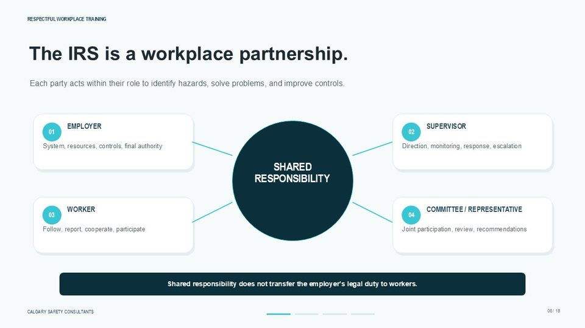  Notes __________________ | The IRS is a workplace partnership.  The IRS creates an employer-worker partnership for preventing harm. Employers establish policies, programs, resources, and controls. Supervisors translate those requirements into day-to-day direction, monitoring, and response. Workers follow safe work practices, report hazards and concerns, and participate in improving the work. Health and safety committees or representatives support joint participation by reviewing concerns, inspections, investigations, and recommendations where required.  Depending on the jurisdiction and work arrangement, owners, contractors, suppliers, constructors, or prime contractors may also have duties. The key is coordination: information must move to the person who has authority to act.  KEY POINTS  • Each party acts within their role to identify hazards, solve problems, and improve controls.  • EMPLOYER  • SUPERVISOR  • System, resources, controls, final authority

LESSON 02 • SLIDE 06 OF 15  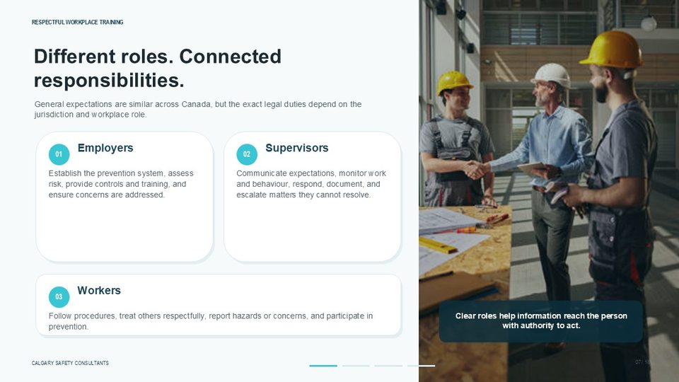  Notes __________________ | Who’s Responsible? Everyone  Responsibilities are connected, but they are not identical. Employers generally lead the prevention system, assess risks, establish procedures, provide training, and ensure concerns are addressed. Supervisors communicate expectations, observe conditions and behaviour, correct deficiencies, support reporting, and escalate matters they cannot resolve. Workers follow applicable requirements, use the reporting process, cooperate with preventive measures, and treat others respectfully.  In harassment and violence prevention, a supervisor should not dismiss a report as a personality conflict or attempt to investigate beyond their authority. They should protect immediate safety, document the concern, and follow the organization’s process.  KEY POINTS  • Different roles. Connected responsibilities.  • General expectations are similar across Canada, but the exact legal duties depend on the jurisdiction and workplace role.  • Employers  • Supervisors

GENERAL NOTES

LESSON 02 • SLIDE 07 OF 15  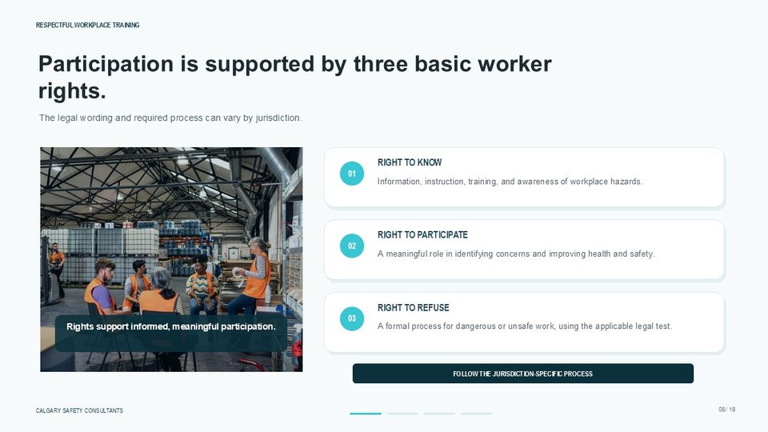  Notes __________________ | Participation is supported by three basic worker rights.  Canadian workers have three basic occupational health and safety rights: the right to know about hazards and protective measures, the right to participate in health and safety activities, and the right to refuse dangerous or unsafe work in accordance with the applicable law. These rights support the IRS because they give workers information, a voice, and a formal response when serious risk cannot be resolved through normal channels.  The legal wording, threshold, and procedure for a work refusal differ by jurisdiction. Workers must follow the required process, and employers and supervisors must not retaliate against good-faith participation protected by law.  KEY POINTS  • The legal wording and required process can vary by jurisdiction.  • RIGHT TO KNOW  • Information, instruction, training, and awareness of workplace hazards.  • RIGHT TO PARTICIPATE

LESSON 02 • SLIDE 08 OF 15  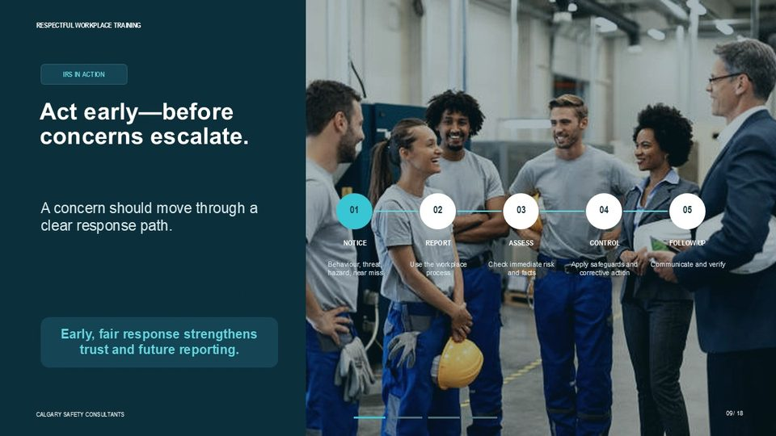  Notes __________________ | IRS in Action – Respect is Everyone’s Job  The IRS is most effective when concerns are addressed early. A worker may notice repeated disrespectful comments, a threatening interaction, an unsafe condition, or a near miss. The first step is to report the facts through the workplace process. The supervisor or designated recipient should assess immediate safety, preserve confidentiality as required, and escalate the matter to the appropriate person.  The employer then applies the required prevention, resolution, or investigation process and implements corrective measures. Follow-up matters. When people see that concerns are received and addressed fairly, they are more likely to report future issues before they escalate.  KEY POINTS  • IRS IN ACTION  • Act early—before concerns escalate.  • The IRS empowers everyone to act before problems escalate into incidents.  • A concern should move through a clear response path.

LESSON 02 • SLIDE 09 OF 15  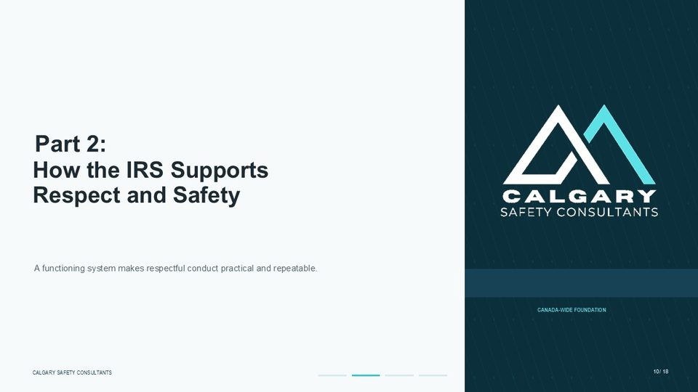  Notes __________________ | Part 2: How IRS Supports Respect and Safety  Part Two looks at how the IRS supports both respect and safety. A respectful workplace depends on more than individual courtesy. It requires a functioning system that encourages early reporting, provides clear response routes, assigns responsibilities, and verifies that concerns are resolved.  KEY POINTS  • How the IRS Supports Respect and Safety  • A functioning system makes respectful conduct practical and repeatable.

GENERAL NOTES

LESSON 02 • SLIDE 10 OF 15  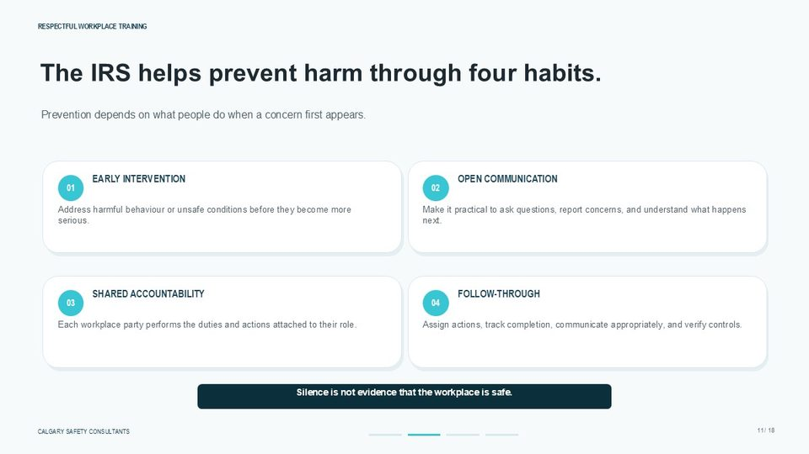  Notes __________________ | The IRS helps prevent harassment…  Four habits make the IRS practical. Early intervention addresses harmful behaviour or unsafe conditions before they become more serious. Open communication allows people to ask questions, report concerns, and receive clear information about what happens next. Shared accountability means each workplace party performs the duties attached to their role. Follow-through means the organization assigns actions, tracks completion, communicates appropriately, and verifies that controls work.  Silence is not proof that the workplace is safe. It may indicate that workers do not trust the process or do not believe action will follow.  KEY POINTS  • The IRS helps prevent harm through four habits.  • Prevention depends on what people do when a concern first appears.  • By encouraging early intervention, open communication, and shared accountability.  • EARLY INTERVENTION

LESSON 02 • SLIDE 11 OF 15  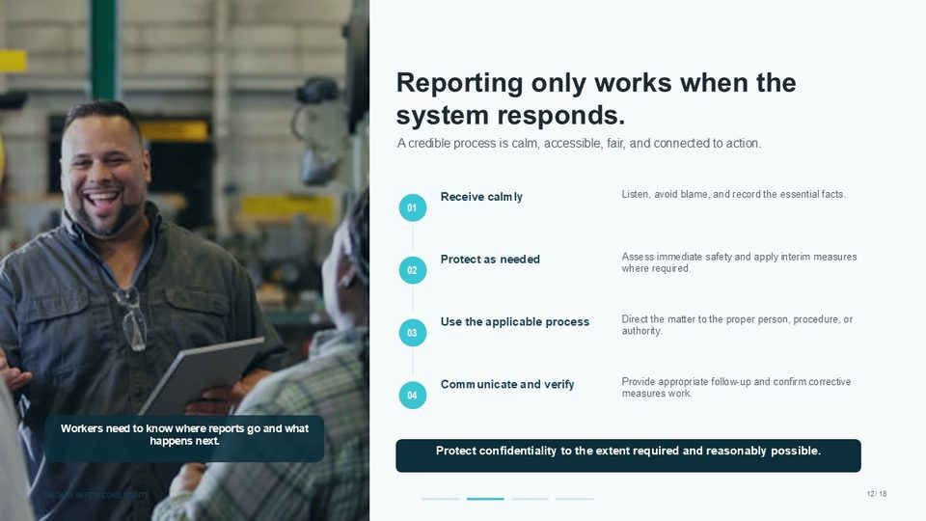  Notes __________________ | Reporting only works when the system responds.  Reporting only strengthens prevention when the system responds. The person receiving a concern should listen calmly, avoid blame, record the essential facts, and determine whether immediate protective steps are required. The matter must then be directed through the process required by the applicable legislation and workplace policy.  That process may involve informal resolution, a formal investigation, a designated recipient, a committee or representative, human resources, security, emergency services, or the regulator. Next is to communicate and verify the findings. Confidentiality should be protected to the extent required and reasonably possible, but it should not be promised in absolute terms when information must be shared to assess risk or meet legal duties.  KEY POINTS  • A credible process is calm, accessible, fair, and connected to action.  • Listen, avoid blame, and record the essential facts.  • Receive calmly  • Assess immediate safety and apply interim measures where required.

LESSON 02 • SLIDE 12 OF 15    Notes __________________ | Part 3: Knowledge Check  Part Three is a knowledge check. Focus on the worker’s role within the IRS, while remembering that the employer still has broader system responsibilities.  KEY POINTS  • Bringing it all Together  • Pause the video and test your understanding of the worker’s role.

GENERAL NOTES

LESSON 02 • SLIDE 13 OF 15  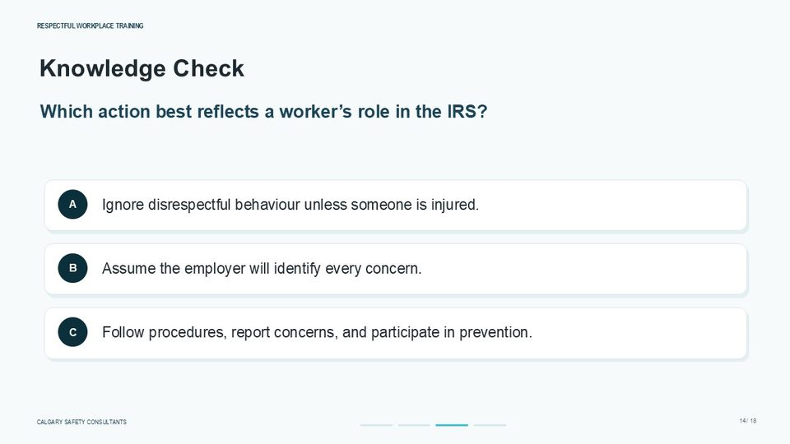  Notes __________________ | Which of the following is a worker’s responsibility under the IRS?  Which action best reflects a worker’s role in the IRS? A. Ignore disrespectful behaviour unless someone is injured. B. Assume the employer will identify every concern. C. Follow procedures, report concerns, and participate in prevention. The correct answer is C: follow procedures, report concerns, and participate in prevention. Ignoring disrespectful behaviour can allow risk to continue or escalate.  Assuming the employer will identify every problem is also ineffective because employers and supervisors may not see what workers experience during daily work. Workers contribute by reporting factual concerns, following established procedures, cooperating with reasonable measures, and participating through committees, representatives, inspections, or other safety activities. This worker role supports the IRS; it does not shift the employer’s legal accountability onto the worker.  KEY POINTS  • Knowledge Check  • Which action best reflects a worker’s role in the IRS?  • A  • Ignore disrespectful behaviour unless someone is injured.

LESSON 02 • SLIDE 14 OF 15  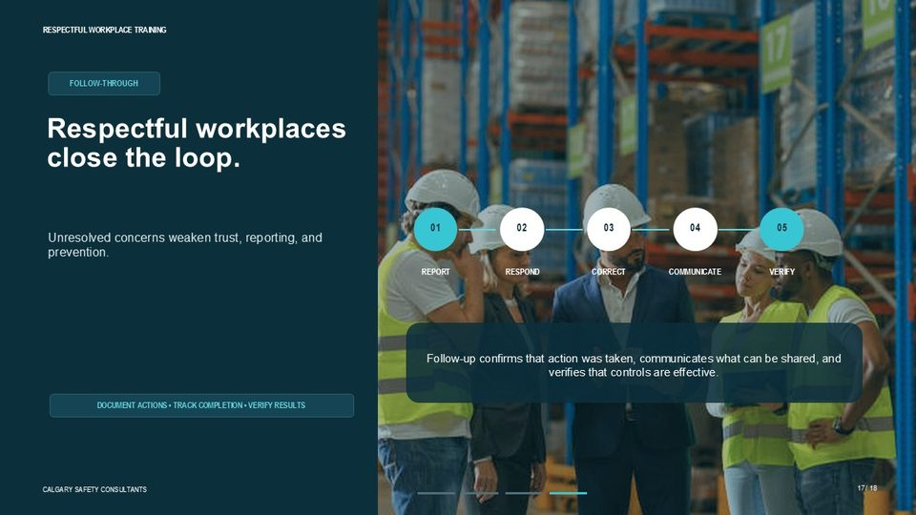  Notes __________________ | Respectful workplaces close the loop.  Remember, Respectful workplaces close the loop. A concern is reported, received, assessed, corrected, communicated, and verified. The communication step does not require disclosing confidential personal information. It means the reporting person and other affected parties receive enough information to understand that the concern was considered and that appropriate action was taken.  Committees or representatives may review trends, controls, or recommendations where permitted, without accessing information that must remain confidential. Unresolved or repeatedly deferred concerns weaken trust, reduce reporting, and allow operational and people risks to remain.  KEY POINTS  • FOLLOW-THROUGH  • Unresolved concerns weaken trust, reporting, and prevention.  • REPORT  • RESPOND

LESSON 02 • SLIDE 15 OF 15  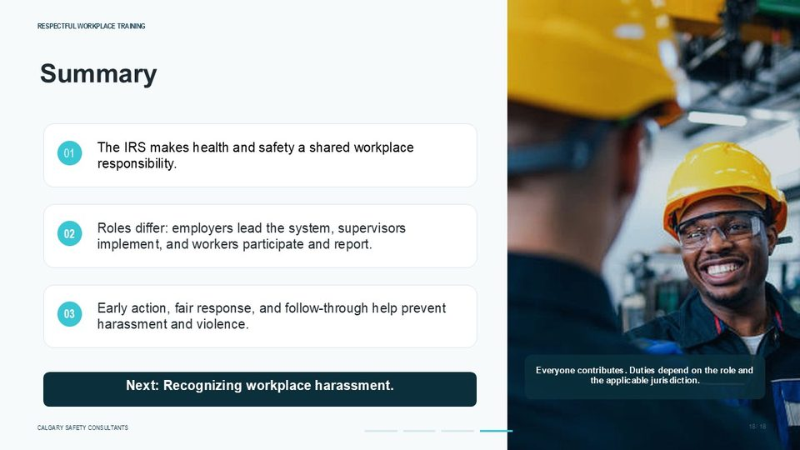  Notes __________________ | Summary  Let’s summarize what we learned. The Internal Responsibility System makes health and safety a shared workplace responsibility across Canada. Employers lead and resource the prevention system. Supervisors apply expectations and respond to concerns. Workers follow procedures, report issues, and participate in prevention. These roles differ, but they must work together. Early action, fair response, and verified follow-through help prevent harassment, violence, and other workplace harm.  In the next lesson, we will look more closely at workplace harassment, including how to recognize conduct, distinguish it from reasonable management action, and use the appropriate reporting process.  KEY POINTS  • The IRS makes health and safety a shared workplace responsibility.  • Roles differ: employers lead the system, supervisors implement, and workers participate and report.  • Early action, fair response, and follow-through help prevent harassment and violence.  • Everyone contributes. Duties depend on the role and the applicable jurisdiction.

GENERAL NOTES

LESSON 02 SUMMARY
Shared Responsibility & the Internal Responsibility System (IRS)
The following points bring the lesson together. Use them to review the main prevention message and connect it to the procedures and expectations in your workplace.
01 | The IRS connects leadership, supervision, worker action, and formal participation mechanisms. Each party contributes information and action, but the scope of each party's duty depends on its legal role and level of authority.
02 | Worker rights support meaningful participation. The right to know provides hazard and control information; the right to participate supports involvement in prevention; and the right to refuse is exercised through the process required by the applicable jurisdiction.
03 | Early intervention is one of the strongest benefits of the IRS. Reporting a pattern of disrespect, a threat, a near miss, or another concern gives the workplace an opportunity to assess risk and act before the situation becomes more serious.
04 | A credible reporting process receives concerns calmly, records essential facts, assesses immediate safety, applies interim protection where required, directs the matter to the correct process, and protects confidentiality to the extent required and reasonably possible.
05 | Follow-through builds trust. The workplace should confirm that the concern was received, take appropriate corrective action, communicate what can properly be communicated, and verify that the controls are working.
Reflection and application
• What is my role in the Internal Responsibility System?
• Who receives reports in this workplace when the usual supervisor is involved in the concern?
• How will a reporting person know that the workplace has followed through?
________________________________________________________________________________
________________________________________________________________________________
GENERAL NOTES

MODULE ONE / LESSON 03

Workplace Culture & Psychological Safety
Voice | Respect | Reporting | Follow-through
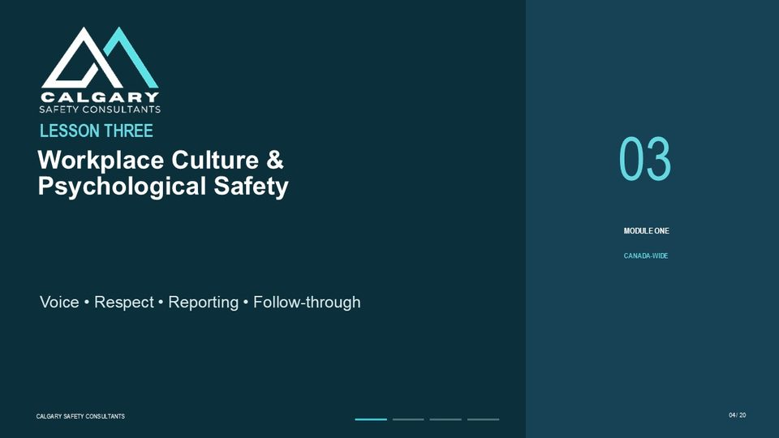
Lesson overview
Workplace culture is formed by the behaviour and decisions that are repeatedly rewarded, tolerated, and corrected. Written values matter, but workers judge the real standard by what happens when someone asks a question, makes a mistake, raises a concern, challenges an unsafe practice, or reports harmful behaviour.
Psychological safety is the practical ability to use one's voice for legitimate work purposes without expecting humiliation, ridicule, blame, or retaliation. It supports questions, feedback, reporting, and learning. Psychological safety is not permission to ignore standards or avoid accountability. It means that accountability is handled fairly and professionally, and that a safe voice connects to a credible response.
By the end of this lesson you should be able to
• Explain the connection between workplace culture and psychological safety.
• Recognize cultural signals that encourage or discourage speaking up.
• Describe how tolerated behaviour can become normalized and increase risk.
• Identify practical ways workers and leaders can support a respectful culture.
• Choose a safe response without taking on the role of investigator.
GENERAL NOTES

LESSON 03 • SLIDE 01 OF 20  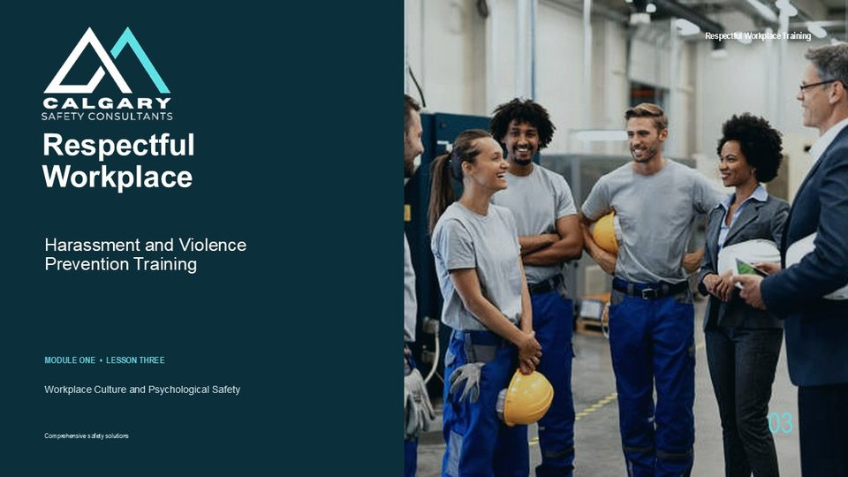  Notes __________________ | Respectful Workplace: Harassment and Violence Prevention Training  In this lesson, we are looking at workplace culture and psychological safety. These two ideas are closely connected because culture affects whether people feel able to speak up, ask questions, report concerns, and trust that the organization will respond fairly. A respectful workplace is not created by policy wording alone.  It is shaped by what happens every day when workers interact with each other, supervisors make decisions, concerns are raised, and leaders decide what they will reward, tolerate, or correct. This lesson is presented as a Canada-wide foundation. The exact legal definitions, reporting requirements, investigation steps, confidentiality expectations, and prevention duties can vary between federal, provincial, and territorial jurisdictions.  Always use the legislation and workplace procedures that apply to your workplace.  KEY POINTS  • Respectful Workplace  • Harassment and Violence Prevention Training  • Workplace Culture and Psychological Safety

LESSON 03 • SLIDE 02 OF 20    Notes __________________ | Culture is what the workplace repeatedly rewards, tolerates, and corrects.  Culture is what the workplace repeatedly rewards, tolerates, and corrects. That means culture is not only what appears in a policy, on a poster, or in a set of company values. Culture is what workers experience when they watch how people are treated, how leaders respond to concerns, and whether unacceptable behaviour is corrected consistently. Written values matter, but they only become real when daily decisions reinforce them.  For example, if a workplace says respect is important but excuses bullying because someone is a high performer, workers quickly learn that the written standard is not the real standard. People also watch what happens after someone raises a concern. If the concern is handled calmly, fairly, and with follow-through, trust improves. If the person is ignored, blamed, mocked, or punished, reporting becomes less likely and risk can remain hidden.  KEY POINTS  • WORKPLACE CULTURE  • Written values matter only when daily decisions reinforce them.  • REWARD  • TOLERATE

LESSON 03 • SLIDE 03 OF 20  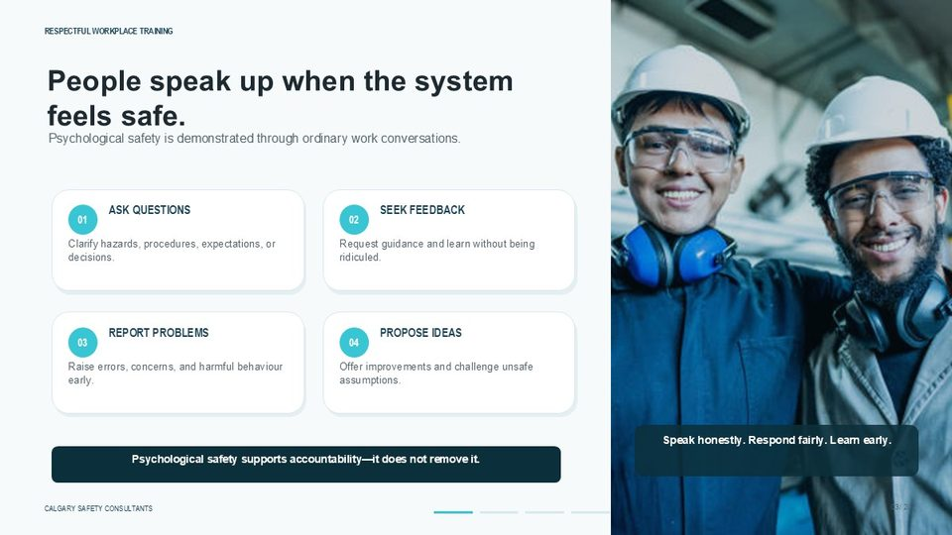  Notes __________________ | People speak up when the system feels safe.  People speak up when the system feels safe. Psychological safety is demonstrated through ordinary work conversations. It shows up when workers can ask questions, seek feedback, report problems, and propose ideas without expecting humiliation, ridicule, blame, or reprisal for participating in good faith. This does not mean there are no standards. It does not mean every idea must be accepted, every mistake has no consequence, or every conversation will be comfortable.  Psychological safety supports accountability because it allows problems to become visible early enough to be understood and corrected. When people can speak honestly and receive a fair response, the organization learns sooner. Hazards, harmful behaviour, communication issues, and weak controls are identified before they become more serious. The goal is simple: speak honestly, respond fairly, and learn early.  KEY POINTS  • Psychological safety is demonstrated through ordinary work conversations.  • ASK QUESTIONS  • SEEK FEEDBACK  • Clarify hazards, procedures, expectations, or decisions.

GENERAL NOTES

LESSON 03 • SLIDE 04 OF 20  Notes __________________ | LESSON THREE: The Link Between Workplace Culture and Psychological Safety  Lesson Three focuses on the link between workplace culture and psychological safety. We will connect four practical ideas: voice, respect, reporting, and follow-through. Voice means workers can raise questions and concerns. Respect means people are treated professionally, even when issues are difficult. Reporting means concerns have a clear route into the workplace process. Follow-through means action is assigned, completed, communicated appropriately, and verified.  As we move through the lesson, think about the everyday signals in your own workplace. Ask yourself what behaviour is rewarded, what behaviour is tolerated, what behaviour is corrected, and whether people believe it is safe to report concerns before harm occurs.  KEY POINTS  • Workplace Culture & Psychological Safety  • Voice • Respect • Reporting • Follow-through

LESSON 03 • SLIDE 05 OF 20  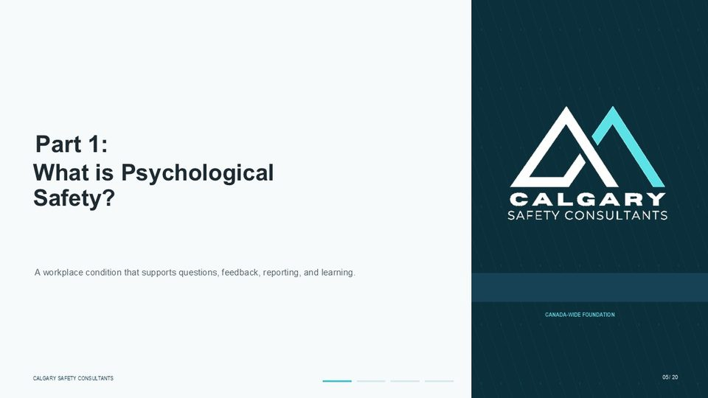  Notes __________________ | Part 1: What is Psychological Safety?  Part One begins with a basic question: what is psychological safety? For this training, psychological safety means a workplace condition that supports questions, feedback, reporting, and learning. It is the practical ability to use your voice without expecting unfair punishment or embarrassment when you raise a legitimate concern in good faith. This matters in harassment and violence prevention because early information is essential.  Workers may notice disrespect, exclusion, intimidation, threats, or changes in behaviour before management sees a formal complaint. If people do not feel safe to speak, those warning signs may never reach the people who can act. Psychological safety is therefore not a soft concept. It is part of a functioning prevention system because it helps the workplace identify risk, correct weak controls, and respond before issues escalate.  KEY POINTS  • What is Psychological Safety?  • A workplace condition that supports questions, feedback, reporting, and learning.

LESSON 03 • SLIDE 06 OF 20  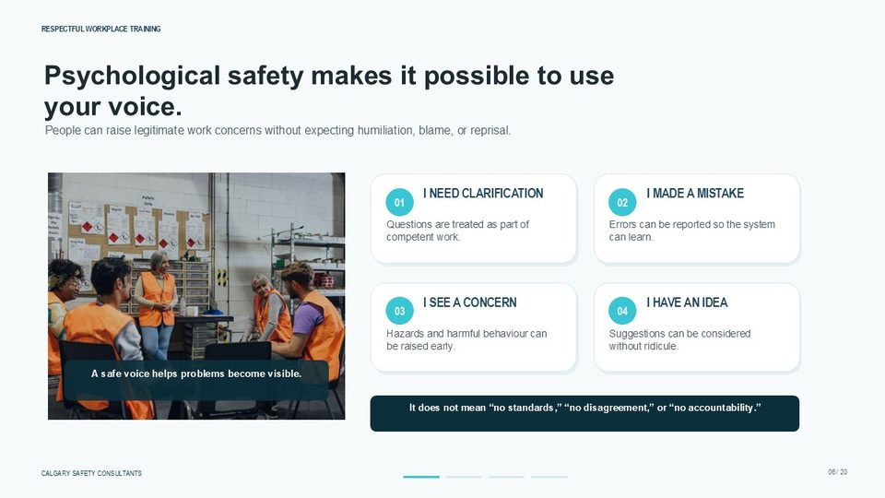  Notes __________________ | Psychological safety makes it possible to use your voice.  Psychological safety makes it possible to use your voice. A safe voice allows someone to say, I need clarification, when expectations are unclear. Questions should be treated as part of competent work, not as a sign that someone is weak, difficult, or not paying attention. A safe voice also allows someone to say, I made a mistake. When errors can be reported, the organization can learn from them instead of allowing the same condition to continue.  The same idea applies when someone says, I see a concern, or I have an idea. Hazards, harmful behaviour, and practical improvements become visible through worker participation. Psychological safety does not mean no standards, no disagreement, or no accountability. It means people can raise legitimate work concerns without expecting humiliation, blame, or reprisal. That is how a safe voice helps problems become visible.  KEY POINTS  • People can raise legitimate work concerns without expecting humiliation, blame, or reprisal.  • I NEED CLARIFICATION  • I MADE A MISTAKE  • Questions are treated as part of competent work.

GENERAL NOTES

LESSON 03 • SLIDE 07 OF 20  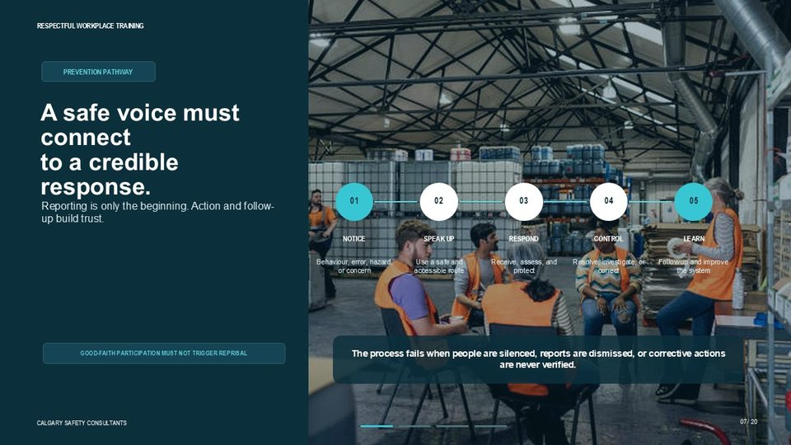  Notes __________________ | A safe voice must connect to a credible response.  A safe voice must connect to a credible response. Reporting is only the beginning. If a worker notices behaviour, an error, a hazard, or another concern, they need a safe and accessible way to speak up. Once that concern is raised, the workplace must receive it, assess it, protect people where required, and determine the proper next step. The prevention pathway on this slide moves from notice, to speak up, to respond, to control, and then to learn.  Control may involve correcting behaviour, applying interim safeguards, using the workplace procedure, completing an investigation where required, or improving the system so the same issue is less likely to repeat. The process fails when people are silenced, reports are dismissed, or corrective actions are never verified. Good-faith participation must not trigger reprisal. Trust grows when workers see that concerns are taken seriously and followed through to completion.  KEY POINTS  • PREVENTION PATHWAY  • Reporting is only the beginning. Action and follow-up build trust.  • NOTICE  • SPEAK UP

LESSON 03 • SLIDE 08 OF 20  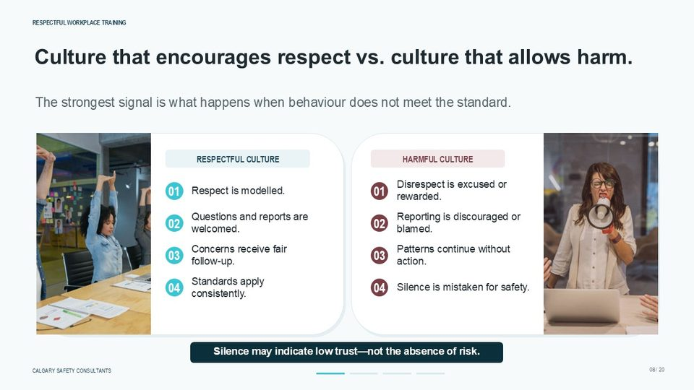  Notes __________________ | Culture That Encourages Respect vs. Culture That Allows Harm  This slide compares a culture that encourages respect with a culture that allows harm. In a respectful culture, respect is modelled, questions and reports are welcomed, concerns receive fair follow-up, and standards apply consistently. The strongest signal is not what the policy says; the strongest signal is what happens when behaviour does not meet the standard. A harmful culture works differently. Disrespect may be excused or rewarded.  Reporting may be discouraged, blamed, or treated as disloyal. Patterns may continue without meaningful action, and silence may be mistaken for safety. That last point is important. Silence may indicate low trust, not the absence of risk. A quiet workplace is not automatically a safe workplace. Leaders and supervisors need to look at whether people know how to report, whether they believe reporting is safe, and whether past concerns were handled fairly.  KEY POINTS  • Culture that encourages respect vs. culture that allows harm.  • The strongest signal is what happens when behaviour does not meet the standard.  • RESPECTFUL CULTURE  • HARMFUL CULTURE

LESSON 03 • SLIDE 09 OF 20  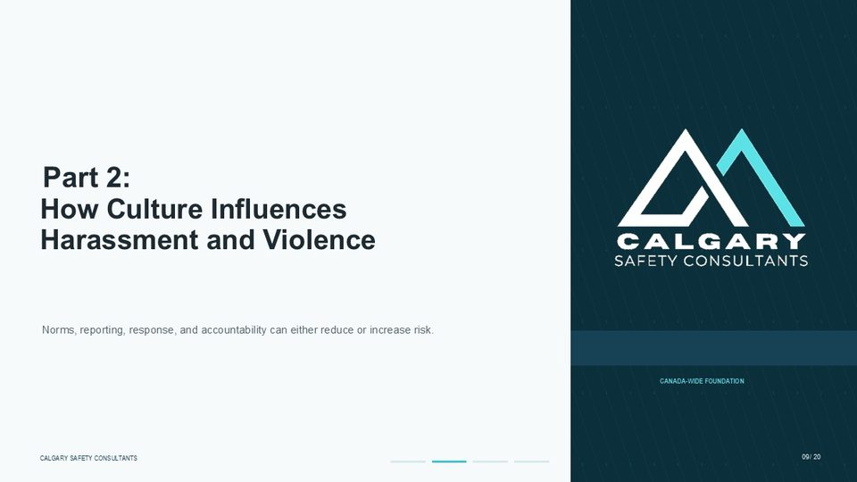  Notes __________________ | Part 2: How Culture Influences Harassment and Violence  Part Two looks at how workplace culture influences harassment and violence risk. Culture affects the norms people follow, the way concerns are reported, the response workers expect, and the accountability applied when behaviour falls below the standard. These factors can either reduce risk or allow risk to increase. In a strong culture, people understand the expected standard, report concerns early, and trust that the response will be fair.  In a weak culture, disrespect may become normal, concerns may be minimized, and workers may stop reporting because they do not believe anything useful will happen. As we go through this section, focus on cause and effect. What the workplace tolerates affects what people repeat. What people repeat affects the level of risk. What the organization corrects affects whether trust improves or declines.  KEY POINTS  • How Culture Influences Harassment and Violence  • Norms, reporting, response, and accountability can either reduce or increase risk.

GENERAL NOTES

LESSON 03 • SLIDE 10 OF 20  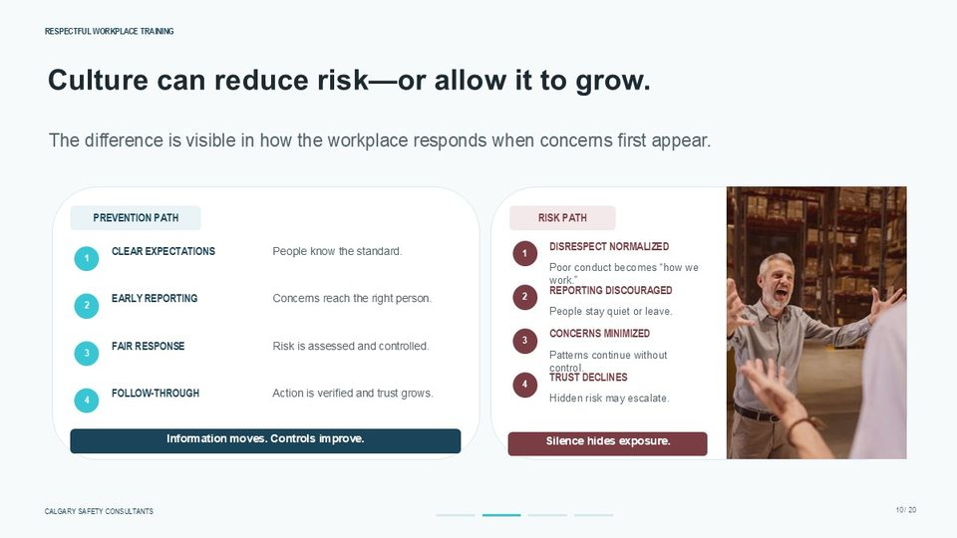  Notes __________________ | Culture can reduce risk—or allow it to grow.  Culture can reduce risk, or it can allow risk to grow. The prevention path starts with clear expectations. People need to know the standard for respectful conduct, reporting, and safe behaviour. When expectations are clear, concerns are more likely to reach the right person early. The next part of the prevention path is a fair response. The workplace assesses the concern, protects people where required, controls the risk, and follows through.  When action is verified, trust grows, information moves, and controls improve. The risk path moves in the opposite direction. Disrespect becomes normalized, reporting is discouraged, concerns are minimized, and trust declines. When people stay quiet or leave, the workplace may lose the information needed to prevent harm. Silence can hide exposure, and hidden exposure can escalate.  KEY POINTS  • The difference is visible in how the workplace responds when concerns first appear.  • PREVENTION PATH  • RISK PATH  • DISRESPECT NORMALIZED

LESSON 03 • SLIDE 11 OF 20  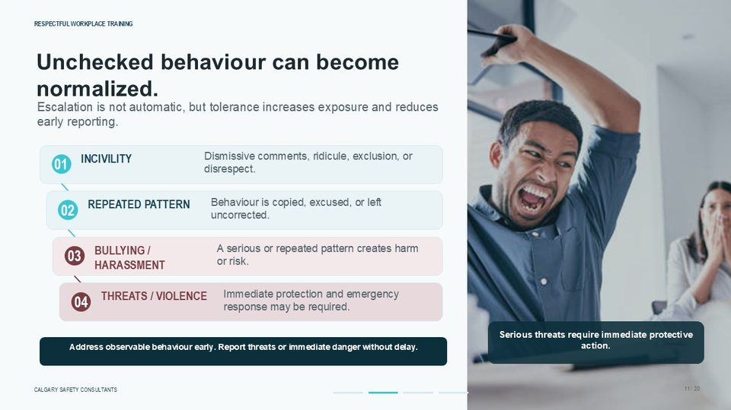  Notes __________________ | Unchecked behaviour can become normalized.  Unchecked behaviour can become normalized. Escalation is not automatic. A single rude comment does not always become harassment, and every conflict does not become violence. However, tolerance increases exposure and reduces early reporting. When poor conduct is copied, excused, or left uncorrected, it can become part of how the workplace operates. The progression on this slide starts with incivility, such as dismissive comments, ridicule, exclusion, or disrespect.  If that behaviour becomes a repeated pattern and is not corrected, it may create or contribute to bullying, harassment, or other harmful conduct. Threats and violence require immediate attention. If there is immediate danger, the priority is protection, emergency response, and getting help without delay. The practical message is to address observable behaviour early, and to report threats or immediate danger immediately.  KEY POINTS  • Escalation is not automatic, but tolerance increases exposure and reduces early reporting.  • Dismissive comments, ridicule, exclusion, or disrespect.  • INCIVILITY  • Behaviour is copied, excused, or left uncorrected.

LESSON 03 • SLIDE 12 OF 20  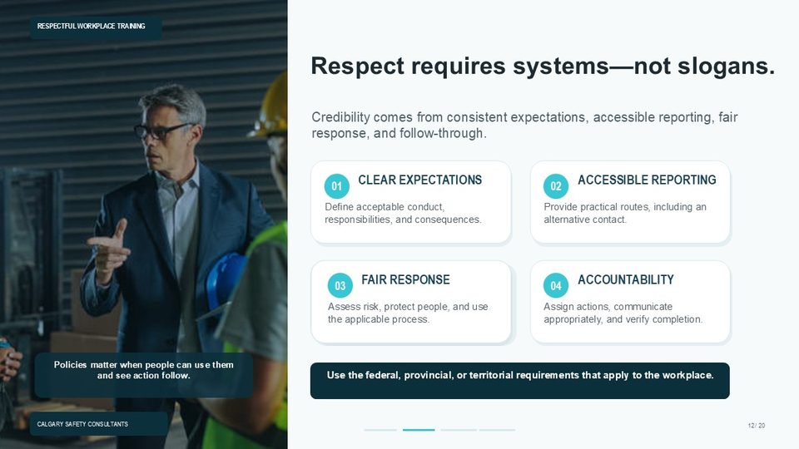  Notes __________________ | Respect requires systems—not slogans.  Respect requires systems, not slogans. A respectful workplace needs more than a statement that everyone should treat each other well. Credibility comes from consistent expectations, accessible reporting, fair response, and follow-through. Workers need to know what acceptable conduct looks like, what responsibilities apply to their role, and what consequences may follow when standards are not met. Accessible reporting is also essential.  A worker should know where to report a concern, and there should be an alternative contact if the normal reporting route is not appropriate. Once a concern is received, the workplace must assess risk, protect people where required, and use the applicable process. Accountability means actions are assigned, communicated appropriately, and verified. Use the federal, provincial, or territorial requirements that apply to the workplace.  Policies matter most when people can actually use them and see action follow.  KEY POINTS  • Credibility comes from consistent expectations, accessible reporting, fair response, and follow-through.  • CLEAR EXPECTATIONS  • ACCESSIBLE REPORTING  • Define acceptable conduct, responsibilities, and consequences.

GENERAL NOTES

LESSON 03 • SLIDE 13 OF 20  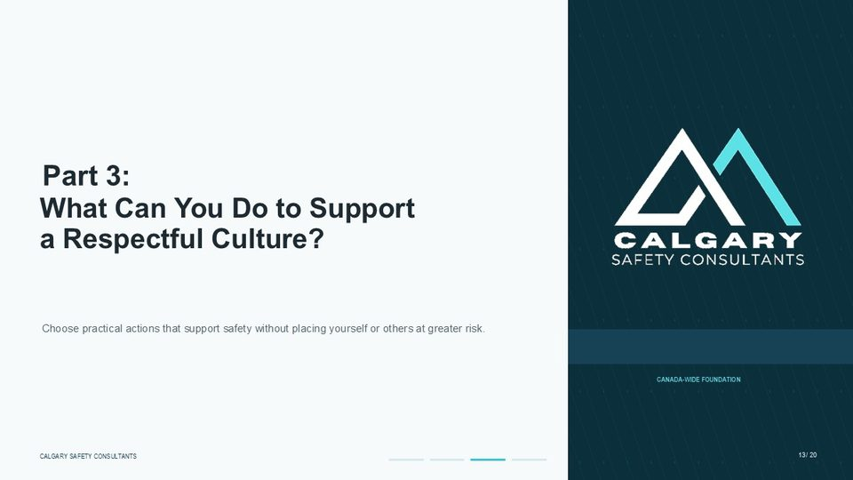  Notes __________________ | Part 3: What Can You Do to Support a Respectful Culture?  Part Three asks what you can do to support a respectful culture. This section focuses on practical actions. Supporting a respectful culture does not mean taking on responsibilities beyond your role, investigating complaints on your own, physically confronting a threatening person, or placing yourself or others at greater risk. Instead, the goal is to make safe choices that support the workplace prevention system.  That can include modelling respect, listening without ridicule, reporting factual concerns through the proper process, supporting others, and getting help when a situation is serious or unsafe. Every workplace role contributes to culture. The way people speak, listen, report, respond, and follow through affects whether respect is treated as a real operating expectation.  KEY POINTS  • What Can You Do to Support a Respectful Culture?  • Choose practical actions that support safety without placing yourself or others at greater risk.

LESSON 03 • SLIDE 14 OF 20  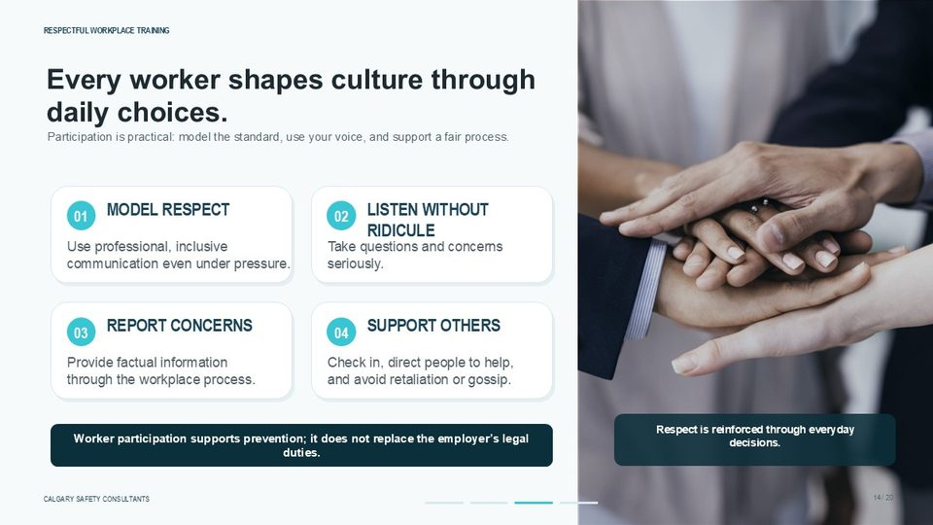  Notes __________________ | Every worker shapes culture through daily choices.  Every worker shapes culture through daily choices. Participation is practical. Workers can model respect by using professional and inclusive communication, even when work is busy, stressful, or difficult. Respect is not only tested when things are easy; it is often most important when there is pressure, disagreement, or uncertainty. Workers can also listen without ridicule. When someone asks a question or raises a concern, taking that concern seriously helps maintain trust.  Reporting concerns is another important action. Reports should be factual, timely, and made through the workplace process. Supporting others may involve checking in, helping someone find the right contact, and avoiding retaliation, gossip, or speculation. Worker participation supports prevention, but it does not replace the employer’s legal duties. Respect is reinforced through everyday decisions.  KEY POINTS  • Participation is practical: model the standard, use your voice, and support a fair process.  • MODEL RESPECT  • LISTEN WITHOUT RIDICULE  • Use professional, inclusive communication even under pressure.

LESSON 03 • SLIDE 15 OF 20  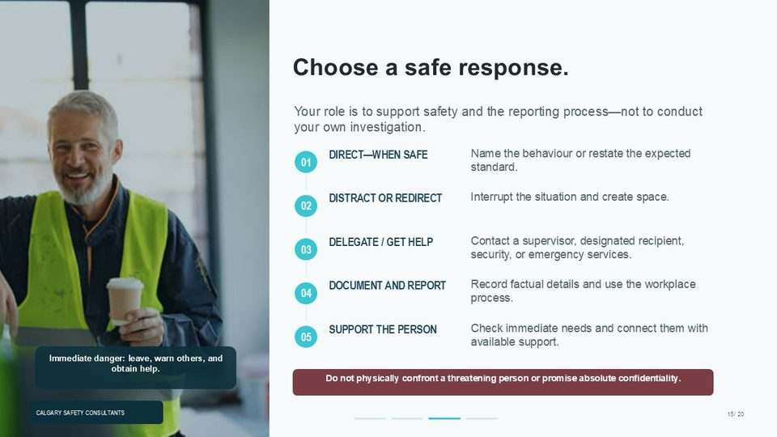  Notes __________________ | Choose a safe response.  Choose a safe response. Your role is to support safety and the reporting process, not to conduct your own investigation. The right response depends on the situation, your role, the level of risk, and what is safe in the moment. When it is safe, a direct response may involve naming the behaviour or restating the expected standard. A distract or redirect response can interrupt the situation and create space without escalating the conflict.  Delegating or getting help may mean contacting a supervisor, a designated recipient, security, or emergency services. You may also document and report by recording factual details and using the workplace process. Supporting the person may involve checking immediate needs and connecting them with available help. Do not physically confront a threatening person, and do not promise absolute confidentiality. If there is immediate danger, leave, warn others where safe to do so, and obtain help.  KEY POINTS  • Your role is to support safety and the reporting process—not to conduct your own investigation.  • Name the behaviour or restate the expected standard.  • DIRECT—WHEN SAFE  • Interrupt the situation and create space.

GENERAL NOTES

LESSON 03 • SLIDE 16 OF 20  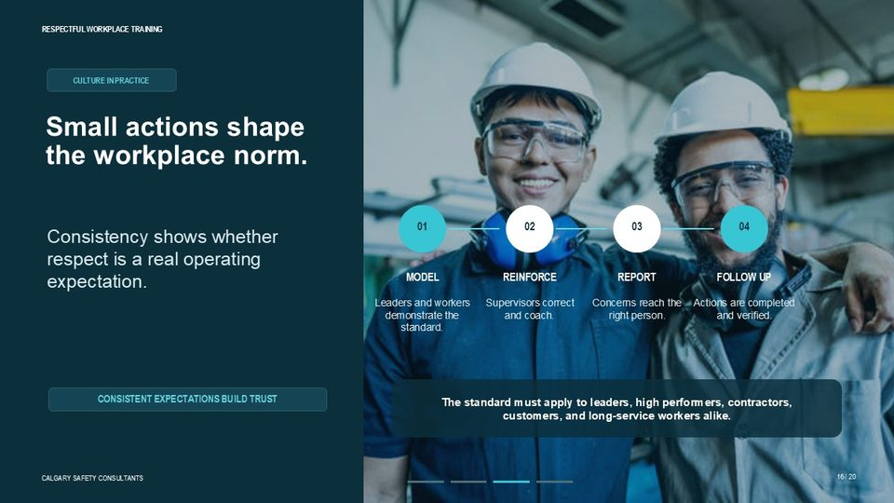  Notes __________________ | Small actions shape the workplace norm.  Small actions shape the workplace norm. Culture in practice is built through consistency. Leaders and workers model the standard through their behaviour. Supervisors reinforce the standard by correcting and coaching when expectations are not met. Workers and supervisors use reporting routes so concerns reach the right person. Follow-up confirms that actions are completed and verified. The key is that the standard must apply consistently.  Respectful conduct requirements should apply to leaders, high performers, contractors, customers, and long-service workers alike. If some people are allowed to ignore the standard because of status, productivity, seniority, or business pressure, trust declines. Consistent expectations build trust because workers can see that respect is not selective. It is part of how the workplace operates.  KEY POINTS  • CULTURE IN PRACTICE  • Consistency shows whether respect is a real operating expectation.  • MODEL  • REINFORCE

LESSON 03 • SLIDE 17 OF 20  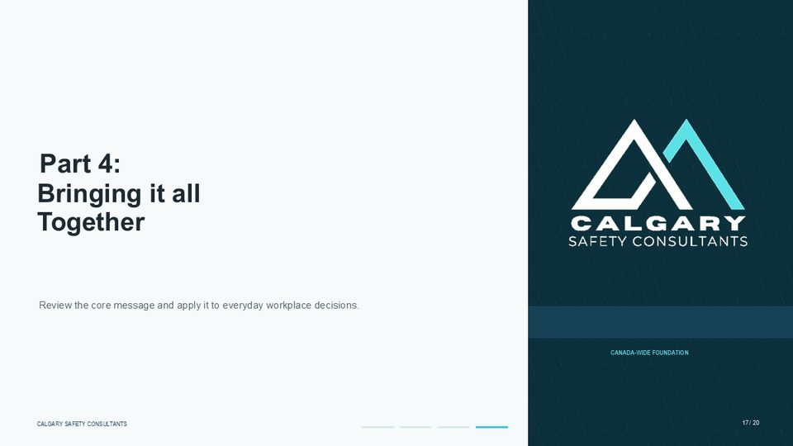  Notes __________________ | Part 4: Bringing it all Together  Part Four brings the lesson together. The core message is that workplace culture and psychological safety are not separate from harassment and violence prevention. They influence whether people speak up, whether information moves, whether concerns receive a fair response, and whether the workplace learns from what is reported. As you apply this lesson, think about everyday workplace decisions. Is respectful behaviour being modelled? Are questions treated as part of competent work?  Are concerns received without ridicule or blame? Are reports followed up and verified? Prevention becomes stronger when voice, respect, reporting, and follow-through work together.  KEY POINTS  • Bringing it all Together  • Review the core message and apply it to everyday workplace decisions.

LESSON 03 • SLIDE 18 OF 20  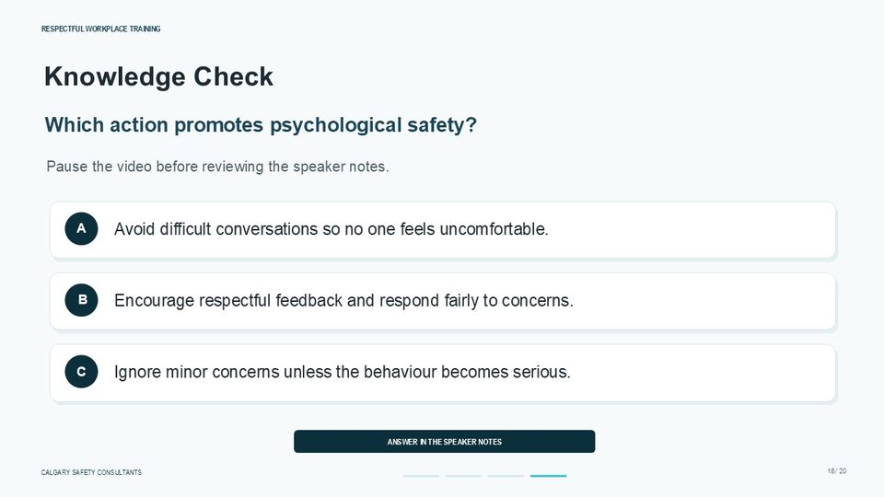  Notes __________________ | Knowledge Check  Which action promotes psychological safety? Option A: avoid difficult conversations so no one feels uncomfortable. Option B: encourage respectful feedback and respond fairly to concerns. Option C: ignore minor concerns unless the behaviour becomes serious. The correct answer is B: encourage respectful feedback and respond fairly to concerns. Psychological safety is not created by avoiding difficult conversations.  Difficult conversations may be necessary to clarify expectations, correct behaviour, resolve conflict, or protect people from harm. Psychological safety is also not created by ignoring minor concerns. Small issues can reveal patterns, weak controls, or low trust. Pause the video here and choose the best answer before continuing.  KEY POINTS  • Which action promotes psychological safety?  • Pause the video before reviewing the speaker notes.  • Which of the following promotes psychological safety in the workplace? Avoiding difficult conversations Encouraging respectful feedback Ignoring minor concerns  • Avoid difficult conversations so no one feels uncomfortable.

GENERAL NOTES

LESSON 03 • SLIDE 19 OF 20  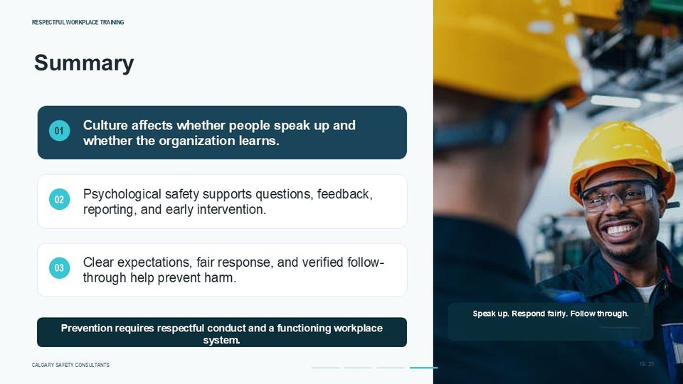  Notes __________________ | Summary  To summarize this lesson, culture affects whether people speak up and whether the organization learns. A respectful culture makes it more likely that workers will ask questions, report concerns, provide feedback, and participate in prevention. Psychological safety supports that process by making it possible to raise legitimate concerns without expecting humiliation, blame, ridicule, or reprisal for good-faith participation.  Clear expectations, fair response, and verified follow-through help prevent harm. A workplace that receives concerns but does not act on them will lose trust. A workplace that responds fairly and verifies corrective action is more likely to identify risk early and improve its controls. The practical takeaway is this: prevention requires respectful conduct and a functioning workplace system. Speak up. Respond fairly. Follow through.  KEY POINTS  • Culture affects whether people speak up and whether the organization learns.  • Psychological safety supports questions, feedback, reporting, and early intervention.  • Clear expectations, fair response, and verified follow-through help prevent harm.  • Speak up. Respond fairly. Follow through.

LESSON 03 • SLIDE 20 OF 20  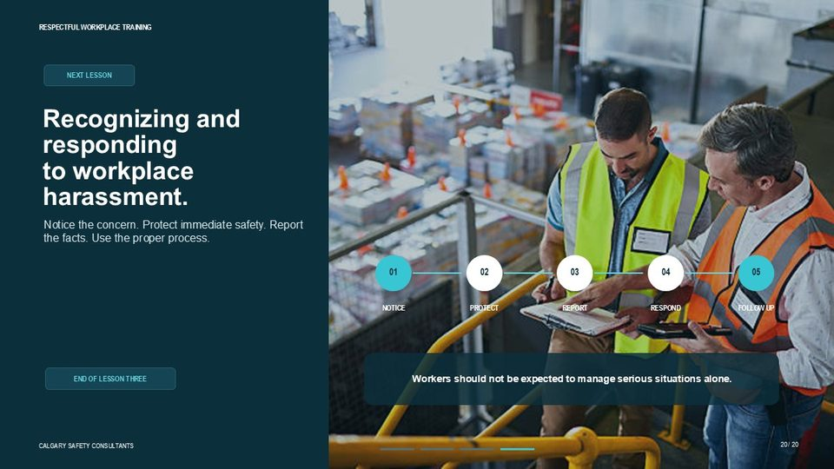  Notes __________________ | Recognizing and responding to workplace harassment.  This lesson has shown why culture and psychological safety matter. The next step is to apply that foundation to specific concerns by noticing the issue, protecting immediate safety, reporting the facts, using the proper process, responding appropriately, and following up. Workers should not be expected to manage serious situations alone.  If there is immediate danger, the priority is to leave the situation where possible, warn others if it is safe to do so, and get help through the appropriate workplace or emergency response process. That completes Lesson Three. Remember that respectful workplaces are built through everyday behaviour, safe reporting, fair response, and verified follow-through. In the next lesson, we will focus on recognizing and responding to workplace harassment.  KEY POINTS  • NEXT LESSON  • Notice the concern. Protect immediate safety. Report the facts. Use the proper process.  • NOTICE  • PROTECT

GENERAL NOTES

LESSON 03 SUMMARY
Workplace Culture & Psychological Safety
The following points bring the lesson together. Use them to review the main prevention message and connect it to the procedures and expectations in your workplace.
01 | Culture becomes visible through repeated choices. If respectful behaviour is modelled, concerns are welcomed, and standards are applied consistently, people are more likely to share information early. If poor behaviour is tolerated or reporting leads to blame, silence becomes a predictable response.
02 | Psychological safety supports performance and prevention because it allows people to ask for clarification, identify errors, request help, offer feedback, and report concerns. It does not remove performance expectations or guarantee agreement with every suggestion.
03 | A safe reporting route must connect to action. Receiving a concern without assessment, follow-up, or communication weakens trust and makes future reporting less likely.
04 | Unchecked behaviour can become normalized. Escalation is not automatic, but repeated tolerance increases exposure, shifts the perceived standard, and can allow more serious harassment or violence risk to develop.
05 | Workers can model the standard, speak directly when it is safe, interrupt or redirect a situation, obtain help, document factual information, use the reporting process, and support the affected person. They should not conduct their own investigation, physically confront a threatening person, or promise absolute confidentiality.
Reflection and application
• What happens in this workplace when someone raises a difficult concern?
• Which everyday behaviours show that questions and feedback are welcome?
• What safe response options are available if direct intervention is not appropriate?
________________________________________________________________________________
________________________________________________________________________________
GENERAL NOTES

MODULE ONE / LESSON 04

Behaviour, Attitude & Mindset
Words | Cues | Awareness | Self-regulation

Lesson overview
Respect is communicated before a policy is opened. Tone, attention, language, boundaries, posture, physical distance, decision-making, and follow-through all affect how an interaction is experienced. Small behaviours can build trust when they are consistently respectful, or weaken trust when interruption, sarcasm, exclusion, dismissal, or aggressive delivery becomes a pattern.
This lesson emphasizes context and self-awareness. Non-verbal cues are not universal, and an observation should not be treated as proof of another person's motive or character. Bias, stress, and emotion can affect what people notice and how they respond. Emotional intelligence and self-regulation help a person pause, clarify, listen, acknowledge input, manage delivery, repair missteps, and choose a safer next step.
By the end of this lesson you should be able to
• Identify observable behaviours that support or undermine workplace respect.
• Use inclusive, context-aware verbal and non-verbal communication.
• Separate observation from interpretation and challenge unsupported assumptions.
• Recognize how bias, stress, and emotional state can affect workplace interactions.
• Apply practical self-regulation and communication strategies during difficult conversations.
GENERAL NOTES

LESSON 04 • SLIDE 01 OF 32  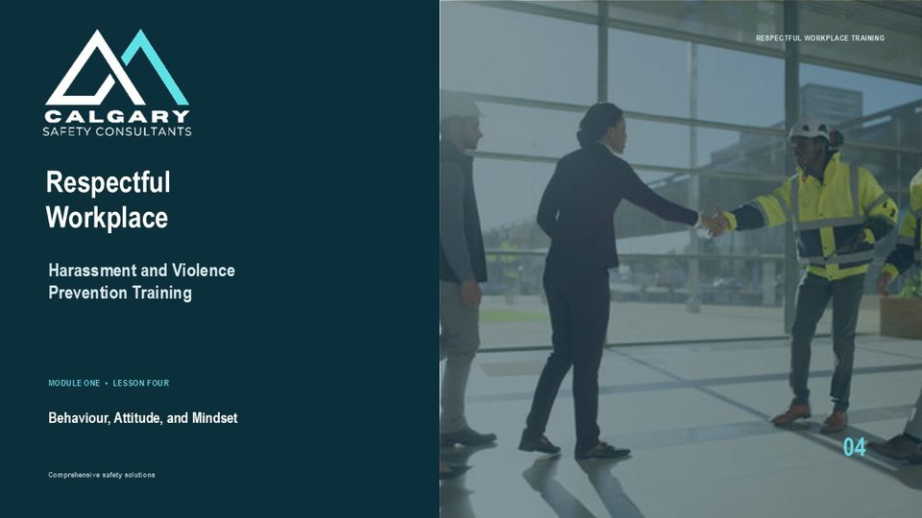  Notes __________________ | Respectful Workplace  This lesson focuses on the everyday behaviour, attitude, mindset, non-verbal communication, and emotional self-management that shape how safe and respected people feel at work. Policies establish expectations, but workers experience respect through ordinary conversations, decisions, corrections, and follow-through. This is a Canada-wide foundation.  Harassment and violence requirements, reporting routes, investigation processes, and legal definitions vary among federal, provincial, and territorial jurisdictions. Learners should always follow the current legislation and the workplace policy and procedures that apply where the work is performed.  KEY POINTS  • Harassment and Violence Prevention Training  • Behaviour, Attitude, and Mindset

LESSON 04 • SLIDE 02 OF 32    Notes __________________ | Respect is communicated before a policy is opened.  Respect is experienced through day-to-day behaviour. People notice whether they are allowed to finish speaking, whether questions are treated seriously, whether decisions are explained, and whether concerns receive a fair response. Tone and non-verbal communication often affect the interaction before anyone refers to a written policy. The implication is practical: ordinary behaviour influences whether workers cooperate, share information, report problems early, and trust the workplace process.  Consistent respectful conduct supports psychological safety and operational reliability. Dismissive or unpredictable conduct can silence information, increase conflict, and make small issues harder to resolve.  KEY POINTS  • EVERYDAY RESPECT  • People notice tone, attention, boundaries, and follow-through.  • WORDS  • NON-VERBAL CUES

LESSON 04 • SLIDE 03 OF 32  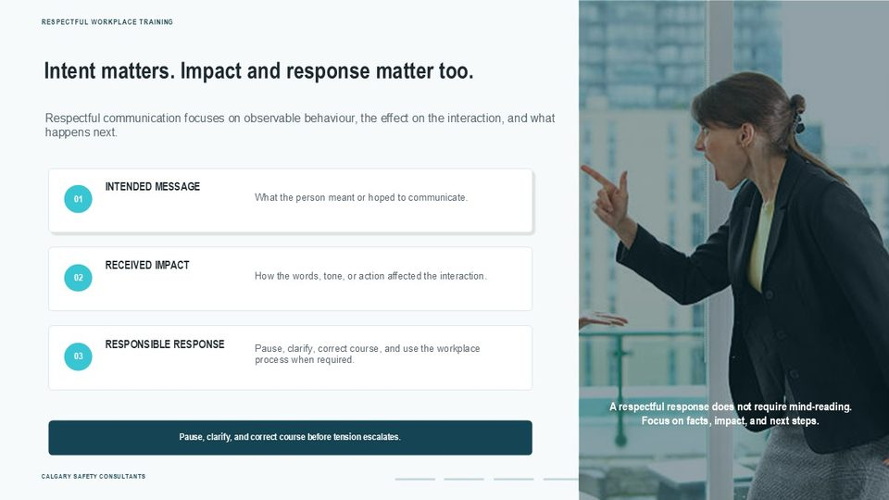  Notes __________________ | Intent matters. Impact and response matter too.  A respectful workplace distinguishes intent from impact. A person may not intend to dismiss, embarrass, exclude, or intimidate someone, yet the words, tone, or action can still affect the interaction. At the same time, one uncomfortable moment does not automatically establish harassment. The appropriate response is to focus on observable facts, listen to the concern, clarify what happened, and use the workplace process when the behaviour may breach policy or legislation.  The practical action is to avoid debating another person's feelings or assuming motive. Ask what was said or done, consider the effect, and decide what correction, support, reporting, or follow-up is required.  KEY POINTS  • Respectful communication focuses on observable behaviour, the effect on the interaction, and what happens next.  • What the person meant or hoped to communicate.  • INTENDED MESSAGE  • How the words, tone, or action affected the interaction.

GENERAL NOTES

LESSON 04 • SLIDE 04 OF 32  Notes __________________ | Behaviour, Attitude & Mindset  Lesson Four builds on the earlier lessons by examining how individual behaviour contributes to workplace culture. By the end of the lesson, learners should be able to identify everyday behaviours that support or undermine respect, use more inclusive and context-aware communication cues, recognize how bias and stress can affect judgment, and apply self-regulation strategies during difficult interactions.  The lesson also reinforces an important Canada-wide principle: respectful communication supports prevention, but it does not replace formal reporting or response requirements. Serious concerns, threats, harassment, or violence must be addressed through the applicable workplace policy, emergency process, and jurisdictional requirements.  KEY POINTS  • Daily choices that influence workplace respect  • WORDS • CUES • AWARENESS • SELF-REGULATION

LESSON 04 • SLIDE 05 OF 32  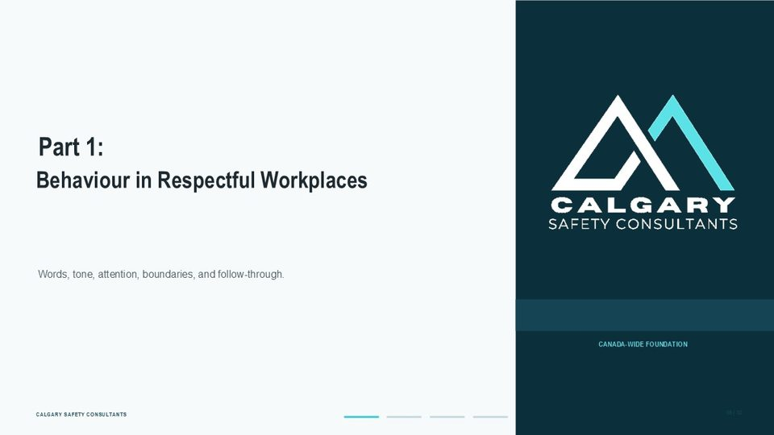  Notes __________________ | Part 1:  Part One focuses on observable behaviour. Respectful workplaces are shaped through small, repeated actions: allowing people to speak, using professional language, listening to concerns, explaining decisions, respecting boundaries, and following through on commitments. These behaviours may appear simple, but their effect is cumulative. Consistency builds trust.  Repeated interruptions, sarcasm, exclusion, or dismissive responses can become normalized and make workers less willing to participate or report concerns.  KEY POINTS  • Behaviour in Respectful Workplaces  • Words, tone, attention, boundaries, and follow-through.

LESSON 04 • SLIDE 06 OF 32  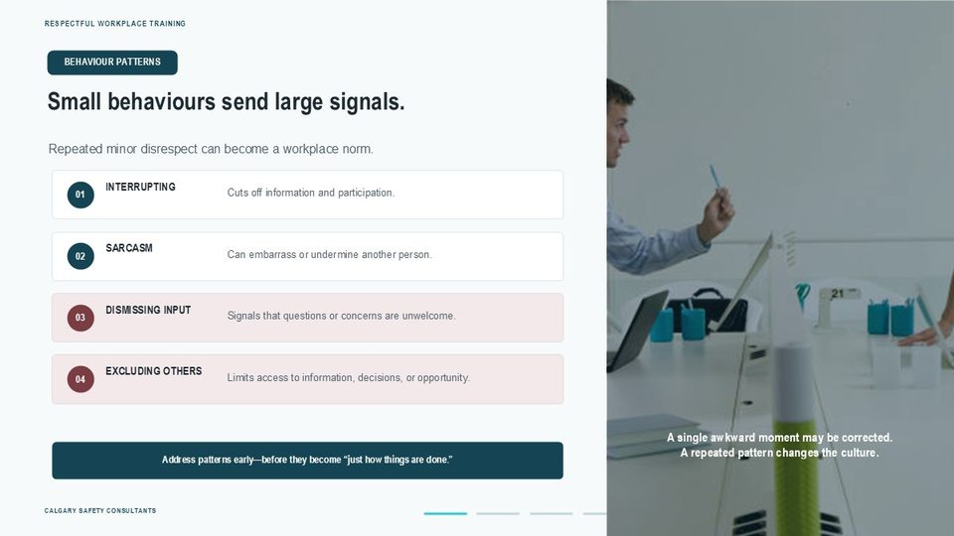  Notes __________________ | Small behaviours send large signals.  Small behaviours are easy to dismiss because they may not appear serious on their own. Examples include repeatedly interrupting one person, using sarcasm during corrections, ignoring suggestions, excluding someone from necessary conversations, or responding to questions with ridicule. A single misstep may be repaired through a timely correction. Repeated behaviour can create a pattern that discourages participation and normalizes disrespect.  Supervisors and workers should address patterns early and proportionately. The goal is not to label every disagreement as harassment. The goal is to stop avoidable conduct from becoming a predictable condition of work, with consequences for morale, reporting, productivity, turnover, and claims.  KEY POINTS  • BEHAVIOUR PATTERNS  • Repeated minor disrespect can become a workplace norm.  • Cuts off information and participation.  • INTERRUPTING

GENERAL NOTES

LESSON 04 • SLIDE 07 OF 32  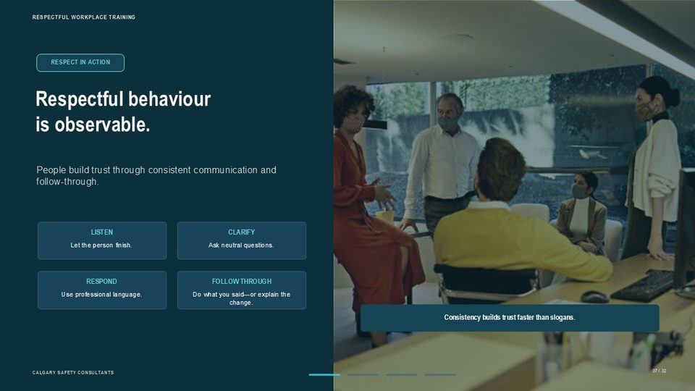  Notes __________________ | Respectful behaviour is observable.  Respectful behaviour can be described in practical terms. Let people finish speaking. Ask questions before reaching conclusions. Use professional language, even when correcting performance or disagreeing. Explain decisions that affect the work. Follow through on commitments, or communicate promptly when circumstances change. These actions matter because credibility is built through repetition. A workplace can display strong values and still lose trust when daily behaviour is inconsistent.  When communication is predictable and fair, workers are more likely to raise hazards, admit errors, seek clarification, and contribute useful information before a problem affects safety or operations.  KEY POINTS  • RESPECT IN ACTION  • People build trust through consistent communication and follow-through.  • LISTEN  • CLARIFY

LESSON 04 • SLIDE 08 OF 32  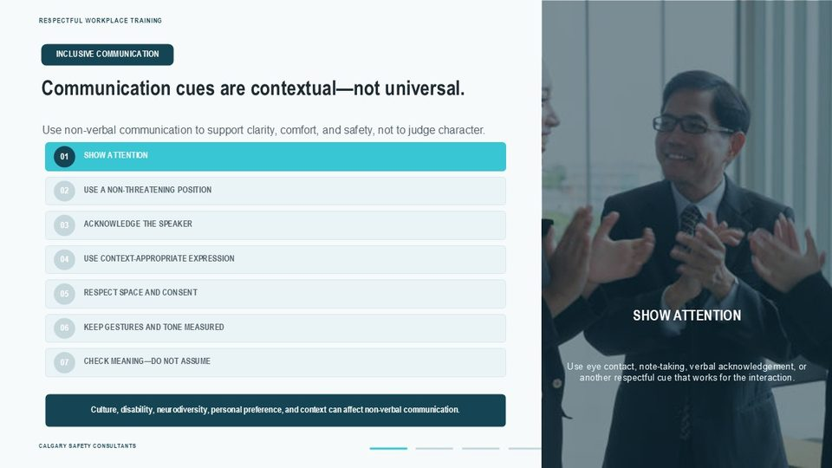  Notes __________________ | Communication cues are contextual—not universal.  Traditional body-language advice often emphasizes eye contact. A more inclusive approach is to show attention in a way that works for the people and the task. Some people use direct eye contact. Others listen better while looking away, taking notes, monitoring equipment, or focusing on a screen. Culture, disability, neurodiversity, trauma, and personal preference can all affect eye contact. Do not use one non-verbal cue as proof of honesty, respect, confidence, or interest.  Focus on the whole interaction. Is the person listening? Can they respond? Are expectations clear? Ask rather than assume.  KEY POINTS  • INCLUSIVE COMMUNICATION  • Use non-verbal communication to support clarity, comfort, and safety, not to judge character.  • SHOW ATTENTION  • USE A NON-THREATENING POSITION

LESSON 04 • SLIDE 09 OF 32  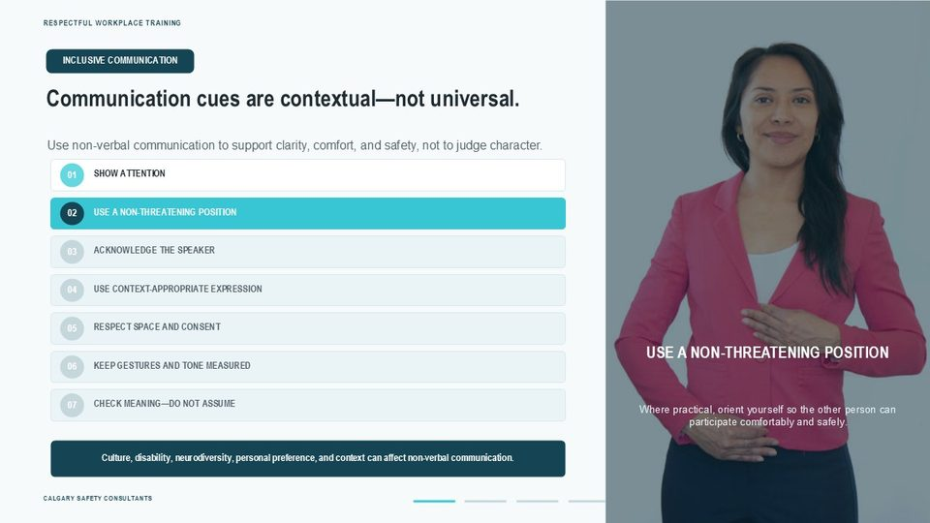  Notes __________________ | Communication cues are contextual—not universal.  An open or non-threatening position can support communication, but posture must be understood in context. Workers may cross their arms because they are cold, in pain, wearing protective equipment, or simply comfortable. Mobility limitations, workstation design, fatigue, and cultural norms can also affect posture. The practical goal is not to enforce a particular pose. It is to avoid crowding, looming, blocking an exit, or using body position to intimidate.  Where practical, position yourself so the other person can participate comfortably and safely.  KEY POINTS  • INCLUSIVE COMMUNICATION  • Use non-verbal communication to support clarity, comfort, and safety, not to judge character.  • SHOW ATTENTION  • USE A NON-THREATENING POSITION

GENERAL NOTES

LESSON 04 • SLIDE 10 OF 32  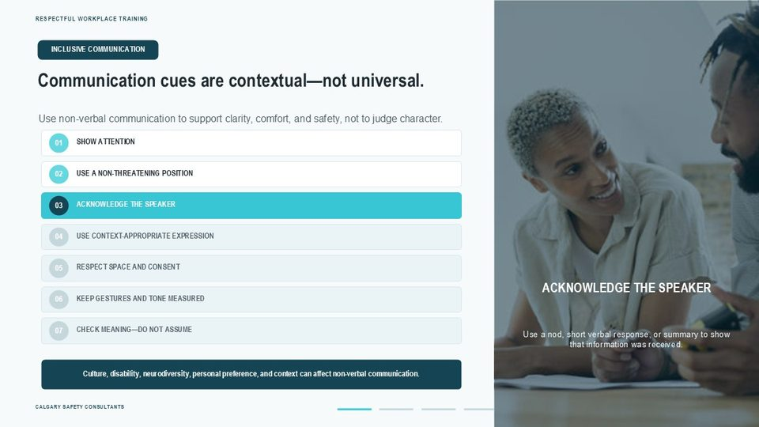  Notes __________________ | Communication cues are contextual—not universal.  Acknowledgement helps the speaker know that information has been received. This may involve a nod, a short verbal response such as “I understand,” taking notes, or briefly summarizing the key point. The appropriate cue depends on the person, the task, the noise level, language needs, and the work environment. Acknowledgement is not the same as agreement. You can show that you heard a concern while still reviewing the facts or reaching a different conclusion.  KEY POINTS  • INCLUSIVE COMMUNICATION  • Use non-verbal communication to support clarity, comfort, and safety, not to judge character.  • SHOW ATTENTION  • USE A NON-THREATENING POSITION

LESSON 04 • SLIDE 11 OF 32  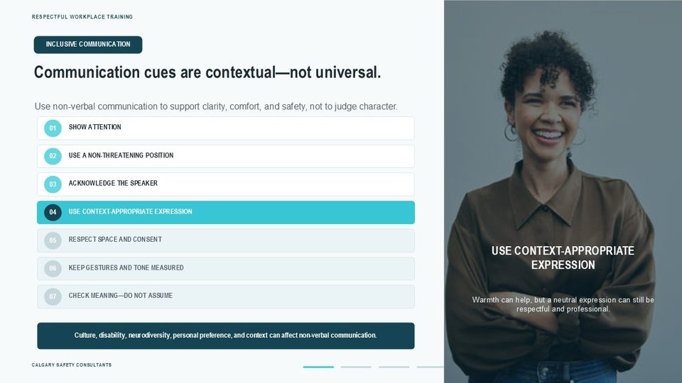  Notes __________________ | Communication cues are contextual—not universal.  Facial expression can affect tone, but smiling is not a requirement for respectful work. A genuine smile may help during a positive interaction. In a serious discussion, a neutral or concerned expression may be more appropriate. Some people naturally display less facial expression, and disability, culture, neurodiversity, or stress may affect how expression is perceived. Evaluate professionalism through behaviour and communication, not through an expectation that workers must look cheerful.  KEY POINTS  • INCLUSIVE COMMUNICATION  • Use non-verbal communication to support clarity, comfort, and safety, not to judge character.  • SHOW ATTENTION  • USE A NON-THREATENING POSITION

LESSON 04 • SLIDE 12 OF 32  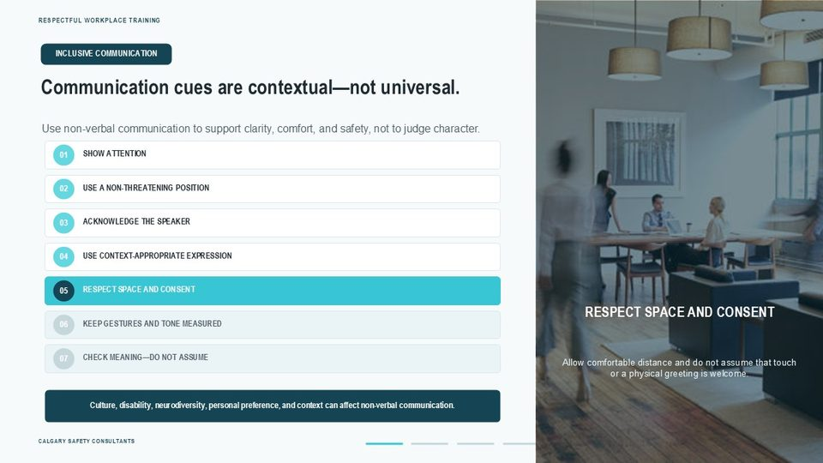  Notes __________________ | Communication cues are contextual—not universal.  Personal space and physical contact require awareness and consent. Comfortable distance varies among people, cultures, tasks, and workplaces. PPE, mobility devices, hearing needs, noise, and emergency conditions may also affect positioning. Do not assume that a handshake, hug, touch on the shoulder, or other physical greeting is welcome. Use a verbal greeting when uncertain, allow space, and respect a person's boundary without demanding an explanation.  KEY POINTS  • INCLUSIVE COMMUNICATION  • Use non-verbal communication to support clarity, comfort, and safety, not to judge character.  • SHOW ATTENTION  • USE A NON-THREATENING POSITION

GENERAL NOTES

LESSON 04 • SLIDE 13 OF 32  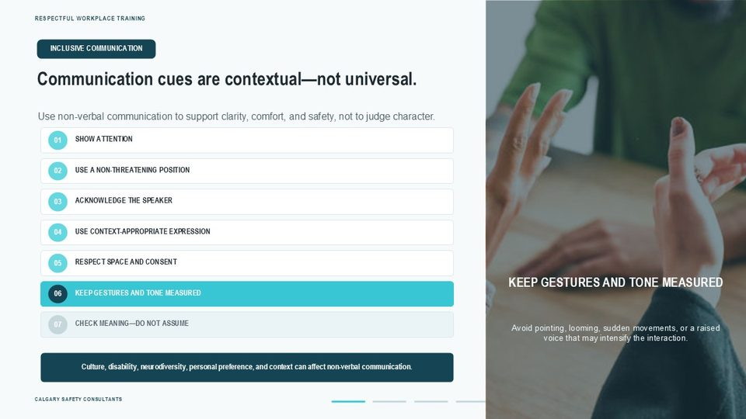  Notes __________________ | Communication cues are contextual—not universal.  Calm, measured gestures and tone can help prevent escalation. Avoid pointing close to another person's face, standing over someone, blocking movement, making sudden aggressive gestures, or raising your voice. If the interaction is becoming heated, slow your speech, create appropriate distance, and suggest a short pause or support from a supervisor. Where there is a threat of violence or immediate danger, follow the workplace emergency process rather than attempting to manage the situation alone.  KEY POINTS  • INCLUSIVE COMMUNICATION  • Use non-verbal communication to support clarity, comfort, and safety, not to judge character.  • SHOW ATTENTION  • USE A NON-THREATENING POSITION

LESSON 04 • SLIDE 14 OF 32  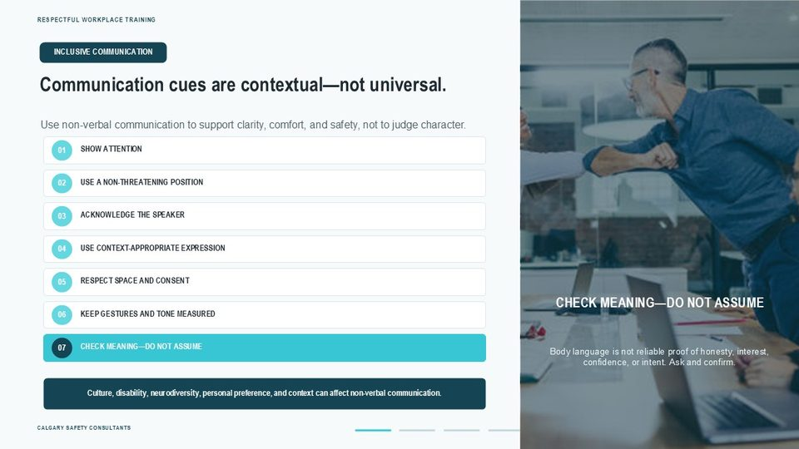  Notes __________________ | Communication cues are contextual—not universal.  Non-verbal communication must be interpreted carefully. Looking away does not prove dishonesty. A neutral expression does not prove indifference. Limited eye contact does not prove disrespect. Instead of assigning motive, describe what you observed and ask a clear question. Respect is strengthened when words, tone, actions, and follow-through are consistent. When meaning is unclear, confirm it directly and respectfully.  KEY POINTS  • INCLUSIVE COMMUNICATION  • Use non-verbal communication to support clarity, comfort, and safety, not to judge character.  • SHOW ATTENTION  • USE A NON-THREATENING POSITION

LESSON 04 • SLIDE 15 OF 32  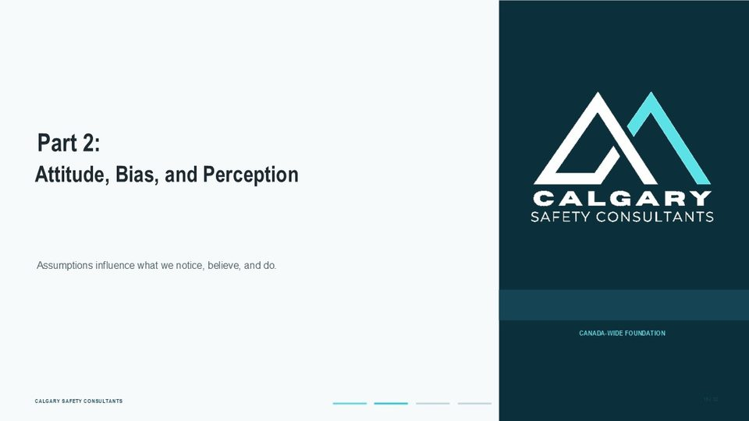  Notes __________________ | Part 2:  Part Two examines attitude, bias, and perception. Everyone interprets situations through experience, expectations, and assumptions. The risk appears when interpretation is treated as fact, or when bias influences who is included, trusted, heard, corrected, promoted, or believed. A respectful workplace does not require people to have identical perspectives.  It requires fair processes, consistent criteria, curiosity, and the willingness to challenge assumptions before they shape behaviour or decisions.  KEY POINTS  • Attitude, Bias, and Perception  • Assumptions influence what we notice, believe, and do.

GENERAL NOTES

LESSON 04 • SLIDE 16 OF 32  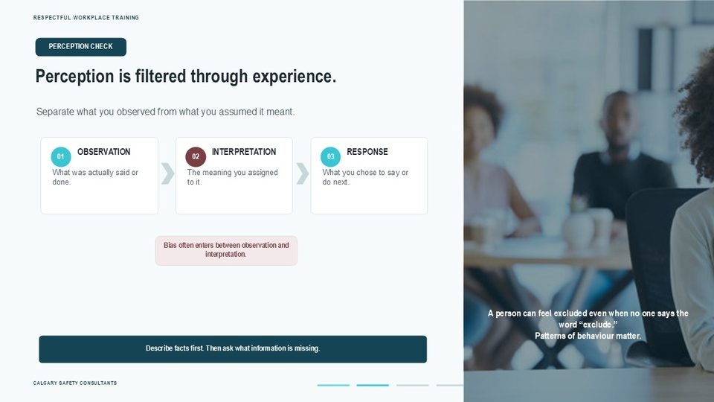  Notes __________________ | Perception is filtered through experience.  Perception begins with observation, but interpretation can quickly become mixed with assumption. For example, “the worker looked away” is an observation. “The worker was dishonest” is an interpretation. “They did not speak during the meeting” is an observation. “They had nothing useful to contribute” is an assumption. The action is to separate facts from meaning. Describe what was said or done, ask neutral questions, and seek relevant context before deciding how to respond.  This improves fairness, reduces conflict, and produces stronger documentation when a concern must be reviewed through the workplace process.  KEY POINTS  • PERCEPTION CHECK  • Separate what you observed from what you assumed it meant.  • OBSERVATION  • INTERPRETATION

LESSON 04 • SLIDE 17 OF 32  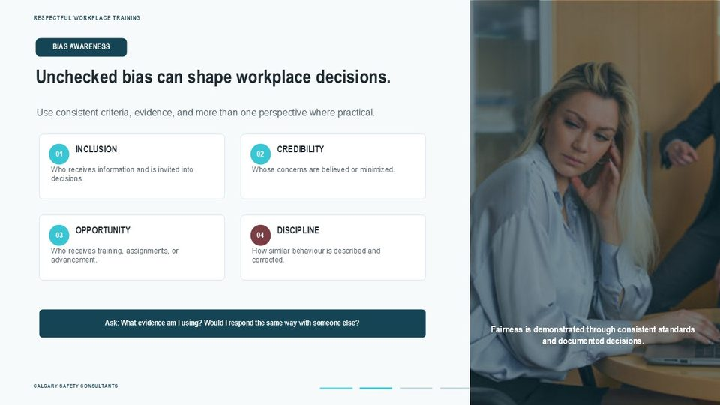  Notes __________________ | Unchecked bias can shape workplace decisions.  Bias can be conscious or unconscious, and it can affect ordinary workplace decisions. It may influence who is interrupted, who is described as “aggressive,” whose mistake is treated as a learning opportunity, who is viewed as leadership material, or whose concern is dismissed as overreacting. Bias can relate to age, race, culture, language, gender, disability, personality, employment status, or other characteristics.  The practical controls are consistent criteria, documented reasons, multiple perspectives where appropriate, and questions that test assumptions. Human rights and occupational health and safety requirements vary by jurisdiction, so concerns involving discrimination, harassment, or violence must be handled through the applicable workplace and legal process.  KEY POINTS  • BIAS AWARENESS  • Use consistent criteria, evidence, and more than one perspective where practical.  • INCLUSION  • CREDIBILITY

LESSON 04 • SLIDE 18 OF 32  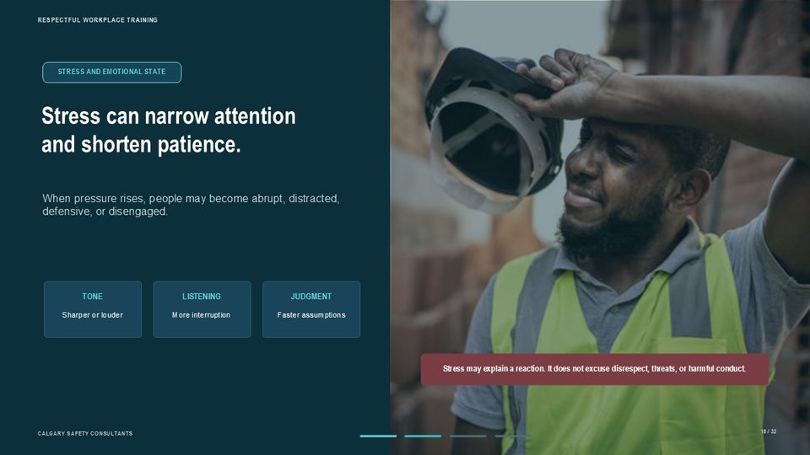  Notes __________________ | Stress can narrow attention and shorten patience.  Stress can affect tone, attention, patience, and judgment. A person under pressure may interrupt more, listen less, make faster assumptions, or respond defensively. Recognizing that pattern creates an opportunity to pause and reset. It does not excuse threats, harassment, violence, or repeated harmful conduct. Individual self-management is only part of the control.  Employers and supervisors should also consider workload, staffing, fatigue, role clarity, change, conflicting priorities, and other psychosocial factors that may be increasing pressure. The practical response combines personal regulation with organizational action on the conditions contributing to the stress.  KEY POINTS  • STRESS AND EMOTIONAL STATE  • When pressure rises, people may become abrupt, distracted, defensive, or disengaged.  • TONE  • LISTENING

GENERAL NOTES

LESSON 04 • SLIDE 19 OF 32  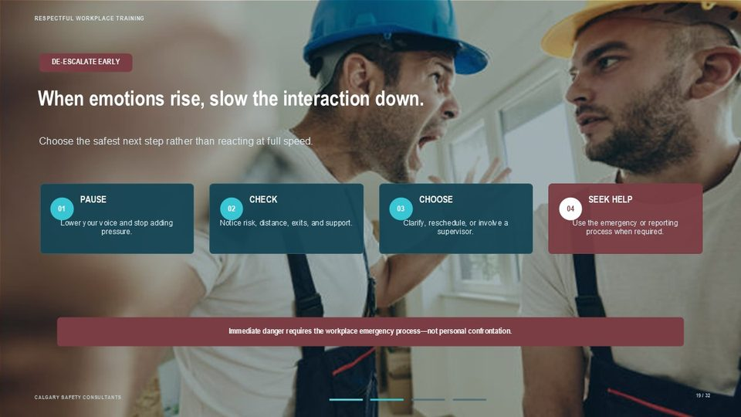  Notes __________________ | When emotions rise, slow the interaction down.  When an interaction becomes heated, the first priority is safety. Slow the conversation down. Use a calm, simple voice. Avoid telling the person to “calm down,” arguing about motive, or moving closer to prove a point. Create appropriate distance, keep access to an exit, and involve a supervisor or another support person when needed. A pause may mean taking a short break and returning to the issue, moving the conversation to a safer setting, or documenting and reporting the concern.  If there is a threat, weapon, physical aggression, or immediate danger, follow the workplace emergency procedure and obtain assistance. Workers are not expected to physically confront a threatening person or investigate serious conduct on their own.  KEY POINTS  • DE-ESCALATE EARLY  • Choose the safest next step rather than reacting at full speed.  • PAUSE  • CHECK

LESSON 04 • SLIDE 20 OF 32  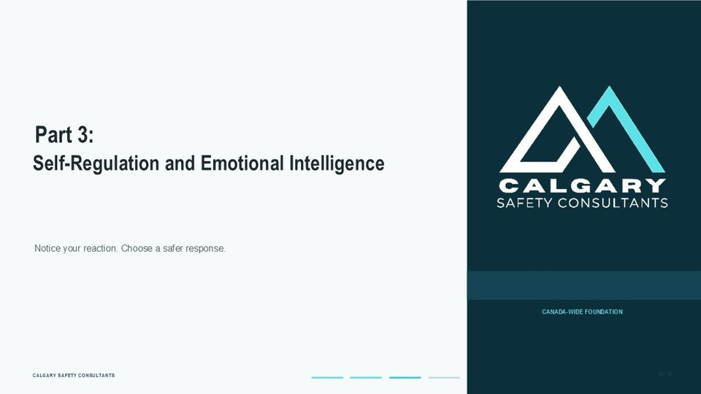  Notes __________________ | Part 3:  Part Three focuses on emotional intelligence and self-regulation. The objective is not to eliminate emotion or expect workers to remain unaffected by difficult events. The objective is to recognize emotional triggers, understand how reactions may affect others, and choose a response that protects safety, dignity, and the quality of the decision. Self-regulation is a skill that can be practised.  It also works best in a workplace that provides clear expectations, reasonable support, and an accessible process for addressing serious concerns.  KEY POINTS  • Self-Regulation and Emotional Intelligence  • Notice your reaction. Choose a safer response.

LESSON 04 • SLIDE 21 OF 32  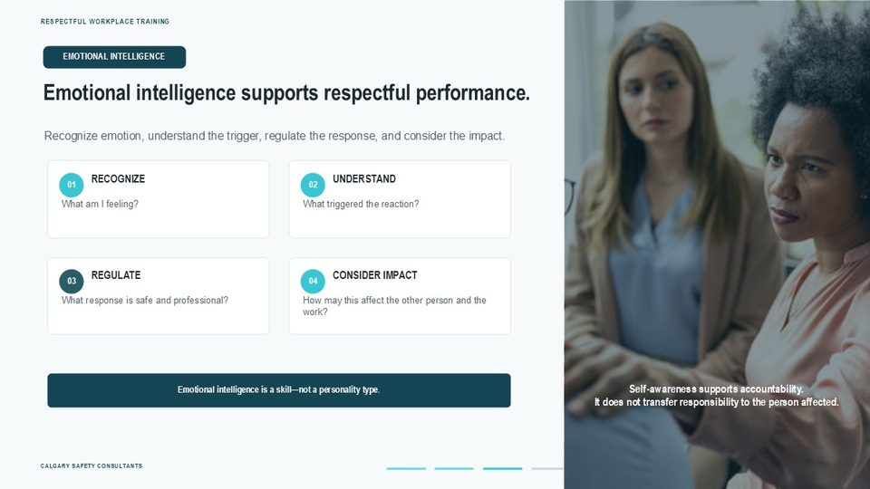  Notes __________________ | Emotional intelligence supports respectful performance.  Emotional intelligence involves recognizing and managing your own emotions while considering how your behaviour affects others. In practical terms, it means noticing a trigger, understanding the reaction, choosing a professional response, and considering the effect on the person and the work. It does not mean suppressing emotion, diagnosing coworkers, or expecting the person affected by harmful conduct to manage someone else's reaction. Emotional intelligence supports accountability.  A worker can be frustrated and still communicate respectfully. A supervisor can correct performance and still listen, explain expectations, and avoid humiliation. The skill is shown through what the person does next.  KEY POINTS  • EMOTIONAL INTELLIGENCE  • Recognize emotion, understand the trigger, regulate the response, and consider the impact.  • RECOGNIZE  • UNDERSTAND

GENERAL NOTES

LESSON 04 • SLIDE 22 OF 32  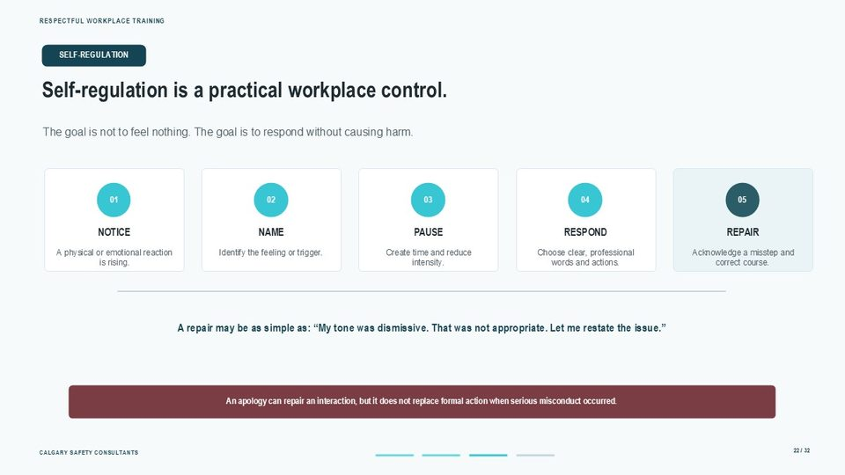  Notes __________________ | Self-regulation is a practical workplace control.  Self-regulation can be treated as a practical control during difficult interactions. Notice the reaction, name what is happening, create a brief pause, and choose the response. If your tone or behaviour was inappropriate, repair the interaction quickly by acknowledging the specific conduct and correcting it. A meaningful repair focuses on behaviour and impact rather than excuses. For example: “My tone was dismissive. That was not appropriate.  Let me restate the issue.” An apology may help restore working relationships, but it does not replace reporting, investigation, corrective action, or support when the behaviour may involve harassment, violence, discrimination, threats, or another serious policy breach.  KEY POINTS  • SELF-REGULATION  • The goal is not to feel nothing. The goal is to respond without causing harm.  • NOTICE  • NAME

LESSON 04 • SLIDE 23 OF 32  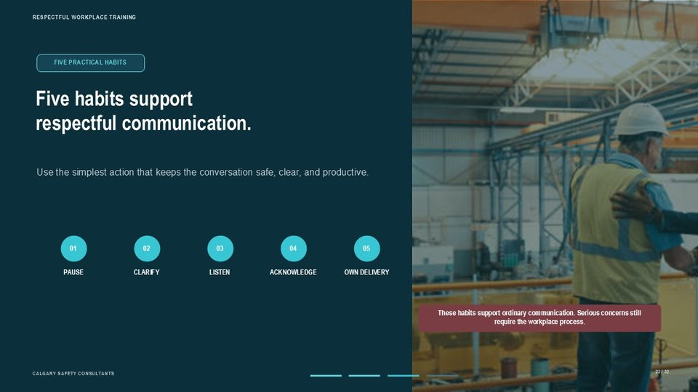  Notes __________________ | Five habits support respectful communication.  The next five slides provide practical habits for everyday communication. Pause before responding. Clarify before assuming intent. Listen for meaning and facts. Acknowledge input even when you disagree. Take responsibility for tone, impact, and repair. These habits can improve ordinary disagreements, corrections, and problem-solving conversations. They are not a substitute for formal reporting or emergency action.  When behaviour involves threats, violence, repeated harassment, discrimination, retaliation, or another serious concern, workers should use the workplace policy and applicable reporting process rather than trying to resolve the matter informally on their own.  KEY POINTS  • FIVE PRACTICAL HABITS  • Use the simplest action that keeps the conversation safe, clear, and productive.  • PAUSE  • CLARIFY

LESSON 04 • SLIDE 24 OF 32  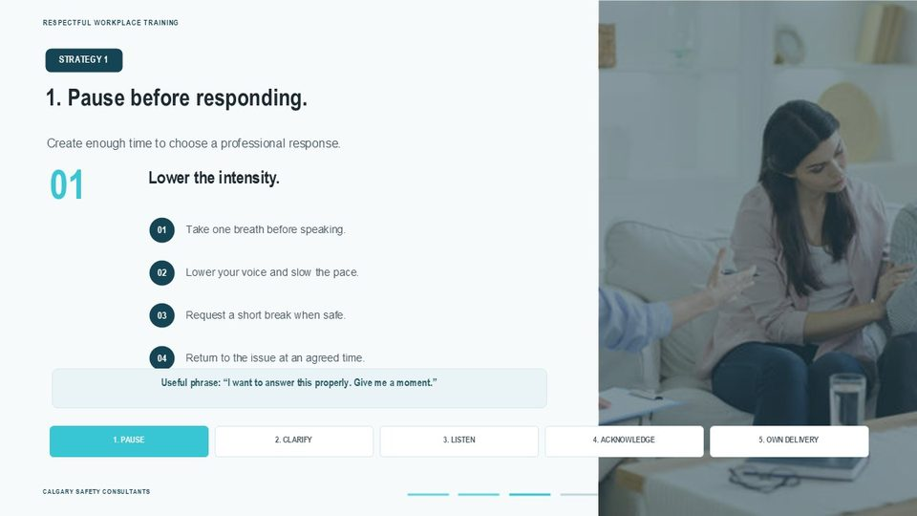  Notes __________________ | 1. Pause before responding.  The first strategy is to pause before responding. A pause does not need to be dramatic. It may be one breath, a slower voice, a brief silence, or a request to continue the conversation in a few minutes. The purpose is to prevent an automatic reaction from becoming a harmful comment, threat, or escalation. A useful phrase is: “I want to answer this properly. Give me a moment.” When a longer break is needed, identify when and how the conversation will resume so the issue is not abandoned.  If the situation is unsafe, do not schedule an informal continuation—use the emergency or reporting process.  KEY POINTS  • STRATEGY 1  • Create enough time to choose a professional response.  • Lower the intensity.  • Take one breath before speaking.

GENERAL NOTES

LESSON 04 • SLIDE 25 OF 32  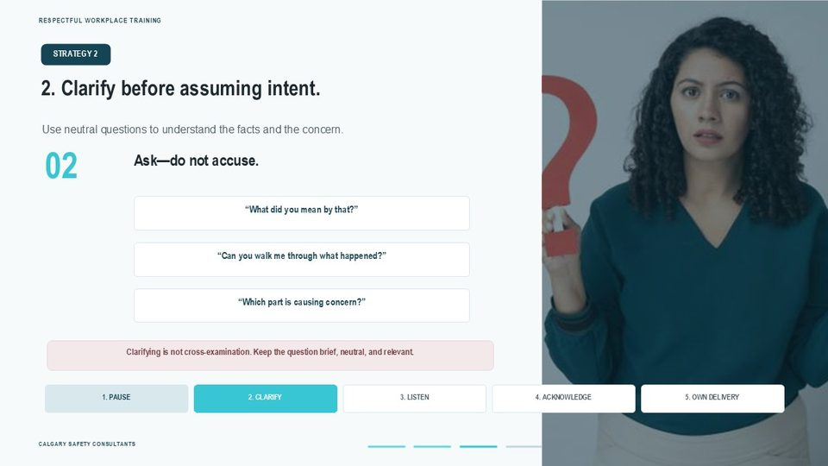  Notes __________________ | 2. Clarify before assuming intent.  The second strategy is to clarify before assuming intent. Neutral questions help separate facts from interpretation. Useful examples include: “What did you mean by that?” “Can you walk me through what happened?” and “Which part is causing concern?” The tone matters. Clarifying is not cross-examination, and it should not be used to pressure someone to withdraw a concern. Keep the question brief, relevant, and open enough for the person to explain.  If the concern may involve harassment, violence, discrimination, or retaliation, receive the information respectfully and follow the designated reporting process rather than conducting your own investigation.  KEY POINTS  • STRATEGY 2  • Use neutral questions to understand the facts and the concern.  • Ask—do not accuse.  • “What did you mean by that?”

LESSON 04 • SLIDE 26 OF 32  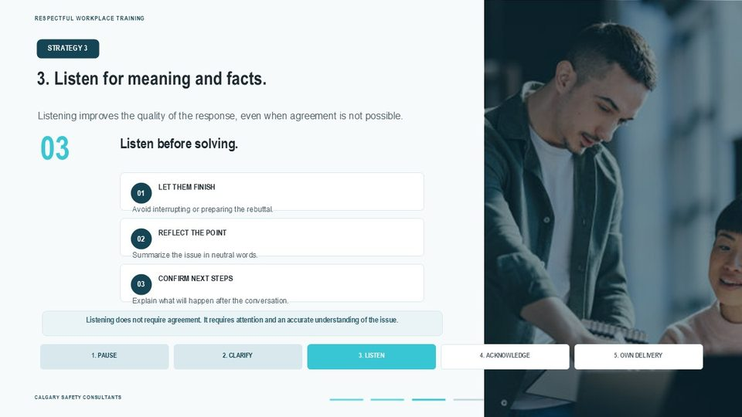  Notes __________________ | 3. Listen for meaning and facts.  The third strategy is active listening. Allow the person to finish. Listen for both the facts and the main concern. Summarize the point in neutral words, and confirm the next step. This helps prevent misunderstandings and shows whether the information was received accurately. Listening does not require agreement. A supervisor may still decide that a procedure was followed or that a requested change is not possible. The respectful response is to explain the decision and the process.  When a concern requires review by another person, avoid promising a specific outcome or absolute confidentiality. Explain what you can do and who needs to be involved.  KEY POINTS  • STRATEGY 3  • Listening improves the quality of the response, even when agreement is not possible.  • Listen before solving.  • LET THEM FINISH

LESSON 04 • SLIDE 27 OF 32  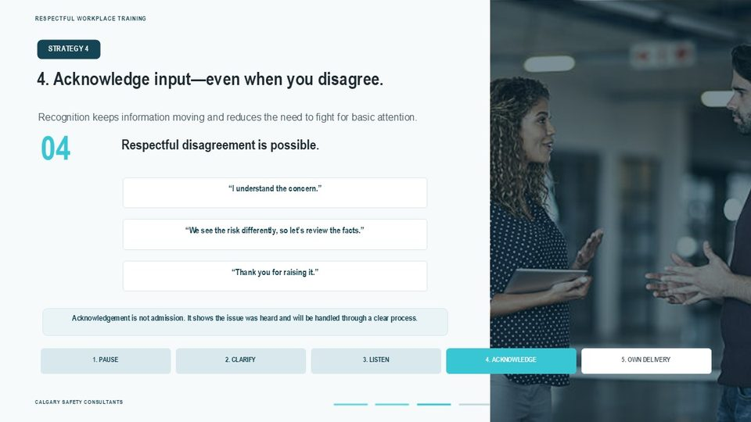  Notes __________________ | 4. Acknowledge input—even when you disagree.  The fourth strategy is to acknowledge input, even when you disagree. Acknowledgement may be as simple as: “I understand the concern,” “Thank you for raising it,” or “We see the risk differently, so let’s review the facts.” This does not require an immediate admission or agreement. It shows that the information was received and that the person does not need to escalate the volume simply to be heard. The next step is important.  Explain whether the issue can be resolved immediately, needs assessment, or must be reported to a designated person. Clear follow-through prevents respectful language from becoming an empty gesture.  KEY POINTS  • STRATEGY 4  • Recognition keeps information moving and reduces the need to fight for basic attention.  • Respectful disagreement is possible.  • “I understand the concern.”

GENERAL NOTES

LESSON 04 • SLIDE 28 OF 32  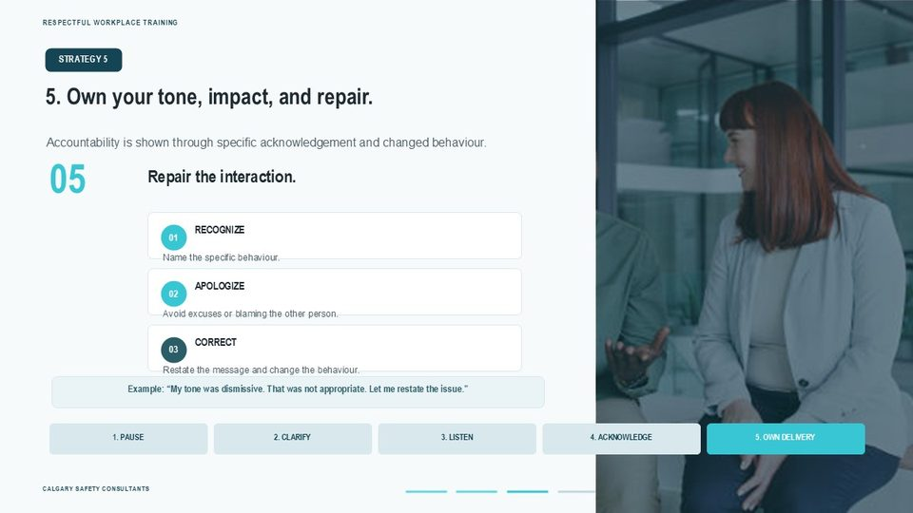  Notes __________________ | 5. Own your tone, impact, and repair.  The fifth strategy is to take responsibility for tone, impact, and repair. A strong repair is specific. Name the behaviour, apologize without shifting blame, and correct the message. For example: “My tone was dismissive. That was not appropriate. Let me restate the issue.” A quick, sincere repair can prevent a small problem from becoming a lasting conflict. It also demonstrates the accountability expected in a respectful workplace.  However, an apology does not erase serious conduct or prevent a worker from reporting. Where the behaviour may involve harassment, violence, discrimination, threats, or retaliation, the employer must still follow the applicable policy and legal process.  KEY POINTS  • STRATEGY 5  • Accountability is shown through specific acknowledgement and changed behaviour.  • Repair the interaction.  • RECOGNIZE

LESSON 04 • SLIDE 29 OF 32  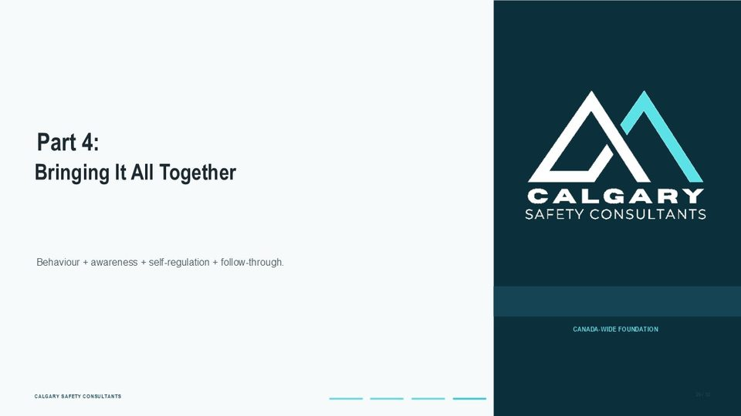  Notes __________________ | Part 4:  Part Four brings the lesson together. Respect is not a single technique. It is the combined effect of observable behaviour, awareness of assumptions, emotional self-regulation, clear communication, and reliable follow-through. The key question is not whether every interaction was perfect. The key question is whether people are willing and able to recognize problems, correct course, report serious concerns, and use the workplace system before harm becomes normalized.  KEY POINTS  • Bringing It All Together  • Behaviour + awareness + self-regulation + follow-through.

LESSON 04 • SLIDE 30 OF 32  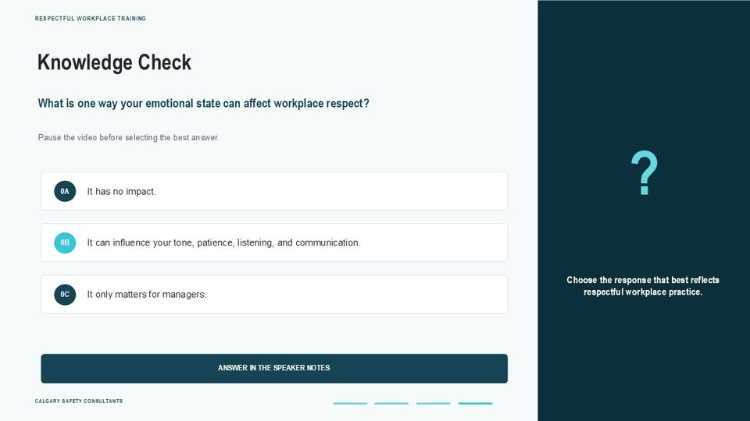  Notes __________________ | Knowledge Check  The correct answer is B: your emotional state can influence your tone, patience, listening, judgment, and communication. Emotional state matters for every workplace party, not only managers. Stress or frustration may explain why a reaction occurred, but it does not excuse disrespectful or harmful conduct. The appropriate response is to recognize the reaction, pause when possible, choose a professional response, and use the workplace process when the concern is serious or safety is at risk.  KEY POINTS  • What is one way your emotional state can affect workplace respect?  • Pause the video before selecting the best answer.  • It has no impact.  • 0A

GENERAL NOTES

LESSON 04 • SLIDE 31 OF 32  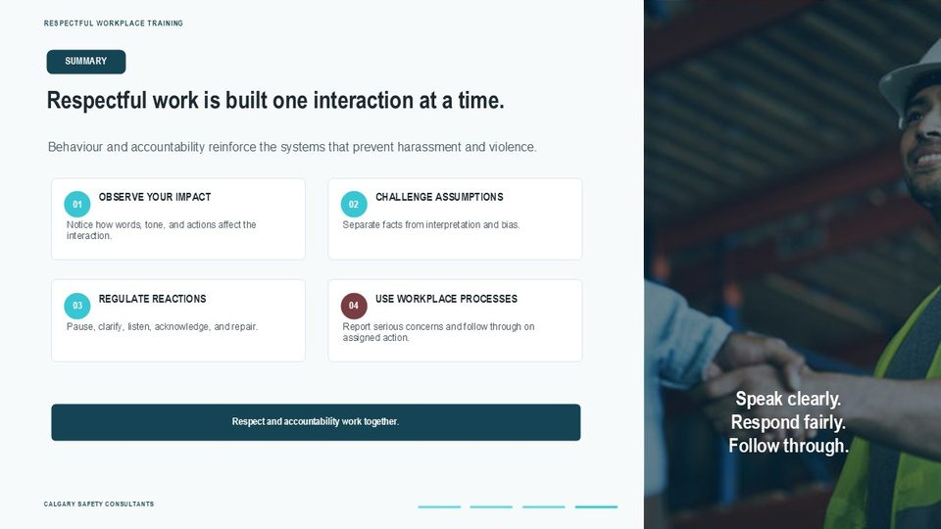  Notes __________________ | Respectful work is built one interaction at a time.  This lesson has connected behaviour, attitude, perception, stress, and self-regulation. Respectful work involves observing your impact, challenging assumptions, managing reactions, communicating clearly, repairing missteps, and using the workplace process for serious concerns. Respect and accountability are not opposites. Clear standards, fair correction, early reporting, and appropriate follow-through help protect workers and the organization.  In practical terms, small improvements in communication can reduce conflict and keep information moving. Strong systems are still required to assess hazards, receive reports, respond to occurrences, support affected workers, and meet the legal requirements of the applicable Canadian jurisdiction.  KEY POINTS  • SUMMARY  • Behaviour and accountability reinforce the systems that prevent harassment and violence.  • OBSERVE YOUR IMPACT  • CHALLENGE ASSUMPTIONS

LESSON 04 • SLIDE 32 OF 32  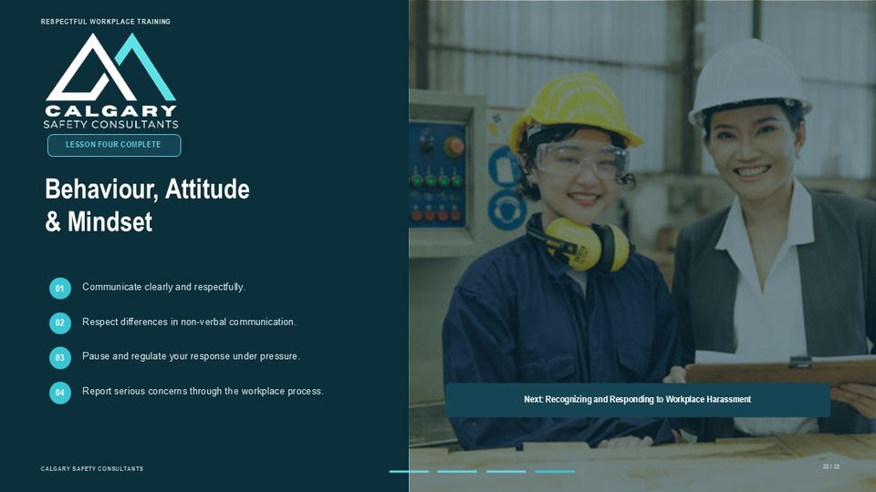  Notes __________________ | Behaviour, Attitude & Mindset  The main points are to communicate clearly, use inclusive and context-aware cues, challenge assumptions, manage reactions under pressure, repair missteps, and report serious concerns through the workplace process. In the next lesson, the training will build on this foundation by examining how to recognize and respond to workplace harassment. Remember that workers should not be expected to manage serious occurrences alone.  Follow the policy, protect immediate safety, report through the designated route, and apply the requirements of the jurisdiction where the work is performed.  KEY POINTS  • Communicate clearly and respectfully.  • Respect differences in non-verbal communication.  • Pause and regulate your response under pressure.  • Report serious concerns through the workplace process.

GENERAL NOTES

LESSON 04 SUMMARY
Behaviour, Attitude & Mindset
The following points bring the lesson together. Use them to review the main prevention message and connect it to the procedures and expectations in your workplace.
01 | Respectful behaviour is observable. Listening, allowing people to finish, using professional language, explaining decisions, respecting boundaries, and following through create reliable signals that people and concerns will be treated seriously.
02 | Non-verbal communication must be interpreted in context. Eye contact, posture, facial expression, personal space, gestures, and tone can be affected by culture, disability, neurodiversity, pain, personal preference, protective equipment, the task, or the environment. Ask and clarify instead of assigning motive.
03 | Perception is filtered through experience and expectation. Separate the observation from the interpretation: describe what was seen or heard, identify the assumption, and seek facts or another perspective before acting.
04 | Stress and emotion can narrow attention, shorten patience, increase defensiveness, and affect judgment. That may explain a reaction, but it does not excuse threats, harassment, violence, or other harmful conduct. Safety and the workplace process still apply.
05 | Five habits support respectful communication: pause before responding, clarify before assuming intent, listen for meaning and facts, acknowledge input even when there is disagreement, and take responsibility for tone, impact, and repair.
Reflection and application
• Which communication cue do I sometimes interpret too quickly?
• What helps me pause and regulate my response when pressure rises?
• How can I make a specific repair after my tone or behaviour has caused harm?
________________________________________________________________________________
MODULE REVIEW
Module One complete
Respectful workplaces are built through clear expectations, shared responsibility, psychological safety, everyday respectful behaviour, and reliable follow-through.
☐ I know the reporting routes and emergency directions that apply in my workplace.
☐ I understand my role and the limits of my role when a concern is raised.
☐ I can describe practical behaviours that support respect and psychological safety.
☐ I can separate observations from assumptions and choose a safer response under pressure.
☐ I understand why response, corrective action, communication, and follow-through matter.
My most important takeaways
________________________________________________________________________________
________________________________________________________________________________
GENERAL NOTES

STUDENT REFERENCE GUIDE

Module Two
Respectful Workplace Harassment and Violence Prevention Training
How to use this guide
This portrait reference guide follows the original Module Two lesson and slide sequence. Each compact slide entry includes the PowerPoint visual, the lesson explanation, practical points to remember, and a line for notes. Every page also includes a general notes area.
Use the guide during training to record examples and questions. After training, return to the lesson overviews and summaries when you need to review responsibilities, reporting expectations, safe response options, or respectful communication practices.
Module roadmap
LESSON 01 | What Is Workplace Harassment?  Definition | Forms | Examples | Impact | Boundaries
LESSON 02 | Preventing Harassment in the Workplace  Culture | Leadership | Bystander action | Prevention tools
LESSON 03 | Prevention Policies, Programs & Plans  Program elements | Roles | Reporting | Review
LESSON 04 | Responding to Workplace Harassment  Reporting | Investigation | Participation | Follow-through
Important: This guide supports the training. Follow the legislation, workplace policies, procedures, reporting routes, and emergency directions that apply to your workplace.
GENERAL NOTES

MODULE TWO / LESSON 01

What Is Workplace Harassment?
Definition | Forms | Examples | Impact | Boundaries

Lesson overview
Workplace harassment is unwelcome conduct that may cause offence, humiliation, or physical or psychological harm. The exact legal wording depends on the jurisdiction and workplace policy, but a sound assessment focuses on observable conduct, context, impact, repetition, and what a reasonable person knew or should have known.
This lesson examines verbal, physical, psychological, sexual, and online harassment; common examples and workplace impacts; and the boundary between harassment and reasonable management action or respectful disagreement. Workers should recognize concerns and use the reporting process rather than trying to investigate on their own.
By the end of this lesson you should be able to
• Describe the common elements used to identify workplace harassment.
• Recognize verbal, physical, psychological, sexual, and online forms of harassment.
• Identify common examples and explain their individual and organizational impacts.
• Distinguish harassment from reasonable management action and respectful disagreement.
• Use the reporting process that applies to the workplace and seek immediate help when safety is at risk.
GENERAL NOTES

LESSON 01 • SLIDE 01 OF 34  Notes __________________ | What Is Workplace Harassment?  Respectful Workplace. Harassment and Violence Prevention Training.  Apply the definition using observable conduct, context, impact, and the reporting procedure that applies to the workplace.  KEY POINTS  • Respectful Workplace.  • Harassment and Violence Prevention Training.

LESSON 01 • SLIDE 02 OF 34  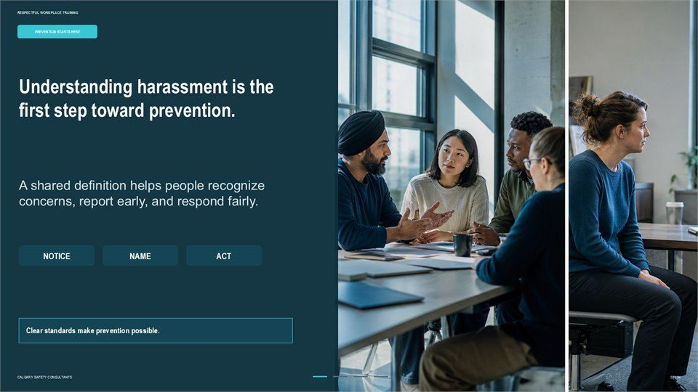  Notes __________________ | Understanding harassment is the first step toward prevention.  A shared definition helps people recognize concerns, report early, and respond fairly. Clear standards make prevention possible.  Apply the definition using observable conduct, context, impact, and the reporting procedure that applies to the workplace.  KEY POINTS  • A shared definition helps people recognize concerns, report early, and respond fairly.  • Clear standards make prevention possible.

LESSON 01 • SLIDE 03 OF 34  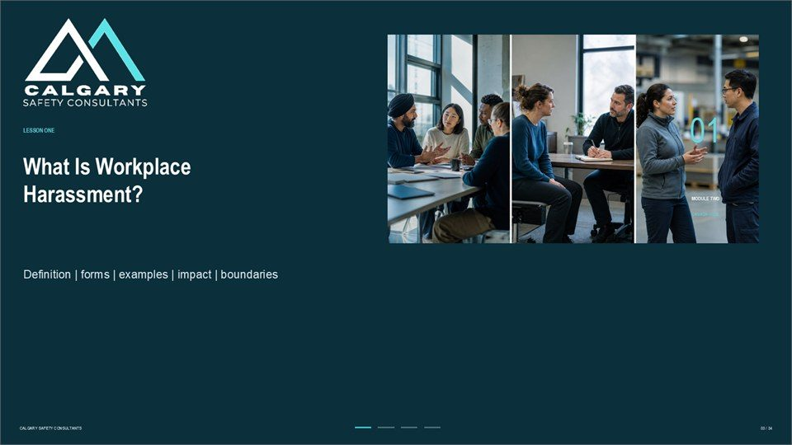  Notes __________________ | What Is Workplace Harassment?  Definition | forms | examples | impact | boundaries.  Apply the definition using observable conduct, context, impact, and the reporting procedure that applies to the workplace.  KEY POINTS  • Definition | forms | examples | impact | boundaries.  • Apply the definition using observable conduct, context, impact, and the reporting procedure that applies...

GENERAL NOTES

LESSON 01 • SLIDE 04 OF 34  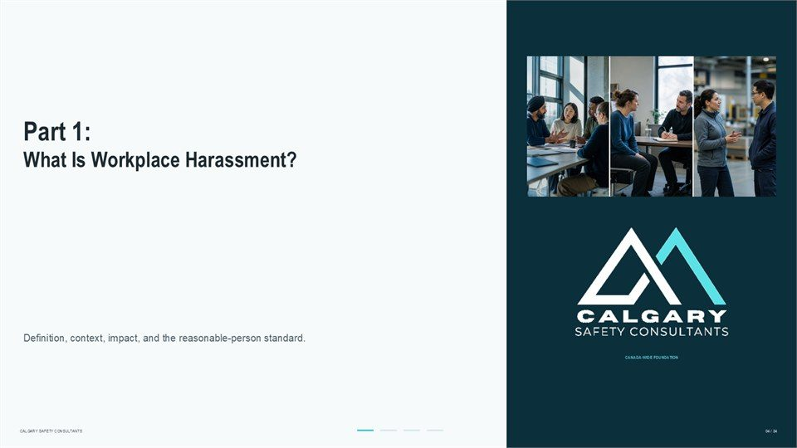  Notes __________________ | Part 1: What Is Workplace Harassment?  What Is Workplace Harassment? Definition, context, impact, and the reasonable-person standard.  Apply the definition using observable conduct, context, impact, and the reporting procedure that applies to the workplace.  KEY POINTS  • What Is Workplace Harassment?  • Definition, context, impact, and the reasonable-person standard.

LESSON 01 • SLIDE 05 OF 34  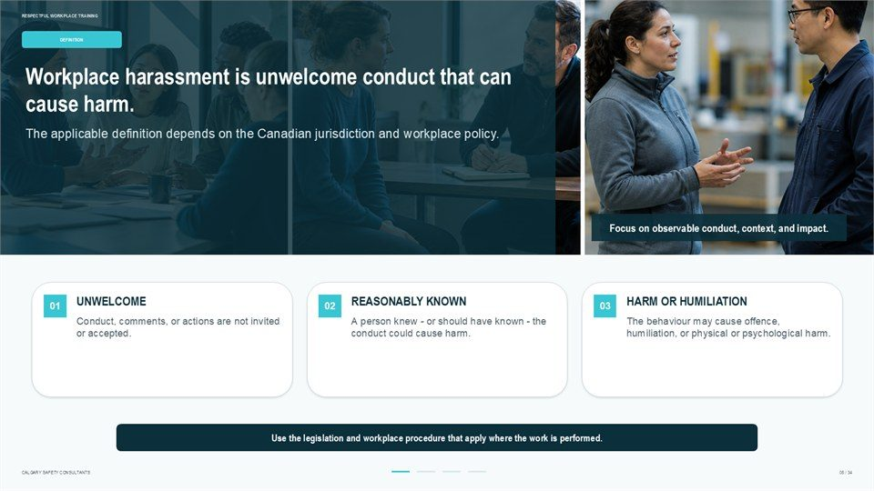  Notes __________________ | Workplace harassment is unwelcome conduct that can cause harm.  The applicable definition depends on the Canadian jurisdiction and workplace policy. Focus on observable conduct, context, and impact. Conduct, comments, or actions are not invited or accepted. A person knew - or should have known - the conduct could cause harm.  The behaviour may cause offence, humiliation, or physical or psychological harm. Use the legislation and workplace procedure that apply where the work is performed.  KEY POINTS  • The applicable definition depends on the Canadian jurisdiction and workplace policy.  • Focus on observable conduct, context, and impact.  • Conduct, comments, or actions are not invited or accepted.

LESSON 01 • SLIDE 06 OF 34  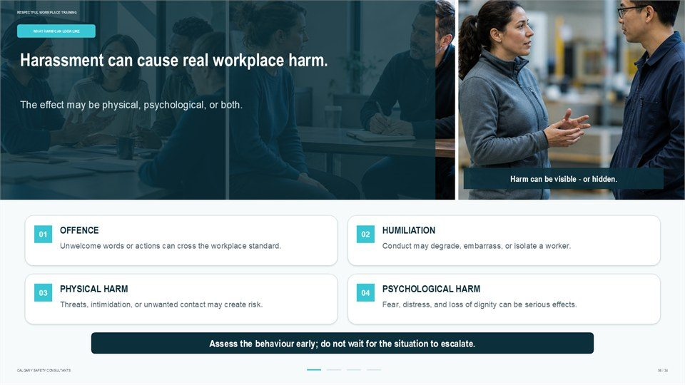  Notes __________________ | Harassment can cause real workplace harm.  The effect may be physical, psychological, or both. Harm can be visible - or hidden. Unwelcome words or actions can cross the workplace standard. Conduct may degrade, embarrass, or isolate a worker. Threats, intimidation, or unwanted contact may create risk. Fear, distress, and loss of dignity can be serious effects.  Assess the behaviour early; do not wait for the situation to escalate.  KEY POINTS  • The effect may be physical, psychological, or both.  • Harm can be visible - or hidden.  • Unwelcome words or actions can cross the workplace standard.

GENERAL NOTES

LESSON 01 • SLIDE 07 OF 34  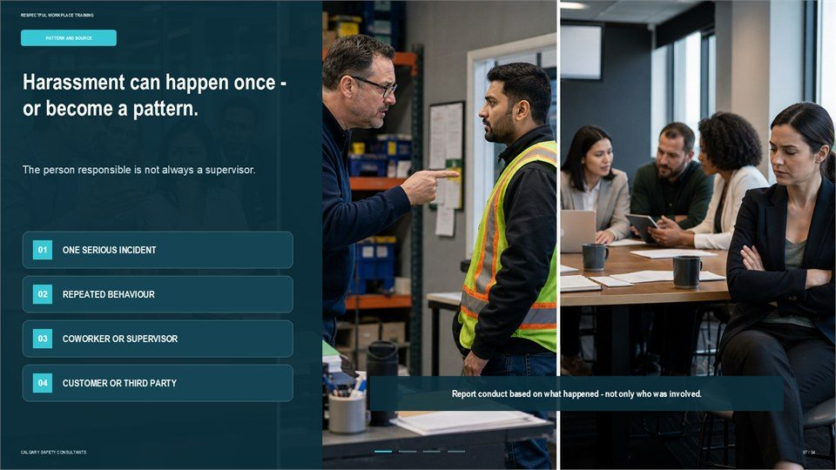  Notes __________________ | Harassment can happen once - or become a pattern.  The person responsible is not always a supervisor. Report conduct based on what happened - not only who was involved.  Apply the definition using observable conduct, context, impact, and the reporting procedure that applies to the workplace.  KEY POINTS  • The person responsible is not always a supervisor.  • Report conduct based on what happened - not only who was involved.

LESSON 01 • SLIDE 08 OF 34  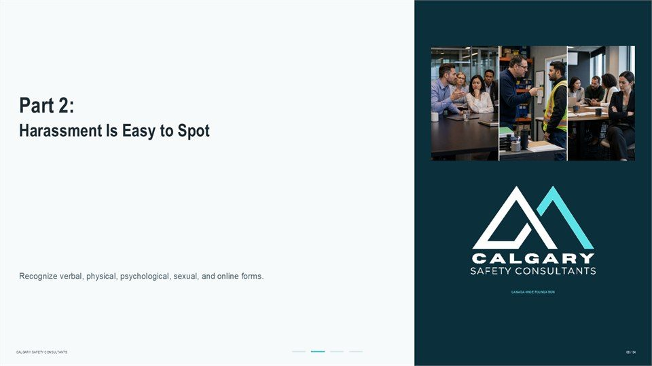  Notes __________________ | Part 2: Harassment Is Easy to Spot  Harassment Is Easy to Spot. Recognize verbal, physical, psychological, sexual, and online forms.  Apply the definition using observable conduct, context, impact, and the reporting procedure that applies to the workplace.  KEY POINTS  • Harassment Is Easy to Spot.  • Recognize verbal, physical, psychological, sexual, and online forms.

LESSON 01 • SLIDE 09 OF 34  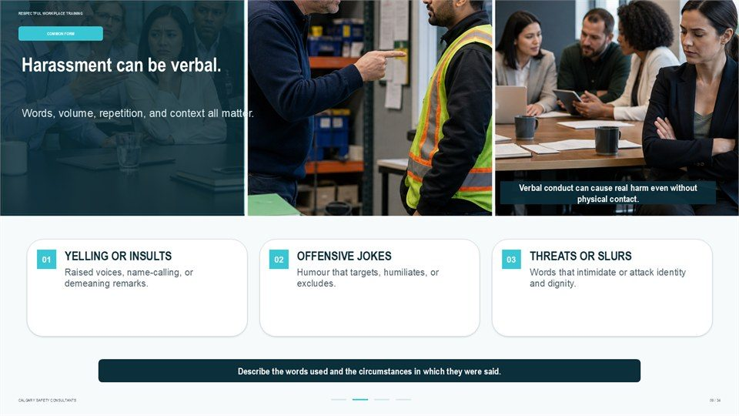  Notes __________________ | Harassment can be verbal.  Words, volume, repetition, and context all matter. Verbal conduct can cause real harm even without physical contact. Raised voices, name-calling, or demeaning remarks. Humour that targets, humiliates, or excludes. Words that intimidate or attack identity and dignity. Describe the words used and the circumstances in which they...  Apply the definition using observable conduct, context, impact, and the reporting procedure that applies to the workplace.  KEY POINTS  • Words, volume, repetition, and context all matter.  • Verbal conduct can cause real harm even without physical contact.  • Raised voices, name-calling, or demeaning remarks.

GENERAL NOTES

LESSON 01 • SLIDE 10 OF 34  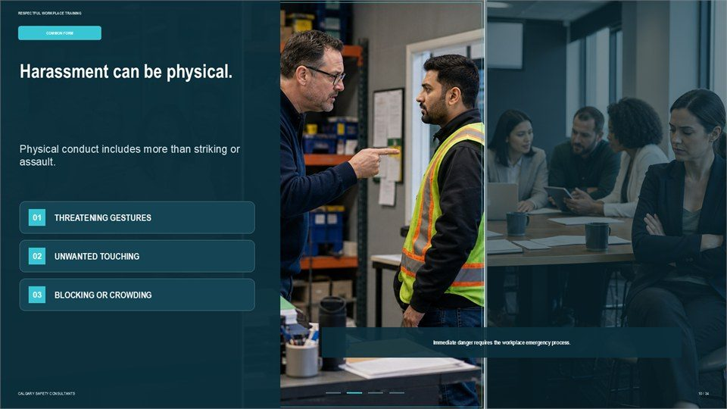  Notes __________________ | Harassment can be physical.  Physical conduct includes more than striking or assault. Immediate danger requires the workplace emergency process.  Apply the definition using observable conduct, context, impact, and the reporting procedure that applies to the workplace.  KEY POINTS  • Physical conduct includes more than striking or assault.  • Immediate danger requires the workplace emergency process.

LESSON 01 • SLIDE 11 OF 34  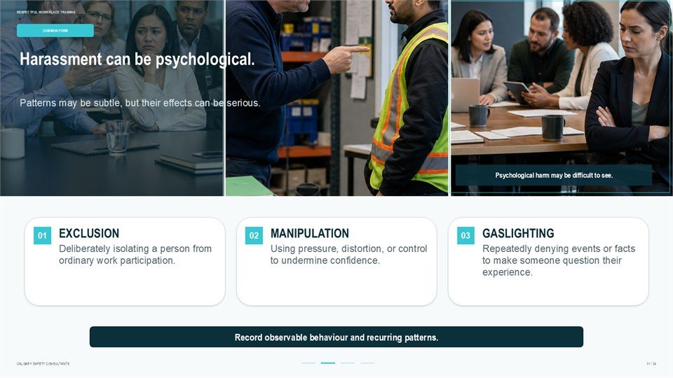  Notes __________________ | Harassment can be psychological.  Patterns may be subtle, but their effects can be serious. Psychological harm may be difficult to see. Deliberately isolating a person from ordinary work participation. Using pressure, distortion, or control to undermine confidence. Repeatedly denying events or facts to make someone question their experience.  Record observable behaviour and recurring patterns.  KEY POINTS  • Patterns may be subtle, but their effects can be serious.  • Psychological harm may be difficult to see.  • Deliberately isolating a person from ordinary work participation.

LESSON 01 • SLIDE 12 OF 34  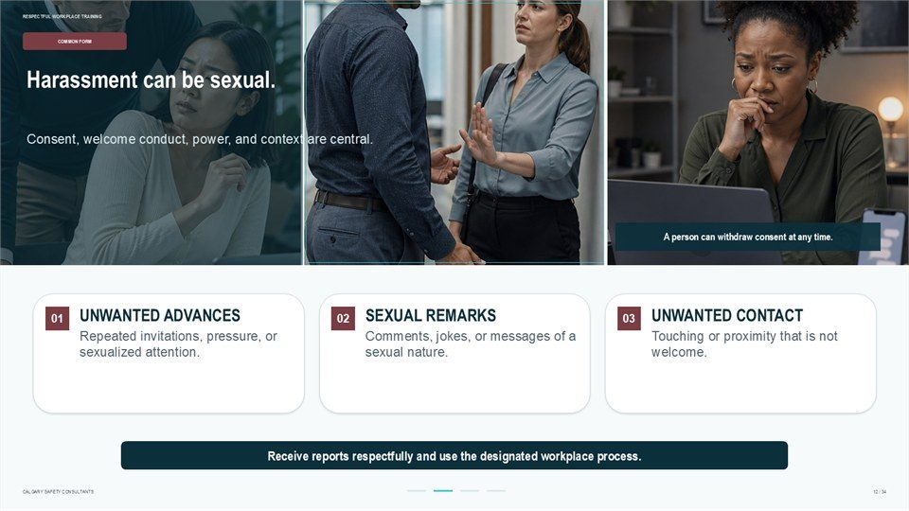  Notes __________________ | Harassment can be sexual.  Consent, welcome conduct, power, and context are central. A person can withdraw consent at any time. Repeated invitations, pressure, or sexualized attention. Comments, jokes, or messages of a sexual nature. Touching or proximity that is not welcome. Receive reports respectfully and use the designated workplace process.  Apply the definition using observable conduct, context, impact, and the reporting procedure that applies to the workplace.  KEY POINTS  • Consent, welcome conduct, power, and context are central.  • A person can withdraw consent at any time.  • Repeated invitations, pressure, or sexualized attention.

GENERAL NOTES

LESSON 01 • SLIDE 13 OF 34  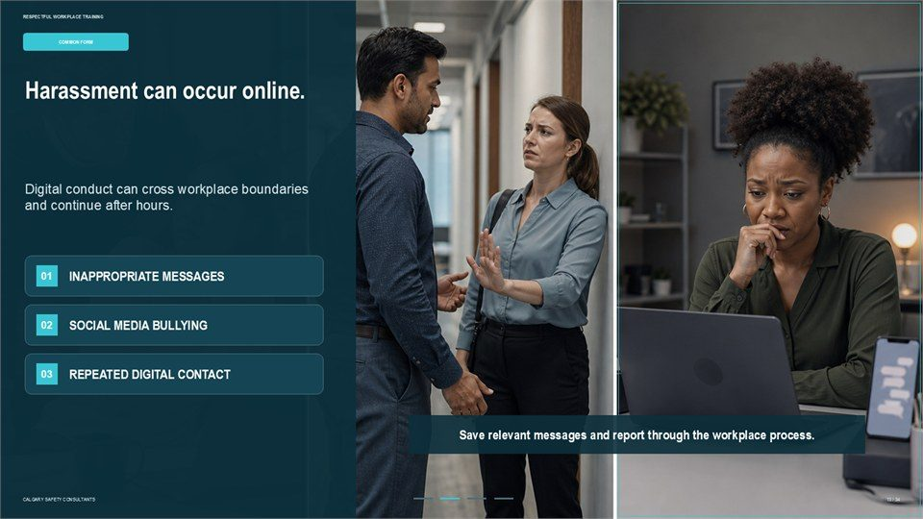  Notes __________________ | Harassment can occur online.  Digital conduct can cross workplace boundaries and continue after hours. Save relevant messages and report through the workplace process.  Apply the definition using observable conduct, context, impact, and the reporting procedure that applies to the workplace.  KEY POINTS  • Digital conduct can cross workplace boundaries and continue after hours.  • Save relevant messages and report through the workplace process.

LESSON 01 • SLIDE 14 OF 34  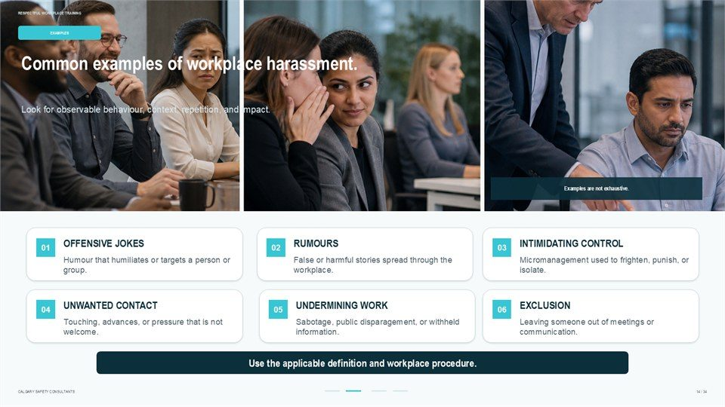  Notes __________________ | Common examples of workplace harassment.  Look for observable behaviour, context, repetition, and impact. Examples are not exhaustive. Humour that humiliates or targets a person or group. False or harmful stories spread through the workplace. Micromanagement used to frighten, punish, or isolate. Touching, advances, or pressure that is not welcome.  Sabotage, public disparagement, or withheld information. Leaving someone out of meetings or communication. Use the applicable definition and workplace procedure.  KEY POINTS  • Look for observable behaviour, context, repetition, and impact.  • Examples are not exhaustive.  • Humour that humiliates or targets a person or group.

LESSON 01 • SLIDE 15 OF 34    Notes __________________ | Offensive jokes or slurs.  Humour is not harmless when it humiliates or excludes. Focus on the conduct and impact - not the label of "joking.". Jokes repeatedly directed at a worker or group. Slurs or comments connected to identity or dignity. "It was only a joke" does not erase harm. A respectful workplace does not normalize targeted humiliation.  Apply the definition using observable conduct, context, impact, and the reporting procedure that applies to the workplace.  KEY POINTS  • Humour is not harmless when it humiliates or excludes.  • Focus on the conduct and impact - not the label of "joking.".  • Jokes repeatedly directed at a worker or group.

GENERAL NOTES

LESSON 01 • SLIDE 16 OF 34    Notes __________________ | Spreading rumours.  Information can be used to isolate, punish, or discredit a worker. Document what was said, where it was shared, and who received it.  Apply the definition using observable conduct, context, impact, and the reporting procedure that applies to the workplace.  KEY POINTS  • Information can be used to isolate, punish, or discredit a worker.  • Document what was said, where it was shared, and who received it.

LESSON 01 • SLIDE 17 OF 34  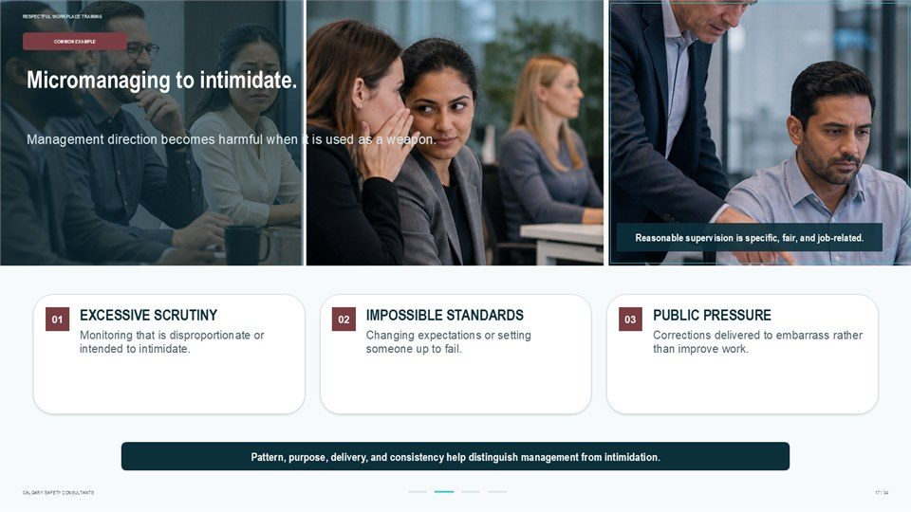  Notes __________________ | Micromanaging to intimidate.  Management direction becomes harmful when it is used as a weapon. Reasonable supervision is specific, fair, and job-related. Monitoring that is disproportionate or intended to intimidate. Changing expectations or setting someone up to fail. Corrections delivered to embarrass rather than improve work.  Pattern, purpose, delivery, and consistency help distinguish management from intimidation.  KEY POINTS  • Management direction becomes harmful when it is used as a weapon.  • Reasonable supervision is specific, fair, and job-related.  • Monitoring that is disproportionate or intended to intimidate.

LESSON 01 • SLIDE 18 OF 34  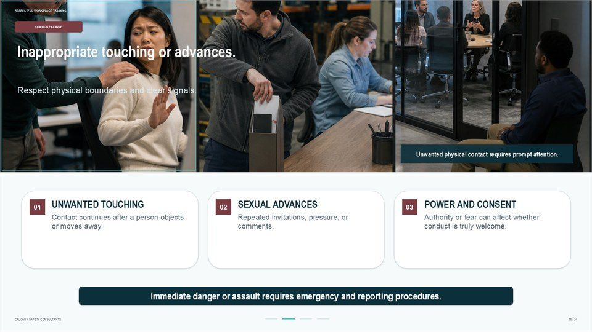  Notes __________________ | Inappropriate touching or advances.  Respect physical boundaries and clear signals. Unwanted physical contact requires prompt attention. Contact continues after a person objects or moves away. Repeated invitations, pressure, or comments. Authority or fear can affect whether conduct is truly welcome. Immediate danger or assault requires emergency and reporting...  Apply the definition using observable conduct, context, impact, and the reporting procedure that applies to the workplace.  KEY POINTS  • Respect physical boundaries and clear signals.  • Unwanted physical contact requires prompt attention.  • Contact continues after a person objects or moves away.

GENERAL NOTES

LESSON 01 • SLIDE 19 OF 34  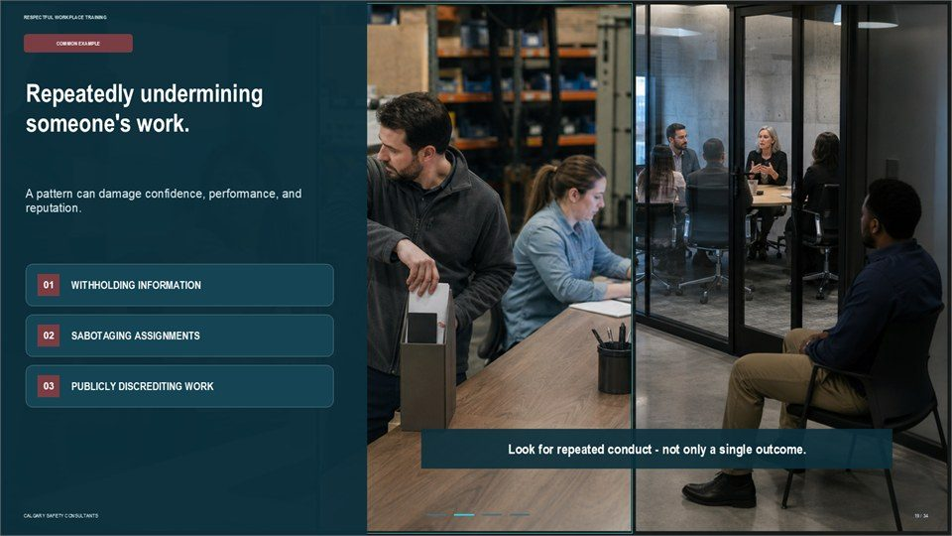  Notes __________________ | Repeatedly undermining someone's work.  A pattern can damage confidence, performance, and reputation. Look for repeated conduct - not only a single outcome.  Apply the definition using observable conduct, context, impact, and the reporting procedure that applies to the workplace.  KEY POINTS  • A pattern can damage confidence, performance, and reputation.  • Look for repeated conduct - not only a single outcome.

LESSON 01 • SLIDE 20 OF 34  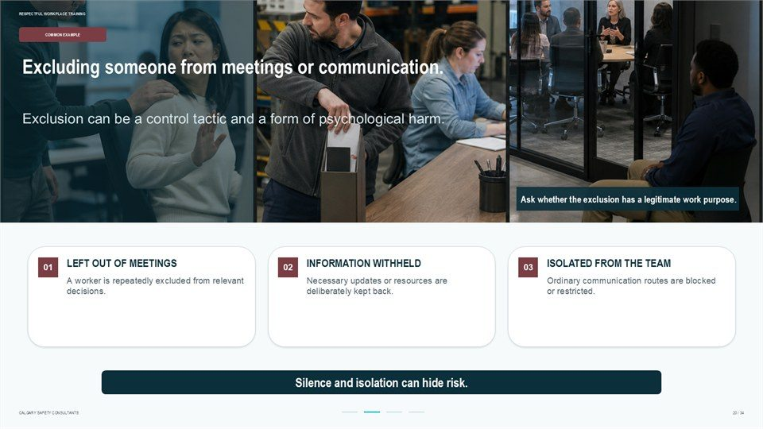  Notes __________________ | Excluding someone from meetings or communication.  Exclusion can be a control tactic and a form of psychological harm. Ask whether the exclusion has a legitimate work purpose. A worker is repeatedly excluded from relevant decisions. Necessary updates or resources are deliberately kept back. Ordinary communication routes are blocked or restricted. Silence and isolation can hide...  Apply the definition using observable conduct, context, impact, and the reporting procedure that applies to the workplace.  KEY POINTS  • Exclusion can be a control tactic and a form of psychological harm.  • Ask whether the exclusion has a legitimate work purpose.  • A worker is repeatedly excluded from relevant decisions.

LESSON 01 • SLIDE 21 OF 34  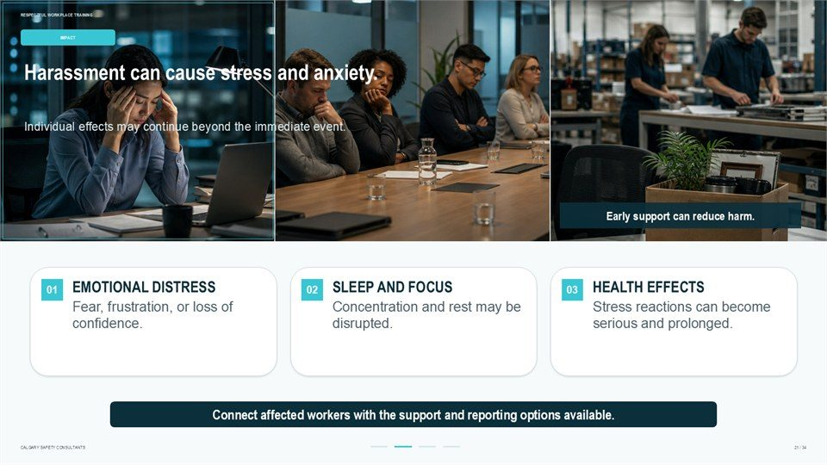  Notes __________________ | Harassment can cause stress and anxiety.  Individual effects may continue beyond the immediate event. Early support can reduce harm. Fear, frustration, or loss of confidence. Concentration and rest may be disrupted. Stress reactions can become serious and prolonged. Connect affected workers with the support and reporting options available.  Apply the definition using observable conduct, context, impact, and the reporting procedure that applies to the workplace.  KEY POINTS  • Individual effects may continue beyond the immediate event.  • Early support can reduce harm.  • Fear, frustration, or loss of confidence.

GENERAL NOTES

LESSON 01 • SLIDE 22 OF 34  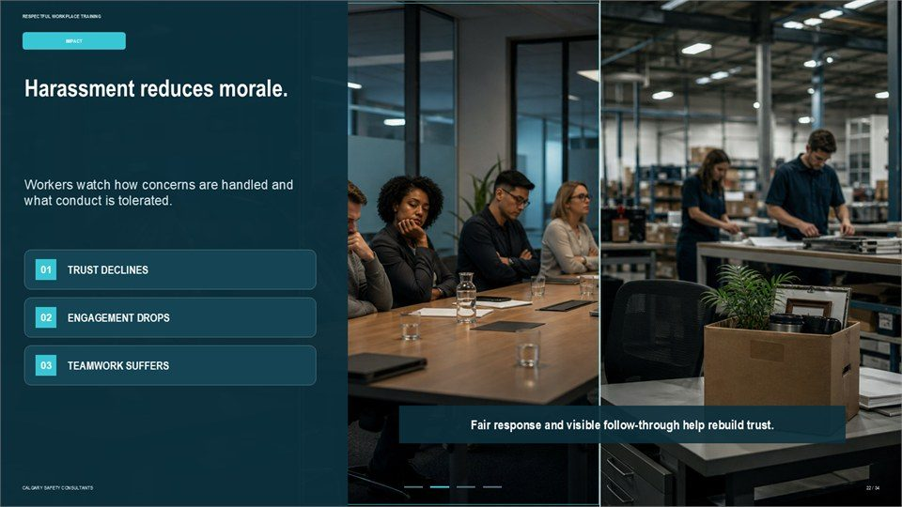  Notes __________________ | Harassment reduces morale.  Workers watch how concerns are handled and what conduct is tolerated. Fair response and visible follow-through help rebuild trust.  Apply the definition using observable conduct, context, impact, and the reporting procedure that applies to the workplace.  KEY POINTS  • Workers watch how concerns are handled and what conduct is tolerated.  • Fair response and visible follow-through help rebuild trust.

LESSON 01 • SLIDE 23 OF 34  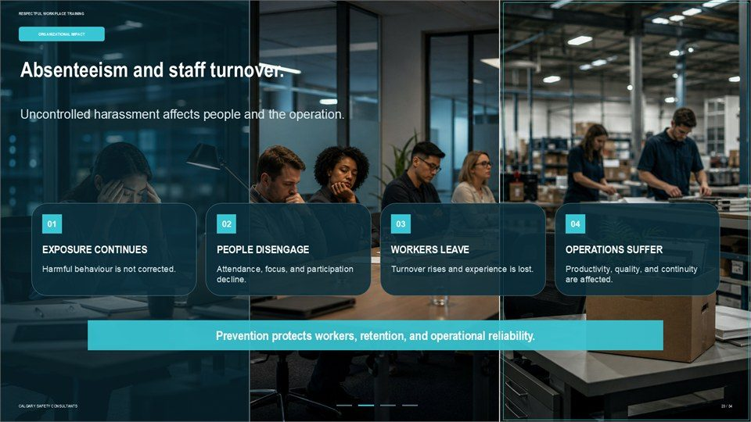  Notes __________________ | Absenteeism and staff turnover.  Uncontrolled harassment affects people and the operation. Harmful behaviour is not corrected. Attendance, focus, and participation decline. Turnover rises and experience is lost. Productivity, quality, and continuity are affected. Prevention protects workers, retention, and operational reliability.  Apply the definition using observable conduct, context, impact, and the reporting procedure that applies to the workplace.  KEY POINTS  • Uncontrolled harassment affects people and the operation.  • Harmful behaviour is not corrected.  • Attendance, focus, and participation decline.

LESSON 01 • SLIDE 24 OF 34  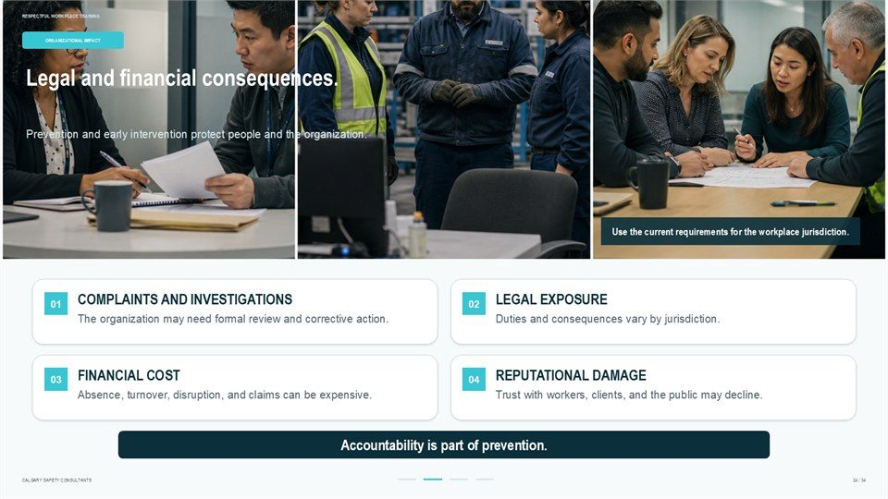  Notes __________________ | Legal and financial consequences.  Prevention and early intervention protect people and the organization. Use the current requirements for the workplace jurisdiction. The organization may need formal review and corrective action. Duties and consequences vary by jurisdiction. Absence, turnover, disruption, and claims can be expensive.  Trust with workers, clients, and the public may decline. Accountability is part of prevention.  KEY POINTS  • Prevention and early intervention protect people and the organization.  • Use the current requirements for the workplace jurisdiction.  • The organization may need formal review and corrective action.

GENERAL NOTES

LESSON 01 • SLIDE 25 OF 34  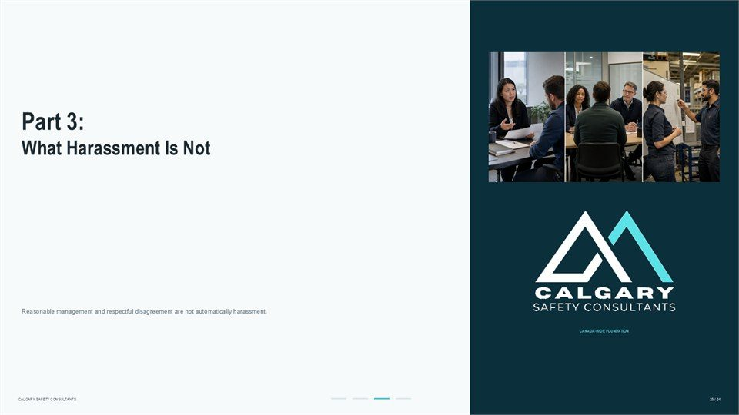  Notes __________________ | Part 3: What Harassment Is Not  What Harassment Is Not. Reasonable management and respectful disagreement are not automatically harassment.  Apply the definition using observable conduct, context, impact, and the reporting procedure that applies to the workplace.  KEY POINTS  • What Harassment Is Not.  • Reasonable management and respectful disagreement are not automatically harassment.

LESSON 01 • SLIDE 26 OF 34    Notes __________________ | Giving performance-related feedback.  Constructive feedback is part of reasonable workplace management. Delivery matters: clear, factual, private, and proportionate. Describe the performance issue and expected standard. Connect the feedback to duties, results, or procedure. Correct the work without humiliation or threats.  Provide a fair opportunity to improve. Feedback can be firm without being demeaning.  KEY POINTS  • Constructive feedback is part of reasonable workplace management.  • Delivery matters: clear, factual, private, and proportionate.  • Describe the performance issue and expected standard.

LESSON 01 • SLIDE 27 OF 34  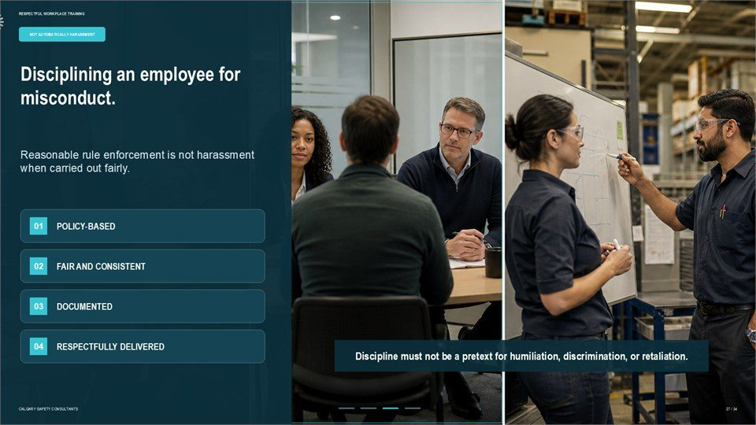  Notes __________________ | Disciplining an employee for misconduct.  Reasonable rule enforcement is not harassment when carried out fairly. Discipline must not be a pretext for humiliation, discrimination, or retaliation.  Apply the definition using observable conduct, context, impact, and the reporting procedure that applies to the workplace.  KEY POINTS  • Reasonable rule enforcement is not harassment when carried out fairly.  • Discipline must not be a pretext for humiliation, discrimination, or retaliation.

GENERAL NOTES

LESSON 01 • SLIDE 28 OF 34  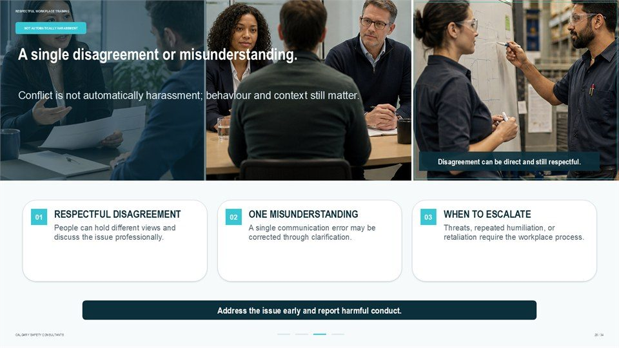  Notes __________________ | A single disagreement or misunderstanding.  Conflict is not automatically harassment; behaviour and context still matter. Disagreement can be direct and still respectful. People can hold different views and discuss the issue professionally. A single communication error may be corrected through clarification.  Threats, repeated humiliation, or retaliation require the workplace process. Address the issue early and report harmful conduct.  KEY POINTS  • Conflict is not automatically harassment; behaviour and context still matter.  • Disagreement can be direct and still respectful.  • People can hold different views and discuss the issue professionally.

LESSON 01 • SLIDE 29 OF 34  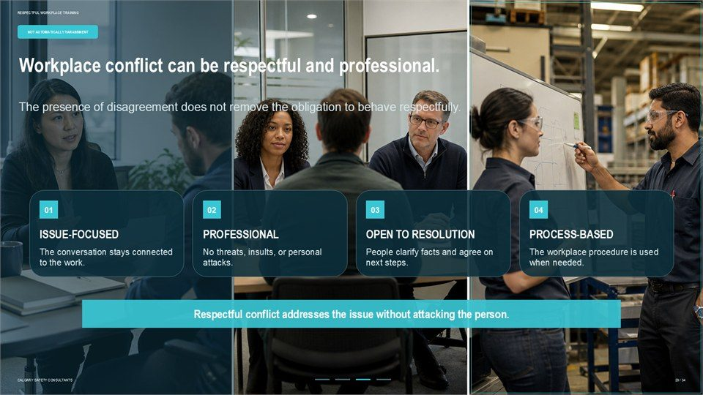  Notes __________________ | Workplace conflict can be respectful and professional.  The presence of disagreement does not remove the obligation to behave respectfully. The conversation stays connected to the work. No threats, insults, or personal attacks. People clarify facts and agree on next steps. The workplace procedure is used when needed. Respectful conflict addresses the issue without attacking the...  Apply the definition using observable conduct, context, impact, and the reporting procedure that applies to the workplace.  KEY POINTS  • The presence of disagreement does not remove the obligation to behave respectfully.  • The conversation stays connected to the work.  • No threats, insults, or personal attacks.

LESSON 01 • SLIDE 30 OF 34  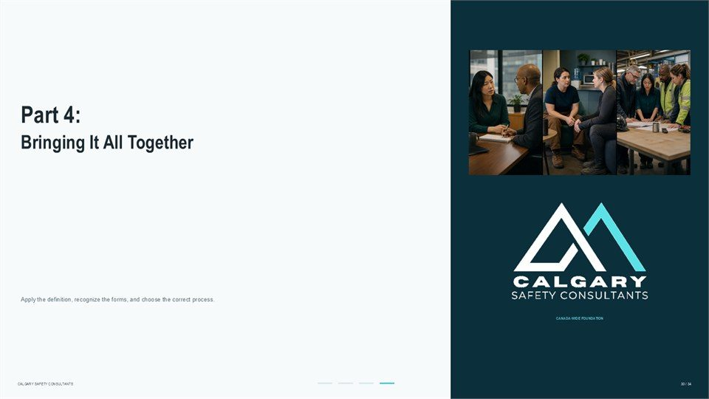  Notes __________________ | Part 4: Bringing It All Together  Bringing It All Together. Apply the definition, recognize the forms, and choose the correct process.  Apply the definition using observable conduct, context, impact, and the reporting procedure that applies to the workplace.  KEY POINTS  • Bringing It All Together.  • Apply the definition, recognize the forms, and choose the correct process.

GENERAL NOTES

LESSON 01 • SLIDE 31 OF 34  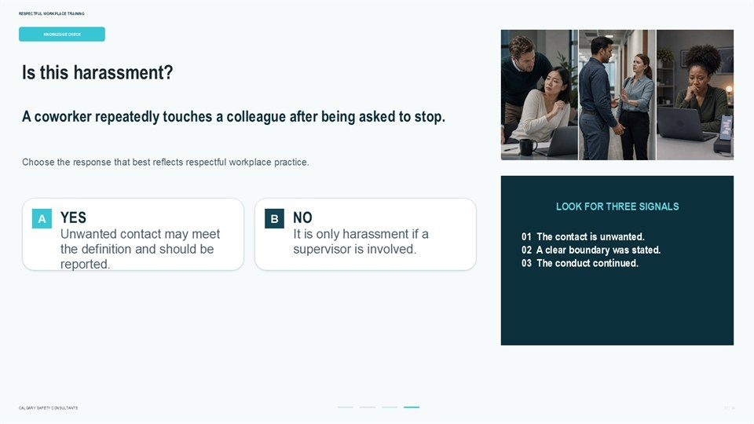  Notes __________________ | Is this harassment?  A coworker repeatedly touches a colleague after being asked to stop. Choose the response that best reflects respectful workplace practice. Unwanted contact may meet the definition and should be reported. It is only harassment if a supervisor is involved. 01 The contact is unwanted. 02 A clear boundary was stated. 03 The conduct...  Apply the definition using observable conduct, context, impact, and the reporting procedure that applies to the workplace.  KEY POINTS  • A coworker repeatedly touches a colleague after being asked to stop.  • Choose the response that best reflects respectful workplace practice.  • Unwanted contact may meet the definition and should be reported.

LESSON 01 • SLIDE 32 OF 34  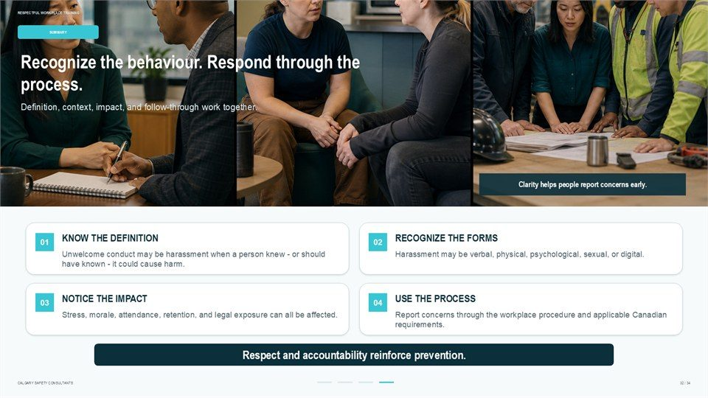  Notes __________________ | Recognize the behaviour. Respond through the process.  Definition, context, impact, and follow-through work together. Clarity helps people report concerns early. Unwelcome conduct may be harassment when a person knew - or should have known - it could cause harm. Harassment may be verbal, physical, psychological, sexual, or digital.  Stress, morale, attendance, retention, and legal exposure can all be affected. Report concerns through the workplace procedure and applicable Canadian requirements. Respect and accountability reinforce prevention.  KEY POINTS  • Definition, context, impact, and follow-through work together.  • Clarity helps people report concerns early.  • Unwelcome conduct may be harassment when a person knew - or should have known - it could cause harm.

LESSON 01 • SLIDE 33 OF 34  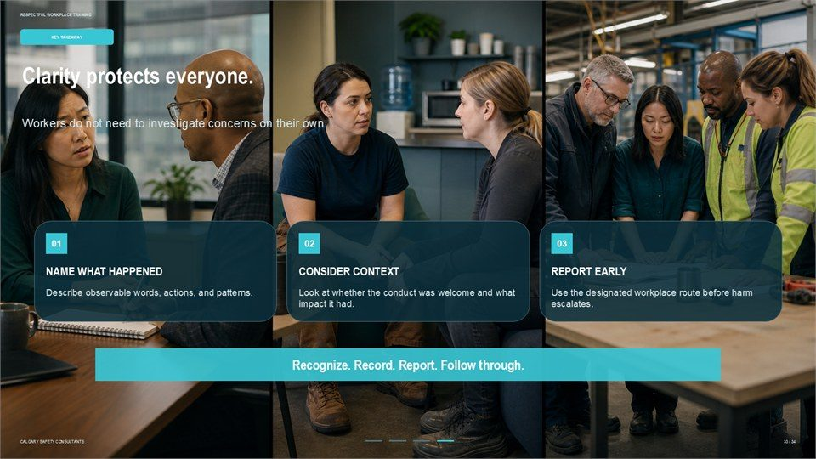  Notes __________________ | Clarity protects everyone.  Workers do not need to investigate concerns on their own. Describe observable words, actions, and patterns. Look at whether the conduct was welcome and what impact it had. Use the designated workplace route before harm escalates. Recognize. Record. Report. Follow through.  Apply the definition using observable conduct, context, impact, and the reporting procedure that applies to the workplace.  KEY POINTS  • Workers do not need to investigate concerns on their own.  • Describe observable words, actions, and patterns.  • Look at whether the conduct was welcome and what impact it had.

GENERAL NOTES

LESSON 01 • SLIDE 34 OF 34  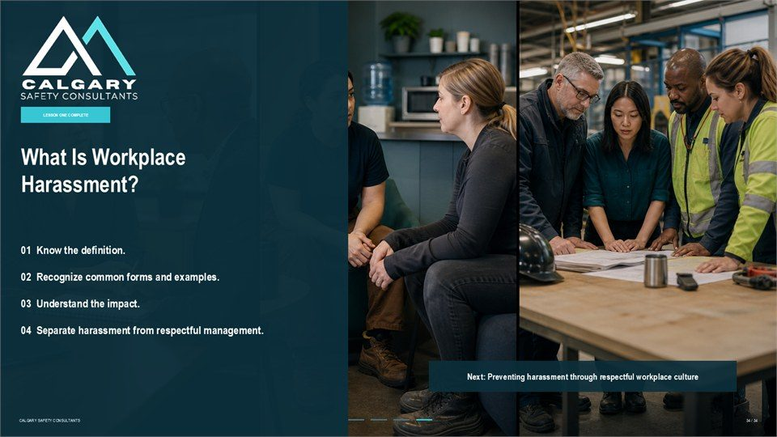  Notes __________________ | What Is Workplace Harassment?  01 Know the definition. 02 Recognize common forms and examples. 03 Understand the impact. 04 Separate harassment from respectful management. Next: Preventing harassment through respectful workplace culture.  Apply the definition using observable conduct, context, impact, and the reporting procedure that applies to the workplace.  KEY POINTS  • 01 Know the definition.  • 02 Recognize common forms and examples.  • 03 Understand the impact.

GENERAL NOTES

LESSON 01 SUMMARY
What Is Workplace Harassment?
The following points bring the lesson together. Use them to review the main prevention message and connect it to the procedures and expectations in your workplace.
01 | Workplace harassment is assessed through the applicable legal and policy definition. Observable conduct, context, impact, repetition, and what a reasonable person knew or should have known all matter.
02 | Harassment may be verbal, physical, psychological, sexual, or online. It may involve one serious incident or a pattern, and it can come from a supervisor, coworker, client, contractor, or another workplace party.
03 | Common examples include offensive jokes or slurs, harmful rumours, intimidation, unwanted touching or advances, repeated undermining, and exclusion without a legitimate work purpose.
04 | Harassment can affect health, trust, morale, attendance, retention, reporting, and operational reliability. Early support and appropriate intervention can reduce harm.
05 | Reasonable performance feedback, fair discipline, and ordinary disagreement are not automatically harassment. Delivery, purpose, proportionality, context, and the applicable definition still matter.
Reflection and application
• Which reporting route applies if the person named in a concern is the usual contact?
• What examples in this workplace could be misunderstood as joking but still cause harm?
• How can I describe observable conduct without making assumptions about intent?
________________________________________________________________________________
________________________________________________________________________________
GENERAL NOTES

MODULE TWO / LESSON 02

Preventing Harassment in the Workplace
Culture | Leadership | Bystander action | Prevention tools

Lesson overview
Prevention begins before a complaint is made. Workplace culture teaches people what is modelled, rewarded, tolerated, and corrected, so ordinary leadership and coworker responses either strengthen a speak-up loop or reinforce silence. Healthy culture makes respect visible and gives workers confidence that concerns will be handled fairly.
This lesson connects leadership, usable policy, training, early response, and bystander action. It emphasizes choosing the lowest-risk useful action, supporting a person after an incident, documenting observable facts, and reporting through the proper route without spreading the story or taking on the role of investigator.
By the end of this lesson you should be able to
• Recognize healthy and unsafe cultural signals that affect whether people speak up.
• Explain how leadership, policy, training, and early response work together as prevention controls.
• Identify practical habits that make respectful conduct visible in everyday work.
• Choose a safe and proportionate bystander option, including direct, distract, delegate, delay, or document.
• Record and report useful facts without escalating risk, compromising privacy, or investigating independently.
GENERAL NOTES

LESSON 02 • SLIDE 01 OF 23  Notes __________________ | Preventing Harassment in the Workplace  Harassment and Violence Prevention Training. Respectful Workplace: Harassment and Violence Prevention Training.  Choose prevention actions that are safe, proportionate, and consistent with the workplace process.  KEY POINTS  • Harassment and Violence Prevention Training.  • Respectful Workplace: Harassment and Violence Prevention Training.

LESSON 02 • SLIDE 02 OF 23  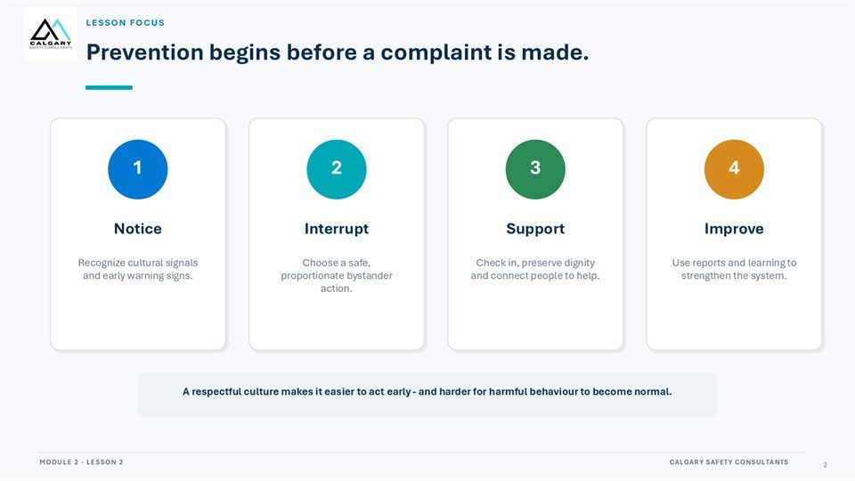  Notes __________________ | Lesson Focus  Prevention begins before a complaint is made. Interrupt. Recognize cultural signals and early warning signs. Choose a safe, proportionate bystander action. Check in, preserve dignity and connect people to help. Use reports and learning to strengthen the system.  A respectful culture makes it easier to act early - and harder for harmful behaviour to become normal.  KEY POINTS  • Prevention begins before a complaint is made.  • Recognize cultural signals and early warning signs.  • Choose a safe, proportionate bystander action.

LESSON 02 • SLIDE 03 OF 23  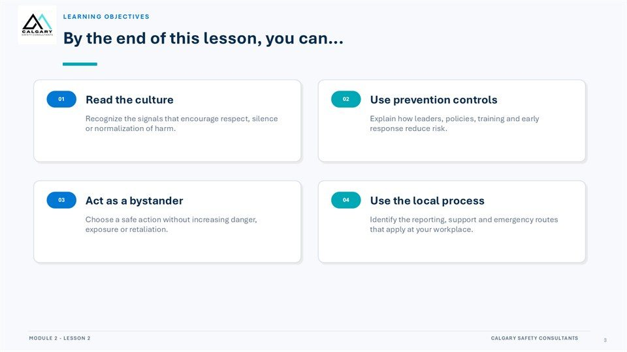  Notes __________________ | Learning Objectives  By the end of this lesson, you can... Read the culture. Use prevention controls. Recognize the signals that encourage respect, silence or normalization of harm. Explain how leaders, policies, training and early response reduce risk. Act as a bystander. Use the local process.  Choose a safe action without increasing danger, exposure or retaliation. Identify the reporting, support and emergency routes that apply at your workplace.  KEY POINTS  • By the end of this lesson, you can...  • Read the culture.  • Use prevention controls.

GENERAL NOTES

LESSON 02 • SLIDE 04 OF 23  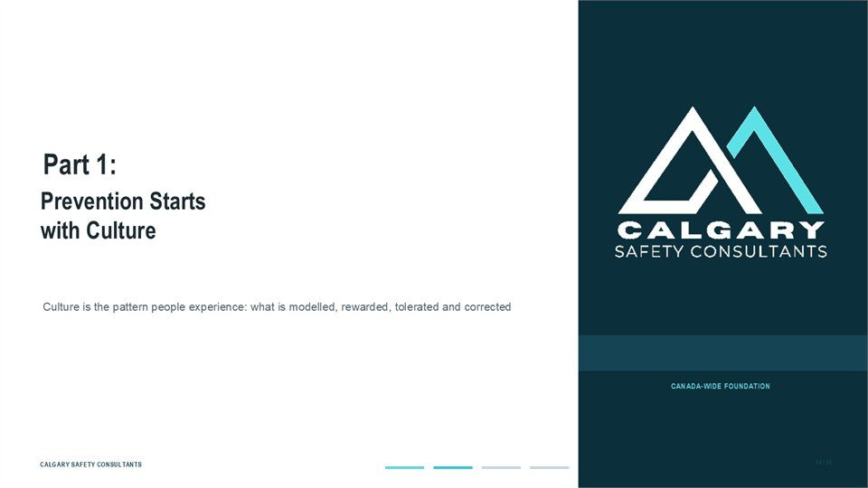  Notes __________________ | Part 1: Prevention Starts with Culture  Prevention Starts with Culture. Culture is the pattern people experience: what is modelled, rewarded, tolerated and corrected.  Choose prevention actions that are safe, proportionate, and consistent with the workplace process.  KEY POINTS  • Prevention Starts with Culture.  • Culture is the pattern people experience: what is modelled, rewarded, tolerated and corrected.

LESSON 02 • SLIDE 05 OF 23  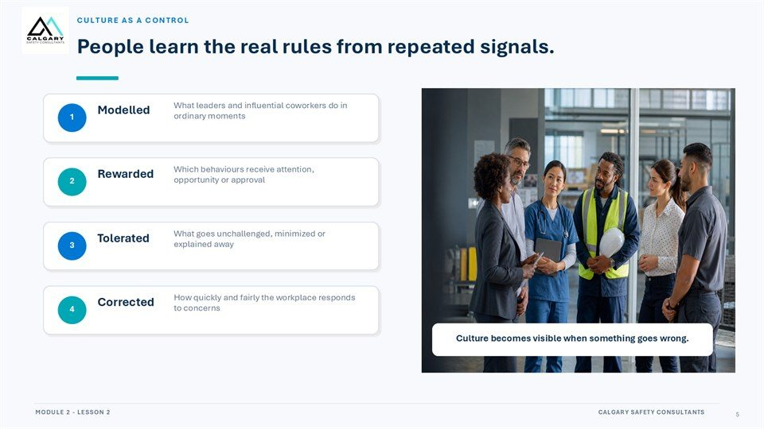  Notes __________________ | People learn the real rules from repeated signals.  What leaders and influential coworkers do in ordinary moments. Modelled. Which behaviours receive attention, opportunity or approval. Rewarded. What goes unchallenged, minimized or explained away. Tolerated. How quickly and fairly the workplace responds to concerns. Corrected. Culture becomes visible when something goes wrong.  Choose prevention actions that are safe, proportionate, and consistent with the workplace process.  KEY POINTS  • What leaders and influential coworkers do in ordinary moments.  • Which behaviours receive attention, opportunity or approval.  • What goes unchallenged, minimized or explained away.

LESSON 02 • SLIDE 06 OF 23  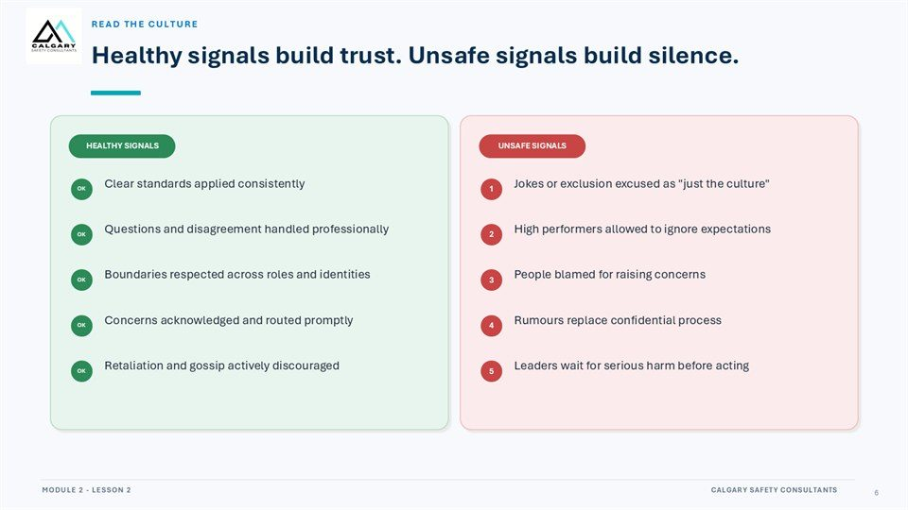  Notes __________________ | Healthy signals build trust. Unsafe signals build silence.  Healthy signals build trust: clear standards are applied consistently; questions and disagreement are handled professionally; boundaries are respected; concerns are acknowledged and routed promptly; and retaliation and gossip are discouraged.  Unsafe signals build silence: harmful conduct is excused as culture; high performers ignore expectations; people are blamed for reporting; rumours replace a confidential process; or leaders wait for serious harm before acting.  KEY POINTS  • Healthy signals build trust and encourage early reporting.  • Unsafe signals normalize harm and reinforce silence.  • Watch what is modelled, tolerated, and corrected.

GENERAL NOTES

LESSON 02 • SLIDE 07 OF 23  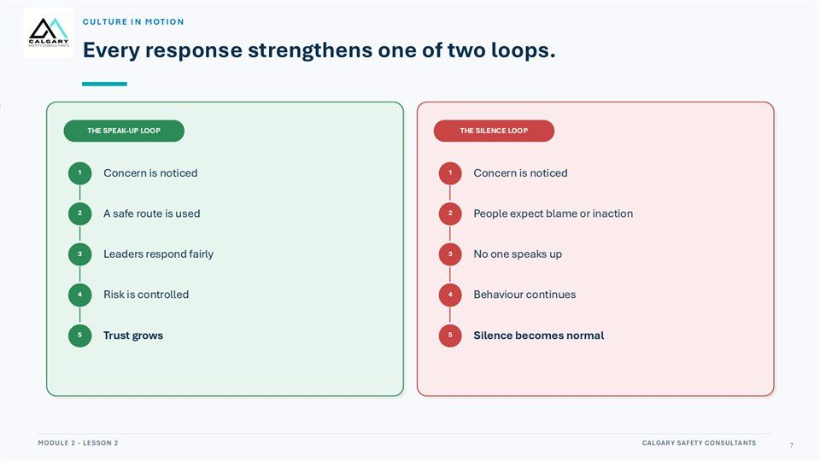  Notes __________________ | Every response strengthens one of two loops.  Concern is noticed. A safe route is used. People expect blame or inaction. Leaders respond fairly. No one speaks up. Risk is controlled. Behaviour continues. Trust grows. Silence becomes normal.  Choose prevention actions that are safe, proportionate, and consistent with the workplace process.  KEY POINTS  • Concern is noticed.  • A safe route is used.  • People expect blame or inaction.

LESSON 02 • SLIDE 08 OF 23  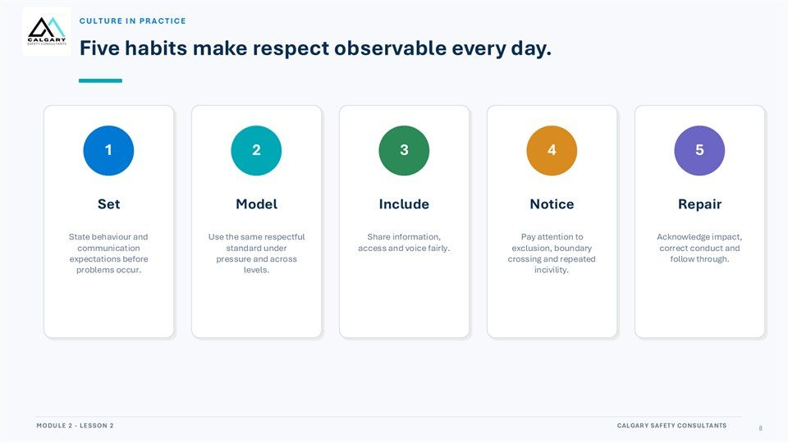  Notes __________________ | Five habits make respect observable every day.  State behaviour and communication expectations before problems occur. Use the same respectful standard under pressure and across levels. Share information, access and voice fairly. Pay attention to exclusion, boundary crossing and repeated incivility. Acknowledge impact, correct conduct and follow through.  Choose prevention actions that are safe, proportionate, and consistent with the workplace process.  KEY POINTS  • State behaviour and communication expectations before problems occur.  • Use the same respectful standard under pressure and across levels.  • Share information, access and voice fairly.

LESSON 02 • SLIDE 09 OF 23  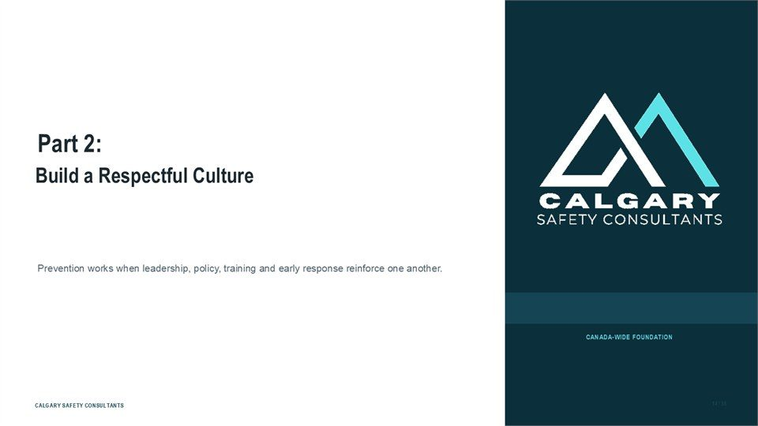  Notes __________________ | Part 2: Build a Respectful Culture  Build a Respectful Culture. Prevention works when leadership, policy, training and early response reinforce one another.  Choose prevention actions that are safe, proportionate, and consistent with the workplace process.  KEY POINTS  • Build a Respectful Culture.  • Prevention works when leadership, policy, training and early response reinforce one another.

GENERAL NOTES

LESSON 02 • SLIDE 10 OF 23  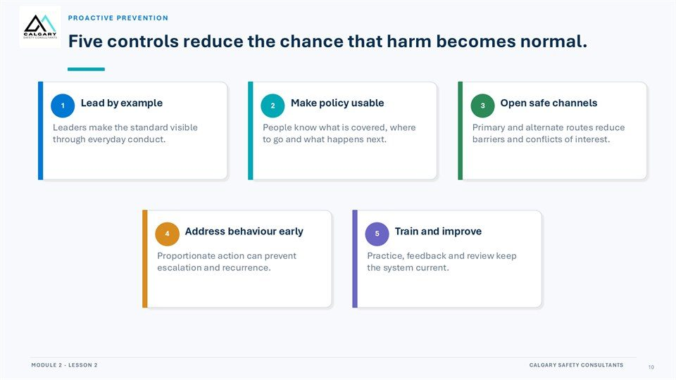  Notes __________________ | Five controls reduce the chance that harm becomes normal.  Lead by example. Make policy usable. Open safe channels. Leaders make the standard visible through everyday conduct. People know what is covered, where to go and what happens next. Primary and alternate routes reduce barriers and conflicts of interest. Address behaviour early. Train and improve.  Proportionate action can prevent escalation and recurrence. Practice, feedback and review keep the system current.  KEY POINTS  • Lead by example.  • Make policy usable.  • Open safe channels.

LESSON 02 • SLIDE 11 OF 23  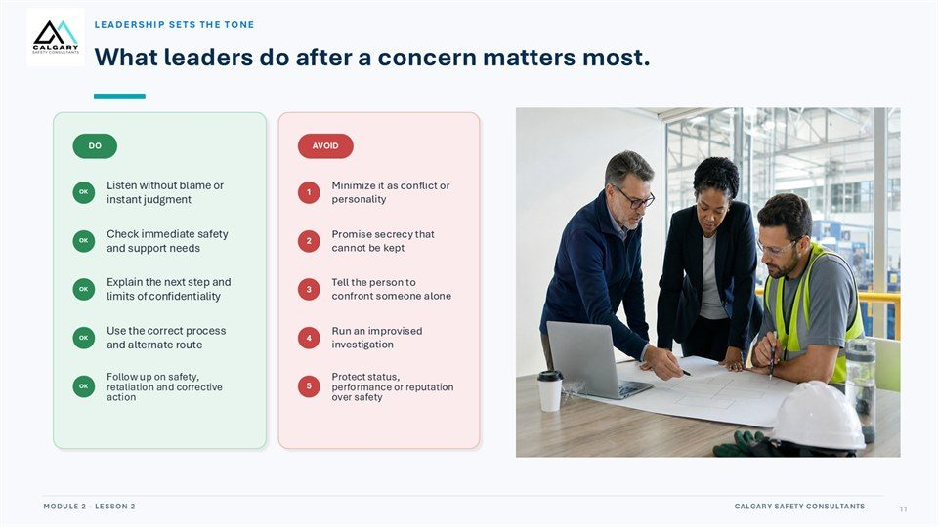  Notes __________________ | What leaders do after a concern matters most.  Leaders should listen without blame, check immediate safety and support needs, explain the next step and privacy limits, use the correct process and alternate route, and follow up on safety, retaliation, and corrective action.  Avoid minimizing the concern, promising secrecy, directing a person to confront someone alone, improvising an investigation, or protecting status, performance, or reputation over safety.  KEY POINTS  • Listen without blame and check immediate safety and support needs.  • Explain next steps, privacy limits, and the correct reporting route.  • Do not minimize, promise secrecy, or improvise an investigation.

LESSON 02 • SLIDE 12 OF 23  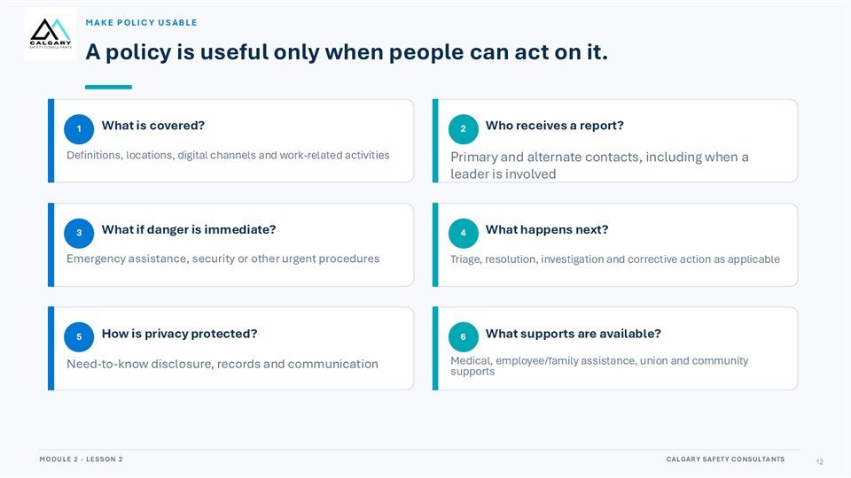  Notes __________________ | A policy is useful only when people can act on it.  What is covered? Who receives a report? Definitions, locations, digital channels and work-related activities. Primary and alternate contacts, including when a leader is involved. What if danger is immediate? What happens next? Emergency assistance, security or other urgent procedures.  Triage, resolution, investigation and corrective action as applicable. How is privacy protected? What supports are available? Need-to-know disclosure, records and communication. Medical, employee/family assistance, union and community supports.  KEY POINTS  • What is covered?  • Who receives a report?  • Definitions, locations, digital channels and work-related activities.

GENERAL NOTES

LESSON 02 • SLIDE 13 OF 23  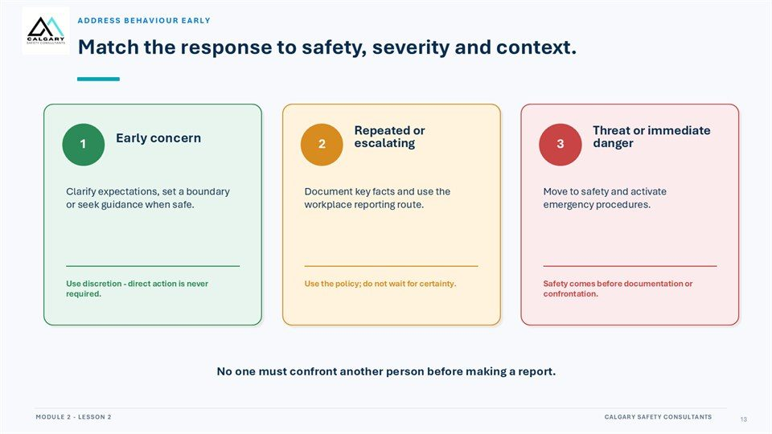  Notes __________________ | Match the response to safety, severity and context.  Early concern. Repeated or escalating. Threat or immediate danger. Clarify expectations, set a boundary or seek guidance when safe. Document key facts and use the workplace reporting route. Move to safety and activate emergency procedures. Use discretion - direct action is never required.  Use the policy; do not wait for certainty. Safety comes before documentation or confrontation. No one must confront another person before making a report.  KEY POINTS  • Early concern.  • Repeated or escalating.  • Threat or immediate danger.

LESSON 02 • SLIDE 14 OF 23  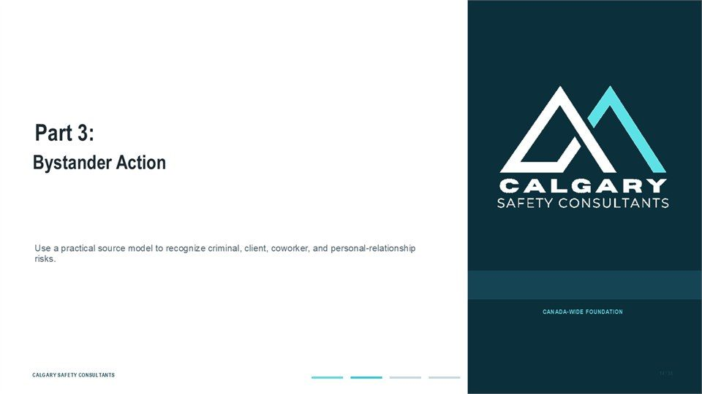  Notes __________________ | Part 3: Bystander Action  Bystander Action. Use a practical source model to recognize criminal, client, coworker, and personal-relationship risks.  Choose prevention actions that are safe, proportionate, and consistent with the workplace process.  KEY POINTS  • Bystander Action.  • Use a practical source model to recognize criminal, client, coworker, and personal-relationship risks.

LESSON 02 • SLIDE 15 OF 23  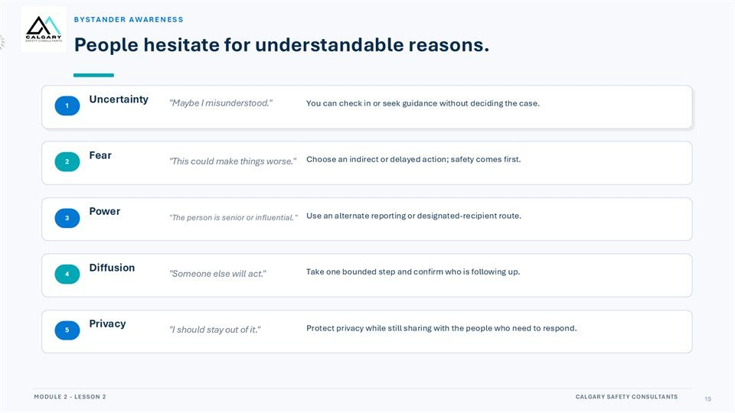  Notes __________________ | People hesitate for understandable reasons.  Uncertainty. "Maybe I misunderstood.". You can check in or seek guidance without deciding the case. "This could make things worse.". Choose an indirect or delayed action; safety comes first. "The person is senior or influential.". Use an alternate reporting or designated-recipient route. Diffusion.  "Someone else will act.". Take one bounded step and confirm who is following up. "I should stay out of it.". Protect privacy while still sharing with the people who need to respond.  KEY POINTS  • Uncertainty.  • "Maybe I misunderstood.".  • You can check in or seek guidance without deciding the case.

GENERAL NOTES

LESSON 02 • SLIDE 16 OF 23  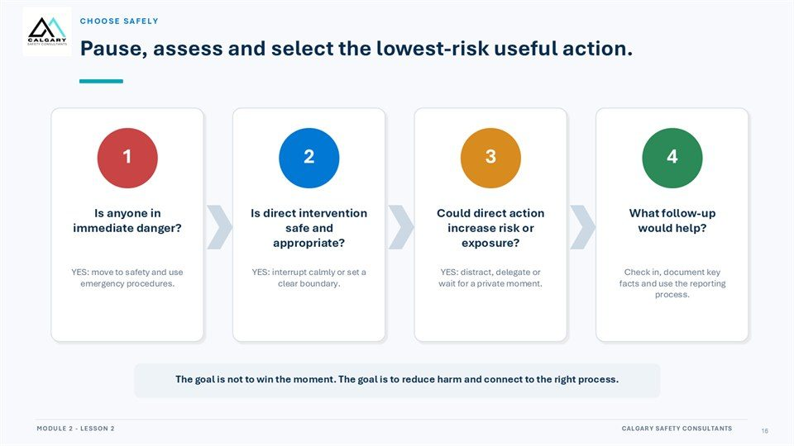  Notes __________________ | Pause, assess and select the lowest-risk useful action.  Is anyone in immediate danger? Is direct intervention safe and appropriate? Could direct action increase risk or exposure? What follow-up would help? YES: move to safety and use emergency procedures. YES: interrupt calmly or set a clear boundary. YES: distract, delegate or wait for a private moment.  Check in, document key facts and use the reporting process. The goal is not to win the moment. The goal is to reduce harm and connect to the right process.  KEY POINTS  • Is anyone in immediate danger?  • Is direct intervention safe and appropriate?  • Could direct action increase risk or exposure?

LESSON 02 • SLIDE 17 OF 23  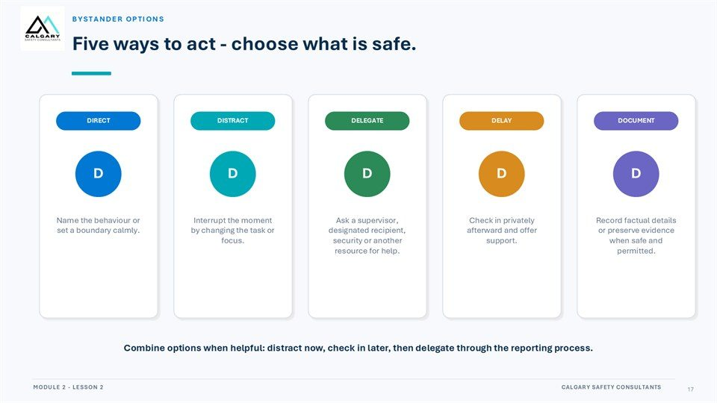  Notes __________________ | Five ways to act - choose what is safe.  Name the behaviour or set a boundary calmly. Interrupt the moment by changing the task or focus. Ask a supervisor, designated recipient, security or another resource for help. Check in privately afterward and offer support. Record factual details or preserve evidence when safe and permitted.  Combine options when helpful: distract now, check in later, then delegate through the reporting process.  KEY POINTS  • Name the behaviour or set a boundary calmly.  • Interrupt the moment by changing the task or focus.  • Ask a supervisor, designated recipient, security or another resource for help.

LESSON 02 • SLIDE 18 OF 23  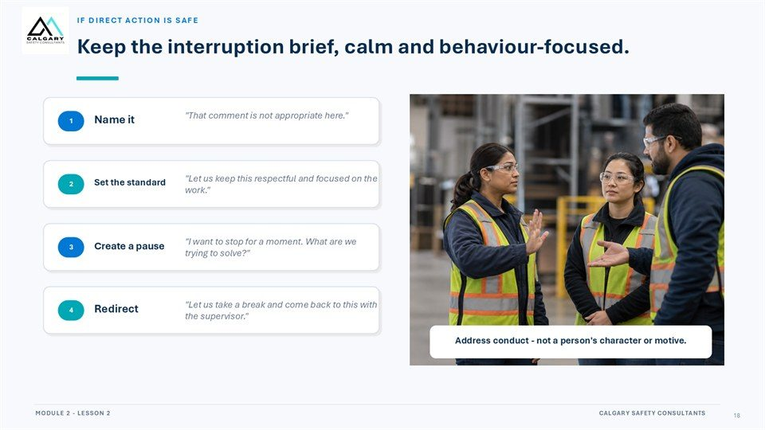  Notes __________________ | Keep the interruption brief, calm and behaviour-focused.  "That comment is not appropriate here.". "Let us keep this respectful and focused on the work.". Set the standard. "I want to stop for a moment. What are we trying to solve?". Create a pause. "Let us take a break and come back to this with the supervisor.". Redirect. Address conduct - not a person's character or motive.  Choose prevention actions that are safe, proportionate, and consistent with the workplace process.  KEY POINTS  • "That comment is not appropriate here.".  • "Let us keep this respectful and focused on the work.".  • Set the standard.

GENERAL NOTES

LESSON 02 • SLIDE 19 OF 23  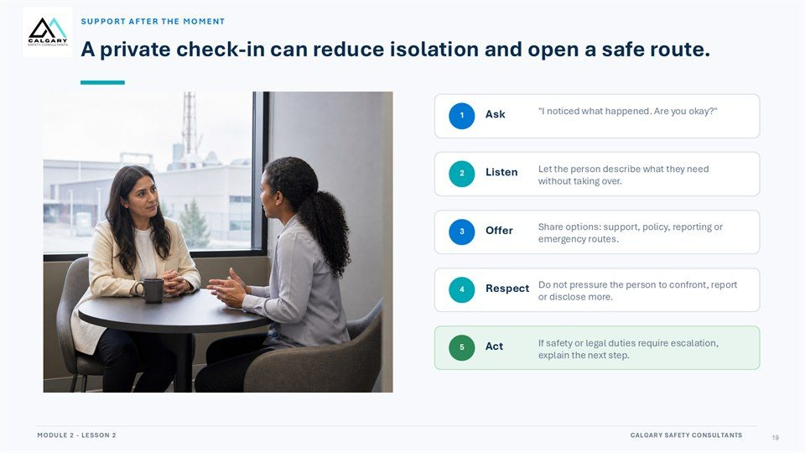  Notes __________________ | A private check-in can reduce isolation and open a safe route.  "I noticed what happened. Are you okay?". Let the person describe what they need without taking over. Share options: support, policy, reporting or emergency routes. Do not pressure the person to confront, report or disclose more. If safety or legal duties require escalation, explain the next step.  Choose prevention actions that are safe, proportionate, and consistent with the workplace process.  KEY POINTS  • "I noticed what happened. Are you okay?".  • Let the person describe what they need without taking over.  • Share options: support, policy, reporting or emergency routes.

LESSON 02 • SLIDE 20 OF 23  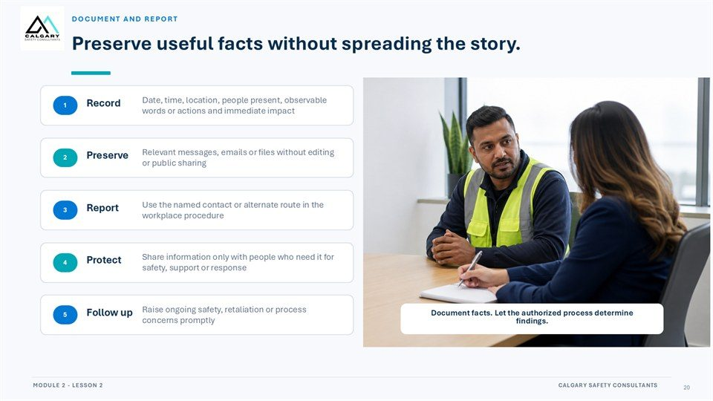  Notes __________________ | Preserve useful facts without spreading the story.  Date, time, location, people present, observable words or actions and immediate impact. Relevant messages, emails or files without editing or public sharing. Preserve. Use the named contact or alternate route in the workplace procedure. Share information only with people who need it for safety, support or response.  Raise ongoing safety, retaliation or process concerns promptly. Follow up. Document facts. Let the authorized process determine findings.  KEY POINTS  • Date, time, location, people present, observable words or actions and immediate impact.  • Relevant messages, emails or files without editing or public sharing.  • Use the named contact or alternate route in the workplace procedure.

LESSON 02 • SLIDE 21 OF 23  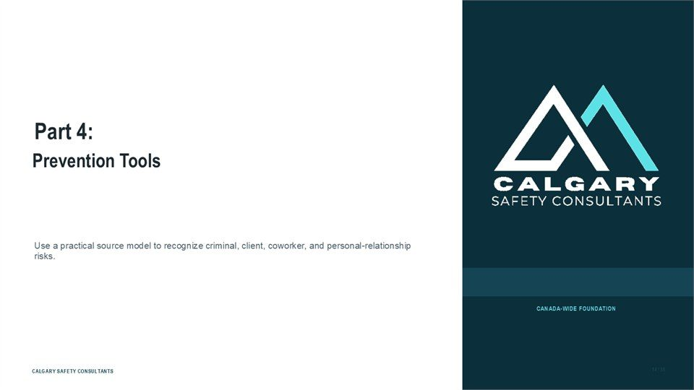  Notes __________________ | Part 4: Prevention Tools  Prevention Tools. Use a practical source model to recognize criminal, client, coworker, and personal-relationship risks.  Choose prevention actions that are safe, proportionate, and consistent with the workplace process.  KEY POINTS  • Prevention Tools.  • Use a practical source model to recognize criminal, client, coworker, and personal-relationship risks.

GENERAL NOTES

LESSON 02 • SLIDE 22 OF 23  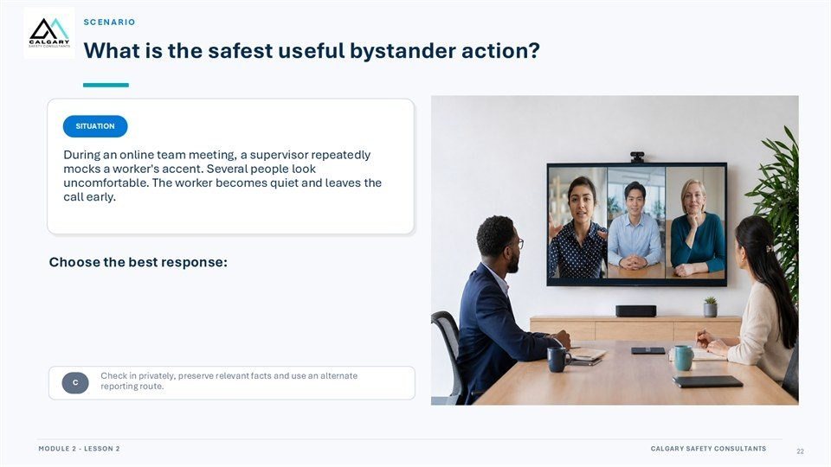  Notes __________________ | Scenario  What is the safest useful bystander action? During an online team meeting, a supervisor repeatedly mocks a worker's accent. Several people look uncomfortable. The worker becomes quiet and leaves the call early. Choose the best response: Ignore it because the worker did not object.  Challenge the supervisor publicly until they apologize. Check in privately, preserve relevant facts and use an alternate reporting route.  KEY POINTS  • What is the safest useful bystander action?  • During an online team meeting, a supervisor repeatedly mocks a worker's accent. Several people look...  • Choose the best response:

LESSON 02 • SLIDE 23 OF 23  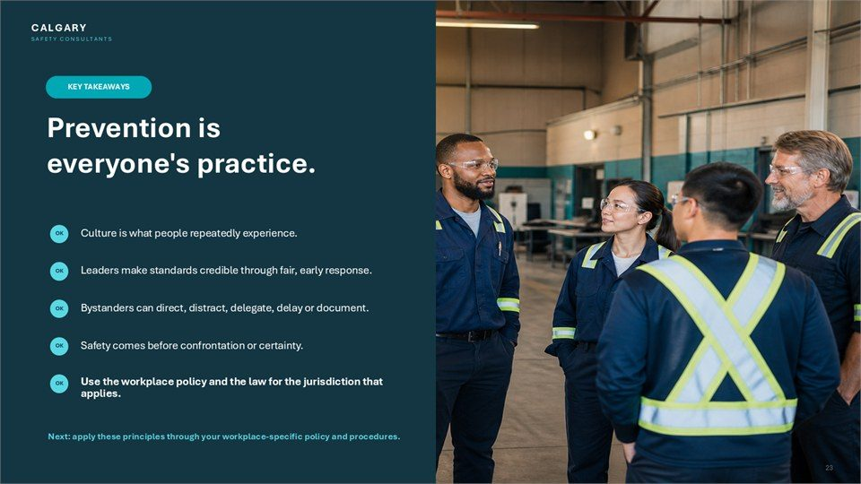  Notes __________________ | Prevention is everyone's practice.  Culture is what people repeatedly experience. Leaders make standards credible through fair, early response. Bystanders can direct, distract, delegate, delay or document. Safety comes before confrontation or certainty. Use the workplace policy and the law for the jurisdiction that applies.  Next: apply these principles through your workplace-specific policy and procedures.  KEY POINTS  • Culture is what people repeatedly experience.  • Leaders make standards credible through fair, early response.  • Bystanders can direct, distract, delegate, delay or document.

GENERAL NOTES

LESSON 02 SUMMARY
Preventing Harassment in the Workplace
The following points bring the lesson together. Use them to review the main prevention message and connect it to the procedures and expectations in your workplace.
01 | Culture is the pattern people experience, not only the values written in a policy. What leaders and influential coworkers model, reward, tolerate, and correct shapes whether people speak up or remain silent.
02 | Prevention controls reinforce one another: leadership example, usable policy, practical training, accessible reporting, and early proportionate response.
03 | A policy is usable when workers know what is covered, where to report, what alternate route is available, what happens next, and how urgent safety concerns are handled.
04 | Bystanders should pause, assess risk, and choose the lowest-risk useful option. Direct, distract, delegate, delay, and document are options, not requirements to confront.
05 | After an incident, a private check-in, accurate notes, and a report through the proper route can reduce isolation and help the workplace act without turning the bystander into an investigator.
Reflection and application
• What signals in this workplace encourage people to speak up early?
• Which bystander option is most realistic and safe in my role?
• Where can I find the primary and alternate reporting routes?
________________________________________________________________________________
________________________________________________________________________________
GENERAL NOTES

MODULE TWO / LESSON 03

Prevention Policies, Programs & Plans
Program elements | Roles | Reporting | Review

Lesson overview
A prevention program is a working cycle rather than a document on a shelf. Although Canadian jurisdictions use different legal names and details, the shared purpose is to define scope, assess risk, select controls, clarify roles, create reporting and emergency routes, explain response steps, protect privacy, train people, keep records, and review effectiveness.
This lesson presents the core architecture of a usable prevention system and the roles that keep it working. It also highlights alternate reporting routes, proportionate confidentiality, accessible communication, jurisdiction-specific review requirements, and an implementation roadmap for building, launching, and improving the program.
By the end of this lesson you should be able to
• Explain why prevention is a cycle of assessment, control, response, review, and improvement.
• Recognize the core elements of a workplace harassment and violence prevention program.
• Identify primary, alternate, and emergency reporting routes and the steps that follow a report.
• Distinguish employer, supervisor, designated recipient, worker, representative, committee, and union roles.
• Confirm the legal, consultation, recordkeeping, training, and review requirements that apply to the workplace.
GENERAL NOTES

LESSON 03 • SLIDE 01 OF 28  Notes __________________ | Prevention Policies, Programs & Plans  Harassment and Violence Prevention Training. Respectful Workplace: Harassment and Violence Prevention Training.  Confirm the applicable jurisdiction, policy, reporting routes, roles, recordkeeping, and review requirements.  KEY POINTS  • Harassment and Violence Prevention Training.  • Respectful Workplace: Harassment and Violence Prevention Training.

LESSON 03 • SLIDE 02 OF 28  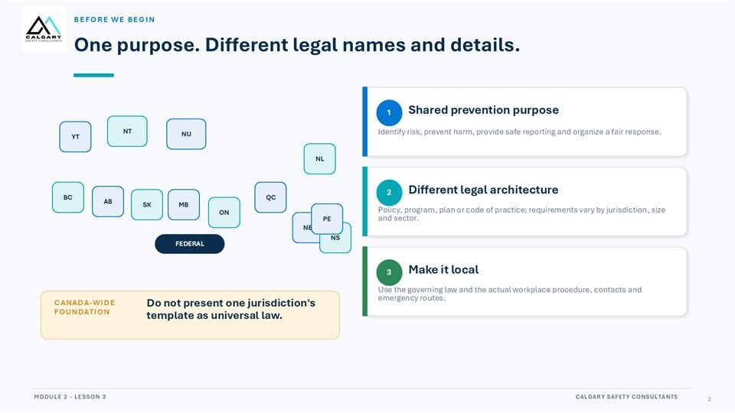  Notes __________________ | Before We Begin  One purpose. Different legal names and details. Shared prevention purpose. Identify risk, prevent harm, provide safe reporting and organize a fair response. Different legal architecture. Policy, program, plan or code of practice; requirements vary by jurisdiction, size and sector. Make it local.  Use the governing law and the actual workplace procedure, contacts and emergency routes. Do not present one jurisdiction's template as universal law.  KEY POINTS  • One purpose. Different legal names and details.  • Shared prevention purpose.  • Identify risk, prevent harm, provide safe reporting and organize a fair response.

LESSON 03 • SLIDE 03 OF 28  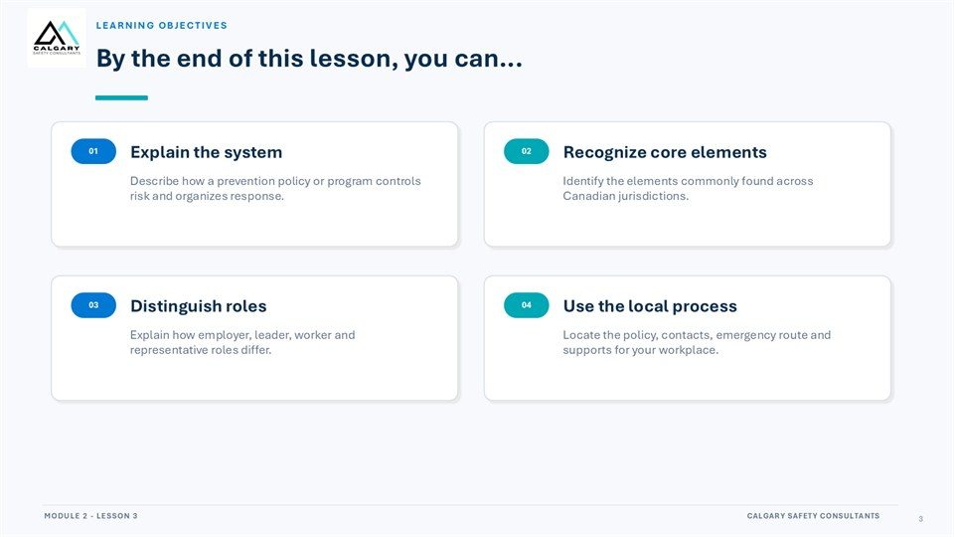  Notes __________________ | Learning Objectives  By the end of this lesson, you can... Explain the system. Recognize core elements. Describe how a prevention policy or program controls risk and organizes response. Identify the elements commonly found across Canadian jurisdictions. Distinguish roles. Use the local process.  Explain how employer, leader, worker and representative roles differ. Locate the policy, contacts, emergency route and supports for your workplace.  KEY POINTS  • By the end of this lesson, you can...  • Explain the system.  • Recognize core elements.

GENERAL NOTES

LESSON 03 • SLIDE 04 OF 28  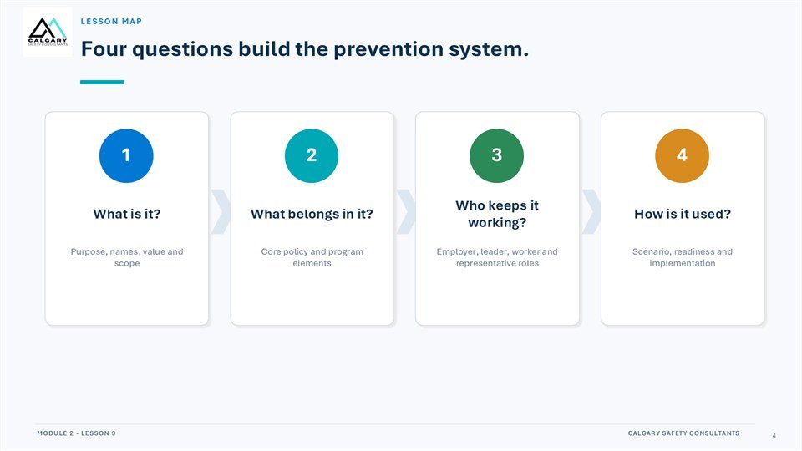  Notes __________________ | Lesson Map  Four questions build the prevention system. What is it? What belongs in it? Who keeps it working? How is it used? Purpose, names, value and scope. Core policy and program elements. Employer, leader, worker and representative roles. Scenario, readiness and implementation.  Confirm the applicable jurisdiction, policy, reporting routes, roles, recordkeeping, and review requirements.  KEY POINTS  • Four questions build the prevention system.  • What is it?  • What belongs in it?

LESSON 03 • SLIDE 05 OF 28  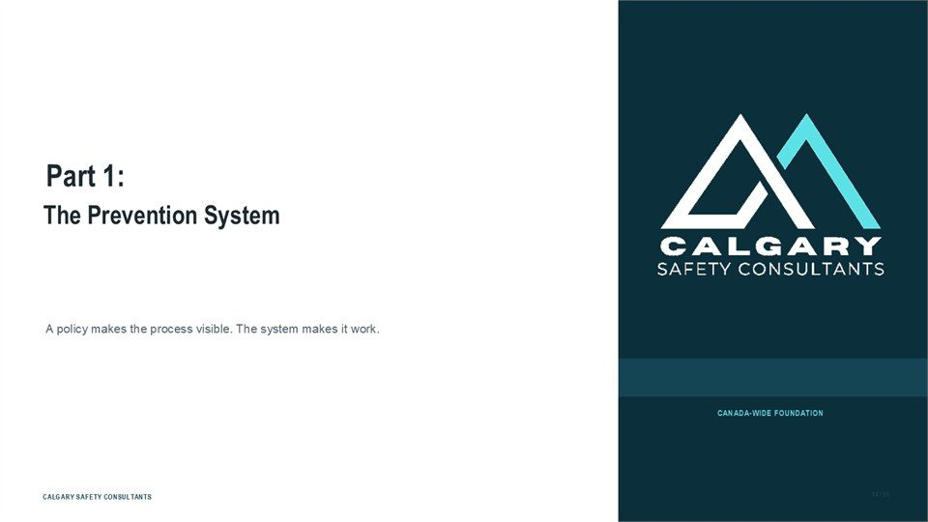  Notes __________________ | Part 1: The Prevention System  The Prevention System. A policy makes the process visible. The system makes it work.  Confirm the applicable jurisdiction, policy, reporting routes, roles, recordkeeping, and review requirements.  KEY POINTS  • The Prevention System.  • A policy makes the process visible. The system makes it work.

LESSON 03 • SLIDE 06 OF 28  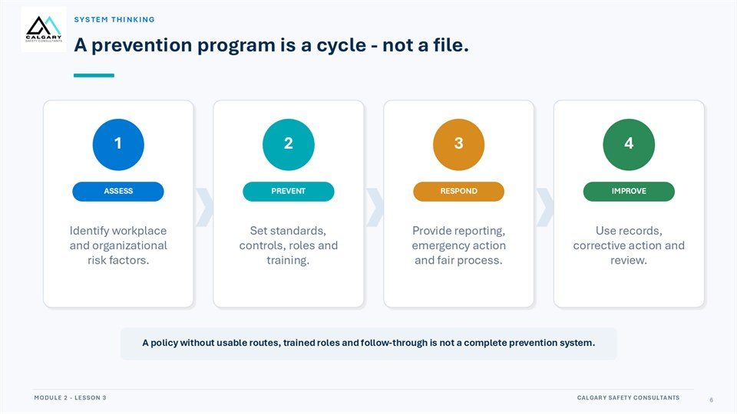  Notes __________________ | A prevention program is a cycle - not a file.  Identify workplace and organizational risk factors. Set standards, controls, roles and training. Provide reporting, emergency action and fair process. Use records, corrective action and review. A policy without usable routes, trained roles and follow-through is not a complete prevention system.  Confirm the applicable jurisdiction, policy, reporting routes, roles, recordkeeping, and review requirements.  KEY POINTS  • Identify workplace and organizational risk factors.  • Set standards, controls, roles and training.  • Provide reporting, emergency action and fair process.

GENERAL NOTES

LESSON 03 • SLIDE 07 OF 28  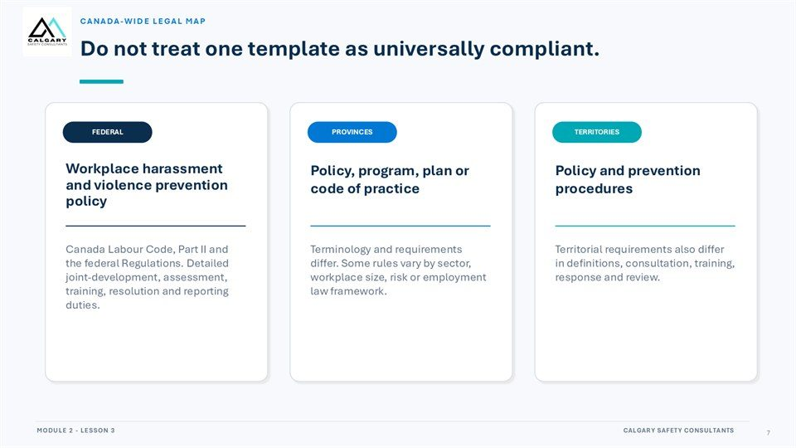  Notes __________________ | Do not treat one template as universally compliant.  Workplace harassment and violence prevention policy. Policy, program, plan or code of practice. Policy and prevention procedures. Canada Labour Code, Part II and the federal Regulations. Detailed joint-development, assessment, training, resolution and reporting duties. Terminology and requirements differ.  Some rules vary by sector, workplace size, risk or employment law framework. Territorial requirements also differ in definitions, consultation, training, response and review.  KEY POINTS  • Workplace harassment and violence prevention policy.  • Policy, program, plan or code of practice.  • Policy and prevention procedures.

LESSON 03 • SLIDE 08 OF 28  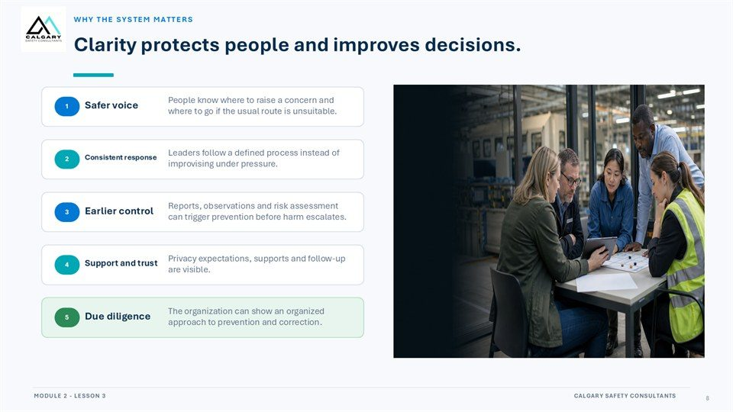  Notes __________________ | Clarity protects people and improves decisions.  People know where to raise a concern and where to go if the usual route is unsuitable. Safer voice. Leaders follow a defined process instead of improvising under pressure. Consistent response. Reports, observations and risk assessment can trigger prevention before harm escalates. Earlier control.  Privacy expectations, supports and follow-up are visible. Support and trust. The organization can show an organized approach to prevention and correction. Due diligence.  KEY POINTS  • People know where to raise a concern and where to go if the usual route is unsuitable.  • Safer voice.  • Leaders follow a defined process instead of improvising under pressure.

LESSON 03 • SLIDE 09 OF 28  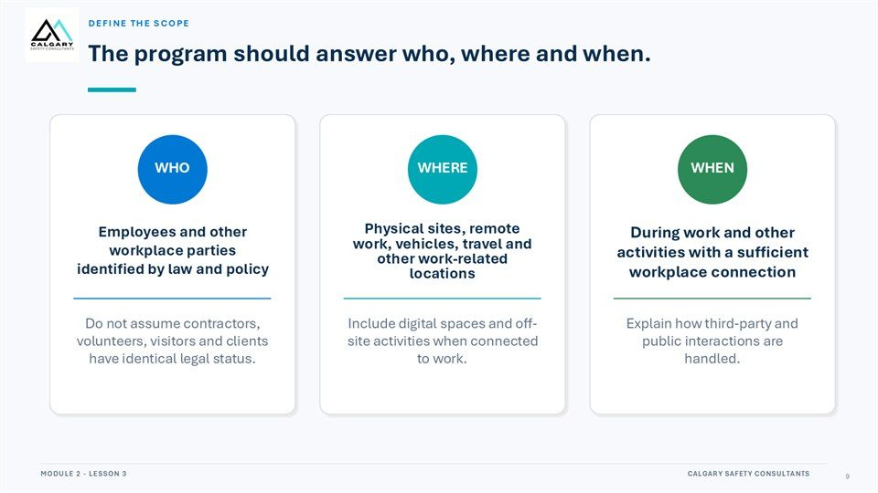  Notes __________________ | The program should answer who, where and when.  Employees and other workplace parties identified by law and policy. Physical sites, remote work, vehicles, travel and other work-related locations. During work and other activities with a sufficient workplace connection. Do not assume contractors, volunteers, visitors and clients have identical legal status.  Include digital spaces and off-site activities when connected to work. Explain how third-party and public interactions are handled.  KEY POINTS  • Employees and other workplace parties identified by law and policy.  • Physical sites, remote work, vehicles, travel and other work-related locations.  • During work and other activities with a sufficient workplace connection.

GENERAL NOTES

LESSON 03 • SLIDE 10 OF 28  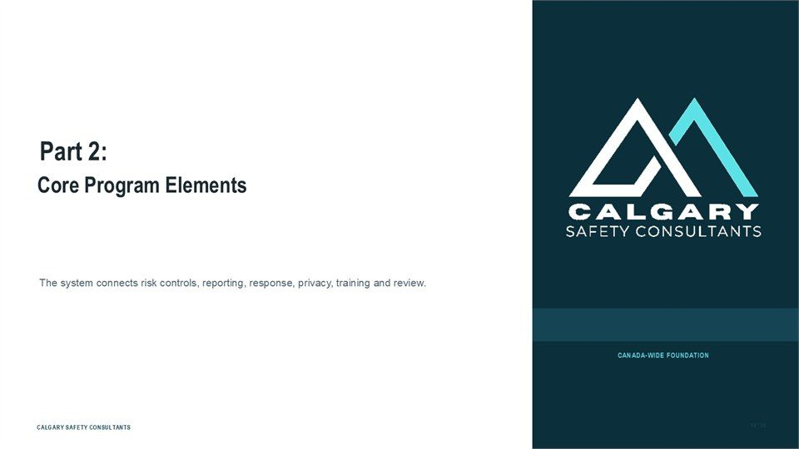  Notes __________________ | Part 2: Core Program Elements  Core Program Elements. The system connects risk controls, reporting, response, privacy, training and review.  Confirm the applicable jurisdiction, policy, reporting routes, roles, recordkeeping, and review requirements.  KEY POINTS  • Core Program Elements.  • The system connects risk controls, reporting, response, privacy, training and review.

LESSON 03 • SLIDE 11 OF 28  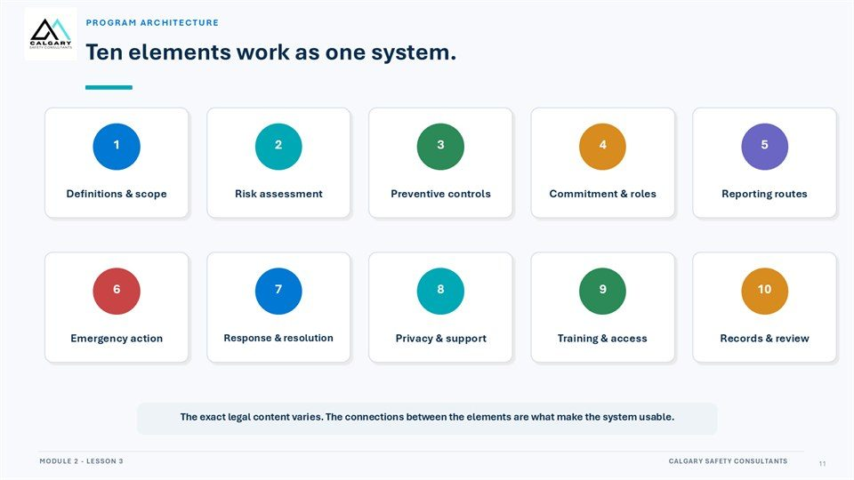  Notes __________________ | Ten elements work as one system.  Definitions & scope. Risk assessment. Preventive controls. Commitment & roles. Reporting routes. Emergency action. Response & resolution. Privacy & support. Training & access. Records & review. The exact legal content varies. The connections between the elements are what make the system usable.  Confirm the applicable jurisdiction, policy, reporting routes, roles, recordkeeping, and review requirements.  KEY POINTS  • Definitions & scope.  • Risk assessment.  • Preventive controls.

LESSON 03 • SLIDE 12 OF 28  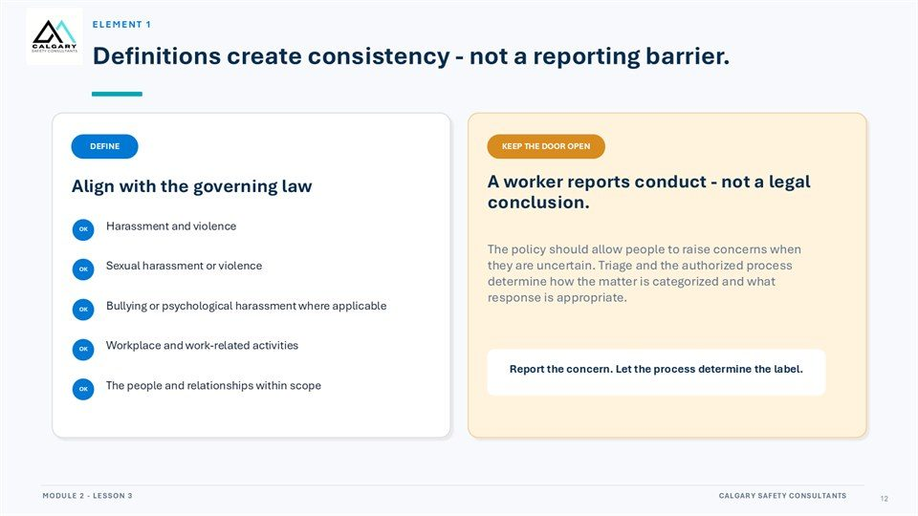  Notes __________________ | Definitions create consistency - not a reporting barrier.  Align with the governing law. A worker reports conduct - not a legal conclusion. Harassment and violence. The policy should allow people to raise concerns when they are uncertain. Triage and the authorized process determine how the matter is categorized and what response is appropriate. Sexual harassment or violence.  Bullying or psychological harassment where applicable. Workplace and work-related activities. Report the concern. Let the process determine the label. The people and relationships within scope.  KEY POINTS  • Align with the governing law.  • A worker reports conduct - not a legal conclusion.  • Harassment and violence.

GENERAL NOTES

LESSON 03 • SLIDE 13 OF 28  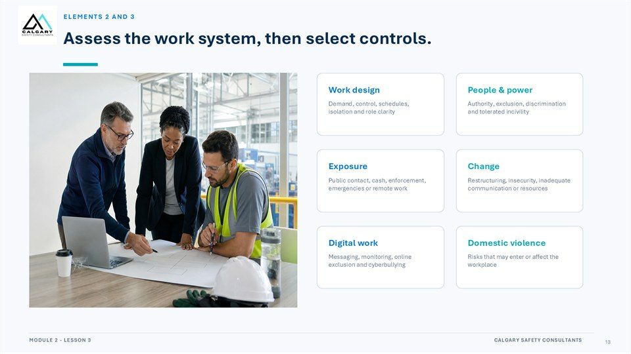  Notes __________________ | Assess the work system, then select controls.  Work design. People & power. Demand, control, schedules, isolation and role clarity. Authority, exclusion, discrimination and tolerated incivility. Exposure. Public contact, cash, enforcement, emergencies or remote work. Restructuring, insecurity, inadequate communication or resources. Digital work. Domestic violence.  Messaging, monitoring, online exclusion and cyberbullying. Risks that may enter or affect the workplace.  KEY POINTS  • Work design.  • People & power.  • Demand, control, schedules, isolation and role clarity.

LESSON 03 • SLIDE 14 OF 28  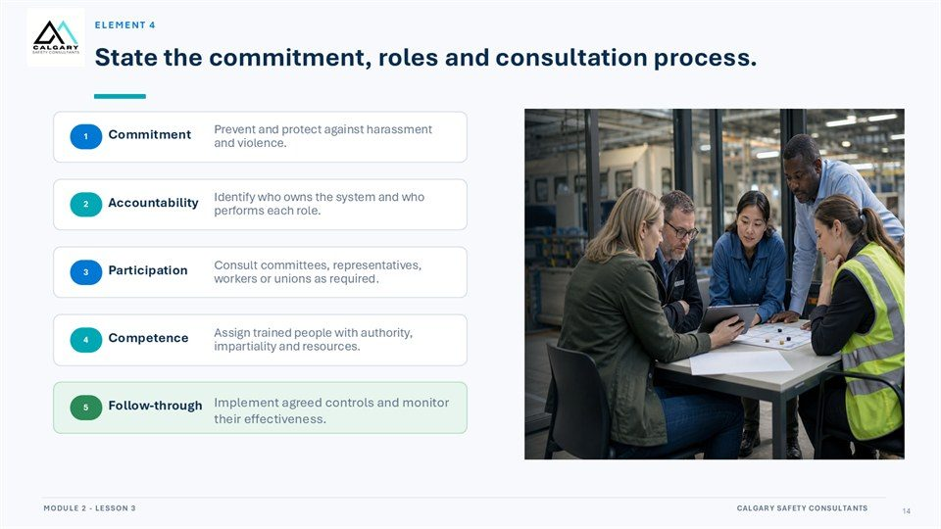  Notes __________________ | State the commitment, roles and consultation process.  Prevent and protect against harassment and violence. Commitment. Identify who owns the system and who performs each role. Accountability. Consult committees, representatives, workers or unions as required. Participation. Assign trained people with authority, impartiality and resources. Competence.  Implement agreed controls and monitor their effectiveness. Follow-through.  KEY POINTS  • Prevent and protect against harassment and violence.  • Commitment.  • Identify who owns the system and who performs each role.

LESSON 03 • SLIDE 15 OF 28  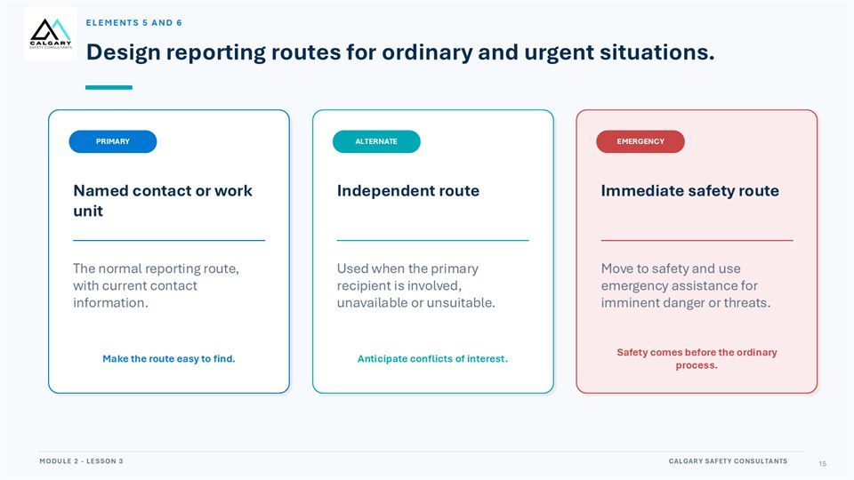  Notes __________________ | Design reporting routes for ordinary and urgent situations.  The primary route is the named contact or work unit used for ordinary reports. An alternate independent route is needed when the primary recipient is involved, unavailable, or unsuitable. The emergency route addresses imminent danger or threats.  Make every route easy to find, anticipate conflicts of interest, and direct people to move to safety and use emergency assistance when immediate danger exists. Safety comes before the ordinary process.  KEY POINTS  • Primary: the normal named contact or work unit.  • Alternate: an independent route for conflicts or access barriers.  • Emergency: immediate safety assistance for imminent danger.

GENERAL NOTES

LESSON 03 • SLIDE 16 OF 28  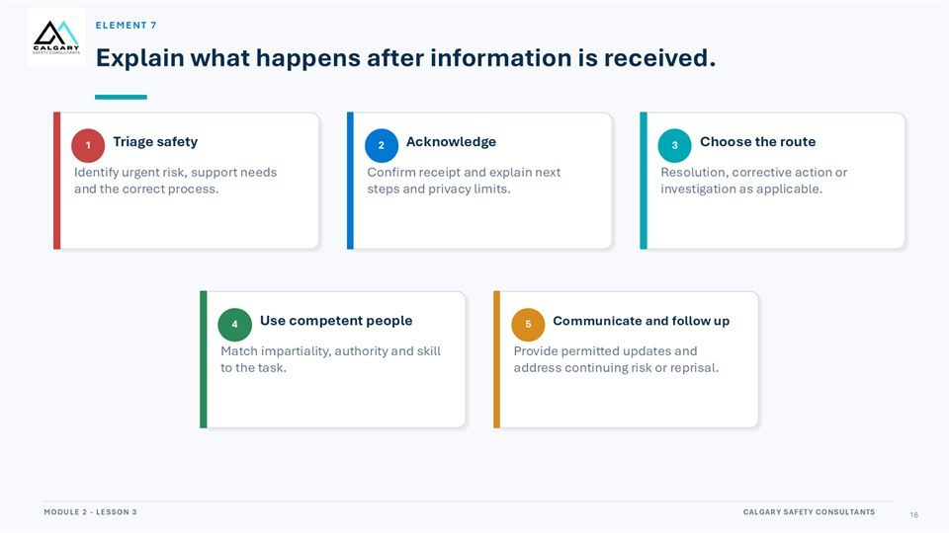  Notes __________________ | Explain what happens after information is received.  Triage safety. Acknowledge. Choose the route. Identify urgent risk, support needs and the correct process. Confirm receipt and explain next steps and privacy limits. Resolution, corrective action or investigation as applicable. Use competent people. Communicate and follow up.  Match impartiality, authority and skill to the task. Provide permitted updates and address continuing risk or reprisal.  KEY POINTS  • Triage safety.  • Acknowledge.  • Choose the route.

LESSON 03 • SLIDE 17 OF 28  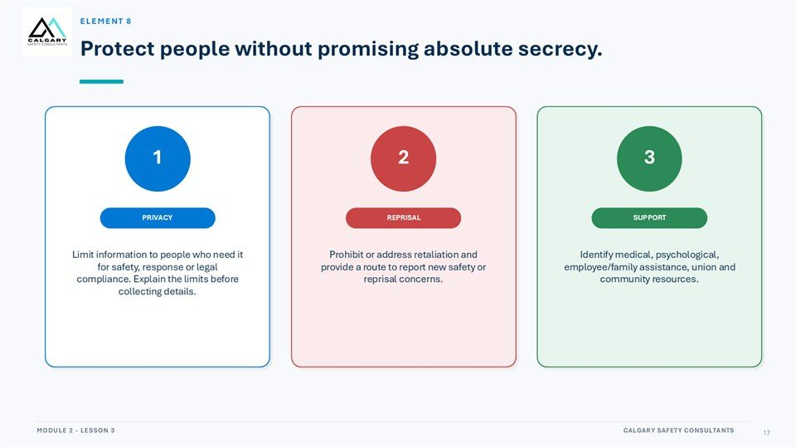  Notes __________________ | Protect people without promising absolute secrecy.  Limit information to people who need it for safety, response or legal compliance. Explain the limits before collecting details. Prohibit or address retaliation and provide a route to report new safety or reprisal concerns. Identify medical, psychological, employee/family assistance, union and community resources.  Confirm the applicable jurisdiction, policy, reporting routes, roles, recordkeeping, and review requirements.  KEY POINTS  • Limit information to people who need it for safety, response or legal compliance. Explain the limits...  • Prohibit or address retaliation and provide a route to report new safety or reprisal concerns.  • Identify medical, psychological, employee/family assistance, union and community resources.

LESSON 03 • SLIDE 18 OF 28  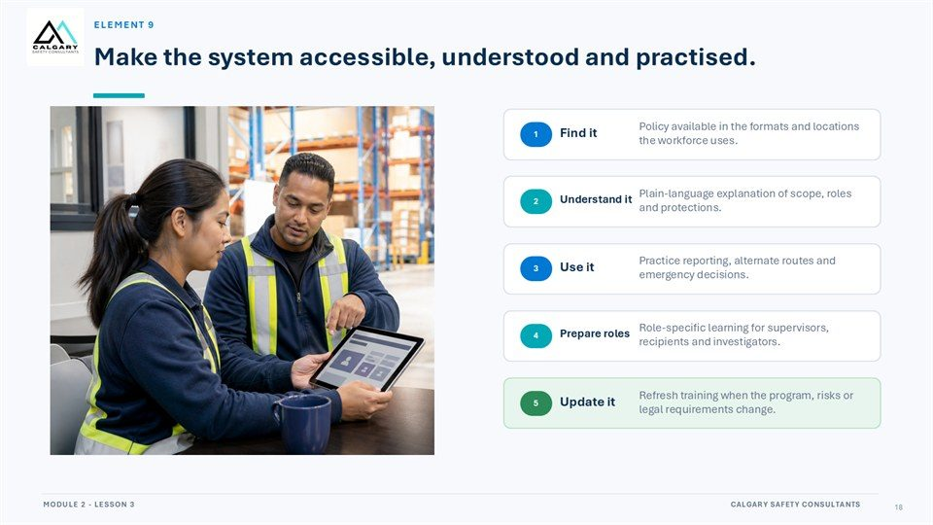  Notes __________________ | Make the system accessible, understood and practised.  Policy available in the formats and locations the workforce uses. Plain-language explanation of scope, roles and protections. Understand it. Practice reporting, alternate routes and emergency decisions. Role-specific learning for supervisors, recipients and investigators. Prepare roles.  Refresh training when the program, risks or legal requirements change. Update it.  KEY POINTS  • Policy available in the formats and locations the workforce uses.  • Plain-language explanation of scope, roles and protections.  • Understand it.

GENERAL NOTES

LESSON 03 • SLIDE 19 OF 28  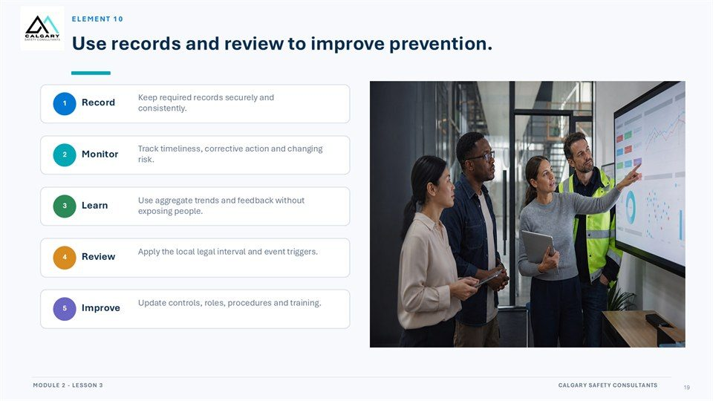  Notes __________________ | Use records and review to improve prevention.  Keep required records securely and consistently. Track timeliness, corrective action and changing risk. Use aggregate trends and feedback without exposing people. Apply the local legal interval and event triggers. Update controls, roles, procedures and training.  Confirm the applicable jurisdiction, policy, reporting routes, roles, recordkeeping, and review requirements.  KEY POINTS  • Keep required records securely and consistently.  • Track timeliness, corrective action and changing risk.  • Use aggregate trends and feedback without exposing people.

LESSON 03 • SLIDE 20 OF 28  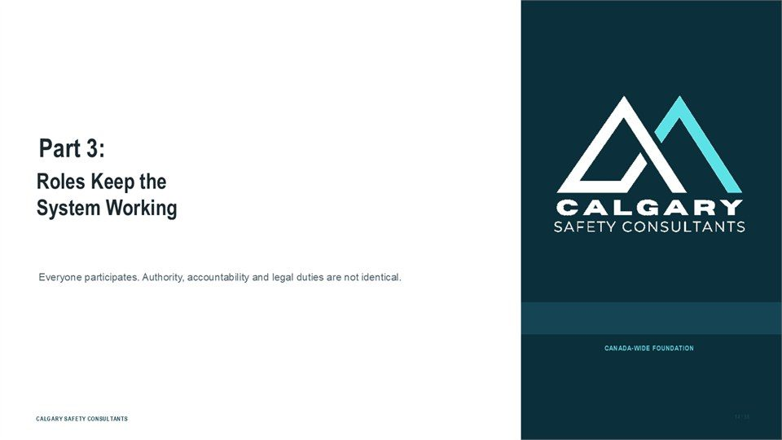  Notes __________________ | Part 3: Roles Keep the System Working  Roles Keep the System Working. Everyone participates. Authority, accountability and legal duties are not identical.  Confirm the applicable jurisdiction, policy, reporting routes, roles, recordkeeping, and review requirements.  KEY POINTS  • Roles Keep the System Working.  • Everyone participates. Authority, accountability and legal duties are not identical.

LESSON 03 • SLIDE 21 OF 28  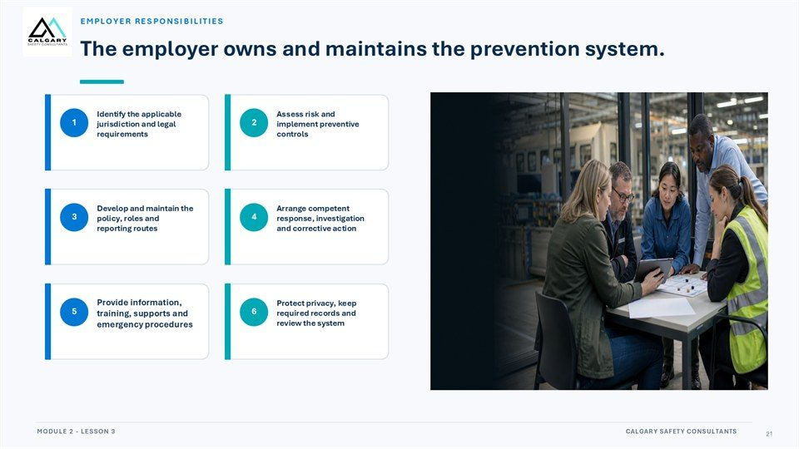  Notes __________________ | The employer owns and maintains the prevention system.  Identify the applicable jurisdiction and legal requirements. Assess risk and implement preventive controls. Develop and maintain the policy, roles and reporting routes. Arrange competent response, investigation and corrective action. Provide information, training, supports and emergency procedures.  Protect privacy, keep required records and review the system.  KEY POINTS  • Identify the applicable jurisdiction and legal requirements.  • Assess risk and implement preventive controls.  • Develop and maintain the policy, roles and reporting routes.

GENERAL NOTES

LESSON 03 • SLIDE 22 OF 28  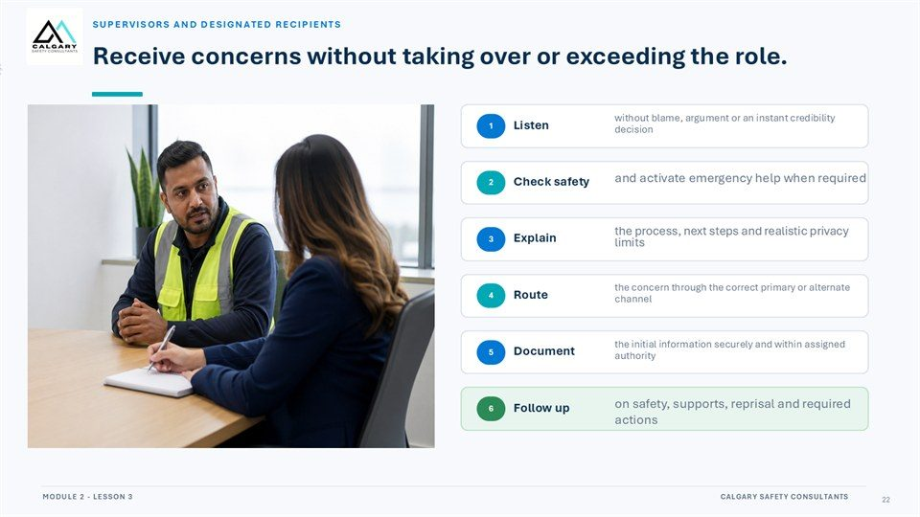  Notes __________________ | Receive concerns without taking over or exceeding the role.  SUPERVISORS AND DESIGNATED RECIPIENTS. without blame, argument or an instant credibility decision. and activate emergency help when required. Check safety. the process, next steps and realistic privacy limits. the concern through the correct primary or alternate channel.  the initial information securely and within assigned authority. Document. on safety, supports, reprisal and required actions. Follow up.  KEY POINTS  • SUPERVISORS AND DESIGNATED RECIPIENTS.  • without blame, argument or an instant credibility decision.  • and activate emergency help when required.

LESSON 03 • SLIDE 23 OF 28  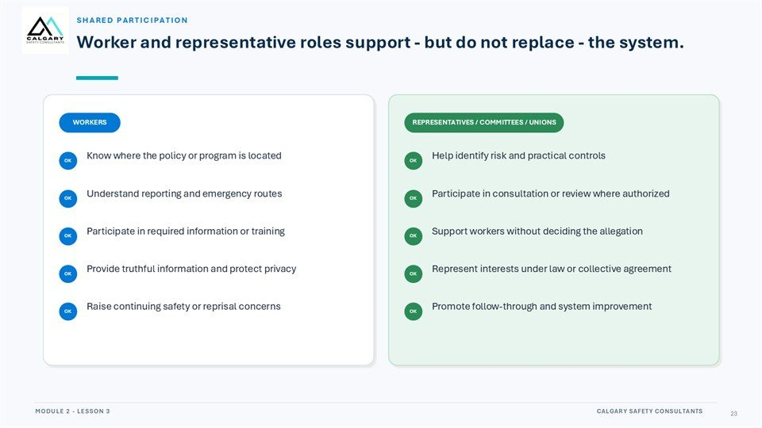  Notes __________________ | Worker and representative roles support - but do not replace - the system.  REPRESENTATIVES / COMMITTEES / UNIONS. Know where the policy or program is located. Help identify risk and practical controls. Understand reporting and emergency routes. Participate in consultation or review where authorized. Participate in required information or training.  Support workers without deciding the allegation. Provide truthful information and protect privacy. Represent interests under law or collective agreement. Raise continuing safety or reprisal concerns. Promote follow-through and system improvement.  KEY POINTS  • REPRESENTATIVES / COMMITTEES / UNIONS.  • Know where the policy or program is located.  • Help identify risk and practical controls.

LESSON 03 • SLIDE 24 OF 28  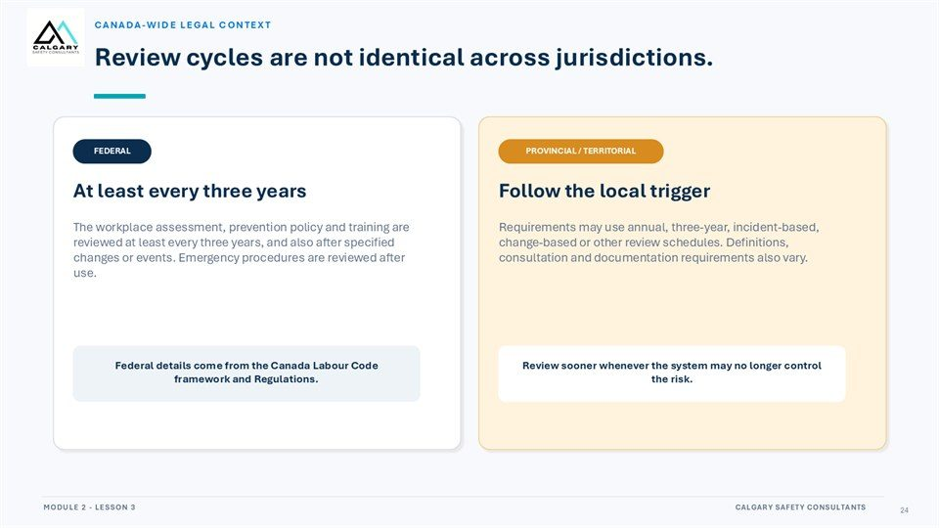  Notes __________________ | Review cycles are not identical across jurisdictions.  At least every three years. Follow the local trigger. The workplace assessment, prevention policy and training are reviewed at least every three years, and also after specified changes or events. Emergency procedures are reviewed after use.  Requirements may use annual, three-year, incident-based, change-based or other review schedules. Definitions, consultation and documentation requirements also vary. Federal details come from the Canada Labour Code framework and Regulations. Review sooner whenever the system may no longer control the risk.  KEY POINTS  • At least every three years.  • Follow the local trigger.  • The workplace assessment, prevention policy and training are reviewed at least every three years, and...

GENERAL NOTES

LESSON 03 • SLIDE 25 OF 28  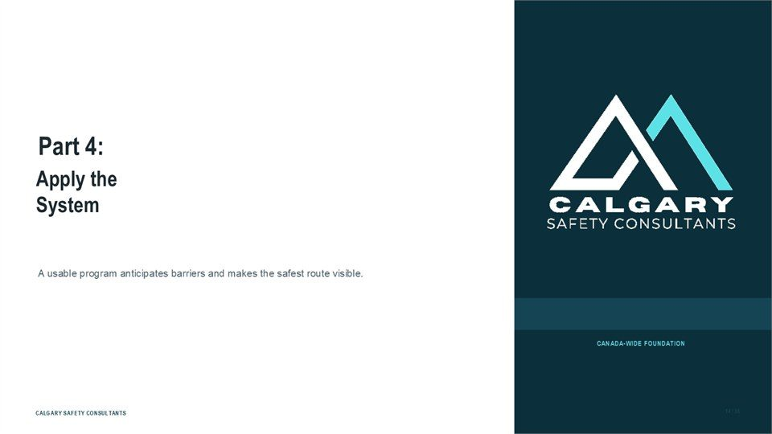  Notes __________________ | Part 4: Apply the System  Apply the System. A usable program anticipates barriers and makes the safest route visible.  Confirm the applicable jurisdiction, policy, reporting routes, roles, recordkeeping, and review requirements.  KEY POINTS  • Apply the System.  • A usable program anticipates barriers and makes the safest route visible.

LESSON 03 • SLIDE 26 OF 28  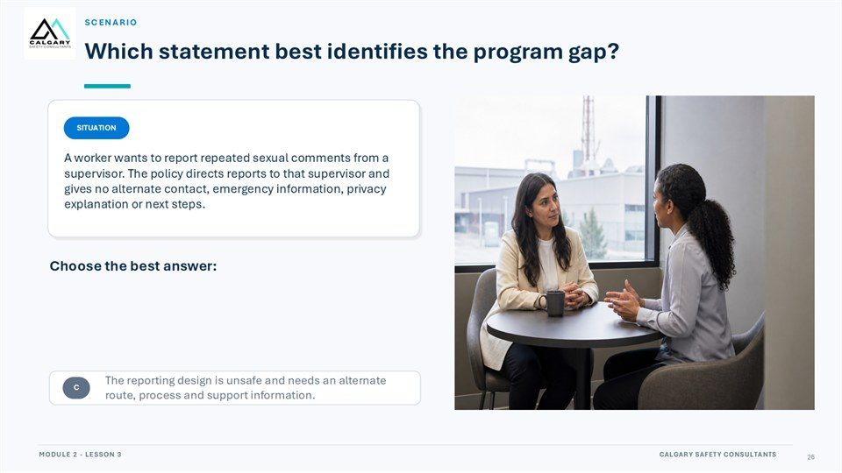  Notes __________________ | Scenario  Which statement best identifies the program gap? A worker wants to report repeated sexual comments from a supervisor. The policy directs reports to that supervisor and gives no alternate contact, emergency information, privacy explanation or next steps.  Choose the best answer: The worker must confront the supervisor before reporting. The program is adequate because the policy exists in writing. The reporting design is unsafe and needs an alternate route, process and support information.  KEY POINTS  • Which statement best identifies the program gap?  • A worker wants to report repeated sexual comments from a supervisor. The policy directs reports to that...  • Choose the best answer:

LESSON 03 • SLIDE 27 OF 28  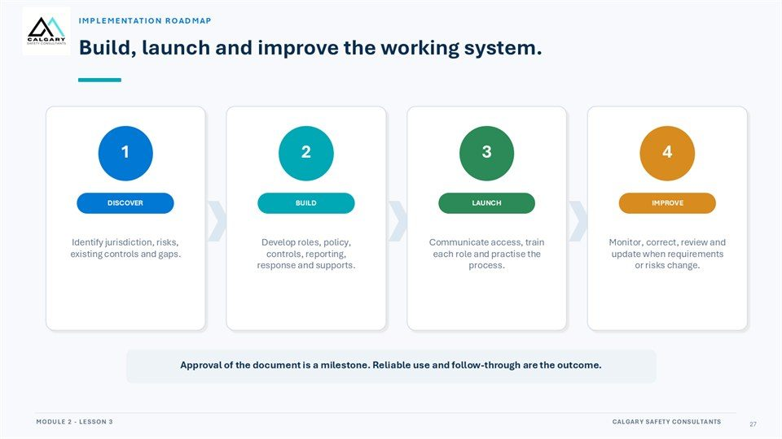  Notes __________________ | Build, launch and improve the working system.  Identify jurisdiction, risks, existing controls and gaps. Develop roles, policy, controls, reporting, response and supports. Communicate access, train each role and practise the process. Monitor, correct, review and update when requirements or risks change. Approval of the document is a milestone.  Reliable use and follow-through are the outcome.  KEY POINTS  • Identify jurisdiction, risks, existing controls and gaps.  • Develop roles, policy, controls, reporting, response and supports.  • Communicate access, train each role and practise the process.

GENERAL NOTES

LESSON 03 • SLIDE 28 OF 28    Notes __________________ | A plan is a working system.  A prevention plan is a working system, not simply a written document. Names and legal details vary across Canada. Core elements connect risk, reporting, response and review. Employers maintain the system; participation and roles are shared. Workers need a primary route, alternate route and emergency process.  Confirm the applicable jurisdiction, policy, reporting routes, roles, recordkeeping, and review requirements.  KEY POINTS  • A prevention plan is a working system, not simply a written document.  • Names and legal details vary across Canada.  • Core elements connect risk, reporting, response and review.

GENERAL NOTES

LESSON 03 SUMMARY
Prevention Policies, Programs & Plans
The following points bring the lesson together. Use them to review the main prevention message and connect it to the procedures and expectations in your workplace.
01 | A prevention policy makes expectations and routes visible; the broader system supplies assessment, controls, training, response, records, review, and accountable follow-through.
02 | The program should define who and what it covers, where it applies, how risks are assessed, and how controls address work design, people, power, and exposure.
03 | Reporting design must include a normal route, an alternate route for conflicts of interest, and clear emergency directions. Workers also need to know what happens after information is received.
04 | Privacy should be protected on a need-to-know basis without promising absolute secrecy. Information, records, and access should be handled securely and consistently.
05 | Employers own and maintain the system while supervisors, designated recipients, workers, representatives, committees, and unions participate within distinct roles. Exact legal duties and review cycles depend on jurisdiction.
Reflection and application
• Does our program provide a clear alternate route when the usual contact is involved?
• Which program element would be hardest for a new worker to find or understand?
• How does this workplace review whether preventive controls are working?
________________________________________________________________________________
________________________________________________________________________________
GENERAL NOTES

MODULE TWO / LESSON 04

Responding to Workplace Harassment
Reporting | Investigation | Participation | Follow-through

Lesson overview
A sound response protects immediate safety, makes risk visible, and supports a fair workplace process. Reporting does not predetermine an outcome; it gives the organization information it can acknowledge, triage, preserve, assess, and act on. Useful reports focus on observable facts and use the primary, alternate, or emergency route that fits the situation.
This lesson follows the investigation process from acknowledgement and assignment through preservation, interviews, analysis, communication, corrective action, and monitoring. It also clarifies privacy, procedural fairness, participant roles, safeguards, reprisal concerns, continuing risk, and the responsibilities of supervisors and designated recipients.
By the end of this lesson you should be able to
• Choose the primary, alternate, or emergency route that fits the situation.
• Report observable facts and preserve relevant information without investigating independently.
• Describe the main stages of a fair workplace investigation and response process.
• Recognize privacy, fairness, support, and participation safeguards for everyone involved.
• Identify reprisal or continuing risk and explain why corrective action must be assigned, monitored, and reviewed.
GENERAL NOTES

LESSON 04 • SLIDE 01 OF 33  Notes __________________ | Responding to Workplace Harassment  Harassment and Violence Prevention Training. Report safely. Support a fair process. Follow through.  Protect immediate safety, report observable facts, and support the fair workplace process through reliable follow-through.  KEY POINTS  • Harassment and Violence Prevention Training.  • Report safely. Support a fair process. Follow through.

LESSON 04 • SLIDE 02 OF 33  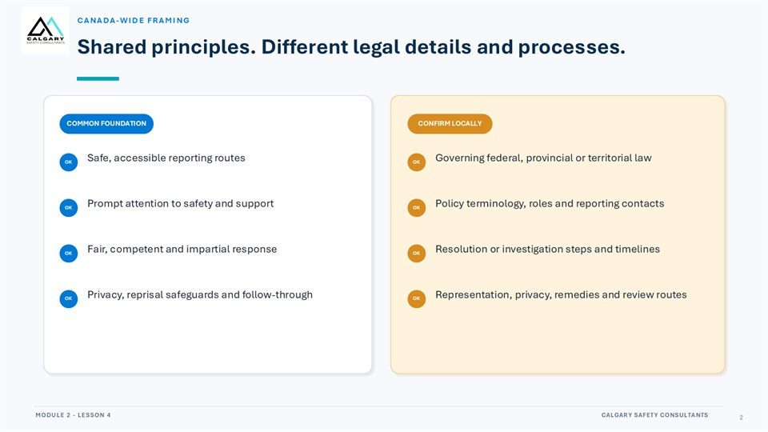  Notes __________________ | Shared principles. Different legal details and processes.  Safe, accessible reporting routes. Governing federal, provincial or territorial law. Prompt attention to safety and support. Policy terminology, roles and reporting contacts. Fair, competent and impartial response. Resolution or investigation steps and timelines. Privacy, reprisal safeguards and follow-through.  Representation, privacy, remedies and review routes.  KEY POINTS  • Safe, accessible reporting routes.  • Governing federal, provincial or territorial law.  • Prompt attention to safety and support.

LESSON 04 • SLIDE 03 OF 33  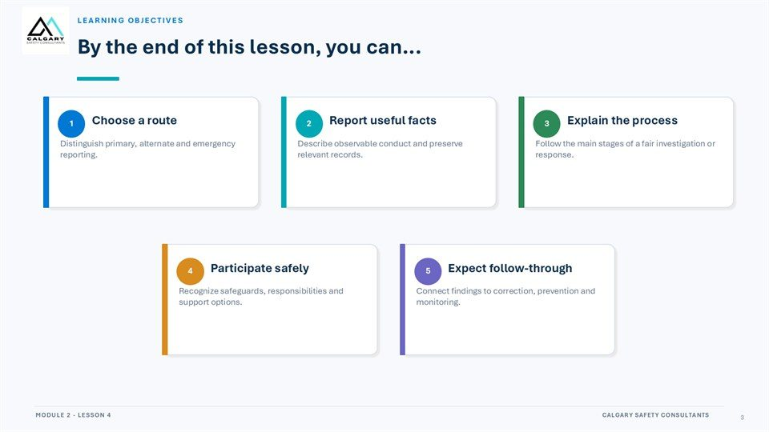  Notes __________________ | Learning Objectives  By the end of this lesson, you can... Choose a route. Report useful facts. Explain the process. Distinguish primary, alternate and emergency reporting. Describe observable conduct and preserve relevant records. Follow the main stages of a fair investigation or response. Participate safely. Expect follow-through.  Recognize safeguards, responsibilities and support options. Connect findings to correction, prevention and monitoring.  KEY POINTS  • By the end of this lesson, you can...  • Choose a route.  • Report useful facts.

GENERAL NOTES

LESSON 04 • SLIDE 04 OF 33  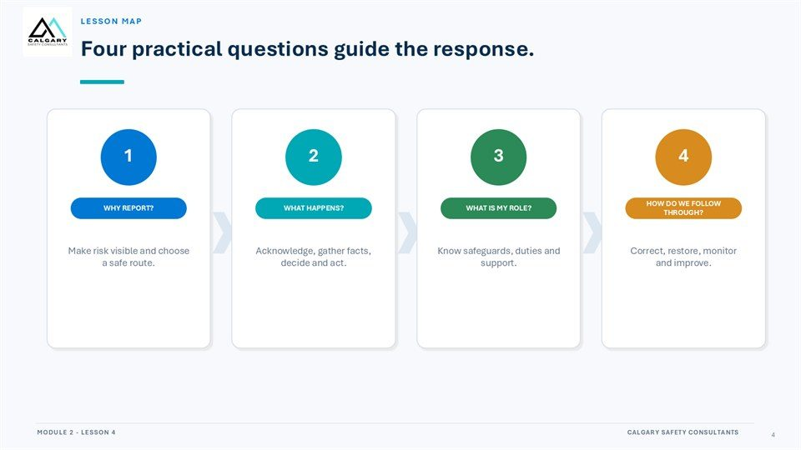  Notes __________________ | Lesson Map  Four practical questions guide the response. WHY REPORT? WHAT HAPPENS? WHAT IS MY ROLE? HOW DO WE FOLLOW THROUGH? Make risk visible and choose a safe route. Acknowledge, gather facts, decide and act. Know safeguards, duties and support. Correct, restore, monitor and improve.  Protect immediate safety, report observable facts, and support the fair workplace process through reliable follow-through.  KEY POINTS  • Four practical questions guide the response.  • WHY REPORT?  • WHAT HAPPENS?

LESSON 04 • SLIDE 05 OF 33  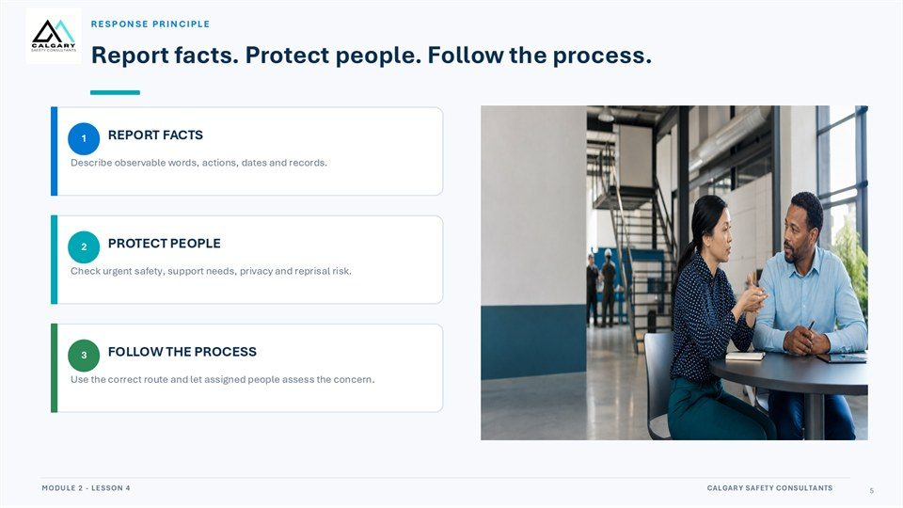  Notes __________________ | Report facts. Protect people. Follow the process.  Describe observable words, actions, dates and records. Check urgent safety, support needs, privacy and reprisal risk. Use the correct route and let assigned people assess the concern.  Protect immediate safety, report observable facts, and support the fair workplace process through reliable follow-through.  KEY POINTS  • Describe observable words, actions, dates and records.  • Check urgent safety, support needs, privacy and reprisal risk.  • Use the correct route and let assigned people assess the concern.

LESSON 04 • SLIDE 06 OF 33  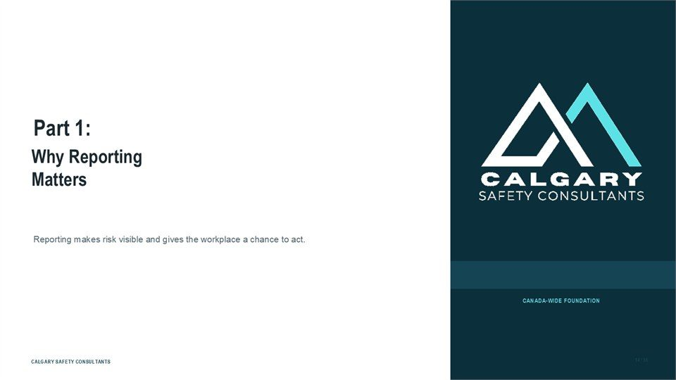  Notes __________________ | Part 1: Why Reporting Matters  Why Reporting Matters. Reporting makes risk visible and gives the workplace a chance to act.  Protect immediate safety, report observable facts, and support the fair workplace process through reliable follow-through.  KEY POINTS  • Why Reporting Matters.  • Reporting makes risk visible and gives the workplace a chance to act.

GENERAL NOTES

LESSON 04 • SLIDE 07 OF 33  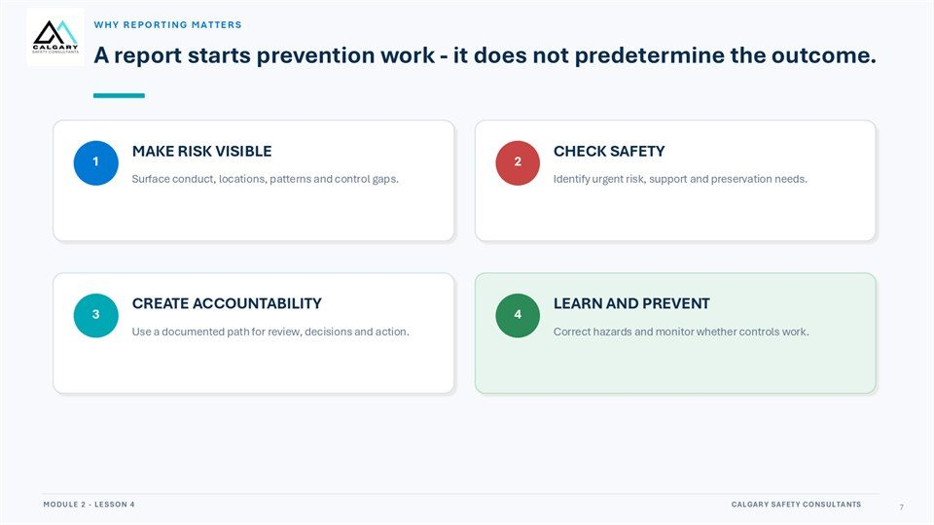  Notes __________________ | A report starts prevention work - it does not predetermine the outcome.  Surface conduct, locations, patterns and control gaps. Identify urgent risk, support and preservation needs. Use a documented path for review, decisions and action. Correct hazards and monitor whether controls work.  Protect immediate safety, report observable facts, and support the fair workplace process through reliable follow-through.  KEY POINTS  • Surface conduct, locations, patterns and control gaps.  • Identify urgent risk, support and preservation needs.  • Use a documented path for review, decisions and action.

LESSON 04 • SLIDE 08 OF 33  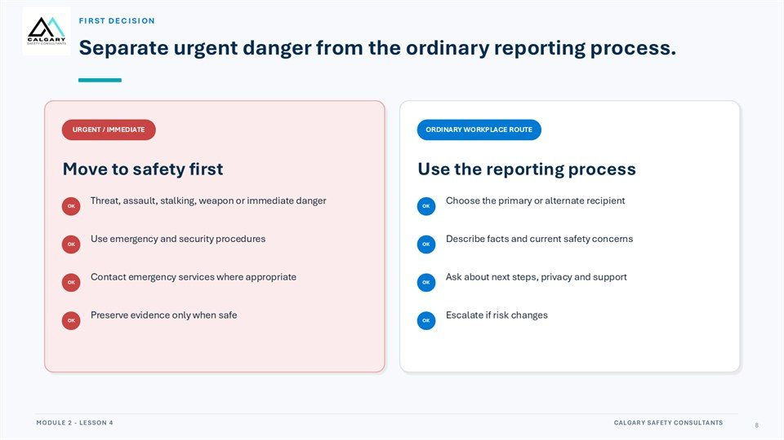  Notes __________________ | Separate urgent danger from the ordinary reporting process.  For urgent or immediate danger, move to safety, use emergency and security procedures, contact emergency services where appropriate, and preserve evidence only when it is safe to do so.  For the ordinary workplace route, choose the primary or alternate recipient, describe observable facts and current safety concerns, ask about next steps, privacy, and support, and escalate if the risk changes.  KEY POINTS  • Urgent danger: move to safety and use emergency procedures.  • Ordinary concern: use the primary or alternate workplace route.  • Escalate promptly if the risk changes.

LESSON 04 • SLIDE 09 OF 33  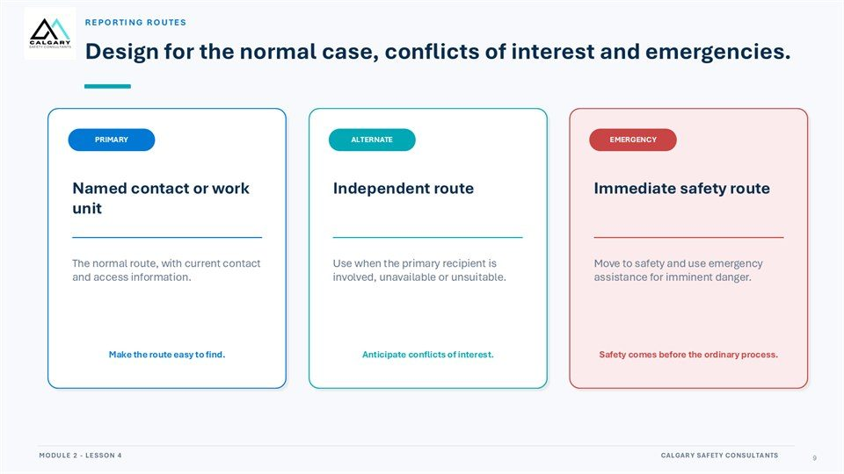  Notes __________________ | Design for the normal case, conflicts of interest and emergencies.  Use the primary named contact or work unit for an ordinary report. Use the alternate independent route when the primary recipient is involved, unavailable, or unsuitable. Use the emergency route for imminent danger.  Keep contact and access information current, make routes easy to find, anticipate conflicts of interest, and direct people to immediate safety assistance before the ordinary process when danger is urgent.  KEY POINTS  • Keep primary and alternate reporting routes current and visible.  • Anticipate conflicts of interest and access barriers.  • Immediate safety takes priority over the ordinary process.

GENERAL NOTES

LESSON 04 • SLIDE 10 OF 33  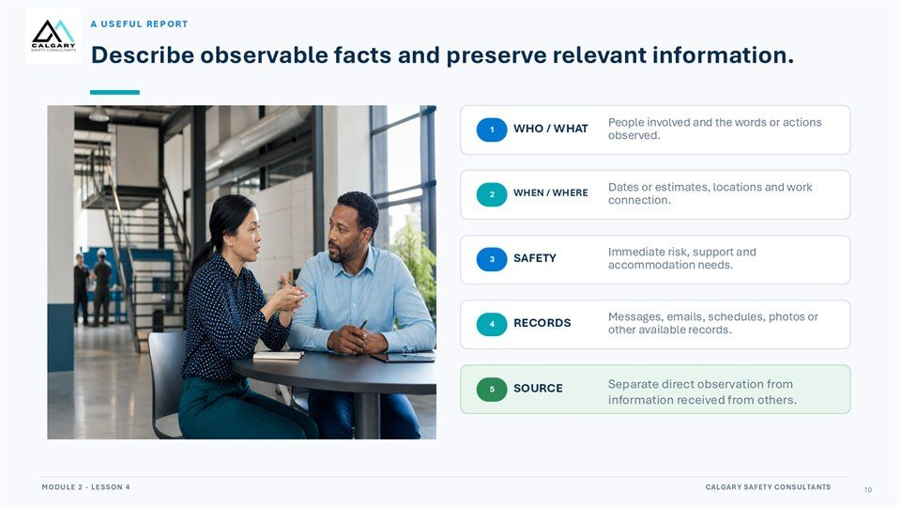  Notes __________________ | Describe observable facts and preserve relevant information.  People involved and the words or actions observed. Dates or estimates, locations and work connection. Immediate risk, support and accommodation needs. Messages, emails, schedules, photos or other available records. Separate direct observation from information received from others.  Protect immediate safety, report observable facts, and support the fair workplace process through reliable follow-through.  KEY POINTS  • People involved and the words or actions observed.  • Dates or estimates, locations and work connection.  • Immediate risk, support and accommodation needs.

LESSON 04 • SLIDE 11 OF 33  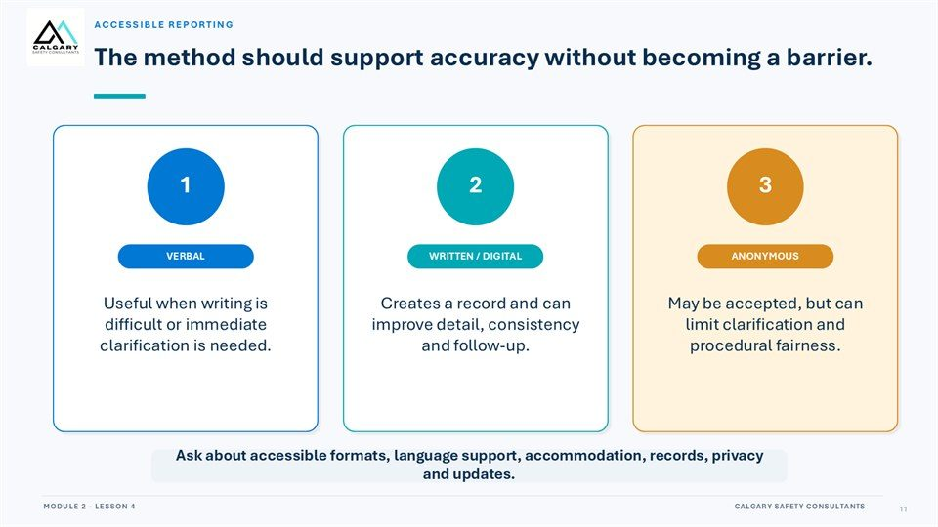  Notes __________________ | The method should support accuracy without becoming a barrier.  Useful when writing is difficult or immediate clarification is needed. Creates a record and can improve detail, consistency and follow-up. May be accepted, but can limit clarification and procedural fairness. Ask about accessible formats, language support, accommodation, records, privacy and updates.  Protect immediate safety, report observable facts, and support the fair workplace process through reliable follow-through.  KEY POINTS  • Useful when writing is difficult or immediate clarification is needed.  • Creates a record and can improve detail, consistency and follow-up.  • May be accepted, but can limit clarification and procedural fairness.

LESSON 04 • SLIDE 12 OF 33  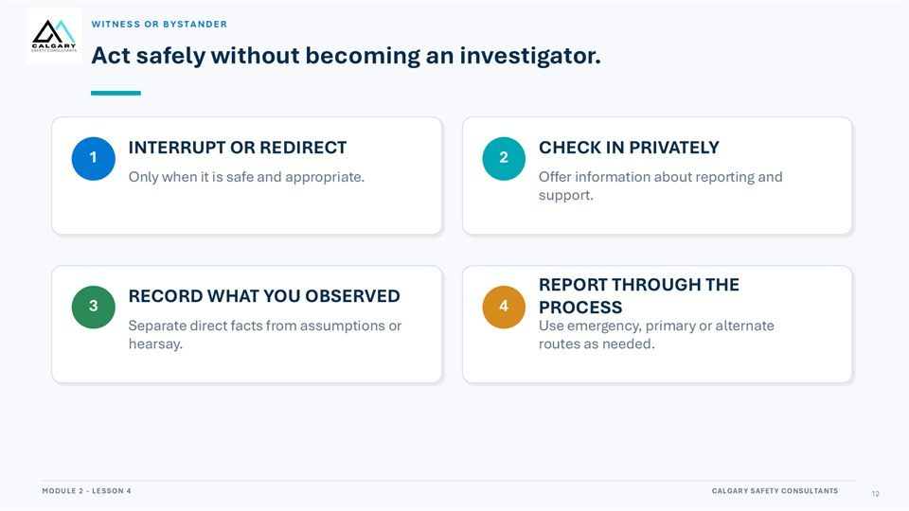  Notes __________________ | Act safely without becoming an investigator.  Only when it is safe and appropriate. Offer information about reporting and support. Separate direct facts from assumptions or hearsay. Use emergency, primary or alternate routes as needed.  Protect immediate safety, report observable facts, and support the fair workplace process through reliable follow-through.  KEY POINTS  • Only when it is safe and appropriate.  • Offer information about reporting and support.  • Separate direct facts from assumptions or hearsay.

GENERAL NOTES

LESSON 04 • SLIDE 13 OF 33  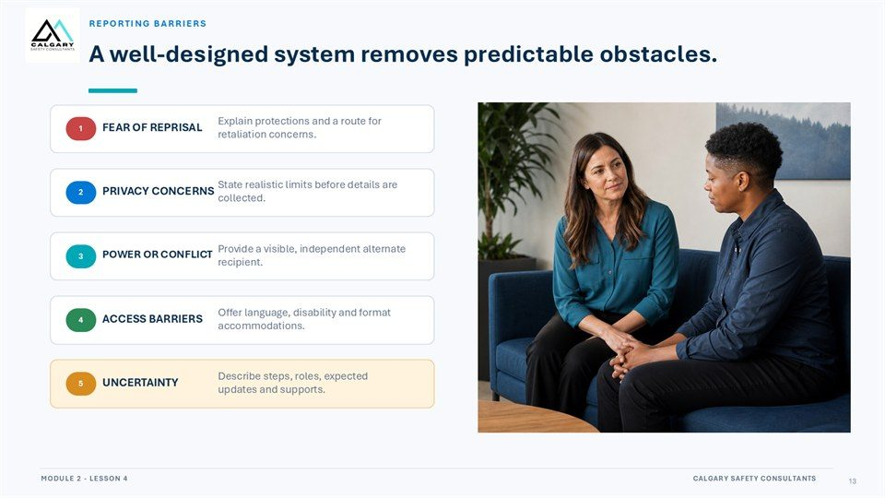  Notes __________________ | A well-designed system removes predictable obstacles.  Explain protections and a route for retaliation concerns. State realistic limits before details are collected. Provide a visible, independent alternate recipient. Offer language, disability and format accommodations. Describe steps, roles, expected updates and supports.  Protect immediate safety, report observable facts, and support the fair workplace process through reliable follow-through.  KEY POINTS  • Explain protections and a route for retaliation concerns.  • State realistic limits before details are collected.  • Provide a visible, independent alternate recipient.

LESSON 04 • SLIDE 14 OF 33  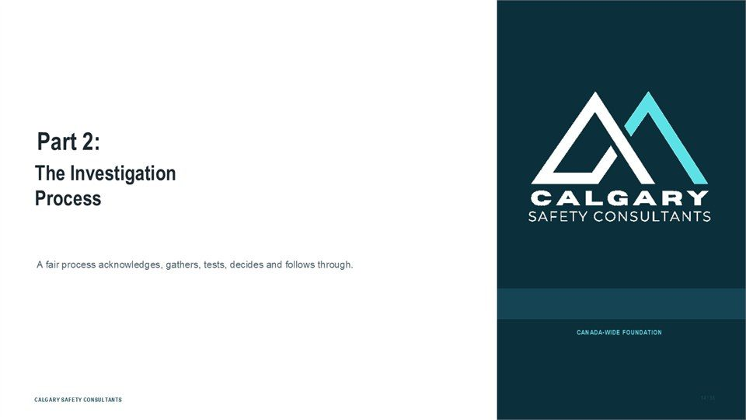  Notes __________________ | Part 2: The Investigation Process  The Investigation Process. A fair process acknowledges, gathers, tests, decides and follows through.  Protect immediate safety, report observable facts, and support the fair workplace process through reliable follow-through.  KEY POINTS  • The Investigation Process.  • A fair process acknowledges, gathers, tests, decides and follows through.

LESSON 04 • SLIDE 15 OF 33  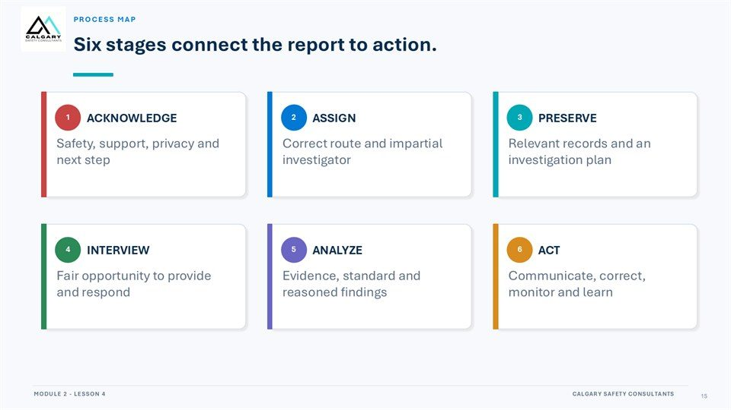  Notes __________________ | Six stages connect the report to action.  Safety, support, privacy and next step. Correct route and impartial investigator. Relevant records and an investigation plan. Fair opportunity to provide and respond. Evidence, standard and reasoned findings. Communicate, correct, monitor and learn.  Protect immediate safety, report observable facts, and support the fair workplace process through reliable follow-through.  KEY POINTS  • Safety, support, privacy and next step.  • Correct route and impartial investigator.  • Relevant records and an investigation plan.

GENERAL NOTES

LESSON 04 • SLIDE 16 OF 33  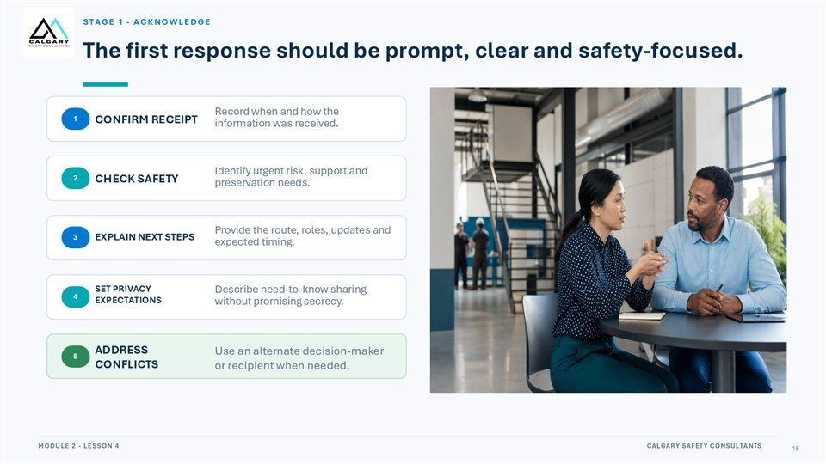  Notes __________________ | The first response should be prompt, clear and safety-focused.  Record when and how the information was received. Identify urgent risk, support and preservation needs. Provide the route, roles, updates and expected timing. Describe need-to-know sharing without promising secrecy. Use an alternate decision-maker or recipient when needed.  Protect immediate safety, report observable facts, and support the fair workplace process through reliable follow-through.  KEY POINTS  • Record when and how the information was received.  • Identify urgent risk, support and preservation needs.  • Provide the route, roles, updates and expected timing.

LESSON 04 • SLIDE 17 OF 33  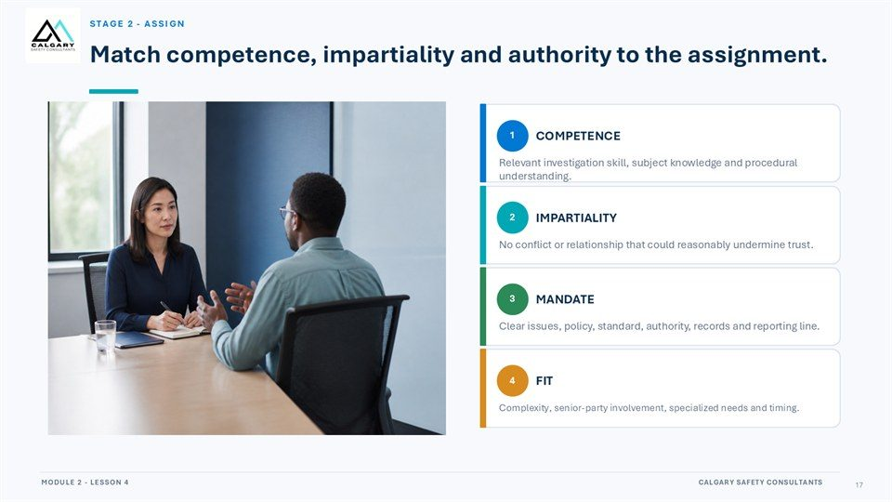  Notes __________________ | Match competence, impartiality and authority to the assignment.  Relevant investigation skill, subject knowledge and procedural understanding. No conflict or relationship that could reasonably undermine trust. Clear issues, policy, standard, authority, records and reporting line. Complexity, senior-party involvement, specialized needs and timing.  Protect immediate safety, report observable facts, and support the fair workplace process through reliable follow-through.  KEY POINTS  • Relevant investigation skill, subject knowledge and procedural understanding.  • No conflict or relationship that could reasonably undermine trust.  • Clear issues, policy, standard, authority, records and reporting line.

LESSON 04 • SLIDE 18 OF 33  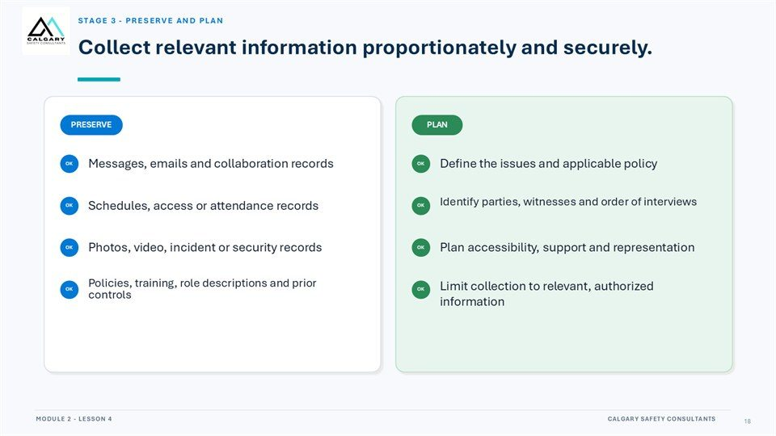  Notes __________________ | Collect relevant information proportionately and securely.  Messages, emails and collaboration records. Define the issues and applicable policy. Identify parties, witnesses and order of interviews. Schedules, access or attendance records. Photos, video, incident or security records. Plan accessibility, support and representation.  Policies, training, role descriptions and prior controls. Limit collection to relevant, authorized information.  KEY POINTS  • Messages, emails and collaboration records.  • Define the issues and applicable policy.  • Identify parties, witnesses and order of interviews.

GENERAL NOTES

LESSON 04 • SLIDE 19 OF 33  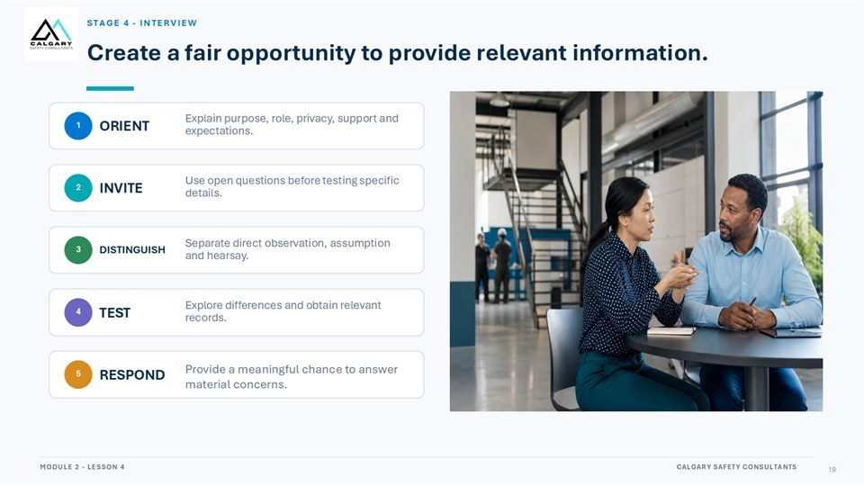  Notes __________________ | Create a fair opportunity to provide relevant information.  Explain purpose, role, privacy, support and expectations. Use open questions before testing specific details. Separate direct observation, assumption and hearsay. Explore differences and obtain relevant records. Provide a meaningful chance to answer material concerns.  Protect immediate safety, report observable facts, and support the fair workplace process through reliable follow-through.  KEY POINTS  • Explain purpose, role, privacy, support and expectations.  • Use open questions before testing specific details.  • Separate direct observation, assumption and hearsay.

LESSON 04 • SLIDE 20 OF 33  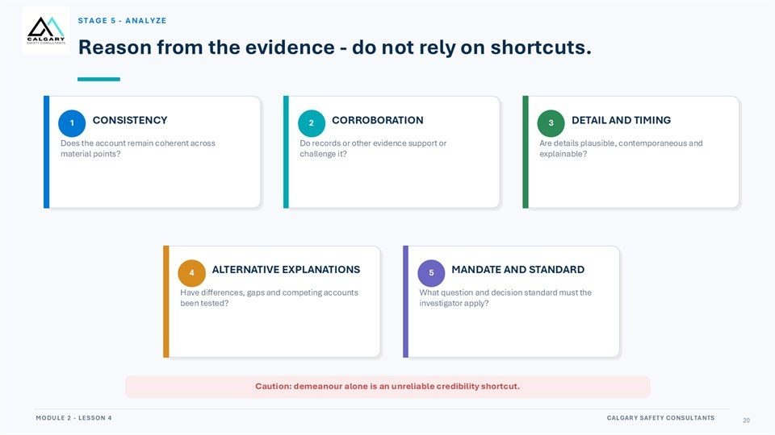  Notes __________________ | Reason from the evidence - do not rely on shortcuts.  Does the account remain coherent across material points? Do records or other evidence support or challenge it? Are details plausible, contemporaneous and explainable? Have differences, gaps and competing accounts been tested? What question and decision standard must the investigator apply? Caution: demeanour alone is  an unreliable credibility shortcut.  KEY POINTS  • Does the account remain coherent across material points?  • Do records or other evidence support or challenge it?  • Are details plausible, contemporaneous and explainable?

LESSON 04 • SLIDE 21 OF 33  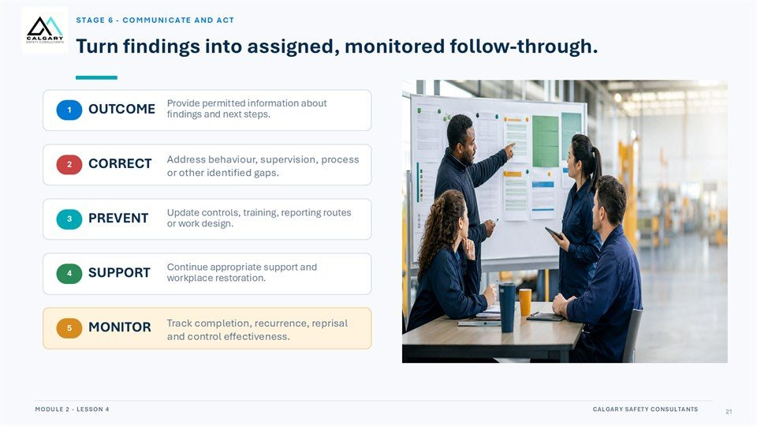  Notes __________________ | Turn findings into assigned, monitored follow-through.  Provide permitted information about findings and next steps. Address behaviour, supervision, process or other identified gaps. Update controls, training, reporting routes or work design. Continue appropriate support and workplace restoration. Track completion, recurrence, reprisal and control effectiveness.  Protect immediate safety, report observable facts, and support the fair workplace process through reliable follow-through.  KEY POINTS  • Provide permitted information about findings and next steps.  • Address behaviour, supervision, process or other identified gaps.  • Update controls, training, reporting routes or work design.

GENERAL NOTES

LESSON 04 • SLIDE 22 OF 33  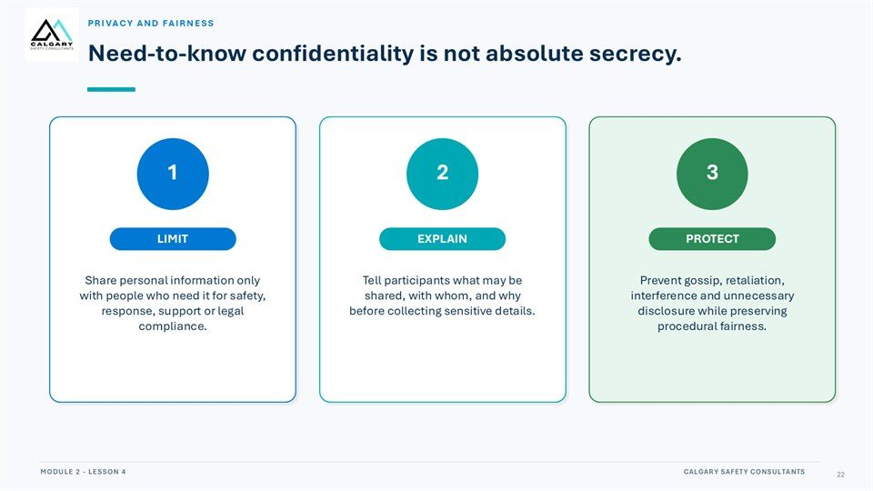  Notes __________________ | Need-to-know confidentiality is not absolute secrecy.  Share personal information only with people who need it for safety, response, support or legal compliance. Tell participants what may be shared, with whom, and why before collecting sensitive details. Prevent gossip, retaliation, interference and unnecessary disclosure while preserving procedural fairness.  Protect immediate safety, report observable facts, and support the fair workplace process through reliable follow-through.  KEY POINTS  • Share personal information only with people who need it for safety, response, support or legal...  • Tell participants what may be shared, with whom, and why before collecting sensitive details.  • Prevent gossip, retaliation, interference and unnecessary disclosure while preserving procedural...

LESSON 04 • SLIDE 23 OF 33  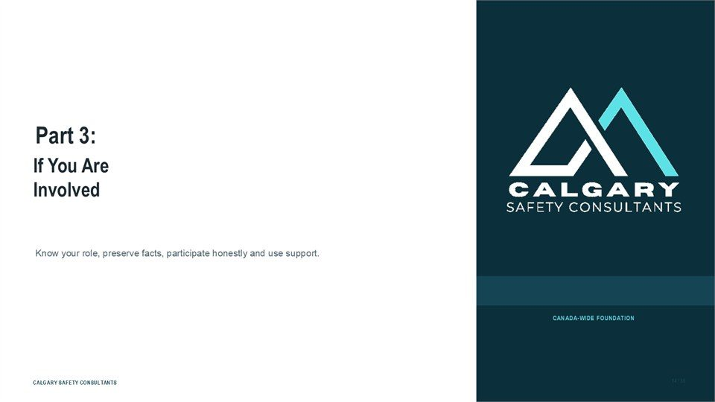  Notes __________________ | Part 3: If You Are Involved  If You Are Involved. Know your role, preserve facts, participate honestly and use support.  Protect immediate safety, report observable facts, and support the fair workplace process through reliable follow-through.  KEY POINTS  • If You Are Involved.  • Know your role, preserve facts, participate honestly and use support.

LESSON 04 • SLIDE 24 OF 33  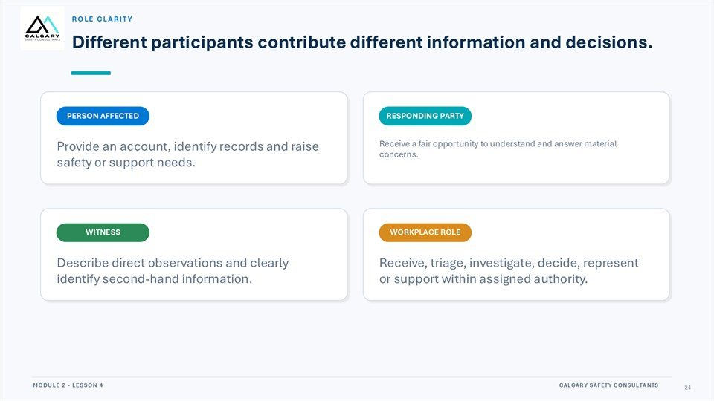  Notes __________________ | Different participants contribute different information and decisions.  Provide an account, identify records and raise safety or support needs. Receive a fair opportunity to understand and answer material concerns. Describe direct observations and clearly identify second-hand information. Receive, triage, investigate, decide, represent or support within assigned authority.  Protect immediate safety, report observable facts, and support the fair workplace process through reliable follow-through.  KEY POINTS  • Provide an account, identify records and raise safety or support needs.  • Receive a fair opportunity to understand and answer material concerns.  • Describe direct observations and clearly identify second-hand information.

GENERAL NOTES

LESSON 04 • SLIDE 25 OF 33  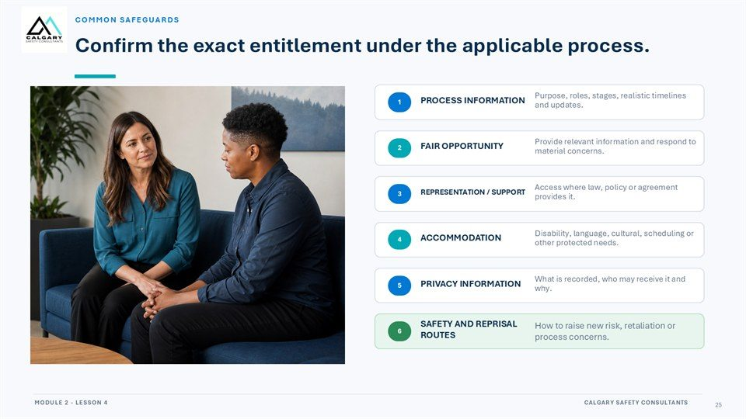  Notes __________________ | Confirm the exact entitlement under the applicable process.  Purpose, roles, stages, realistic timelines and updates. Provide relevant information and respond to material concerns. Access where law, policy or agreement provides it. Disability, language, cultural, scheduling or other protected needs. What is recorded, who may receive it and why.  How to raise new risk, retaliation or process concerns.  KEY POINTS  • Purpose, roles, stages, realistic timelines and updates.  • Provide relevant information and respond to material concerns.  • Access where law, policy or agreement provides it.

LESSON 04 • SLIDE 26 OF 33  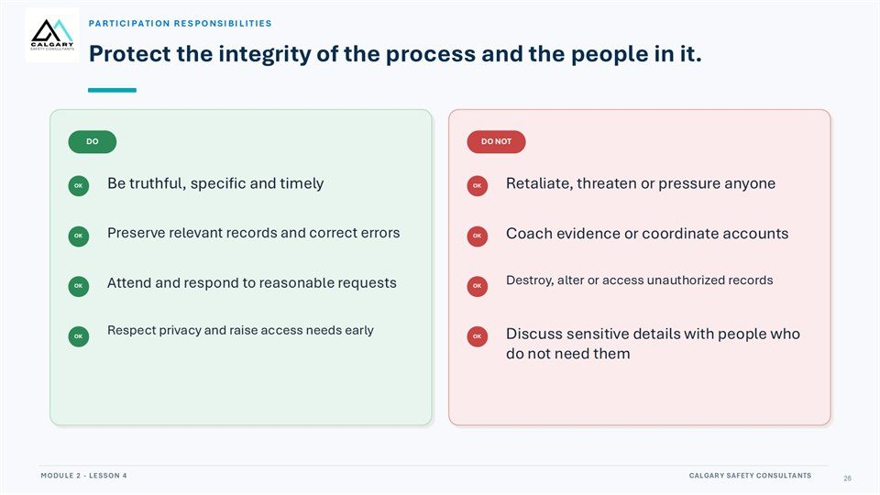  Notes __________________ | Protect the integrity of the process and the people in it.  Participants should be truthful, specific, and timely; preserve relevant records and correct errors; attend and respond to reasonable requests; respect privacy; and raise access or support needs early.  Do not retaliate, threaten, pressure anyone, coach evidence, coordinate accounts, destroy or alter records, access unauthorized records, or discuss sensitive details with people who do not need them.  KEY POINTS  • Be truthful, specific, timely, and preserve relevant records.  • Respect privacy and respond to reasonable process requests.  • Do not retaliate, coach accounts, alter records, or spread details.

LESSON 04 • SLIDE 27 OF 33  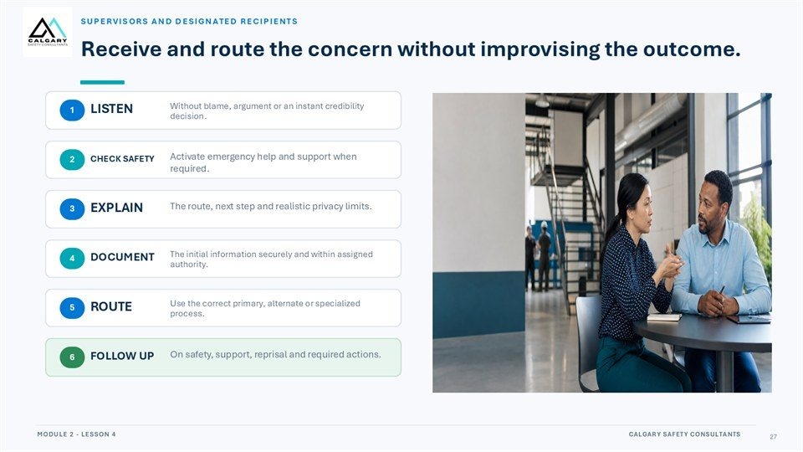  Notes __________________ | Receive and route the concern without improvising the outcome.  SUPERVISORS AND DESIGNATED RECIPIENTS. Without blame, argument or an instant credibility decision. Activate emergency help and support when required. The route, next step and realistic privacy limits. The initial information securely and within assigned authority.  Use the correct primary, alternate or specialized process. On safety, support, reprisal and required actions.  KEY POINTS  • SUPERVISORS AND DESIGNATED RECIPIENTS.  • Without blame, argument or an instant credibility decision.  • Activate emergency help and support when required.

GENERAL NOTES

LESSON 04 • SLIDE 28 OF 33  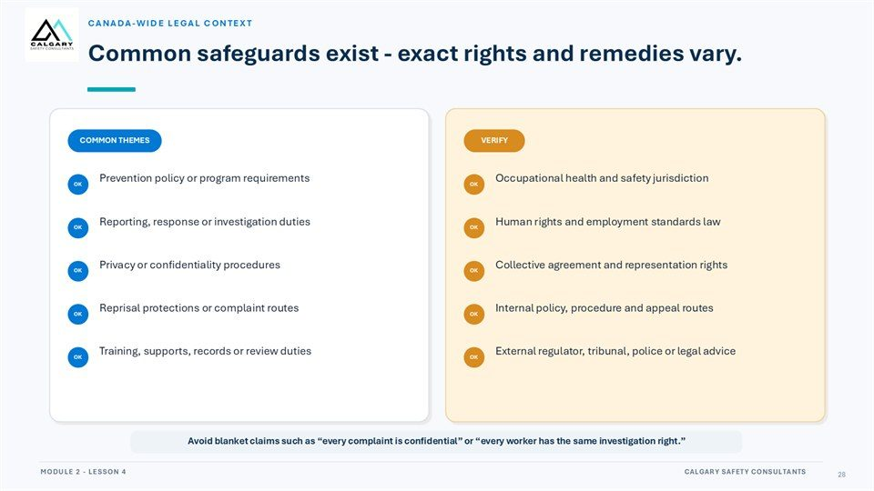  Notes __________________ | Common safeguards exist - exact rights and remedies vary.  Prevention policy or program requirements. Occupational health and safety jurisdiction. Reporting, response or investigation duties. Human rights and employment standards law. Privacy or confidentiality procedures. Collective agreement and representation rights. Reprisal protections or complaint routes.  Internal policy, procedure and appeal routes. Training, supports, records or review duties. External regulator, tribunal, police or legal advice. Avoid blanket claims such as “every complaint is confidential” or “every worker has the same investigation right.”.  KEY POINTS  • Prevention policy or program requirements.  • Occupational health and safety jurisdiction.  • Reporting, response or investigation duties.

LESSON 04 • SLIDE 29 OF 33  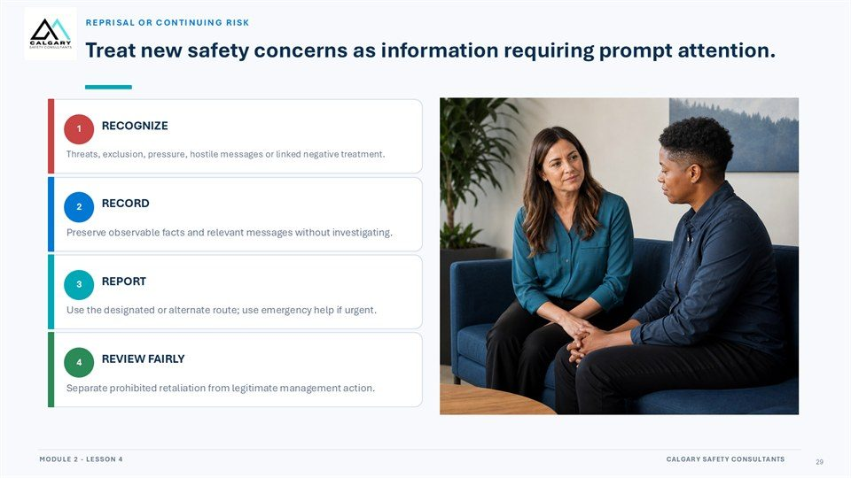  Notes __________________ | Treat new safety concerns as information requiring prompt attention.  Threats, exclusion, pressure, hostile messages or linked negative treatment. Preserve observable facts and relevant messages without investigating. Use the designated or alternate route; use emergency help if urgent. Separate prohibited retaliation from legitimate management action.  Protect immediate safety, report observable facts, and support the fair workplace process through reliable follow-through.  KEY POINTS  • Threats, exclusion, pressure, hostile messages or linked negative treatment.  • Preserve observable facts and relevant messages without investigating.  • Use the designated or alternate route; use emergency help if urgent.

LESSON 04 • SLIDE 30 OF 33  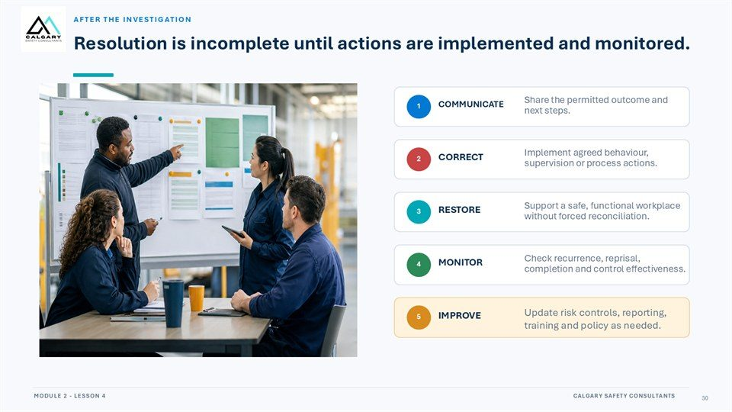  Notes __________________ | Resolution is incomplete until actions are implemented and monitored.  Share the permitted outcome and next steps. Implement agreed behaviour, supervision or process actions. Support a safe, functional workplace without forced reconciliation. Check recurrence, reprisal, completion and control effectiveness. Update risk controls, reporting, training and policy as needed.  Protect immediate safety, report observable facts, and support the fair workplace process through reliable follow-through.  KEY POINTS  • Share the permitted outcome and next steps.  • Implement agreed behaviour, supervision or process actions.  • Support a safe, functional workplace without forced reconciliation.

GENERAL NOTES

LESSON 04 • SLIDE 31 OF 33  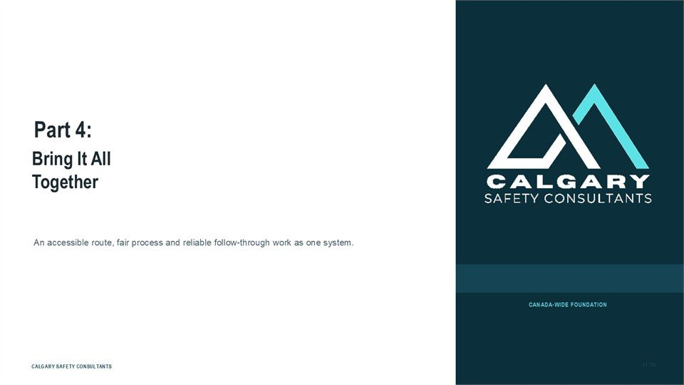  Notes __________________ | Part 4: Bring It All Together  Bring It All Together. An accessible route, fair process and reliable follow-through work as one system.  Protect immediate safety, report observable facts, and support the fair workplace process through reliable follow-through.  KEY POINTS  • Bring It All Together.  • An accessible route, fair process and reliable follow-through work as one system.

LESSON 04 • SLIDE 32 OF 33  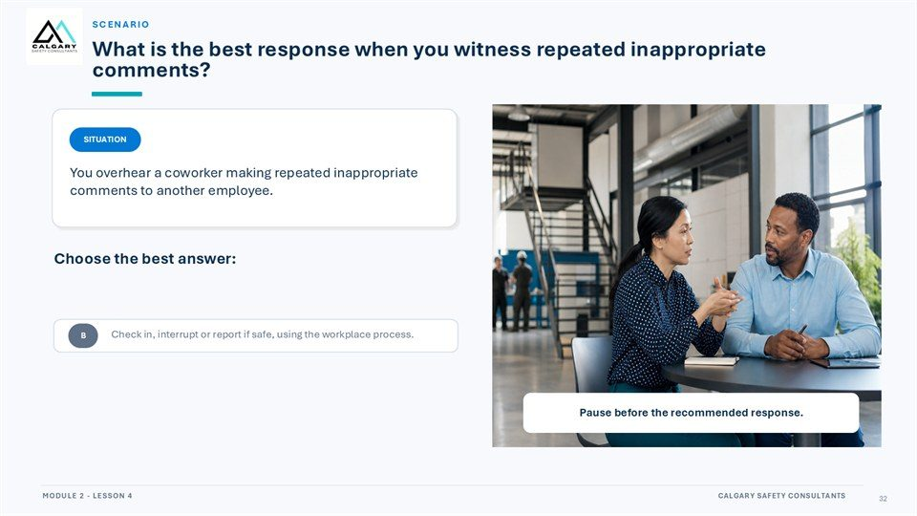  Notes __________________ | Scenario  What is the best response when you witness repeated inappropriate comments? You overhear a coworker making repeated inappropriate comments to another employee. Choose the best answer: Ignore it - it is not your business. Check in, interrupt or report if safe, using the workplace process.  Tell coworkers so everyone knows. Pause before the recommended response. Wait for another incident before acting.  KEY POINTS  • What is the best response when you witness repeated inappropriate comments?  • You overhear a coworker making repeated inappropriate comments to another employee.  • Choose the best answer:

LESSON 04 • SLIDE 33 OF 33  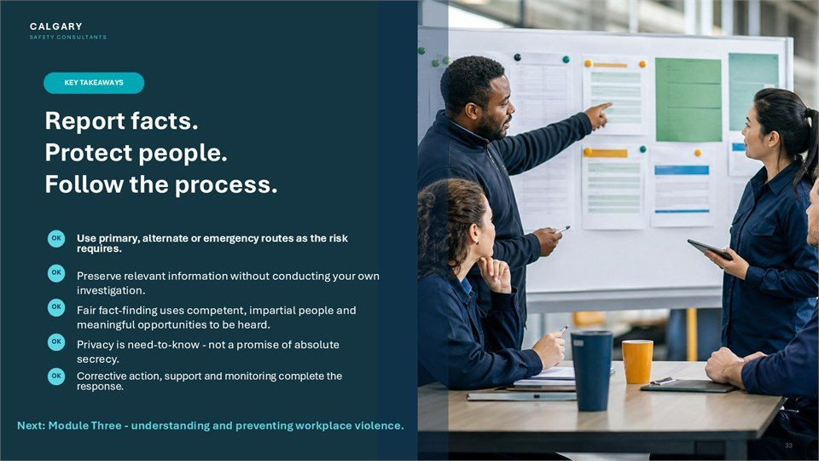  Notes __________________ | Report facts. Protect people. Follow the process.  Use primary, alternate or emergency routes as the risk requires. Preserve relevant information without conducting your own investigation. Fair fact-finding uses competent, impartial people and meaningful opportunities to be heard. Privacy is need-to-know - not a promise of absolute secrecy.  Corrective action, support and monitoring complete the response. Next: Module Three - understanding and preventing workplace violence.  KEY POINTS  • Use primary, alternate or emergency routes as the risk requires.  • Preserve relevant information without conducting your own investigation.  • Fair fact-finding uses competent, impartial people and meaningful opportunities to be heard.

GENERAL NOTES

LESSON 04 SUMMARY
Responding to Workplace Harassment
The following points bring the lesson together. Use them to review the main prevention message and connect it to the procedures and expectations in your workplace.
01 | Separate urgent danger from the ordinary reporting process. Follow emergency directions when safety is at immediate risk; otherwise use the workplace reporting route.
02 | A useful report records who, what, when, where, witnesses, immediate impact, and relevant preserved information. It avoids assumptions, labels, broad distribution, and independent investigation.
03 | A fair process acknowledges the report, assigns a competent and impartial person, preserves information, plans proportionately, interviews participants, analyzes evidence, communicates permitted information, and acts.
04 | Privacy is managed on a need-to-know basis. Each participant should understand purpose, role, stages, realistic timelines, available support, and expectations for preserving the integrity of the process.
05 | Resolution is incomplete until actions are assigned, implemented, monitored, and reviewed. Reprisal or continuing risk is new safety information that requires prompt attention.
Reflection and application
• What information would make a report useful without adding assumptions?
• What support and alternate route are available to a person involved in the process?
• How does this workplace monitor corrective actions and address continuing risk?
________________________________________________________________________________
MODULE REVIEW
Module Two complete
Workplace harassment prevention depends on clear definitions, a usable prevention system, safe reporting routes, fair response, and reliable corrective action and follow-through.
☐ I know the primary, alternate, and emergency reporting routes that apply in my workplace.
☐ I can describe observable conduct and preserve useful facts without investigating on my own.
☐ I can identify practical culture, leadership, policy, and bystander prevention controls.
☐ I understand the main stages and safeguards of a fair workplace response process.
☐ I understand why corrective action, monitoring, communication, and follow-through matter.
My most important takeaways
________________________________________________________________________________
________________________________________________________________________________
GENERAL NOTES

STUDENT REFERENCE GUIDE

Module Three
Respectful Workplace Harassment and Violence Prevention Training
How to use this guide
This portrait reference guide follows the original Module Three lesson and slide sequence. Each compact slide entry includes the PowerPoint visual, the lesson explanation, practical points to remember, and a line for notes. Every page also includes a general notes area.
Use the guide during training to record examples and questions. After training, return to the lesson overviews and summaries when you need to review responsibilities, reporting expectations, safe response options, or respectful communication practices.
Module roadmap
LESSON 01 | Understanding Workplace Violence  Definition | Types | Risk factors | Early recognition
LESSON 02 | Preventing and Controlling Workplace Violence  Risk assessment | Controls | Safe work procedures | Training
LESSON 03 | Violence Prevention Plans Policies and Procedures  Program design | Roles | Reporting | Emergency response | Review
LESSON 04 | Responding to Workplace Violence  Immediate safety | Reporting | Investigation | Support | Follow through
Important: This guide supports the training. Follow the legislation, workplace policies, procedures, reporting routes, and emergency directions that apply to your workplace.
GENERAL NOTES

MODULE THREE / LESSON 01

Understanding Workplace Violence
Definition | Types | Risk factors | Early recognition
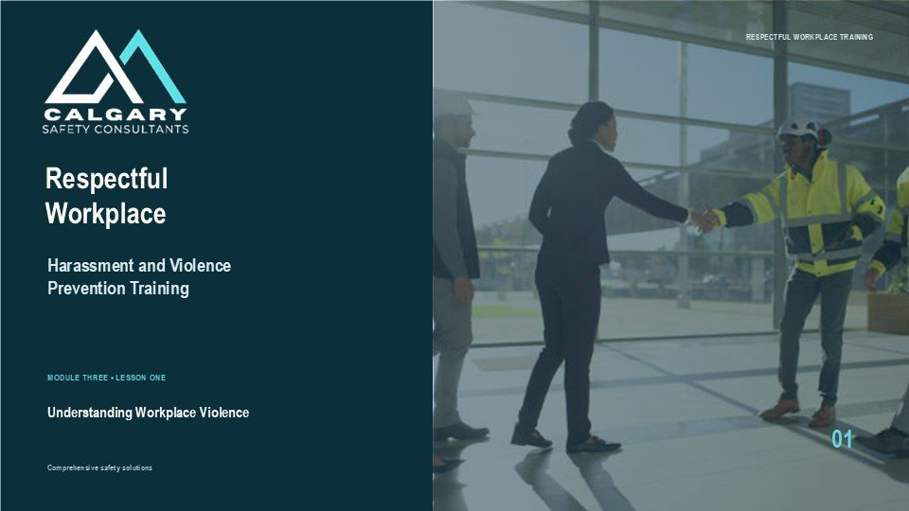
Lesson overview
Workplace violence includes acts, attempted acts, threats, or behaviour that may cause physical or psychological harm. The exact legal definition depends on the jurisdiction and workplace policy, so workers should use the rules and reporting procedures that apply where the work is performed.
This lesson explains common forms of workplace violence, warning signs, risk factors, and the importance of early reporting. It also distinguishes observation from assumption and reinforces that immediate danger requires emergency action before the ordinary reporting process.
By the end of this lesson you should be able to
• Describe workplace violence using the definition that applies to the workplace.
• Recognize physical violence, threats, intimidation, harassment, and other warning behaviours.
• Identify work activities, environments, and situations that may increase the risk of violence.
• Separate observable facts from assumptions when documenting or reporting a concern.
• Choose the workplace reporting route or emergency response that fits the level of risk.
GENERAL NOTES

LESSON 01 • SLIDE 01 OF 38  Notes __________________ | Understanding Workplace Violence  Welcome to Module Three, Lesson One of Respectful Workplace: Harassment and Violence Prevention Training. This lesson introduces workplace violence, its common forms and sources, and the observable warning signs or changes that may require attention.  Learners will review examples from different work settings and consider how awareness, reporting, and an appropriate response can reduce risk. This is a Canada-wide foundation. Legal definitions, prevention duties, reporting routes, emergency procedures, and requirements concerning domestic or family violence vary among...  KEY POINTS  • Respectful Workplace.  • Harassment and Violence Prevention Training.  • MODULE THREE • LESSON ONE.

LESSON 01 • SLIDE 02 OF 38    Notes __________________ | Workplace violence is a serious occupational health and safety issue.  Workplace violence is a serious occupational health and safety issue. Its effects can be physical, psychological, operational, and long-lasting. A violent incident may injure the person directly involved, affect witnesses and coworkers, disrupt work, and reduce confidence in the workplace.  Threats and intimidation can also cause harm even when no physical contact occurs. Prevention begins before an emergency. Workers need clear expectations, practical reporting routes, and confidence that concerns will be assessed. Throughout this lesson, focus on observable conduct and the safest next step....  KEY POINTS  • Workplace violence is a serious occupational health and safety issue.  • Describe observable behaviour, assess immediate safety, and use the reporting or emergency route that...

LESSON 01 • SLIDE 03 OF 38    Notes __________________ | Understanding the forms workplace violence can take is the first step toward prevention.  Understanding the forms workplace violence can take is the first step toward prevention. Violence may be physical, verbal, psychological, sexual, digital, or connected to a personal relationship. These categories can overlap.  A threat may be communicated in person, by telephone, through email or social media, or through behaviour such as stalking, property damage, or blocking someone from leaving. The goal is not to label a person or predict the future. It is to recognize conduct that may create harm, describe the facts clearly, and use the...  KEY POINTS  • Understanding the forms workplace violence can take is the first step toward prevention.  • Describe observable behaviour, assess immediate safety, and use the reporting or emergency route that...

GENERAL NOTES

LESSON 01 • SLIDE 04 OF 38  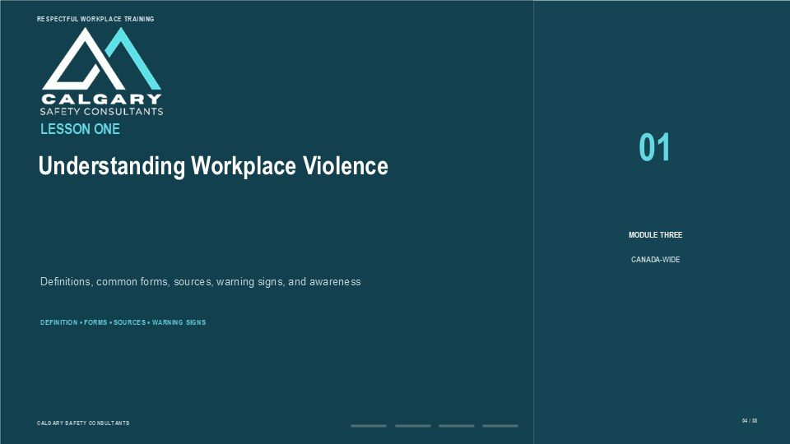  Notes __________________ | Understanding Workplace Violence  This lesson explains workplace violence as a prevention and response issue, not only as a physical assault. Depending on the applicable law and workplace policy, violence may include actions, conduct, threats, gestures, intimidation, stalking, sexual violence, or domestic or family violence that creates a workplace  risk. By the end of the lesson, learners should be able to recognize common forms of workplace violence, describe a practical four-type source model, identify observable changes or behaviours that may require attention, and use the appropriate reporting or emergency route. Warning...  KEY POINTS  • Definitions, common forms, sources, warning signs, and awareness.  • DEFINITION • FORMS • SOURCES • WARNING SIGNS.

LESSON 01 • SLIDE 05 OF 38  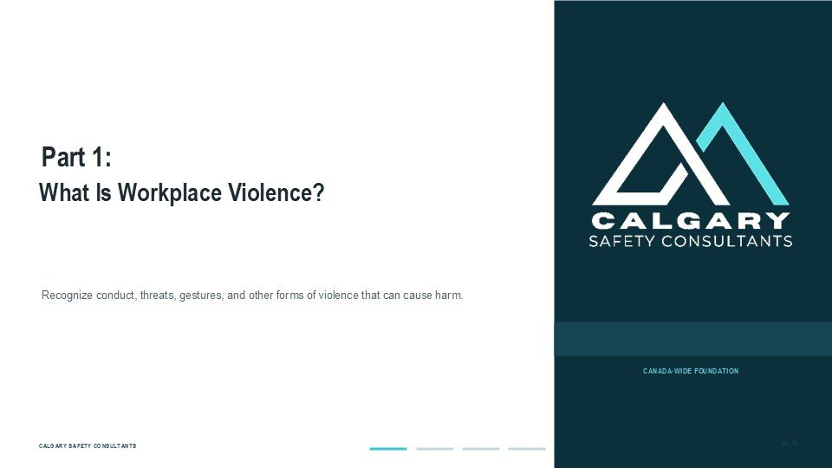  Notes __________________ | Part 1: What Is Workplace Violence?  Part One focuses on what workplace violence can include. Physical assault is one form, but it is not the only form. Threatening language or gestures, intimidation, stalking, sexual violence, technology-facilitated conduct, and domestic or family violence that reaches the workplace may also create serious risk.  The exact legal definition and required response depend on the jurisdiction and workplace. Focus on the conduct and the potential for harm. Workers do not need to decide whether an event meets a legal definition before raising a safety concern. Report observable facts through the...  KEY POINTS  • What Is Workplace Violence?  • Recognize conduct, threats, gestures, and other forms of violence that can cause harm.

LESSON 01 • SLIDE 06 OF 38  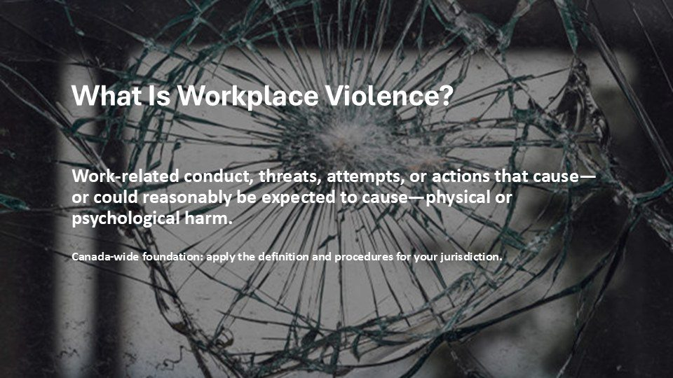  Notes __________________ | What Is Workplace Violence?  This slide provides a practical Canada-wide description of workplace violence. Across Canadian jurisdictions, definitions differ, but they commonly address threatened, attempted, or actual conduct that causes, or could reasonably be expected to cause, physical or psychological harm.  Federal requirements use a broader combined definition of harassment and violence, while provinces and territories use their own wording and procedures. Do not rely on this slide as a substitute for the law or policy that applies to your workplace. The practical response is to describe the conduct, identify any...  KEY POINTS  • Work-related conduct, threats, attempts, or actions that cause—or could reasonably be expected to...  • Describe observable behaviour, assess immediate safety, and use the reporting or emergency route that...

GENERAL NOTES

LESSON 01 • SLIDE 07 OF 38  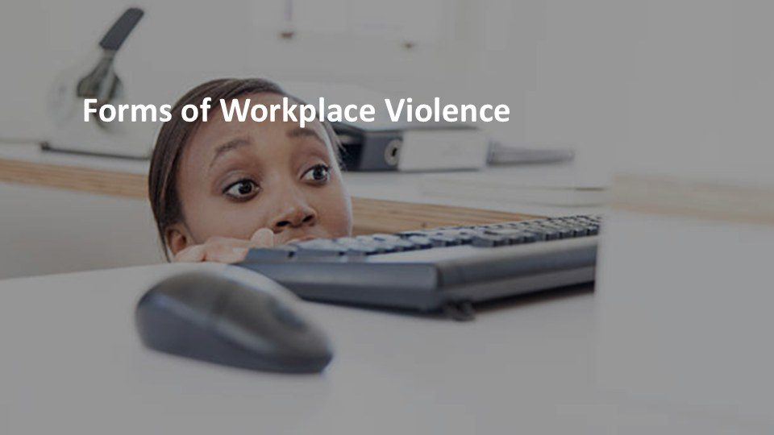  Notes __________________ | Forms of Workplace Violence  Workplace violence can take several forms, and more than one form may be present in the same event. The following slides build the list step by step: physical assault, verbal threats, intimidation or bullying, sexual violence, stalking or harassment, and domestic violence that extends into the workplace.  These examples are not exhaustive, and the applicable definition may group or describe them differently. As each form appears, consider three questions: What observable conduct occurred? What harm or risk could reasonably result? What is the safest reporting or response route? This keeps the...  KEY POINTS  • Forms of Workplace Violence  • Describe observable behaviour, assess immediate safety, and use the reporting or emergency route that...

LESSON 01 • SLIDE 08 OF 38  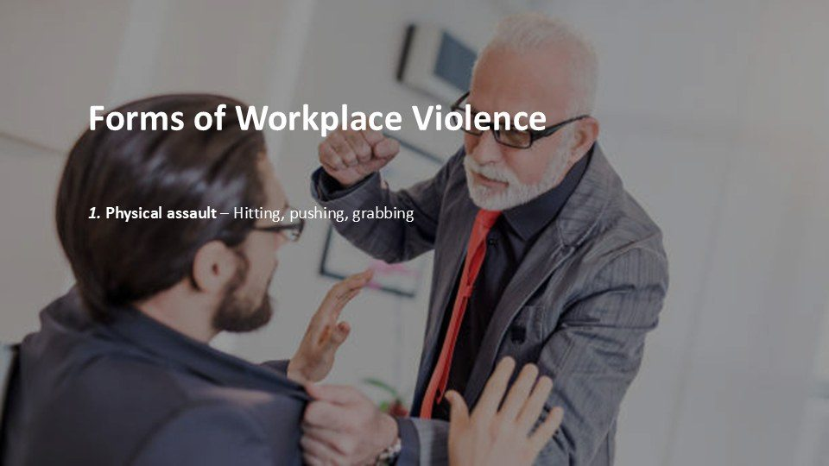  Notes __________________ | Forms of Workplace Violence  The first form is physical assault. Examples include hitting, pushing, grabbing, kicking, spitting, throwing objects, using a weapon, or physically blocking a person from leaving. An attempted assault or a threatening movement may also require action even if no contact occurs.  Property damage can signal escalating risk when it is used to frighten or control someone. Do not place yourself between people or attempt physical intervention unless you are trained, authorized, and it is safe to do so. Create distance, alert others as appropriate, and follow the workplace emergency process. Report...  KEY POINTS  • 1. Physical assault – Hitting, pushing, grabbing.  • Describe observable behaviour, assess immediate safety, and use the reporting or emergency route that...

LESSON 01 • SLIDE 09 OF 38  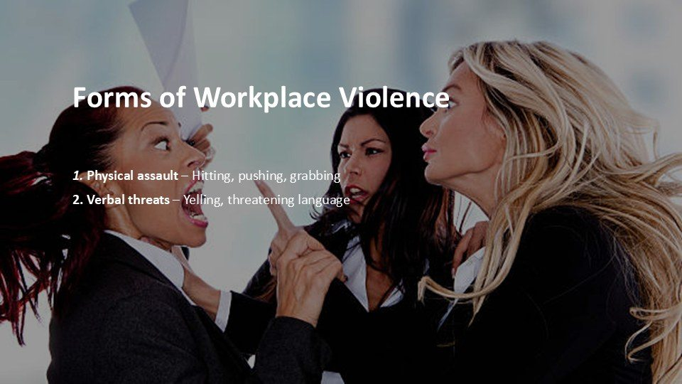  Notes __________________ | Forms of Workplace Violence  The second form is a verbal threat. Threats may be direct or indirect and can be spoken, written, recorded, or sent digitally. Yelling alone does not automatically establish violence, but threatening language, statements of intent to harm, or escalating abuse can create a serious safety concern.  Tone, context, repetition, access to the workplace, and the apparent ability to act may all be relevant. Record the words as accurately as possible and note when, where, and how the threat was communicated. Do not challenge or provoke the person. If the threat appears immediate, move to safety and use...  KEY POINTS  • 1. Physical assault – Hitting, pushing, grabbing 2. Verbal threats – Yelling, threatening language.  • Describe observable behaviour, assess immediate safety, and use the reporting or emergency route that...

GENERAL NOTES

LESSON 01 • SLIDE 10 OF 38  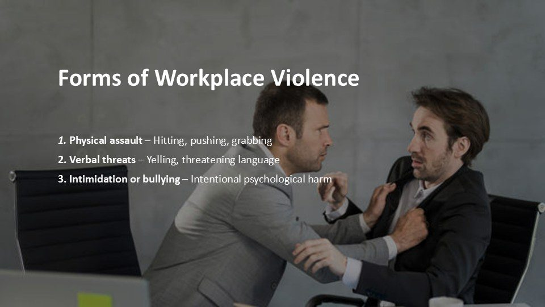  Notes __________________ | Forms of Workplace Violence  The third form involves intimidation, bullying, or other conduct that creates psychological harm or fear. Examples may include threatening gestures, crowding, blocking movement, deliberately damaging property, repeated coercion, or behaviour intended to make a worker fear for their safety.  Harassment and violence can overlap, and the applicable workplace process will determine how a concern is assessed. Describe the behaviour rather than diagnosing intent or personality. Note what happened, who was present, whether the conduct is escalating, and how it affected safety or work. Use the...  KEY POINTS  • 1. Physical assault – Hitting, pushing, grabbing 2. Verbal threats – Yelling, threatening language 3....  • Describe observable behaviour, assess immediate safety, and use the reporting or emergency route that...

LESSON 01 • SLIDE 11 OF 38  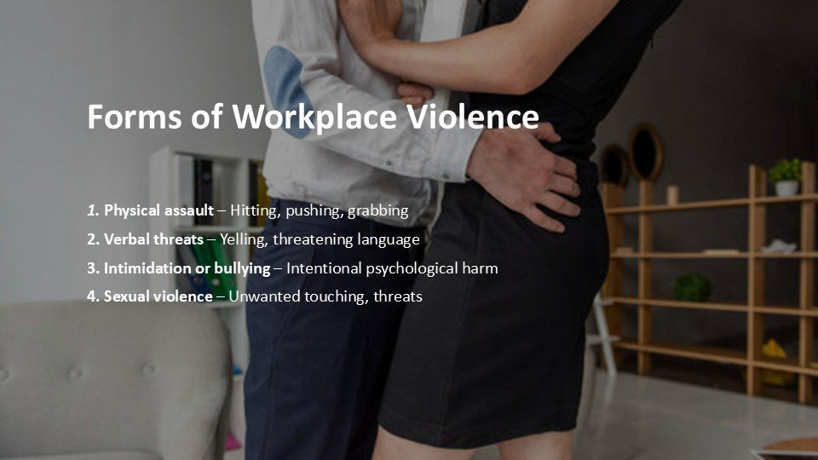  Notes __________________ | Forms of Workplace Violence  The fourth form is sexual violence. It may include sexual assault, attempted assault, unwanted sexual touching, sexual threats, coercion, stalking, or other conduct of a sexual nature that creates physical or psychological harm.  A person may be affected by sexual violence from a coworker, supervisor, client, member of the public, or personal partner. Receive disclosures respectfully and avoid blame, disbelief, or unnecessary questioning. Protect privacy as required, explain available reporting and support options, and follow the workplace procedure....  KEY POINTS  • 1. Physical assault – Hitting, pushing, grabbing 2. Verbal threats – Yelling, threatening language 3....  • Describe observable behaviour, assess immediate safety, and use the reporting or emergency route that...

LESSON 01 • SLIDE 12 OF 38  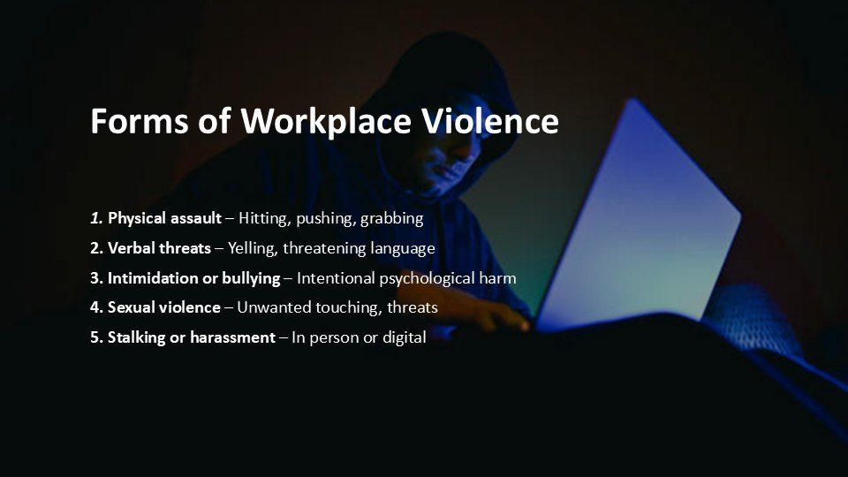  Notes __________________ | Forms of Workplace Violence  The fifth form involves stalking or harassment in person or through technology. Examples may include repeated unwanted contact, following someone, monitoring their movements, appearing at work without a legitimate reason, sending threatening messages, or using digital tools to intimidate or control.  Conduct outside the physical worksite can still create a workplace risk when it is connected to employment or affects safety at work. Preserve relevant messages, dates, account information, and screenshots when it is safe and lawful to do so. Do not reply in a way that increases the risk. Report...  KEY POINTS  • 1. Physical assault – Hitting, pushing, grabbing 2. Verbal threats – Yelling, threatening language 3....  • Describe observable behaviour, assess immediate safety, and use the reporting or emergency route that...

GENERAL NOTES

LESSON 01 • SLIDE 13 OF 38  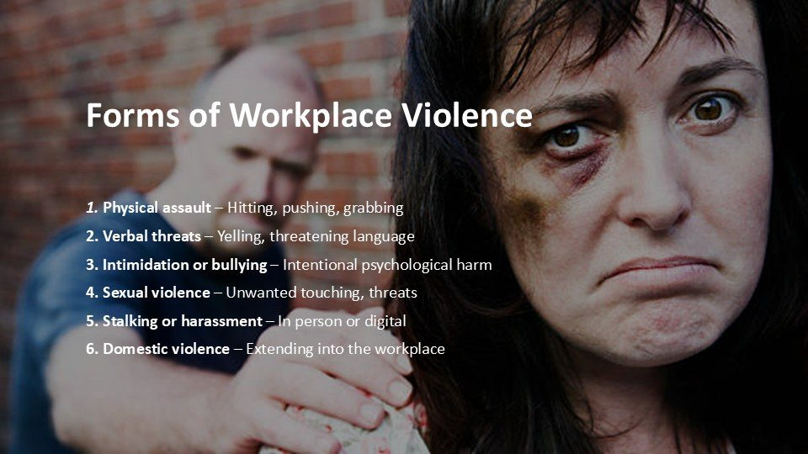  Notes __________________ | Forms of Workplace Violence  Domestic or family violence can become a workplace hazard when it occurs at work, follows a worker to work, or creates a risk to the worker or others. Examples may include repeated calls or messages, stalking, threats, interference with transportation, appearing at the worksite, or targeting coworkers who help the  person. The affected worker may need privacy, flexibility, and a safety plan rather than pressure to disclose more than is necessary. Use the workplace process to connect the person with appropriate support and protective measures. Do not contact or confront the abusive person. If...  KEY POINTS  • 1. Physical assault – Hitting, pushing, grabbing 2. Verbal threats – Yelling, threatening language 3....  • Describe observable behaviour, assess immediate safety, and use the reporting or emergency route that...

LESSON 01 • SLIDE 14 OF 38  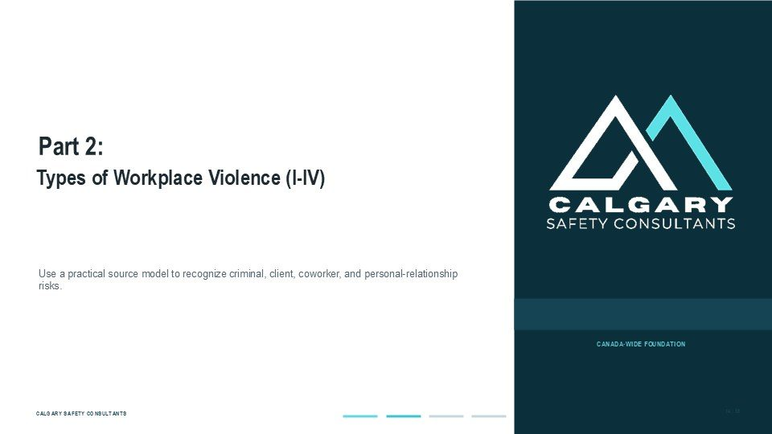  Notes __________________ | Part 2: Types of Workplace Violence (I-IV)  Part Two uses a common four-type model to organize potential sources of workplace violence. Type I involves criminal intent, such as a robbery. Type II involves a client, customer, patient, passenger, student, or other member of the public. Type III involves a current or former worker.  Type IV involves a personal relationship, including domestic or family violence that creates risk at work. This model is a prevention tool, not a substitute for the legal definition or the workplace risk assessment. A situation may fit more than one type, and the appropriate controls depend on the work, the...  KEY POINTS  • Types of Workplace Violence (I-IV).  • Use a practical source model to recognize criminal, client, coworker, and personal-relationship risks.

LESSON 01 • SLIDE 15 OF 38  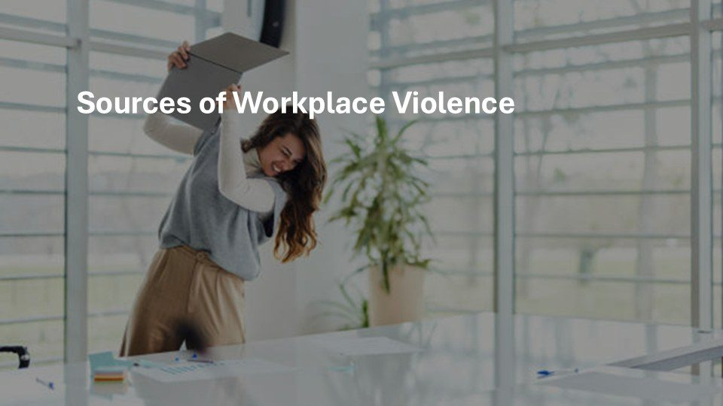  Notes __________________ | Sources of Workplace Violence  Workplace violence can come from different sources. Recognizing the likely source helps a workplace consider suitable controls. The risks associated with a robbery differ from those associated with an aggressive client, a conflict between workers, or domestic violence entering the workplace.  The four-type model on the next slides provides a simple way to organize those sources. The type does not determine whether an event is serious, and it does not replace a hazard assessment. Use it as a prompt: who may create the risk, how could they access the workplace or worker, what warning information...  KEY POINTS  • Sources of Workplace Violence  • Describe observable behaviour, assess immediate safety, and use the reporting or emergency route that...

GENERAL NOTES

LESSON 01 • SLIDE 16 OF 38  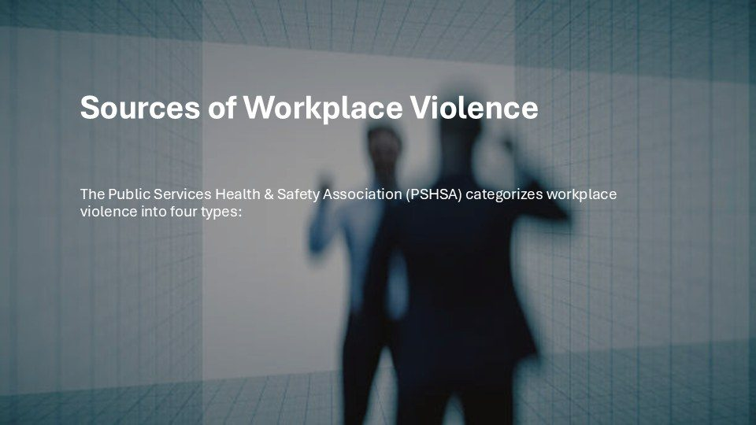  Notes __________________ | Sources of Workplace Violence  This lesson uses a four-type source model commonly applied in workplace-violence prevention. The model groups events according to the relationship between the person creating the risk and the workplace or worker. It can help with hazard assessment, scenario planning, training, and the selection of controls.  It is not a legal test, and terminology may differ among organizations and jurisdictions. As the four types appear, think about the settings where each could arise in your workplace. Consider public access, customer or patient contact, current and former workers, and personal relationships...  KEY POINTS  • The Public Services Health & Safety Association (PSHSA) categorizes workplace violence into four types:​.  • Describe observable behaviour, assess immediate safety, and use the reporting or emergency route that...

LESSON 01 • SLIDE 17 OF 38  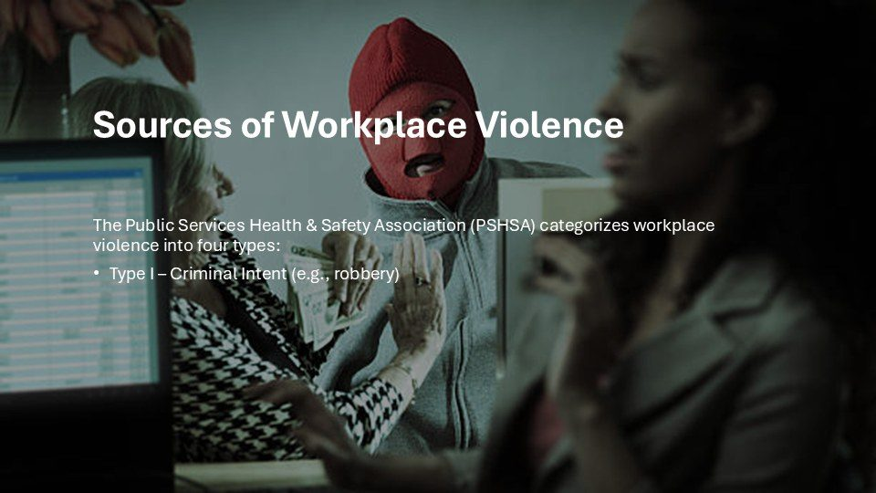  Notes __________________ | Sources of Workplace Violence  Type I is violence connected with criminal intent. The person usually has no legitimate relationship with the workplace and enters to commit a crime, such as robbery, theft, trespassing, or vandalism.  Higher-risk conditions can include handling cash or valuables, working alone, operating late at night, providing mobile services, or working in an isolated location. Controls may include environmental design, lighting, visibility, access control, cash-handling procedures, communication systems, staffing arrangements, and...  KEY POINTS  • The Public Services Health & Safety Association (PSHSA) categorizes workplace violence into four types:​...  • Describe observable behaviour, assess immediate safety, and use the reporting or emergency route that...

LESSON 01 • SLIDE 18 OF 38  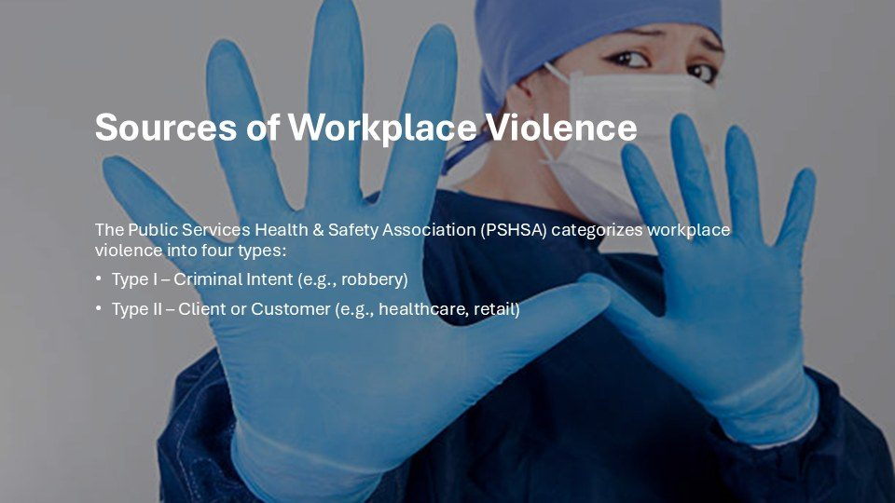  Notes __________________ | Sources of Workplace Violence  Type II involves a client, customer, patient, passenger, student, service user, or other member of the public. Risk can increase where people are distressed, in pain, intoxicated, frustrated, receiving an unwanted decision, or waiting for a service.  Work involving enforcement, health care, social services, retail, transportation, and public-facing roles may require specific controls. Prevention can include service design, adequate staffing, de-escalation training, safe room layouts, barriers, duress systems, information-sharing rules, and clear escalation procedures....  KEY POINTS  • The Public Services Health & Safety Association (PSHSA) categorizes workplace violence into four types:​...  • Describe observable behaviour, assess immediate safety, and use the reporting or emergency route that...

GENERAL NOTES

LESSON 01 • SLIDE 19 OF 38  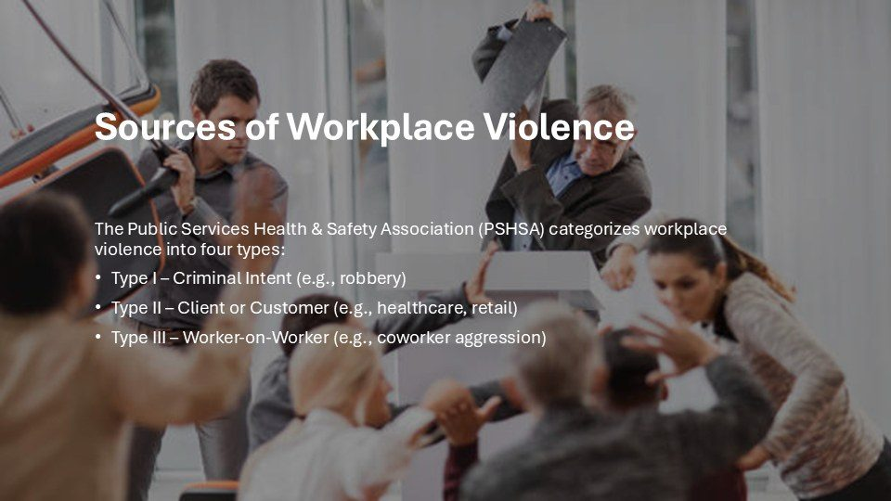  Notes __________________ | Sources of Workplace Violence  Type III is violence involving a current or former worker. It may arise during a dispute, disciplinary process, termination, grievance, or other workplace interaction, but disagreement does not by itself mean violence will occur.  Concerning conduct may include threats, assault, stalking, property damage, or repeated intimidation. Former workers may also retain knowledge of locations, schedules, and access points. Respond to observable conduct, not rumours or stereotypes. Use respectful management practices, clear reporting routes, access-control...  KEY POINTS  • The Public Services Health & Safety Association (PSHSA) categorizes workplace violence into four types:​...  • Describe observable behaviour, assess immediate safety, and use the reporting or emergency route that...

LESSON 01 • SLIDE 20 OF 38  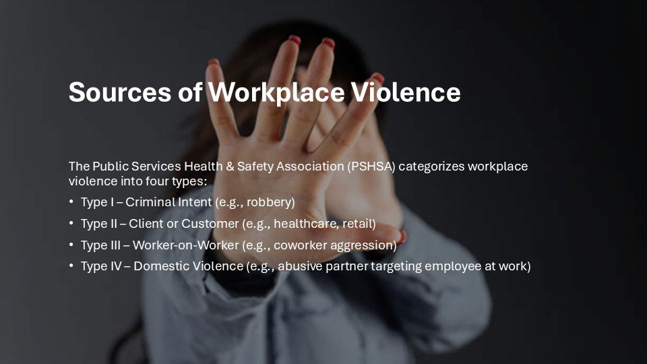  Notes __________________ | Sources of Workplace Violence  Type IV involves a personal relationship that creates risk at work. This often includes domestic or family violence, but it may also involve another personal relationship outside work.  The person creating the risk may contact, stalk, threaten, or approach the worker at the workplace, or may target coworkers and others who provide assistance. A workplace response may include a confidential safety plan, adjusted contact information or scheduling, access controls, reception and security instructions, parking or...  KEY POINTS  • The Public Services Health & Safety Association (PSHSA) categorizes workplace violence into four types:​...  • Describe observable behaviour, assess immediate safety, and use the reporting or emergency route that...

LESSON 01 • SLIDE 21 OF 38  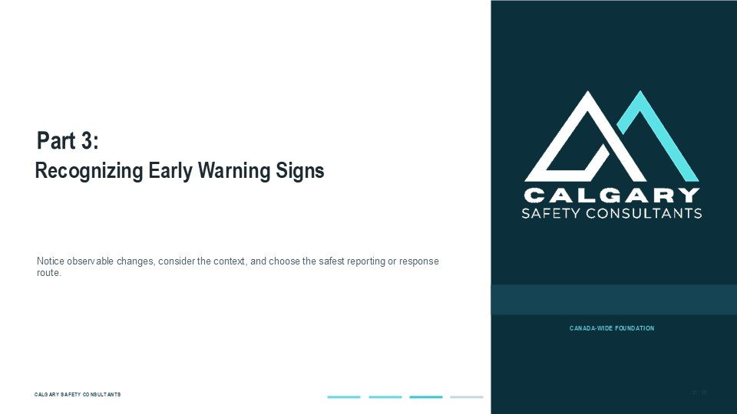  Notes __________________ | Part 3: Recognizing Early Warning Signs  Part Three examines warning signs and changes that may require attention. Examples can include escalating aggression, threats, stalking or obsessive communication, severe distress, sudden changes in behaviour, substance-related impairment, or a documented pattern of concerning incidents.  These indicators must be interpreted in context. They are not proof of intent and should not be used to stereotype, diagnose, or punish a person. Describe what was actually seen or heard, note relevant dates and circumstances, and report through the workplace process. Do not investigate on your own or place...  KEY POINTS  • Recognizing Early Warning Signs.  • Notice observable changes, consider the context, and choose the safest reporting or response route.

GENERAL NOTES

LESSON 01 • SLIDE 22 OF 38  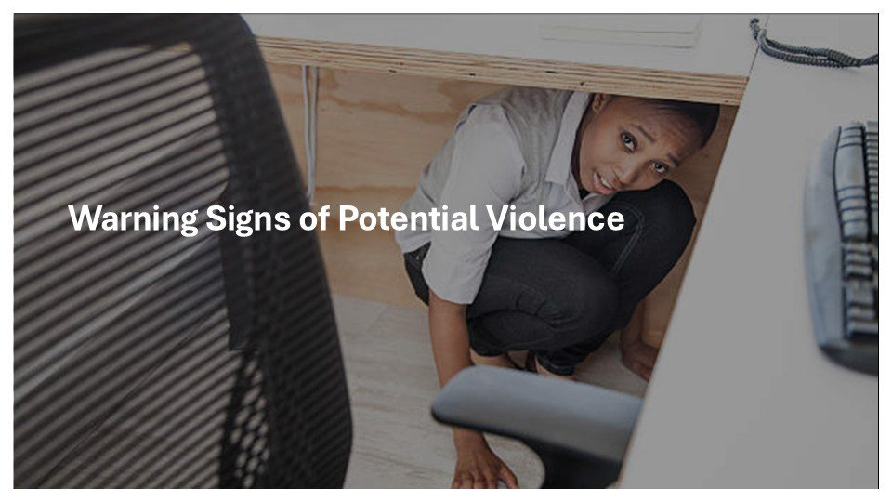  Notes __________________ | Warning Signs of Potential Violence  Warning signs can help people notice that a situation may require attention, but they must be used carefully. No single behaviour reliably predicts violence, and some incidents occur without an obvious warning.  A change in mood, isolation, distress, disability, or substance use should never be treated as proof that someone is dangerous. Focus on conduct, context, escalation, and any specific threat or safety impact. Workers are not expected to conduct a threat assessment on their own. Report observable facts through the designated...  KEY POINTS  • Warning Signs of Potential Violence  • Describe observable behaviour, assess immediate safety, and use the reporting or emergency route that...

LESSON 01 • SLIDE 23 OF 38  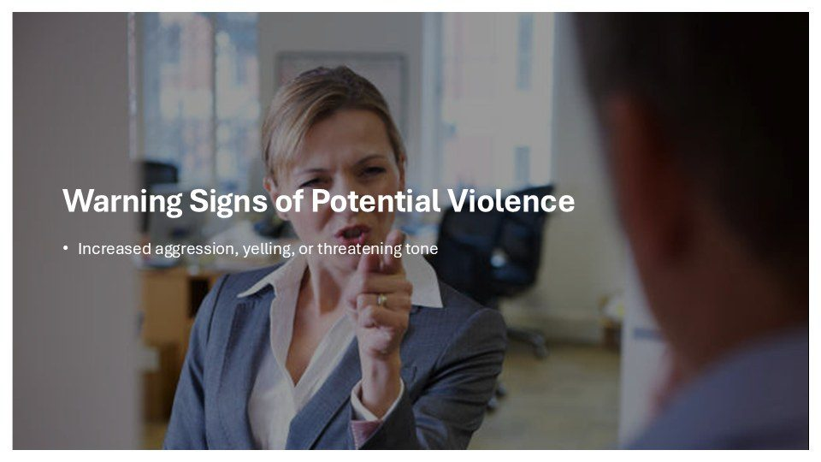  Notes __________________ | Warning Signs of Potential Violence  Increased aggression, yelling, or a threatening tone may signal escalation, especially when paired with specific threats, hostile gestures, property damage, or movement toward another person. Stay calm, keep appropriate distance, and avoid arguing about who is right.  Use clear, respectful language and provide options only when it is safe to do so. Be aware of exits and avoid allowing yourself to become trapped. Report the exact words and behaviour, the location, who was present, and whether the conduct was increasing. If the person threatens harm, displays a weapon, blocks escape, or...  KEY POINTS  • Increased aggression, yelling, or threatening tone.  • Describe observable behaviour, assess immediate safety, and use the reporting or emergency route that...

LESSON 01 • SLIDE 24 OF 38  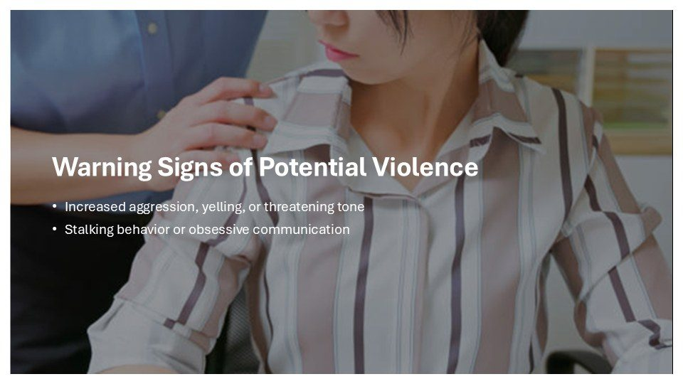  Notes __________________ | Warning Signs of Potential Violence  Stalking or obsessive communication can appear as repeated unwanted calls, messages, monitoring, following, gifts, social-media contact, or uninvited appearances at the workplace. The concern is the pattern, the unwanted nature of the contact, and the risk it creates.  Do not encourage a worker to meet the person alone to resolve the issue. Preserve relevant information and limit disclosure of schedules, locations, and contact details to people who need them for safety or operational reasons. Report the situation through the workplace process so access controls, communication plans, and...  KEY POINTS  • Increased aggression, yelling, or threatening tone Stalking behavior or obsessive communication.  • Describe observable behaviour, assess immediate safety, and use the reporting or emergency route that...

GENERAL NOTES

LESSON 01 • SLIDE 25 OF 38  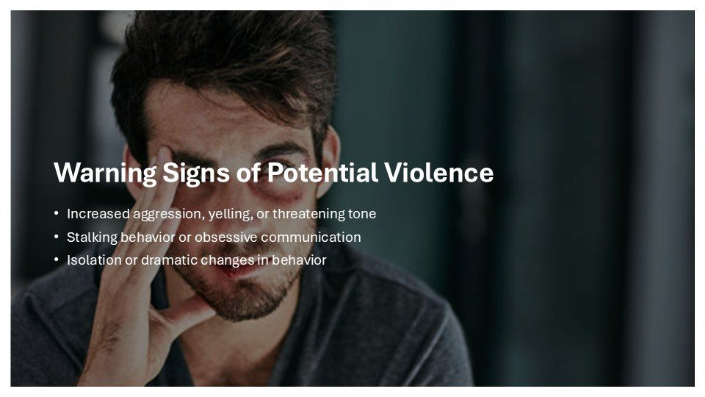  Notes __________________ | Warning Signs of Potential Violence  Isolation or a dramatic change in behaviour may show that a person is distressed, but it does not prove that the person is violent. Changes can have many causes, including health, grief, workload, conflict, discrimination, or personal circumstances. Respond with care and avoid diagnosis, gossip, or assumptions.  If appropriate, a supervisor can check in privately, explain available support, and clarify workplace expectations. Safety action should be based on observable conduct and context. Specific threats, intimidation, stalking, escalating aggression, or behaviour that creates an immediate...  KEY POINTS  • Increased aggression, yelling, or threatening tone Stalking behavior or obsessive communication...  • Describe observable behaviour, assess immediate safety, and use the reporting or emergency route that...

LESSON 01 • SLIDE 26 OF 38  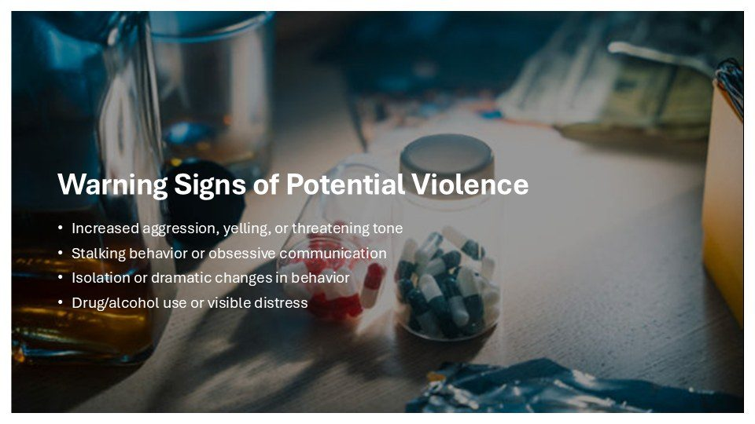  Notes __________________ | Warning Signs of Potential Violence  Impairment or visible distress may affect judgment, communication, and safety, but neither condition should automatically be equated with violence. Observe specific indicators relevant to work, such as inability to perform safely, confusion, severe agitation, threats, or rapid escalation.  Follow the workplace's fitness-for-work, impairment, medical-emergency, and respectful-workplace procedures. Do not attempt to diagnose the cause or search a person's belongings. If the person can be approached safely, use calm language and obtain support from the appropriate supervisor or responder. If...  KEY POINTS  • Increased aggression, yelling, or threatening tone Stalking behavior or obsessive communication...  • Describe observable behaviour, assess immediate safety, and use the reporting or emergency route that...

LESSON 01 • SLIDE 27 OF 38  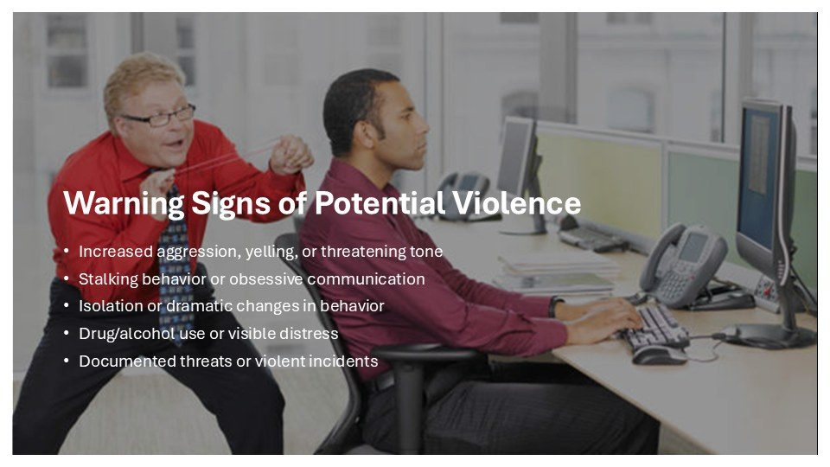  Notes __________________ | Warning Signs of Potential Violence  A documented pattern of threats, violent acts, stalking, or serious escalation can be relevant to a workplace risk assessment. Prior complaints alone do not prove that a person is dangerous. Information must be assessed for reliability, context, recency, and connection to current risk.  Decisions should be made by the people responsible under the workplace policy, with privacy protected and procedural fairness respected. Workers should report new incidents and changes rather than trying to investigate a history themselves. Accurate dates, words, actions, witnesses, and available records are...  KEY POINTS  • Increased aggression, yelling, or threatening tone Stalking behavior or obsessive communication...  • Describe observable behaviour, assess immediate safety, and use the reporting or emergency route that...

GENERAL NOTES

LESSON 01 • SLIDE 28 OF 38    Notes __________________ | Real-World Examples  The next four slides apply the lesson to realistic workplace situations. For each example, identify the likely source type, the conduct creating risk, and the safest response.  Consider whether the event requires an emergency response, immediate protective measures, routine reporting, preservation of information, or a review of workplace controls. There is rarely one universal response. The correct action depends on the seriousness and immediacy of the threat, the people involved, the setting, and the...  KEY POINTS  • Real-World Examples  • Describe observable behaviour, assess immediate safety, and use the reporting or emergency route that...

LESSON 01 • SLIDE 29 OF 38    Notes __________________ | Real-World Examples  In this example, a retail employee is threatened by an angry customer. This generally fits Type II because the person has a customer or service relationship with the workplace. The employee should use de-escalation techniques only within their training and only while it remains safe.  They should maintain distance, avoid blocking the person's exit, and obtain support according to the store's procedure. If the customer makes a credible or immediate threat, displays a weapon, or attempts assault, the employee should move to safety and activate the emergency response. Afterwards, the incident...  KEY POINTS  • A retail employee threatened by an angry customer.  • Describe observable behaviour, assess immediate safety, and use the reporting or emergency route that...

LESSON 01 • SLIDE 30 OF 38  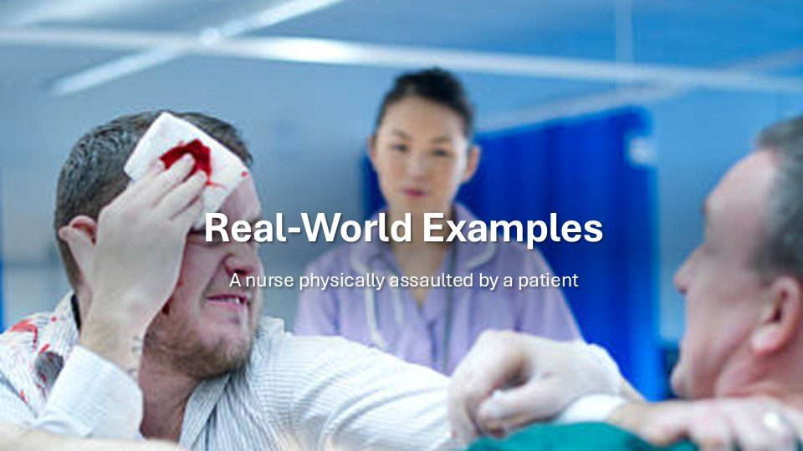  Notes __________________ | Real-World Examples  In this example, a nurse is physically assaulted by a patient. This generally fits Type II because the risk comes from a patient or service recipient. Health conditions, pain, distress, medication, or impairment may help explain behaviour, but they do not remove the need to protect workers and others.  The response should follow the clinical and workplace violence procedures for that setting. Priorities may include summoning trained assistance, creating distance, protecting other patients, obtaining medical care, and documenting the incident. The employer should review relevant risk...  KEY POINTS  • A nurse physically assaulted by a patient.  • Describe observable behaviour, assess immediate safety, and use the reporting or emergency route that...

GENERAL NOTES

LESSON 01 • SLIDE 31 OF 38    Notes __________________ | Real-World Examples  In this example, an office worker is being stalked by an ex-partner. This generally fits Type IV because a personal relationship is creating a workplace risk. The worker should not be expected to manage the situation alone.  A confidential workplace safety plan may address reception and security alerts, access control, contact information, parking, travel, scheduling, remote work, and how coworkers should respond if the person appears. Relevant messages or sightings should be preserved and reported. Information should be shared only as needed for...  KEY POINTS  • An office worker being stalked by an ex-partner.  • Describe observable behaviour, assess immediate safety, and use the reporting or emergency route that...

LESSON 01 • SLIDE 32 OF 38    Notes __________________ | Real-World Examples  In this example, a warehouse worker punches a coworker during a dispute. This generally fits Type III because the violence occurs between workers. The immediate response is to stop exposure: summon assistance, separate people only if it can be done safely by trained or authorized responders, obtain medical care, and  follow the emergency procedure. Coworkers should not crowd the scene or begin an informal investigation. The incident should be reported and assessed under the workplace policy. The employer may need to preserve evidence, protect the people involved, investigate fairly, and review...  KEY POINTS  • A warehouse employee punched by a coworker during a dispute.  • Describe observable behaviour, assess immediate safety, and use the reporting or emergency route that...

LESSON 01 • SLIDE 33 OF 38  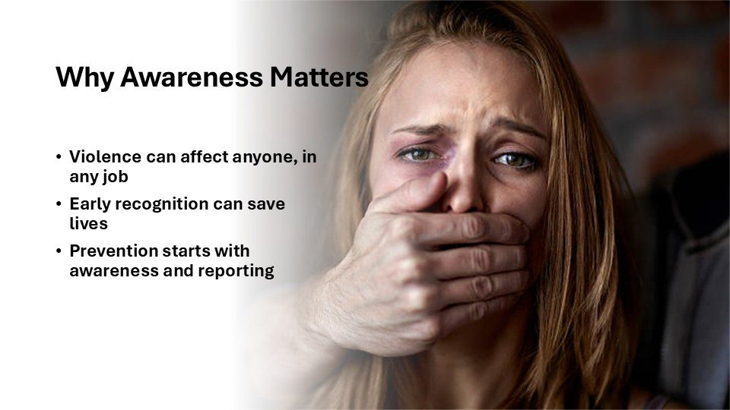  Notes __________________ | Why Awareness Matters  Awareness matters because workplace violence can affect people in any occupation. Risk levels and likely sources differ by job and setting, but no workplace should assume that violence is impossible.  Early recognition means noticing threats, escalation, stalking, unsafe access, or other observable concerns and using the correct process. It does not mean profiling people or treating distress as proof of danger. Reporting supports prevention by giving the workplace information to assess risk, provide support, and improve...  KEY POINTS  • Violence can affect anyone, in any job Early recognition can save lives Prevention starts with awareness...  • Describe observable behaviour, assess immediate safety, and use the reporting or emergency route that...

GENERAL NOTES

LESSON 01 • SLIDE 34 OF 38  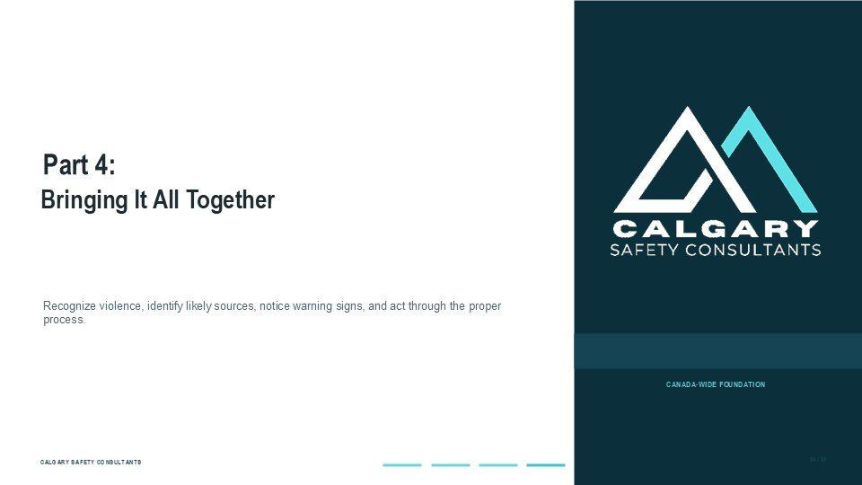  Notes __________________ | Part 4: Bringing It All Together  Part Four brings the lesson together. Workplace violence prevention begins with a broad awareness of potentially harmful conduct, an understanding of where risk may come from, and a willingness to act on observable concerns.  The four-type model helps organize risk, while warning signs help identify situations that may need timely attention. The key message is to respond proportionately and safely. Use the workplace policy, report facts rather than assumptions, protect confidentiality as required, and escalate immediately when there is a threat of...  KEY POINTS  • Bringing It All Together.  • Recognize violence, identify likely sources, notice warning signs, and act through the proper process.

LESSON 01 • SLIDE 35 OF 38  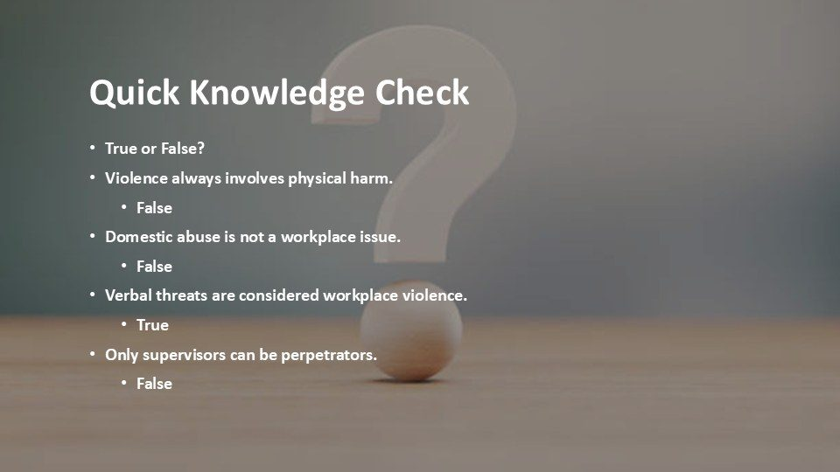  Notes __________________ | Quick Knowledge Check  Use these true-or-false statements to check the key concepts. Violence does not always involve physical harm. Threats, intimidation, stalking, sexual violence, and conduct that causes psychological harm may fall within the applicable definition.  Domestic abuse can become a workplace issue when it occurs at work or creates risk for a worker or others. Verbal threats can be workplace violence, depending on the words and context. A person creating risk may be a supervisor, coworker, former worker, client, customer, member of the public, or personal partner. The correct...  KEY POINTS  • True or False? Violence always involves physical harm. False Domestic abuse is not a workplace issue....  • Describe observable behaviour, assess immediate safety, and use the reporting or emergency route that...

LESSON 01 • SLIDE 36 OF 38    Notes __________________ | This lesson began with the definition and common forms of workplace violence.  This lesson began with the definition and common forms of workplace violence. The central point is that violence is not limited to physical assault. Threats, intimidation, sexual violence, stalking, technology-facilitated conduct, and domestic or family violence may create physical or psychological harm.  Exact definitions and required procedures vary across Canada. When a concern arises, focus on what was said or done, the surrounding context, and whether danger is immediate. Report through the designated workplace process so the concern can be assessed under the correct requirements. Use...  KEY POINTS  • This lesson began with the definition and common forms of workplace violence.  • Describe observable behaviour, assess immediate safety, and use the reporting or emergency route that...

GENERAL NOTES

LESSON 01 • SLIDE 37 OF 38    Notes __________________ | The lesson also introduced the four-type source model and a careful approach to warning...  The lesson also introduced the four-type source model and a careful approach to warning signs. Criminal activity, clients or customers, current or former workers, and personal relationships can each create different risks.  The model helps organize prevention, but it does not replace a workplace-specific hazard assessment. Warning signs are also contextual: no single behaviour proves violent intent, and distress should not be stigmatized. Workers contribute by noticing observable changes or threats, preserving relevant information, and reporting...  KEY POINTS  • The lesson also introduced the four-type source model and a careful approach to warning...  • Describe observable behaviour, assess immediate safety, and use the reporting or emergency route that...

LESSON 01 • SLIDE 38 OF 38    Notes __________________ | In the next lesson, the focus moves from recognition to risk assessment and control...  In the next lesson, the focus moves from recognition to risk assessment and control measures. You will consider how workplace conditions, tasks, public interaction, working alone, access, scheduling, communication, and past incidents can affect risk.  You will also examine how controls can be selected using approaches such as elimination where possible, engineering or environmental measures, administrative procedures, training, and emergency planning. Carry forward the main principle from this lesson: respond to observable risk, not assumptions about people. Use the...  KEY POINTS  • In the next lesson, the focus moves from recognition to risk assessment and control...  • Describe observable behaviour, assess immediate safety, and use the reporting or emergency route that...

GENERAL NOTES

LESSON 01 SUMMARY
Understanding Workplace Violence
The following points bring the lesson together. Use them to review the main prevention message and connect it to the procedures and expectations in your workplace.
01 | Workplace violence can include physical acts, attempted acts, threats, intimidation, or other behaviour that may cause physical or psychological harm.
02 | Risk may come from coworkers, clients, patients, customers, family members, members of the public, or another person connected to the work.
03 | Warning signs and risk factors are information for prevention and assessment. They do not prove intent or justify independent investigation.
04 | Useful reports describe observable conduct, timing, location, witnesses, immediate effects, and any change in risk.
05 | Immediate danger requires emergency action. Other concerns should follow the primary or alternate workplace reporting route.
Reflection and application
• Which tasks or locations in this workplace have the greatest exposure to violence?
• What facts should I record if I observe a threat or warning behaviour?
• Where are the emergency and alternate reporting routes posted?
________________________________________________________________________________
________________________________________________________________________________
GENERAL NOTES

MODULE THREE / LESSON 02

Preventing and Controlling Workplace Violence
Risk assessment | Controls | Safe work procedures | Training
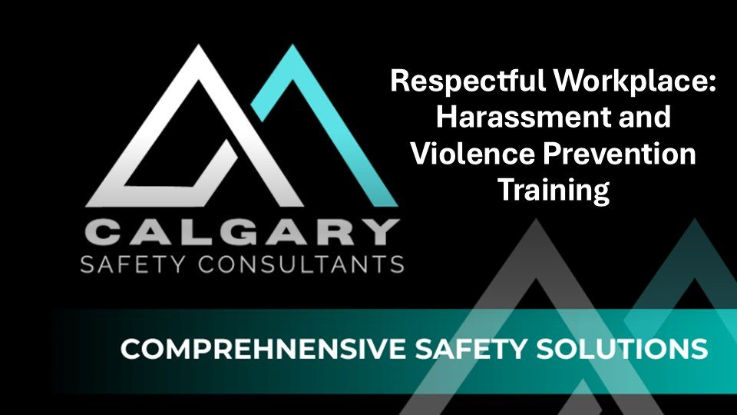
Lesson overview
Violence prevention starts with a practical assessment of where, when, and how workers may be exposed. The assessment should consider the work, the environment, interactions with people, previous incidents, available information, and the controls already in place.
This lesson applies the hierarchy of controls to workplace violence and explains how physical design, staffing, communication, scheduling, safe work procedures, training, personal protective measures, and emergency arrangements work together. Controls should be reviewed when work or risk changes.
By the end of this lesson you should be able to
• Identify the work activities, environments, and interactions that require a violence risk assessment.
• Use the hierarchy of controls to select practical measures that reduce exposure.
• Recognize how workplace design, staffing, communication, and scheduling influence risk.
• Follow safe work procedures for higher risk tasks, lone work, travel, and public interaction.
• Review and improve controls after incidents, near misses, worker feedback, or changes in the work.
GENERAL NOTES

LESSON 02 • SLIDE 01 OF 43  Notes __________________ | Preventing and Controlling Workplace Violence  Respectful Workplace: Harassment and Violence Prevention Training.  Assess the exposure, use the strongest practical controls, train workers, and review whether the controls work.  KEY POINTS  • Respectful Workplace: Harassment and Violence Prevention Training.  • Assess the exposure, use the strongest practical controls, train workers, and review whether the...

LESSON 02 • SLIDE 02 OF 43  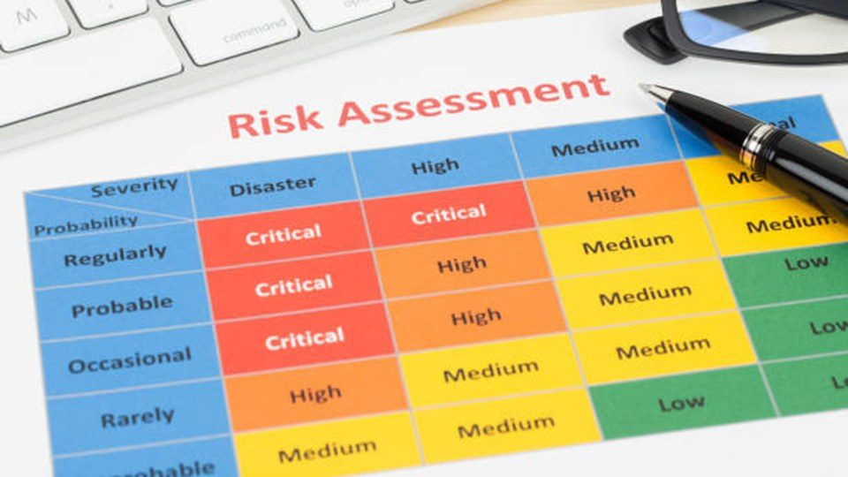  Notes __________________ | Conducting or using a risk assessment is important in violence prevention.  Conducting or using a risk assessment is important in violence prevention. We will stress the significance of environmental and procedural protections, including panic buttons, security protocols, controlled access, buddy systems, and dependable incident reporting systems.  Assess the exposure, use the strongest practical controls, train workers, and review whether the controls work.  KEY POINTS  • Conducting or using a risk assessment is important in violence prevention.  • Assess the exposure, use the strongest practical controls, train workers, and review whether the...

LESSON 02 • SLIDE 03 OF 43    Notes __________________ | Together, these strategies form a comprehensive approach to minimizing the risk of...  Together, these strategies form a comprehensive approach to minimizing the risk of workplace violence.  Assess the exposure, use the strongest practical controls, train workers, and review whether the controls work.  KEY POINTS  • Together, these strategies form a comprehensive approach to minimizing the risk of...  • Assess the exposure, use the strongest practical controls, train workers, and review whether the...

GENERAL NOTES

LESSON 02 • SLIDE 04 OF 43  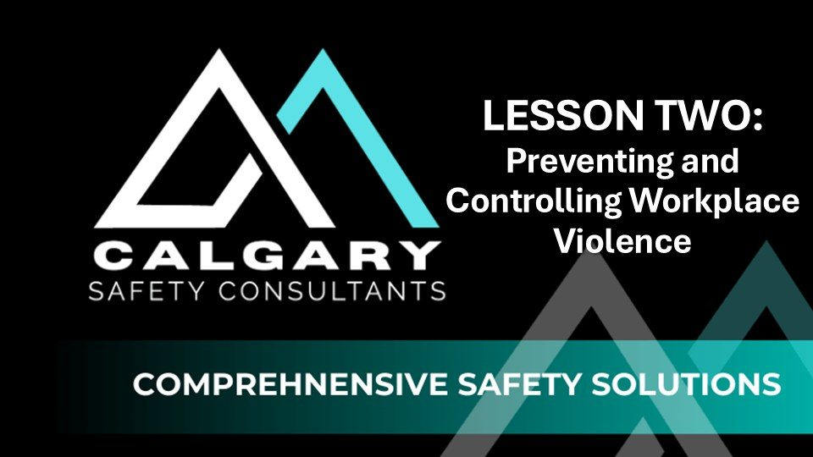  Notes __________________ | LESSON TWO: Preventing and Controlling Workplace Violence  This lesson focuses on how to conduct a workplace violence risk assessment and implement effective prevention strategies. It begins by identifying high-risk environments and roles, such as working alone, handling cash, or performing enforcement duties, where the potential for violence is elevated.  Assess the exposure, use the strongest practical controls, train workers, and review whether the controls work.  KEY POINTS  • LESSON TWO: Preventing and Controlling Workplace Violence  • Assess the exposure, use the strongest practical controls, train workers, and review whether the...

LESSON 02 • SLIDE 05 OF 43  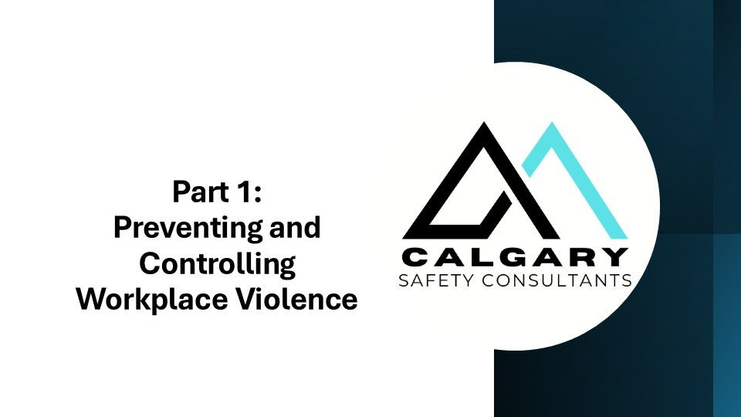  Notes __________________ | Part 1: ; Preventing and Controlling Workplace Violence  Assess the exposure, use the strongest practical controls, train workers, and review whether the controls work.  Assess the exposure, use the strongest practical controls, train workers, and review whether the controls work.  KEY POINTS  • Part 1: ; Preventing and Controlling Workplace Violence  • Assess the exposure, use the strongest practical controls, train workers, and review whether the...

LESSON 02 • SLIDE 06 OF 43  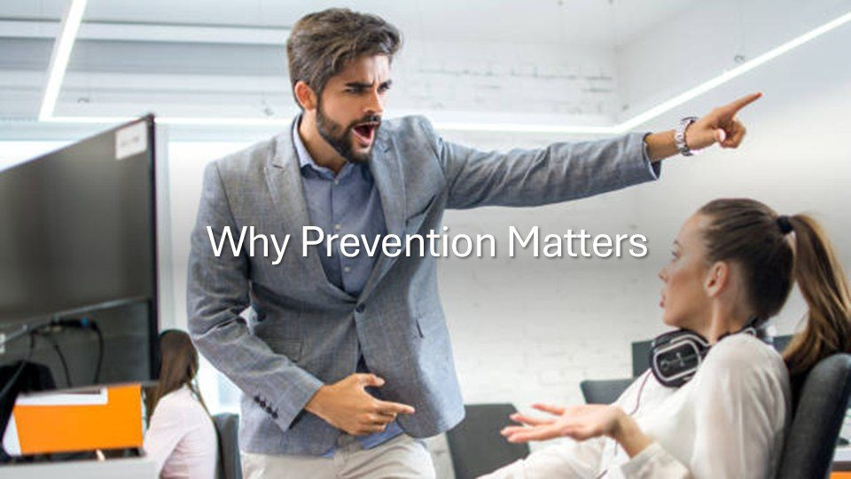  Notes __________________ | Why Prevention Matters  Prevention matters for workplace violence and harassment because it protects the physical and psychological well-being of employees, helps create a respectful and inclusive workplace, and ensures legal compliance with occupational health and safety laws across Canada.  Assess the exposure, use the strongest practical controls, train workers, and review whether the controls work.  KEY POINTS  • Why Prevention Matters  • Assess the exposure, use the strongest practical controls, train workers, and review whether the...

GENERAL NOTES

LESSON 02 • SLIDE 07 OF 43    Notes __________________ | Unaddressed violence or harassment can lead to serious consequences, including emotional...  Unaddressed violence or harassment can lead to serious consequences, including emotional trauma, increased absenteeism, high staff turnover, damaged team morale, and loss of productivity. It also exposes employers to legal and financial risks, including fines, lawsuits, and reputational harm.  Assess the exposure, use the strongest practical controls, train workers, and review whether the controls work.  KEY POINTS  • Unaddressed violence or harassment can lead to serious consequences, including emotional...  • Assess the exposure, use the strongest practical controls, train workers, and review whether the...

LESSON 02 • SLIDE 08 OF 43  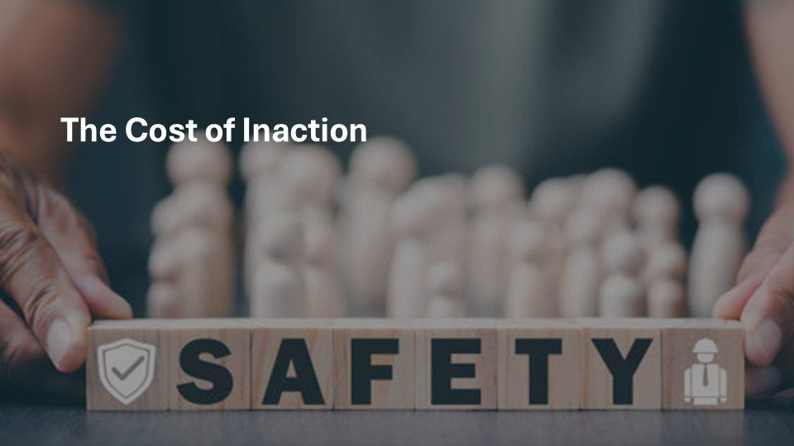  Notes __________________ | The Cost of Inaction  Workplace violence can have serious consequences—both for individuals and organizations.  Assess the exposure, use the strongest practical controls, train workers, and review whether the controls work.  KEY POINTS  • The Cost of Inaction  • Assess the exposure, use the strongest practical controls, train workers, and review whether the...

LESSON 02 • SLIDE 09 OF 43  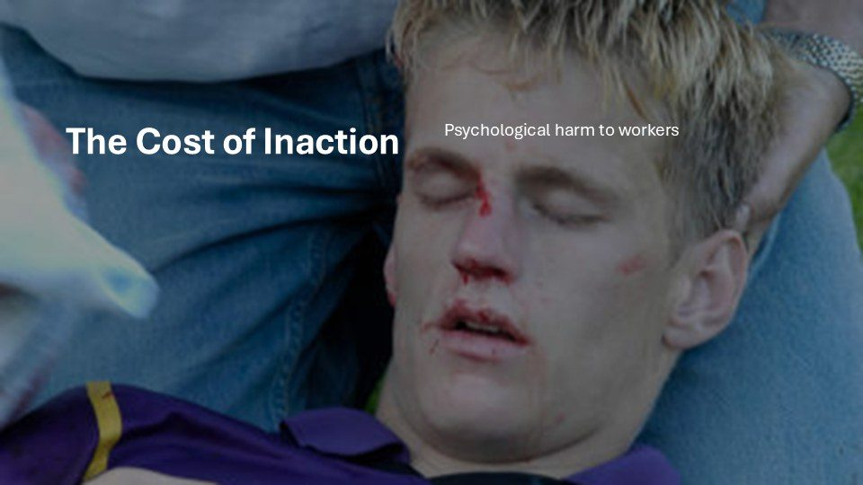  Notes __________________ | The Cost of Inaction  It can lead to physical and emotional harm  Assess the exposure, use the strongest practical controls, train workers, and review whether the controls work.  KEY POINTS  • Psychological harm to workers.  • Assess the exposure, use the strongest practical controls, train workers, and review whether the...

GENERAL NOTES

LESSON 02 • SLIDE 10 OF 43  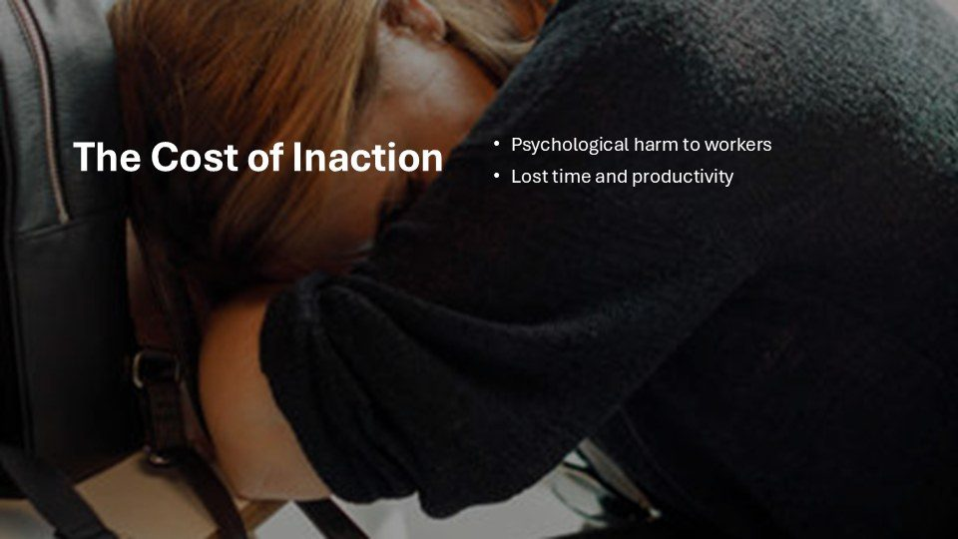  Notes __________________ | The Cost of Inaction  lost productivity,  Assess the exposure, use the strongest practical controls, train workers, and review whether the controls work.  KEY POINTS  • Psychological harm to workers Lost time and productivity.  • Assess the exposure, use the strongest practical controls, train workers, and review whether the...

LESSON 02 • SLIDE 11 OF 43  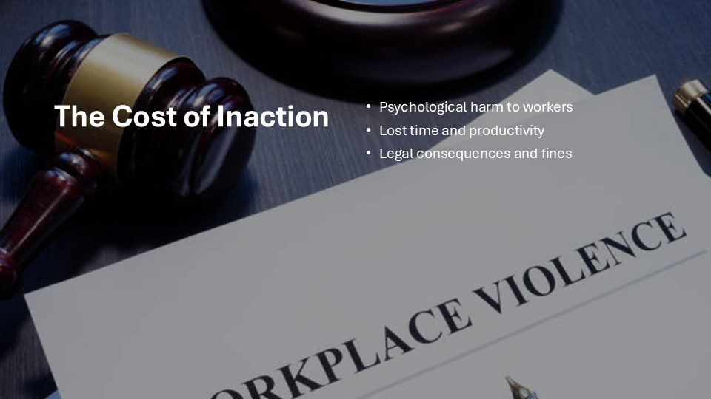  Notes __________________ | The Cost of Inaction  regulatory penalties,  Assess the exposure, use the strongest practical controls, train workers, and review whether the controls work.  KEY POINTS  • Psychological harm to workers Lost time and productivity Legal consequences and fines.  • Assess the exposure, use the strongest practical controls, train workers, and review whether the...

LESSON 02 • SLIDE 12 OF 43  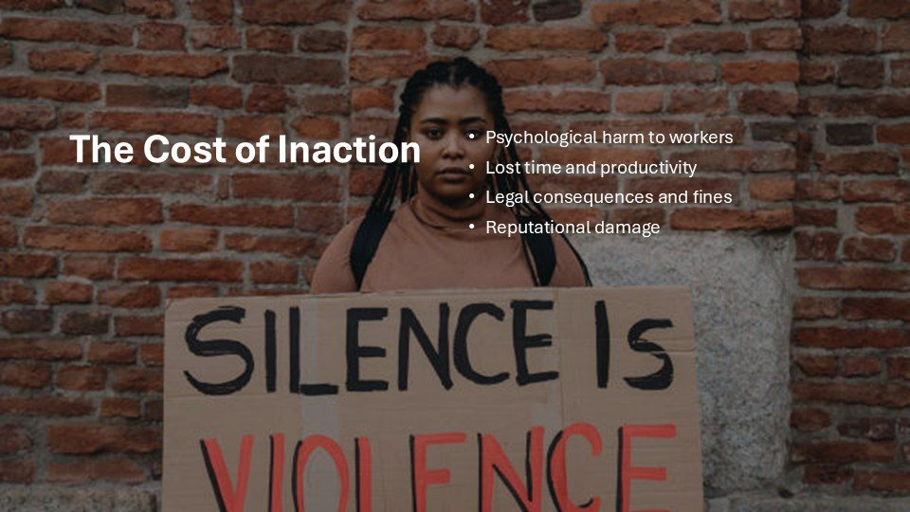  Notes __________________ | The Cost of Inaction  and lasting damage to your company’s reputation. That’s why prevention is a legal and moral responsibility.  Assess the exposure, use the strongest practical controls, train workers, and review whether the controls work.  KEY POINTS  • Psychological harm to workers Lost time and productivity Legal consequences and fines Reputational...  • Assess the exposure, use the strongest practical controls, train workers, and review whether the...

GENERAL NOTES

LESSON 02 • SLIDE 13 OF 43  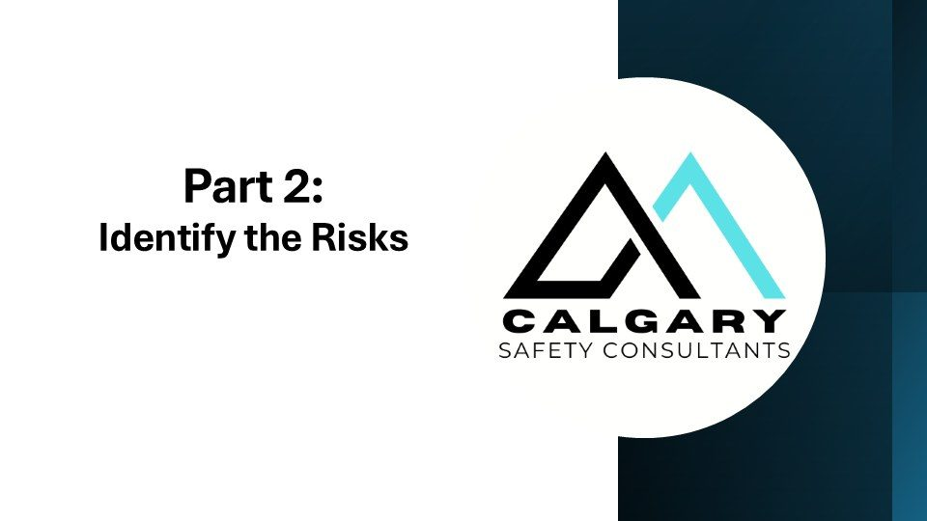  Notes __________________ | Part 2: ; Identify the Risks  Assess the exposure, use the strongest practical controls, train workers, and review whether the controls work.  Assess the exposure, use the strongest practical controls, train workers, and review whether the controls work.  KEY POINTS  • Part 2: ; Identify the Risks  • Assess the exposure, use the strongest practical controls, train workers, and review whether the...

LESSON 02 • SLIDE 14 OF 43  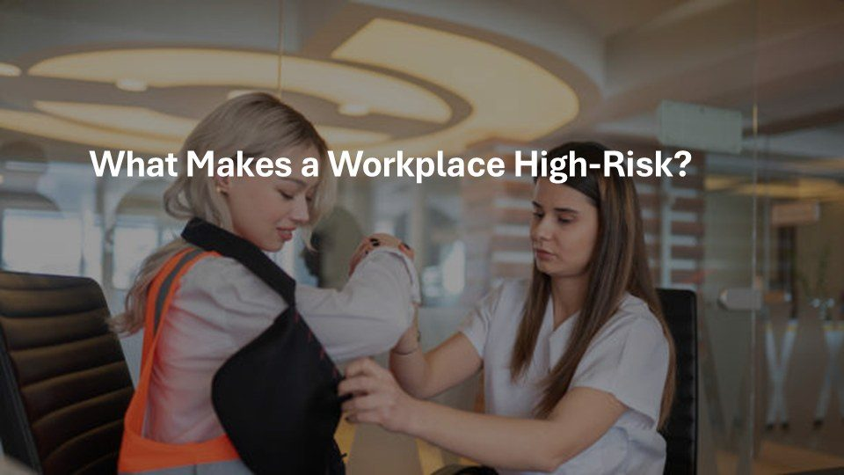  Notes __________________ | What Makes a Workplace High-Risk?  What Makes a Workplace High-Risk? Well, some jobs have more risk than others. Identifying the following risks is the first step in preventing violence.  Assess the exposure, use the strongest practical controls, train workers, and review whether the controls work.  KEY POINTS  • What Makes a Workplace High-Risk?  • Assess the exposure, use the strongest practical controls, train workers, and review whether the...

LESSON 02 • SLIDE 15 OF 43  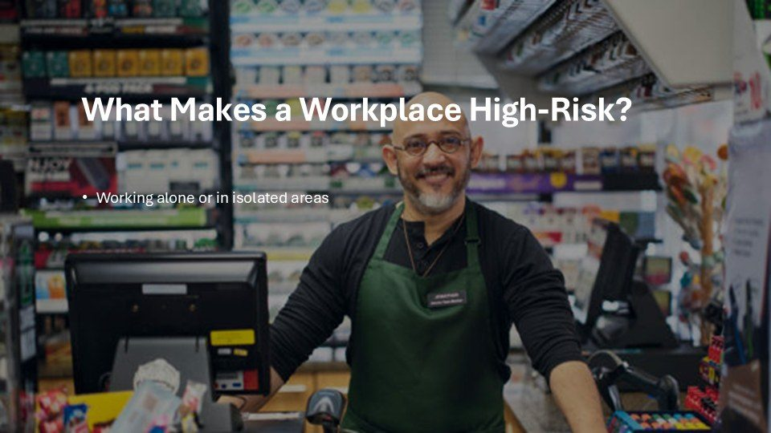  Notes __________________ | What Makes a Workplace High-Risk?  Risk factors include working alone,  Assess the exposure, use the strongest practical controls, train workers, and review whether the controls work.  KEY POINTS  • Working alone or in isolated areas.  • Assess the exposure, use the strongest practical controls, train workers, and review whether the...

GENERAL NOTES

LESSON 02 • SLIDE 16 OF 43    Notes __________________ | What Makes a Workplace High-Risk?  handling money,  Assess the exposure, use the strongest practical controls, train workers, and review whether the controls work.  KEY POINTS  • Working alone or in isolated areas Handling cash or valuables.  • Assess the exposure, use the strongest practical controls, train workers, and review whether the...

LESSON 02 • SLIDE 17 OF 43  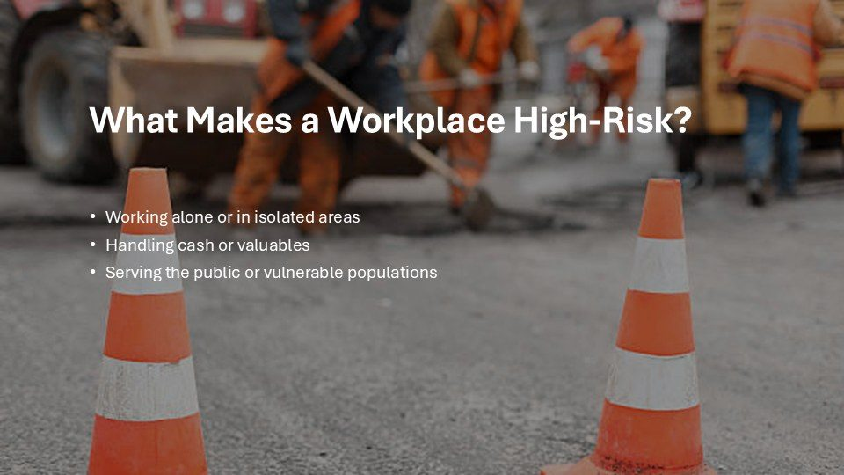  Notes __________________ | What Makes a Workplace High-Risk?  dealing with unpredictable clients or being accessible to the public,  Assess the exposure, use the strongest practical controls, train workers, and review whether the controls work.  KEY POINTS  • Working alone or in isolated areas Handling cash or valuables Serving the public or vulnerable...  • Assess the exposure, use the strongest practical controls, train workers, and review whether the...

LESSON 02 • SLIDE 18 OF 43  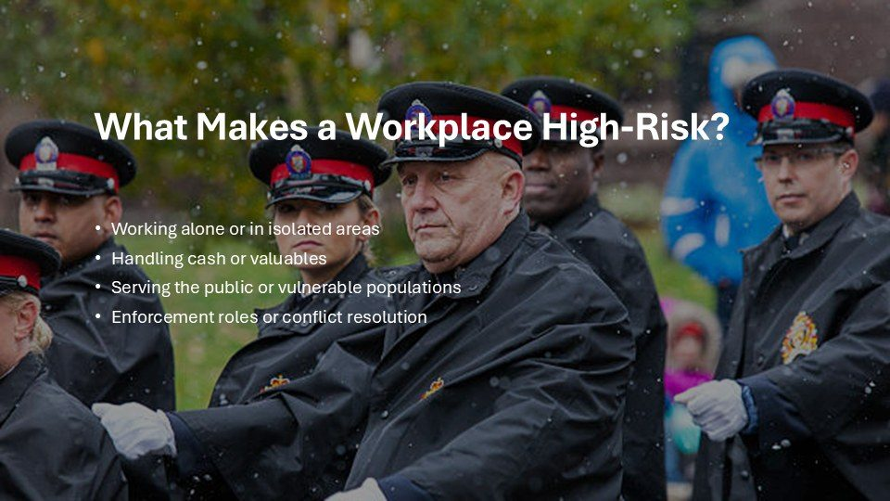  Notes __________________ | What Makes a Workplace High-Risk?  or working in high-stress situations such as law enforcement or security.  Assess the exposure, use the strongest practical controls, train workers, and review whether the controls work.  KEY POINTS  • Working alone or in isolated areas Handling cash or valuables Serving the public or vulnerable...  • Assess the exposure, use the strongest practical controls, train workers, and review whether the...

GENERAL NOTES

LESSON 02 • SLIDE 19 OF 43  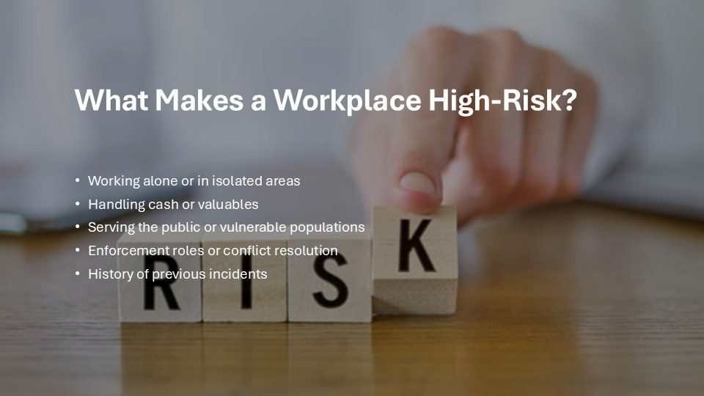  Notes __________________ | What Makes a Workplace High-Risk?  A history of past incidents can also be a red flag.  Assess the exposure, use the strongest practical controls, train workers, and review whether the controls work.  KEY POINTS  • Working alone or in isolated areas Handling cash or valuables Serving the public or vulnerable...  • Assess the exposure, use the strongest practical controls, train workers, and review whether the...

LESSON 02 • SLIDE 20 OF 43  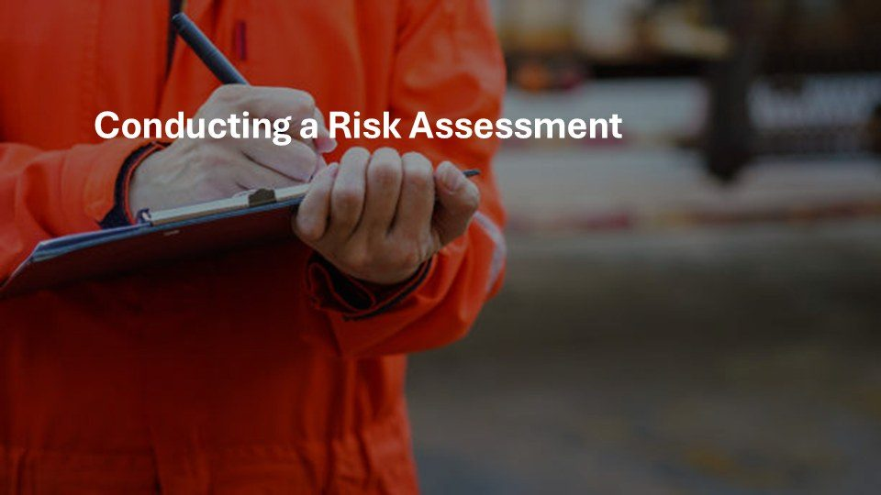  Notes __________________ | Conducting a Risk Assessment  A violence risk assessment helps you understand where and how violence could occur.  Assess the exposure, use the strongest practical controls, train workers, and review whether the controls work.  KEY POINTS  • Conducting a Risk Assessment  • Assess the exposure, use the strongest practical controls, train workers, and review whether the...

LESSON 02 • SLIDE 21 OF 43  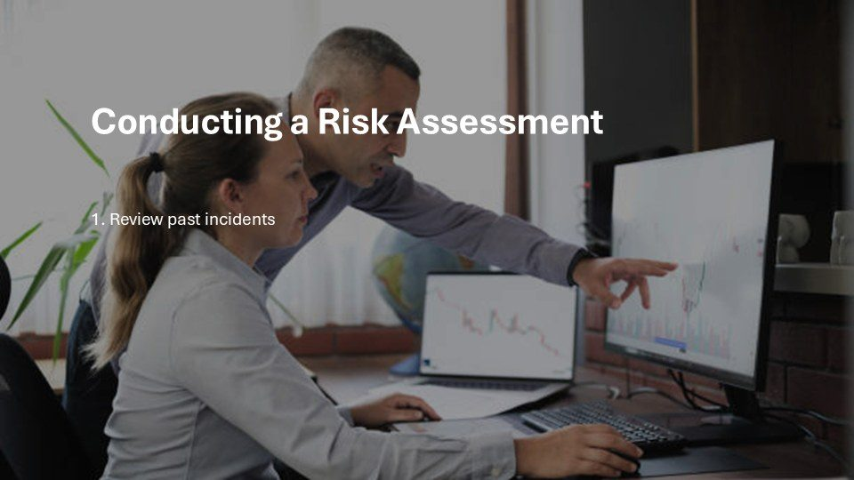  Notes __________________ | Conducting a Risk Assessment  Look at past incidents,  Assess the exposure, use the strongest practical controls, train workers, and review whether the controls work.  KEY POINTS  • 1. Review past incidents.  • Assess the exposure, use the strongest practical controls, train workers, and review whether the...

GENERAL NOTES

LESSON 02 • SLIDE 22 OF 43  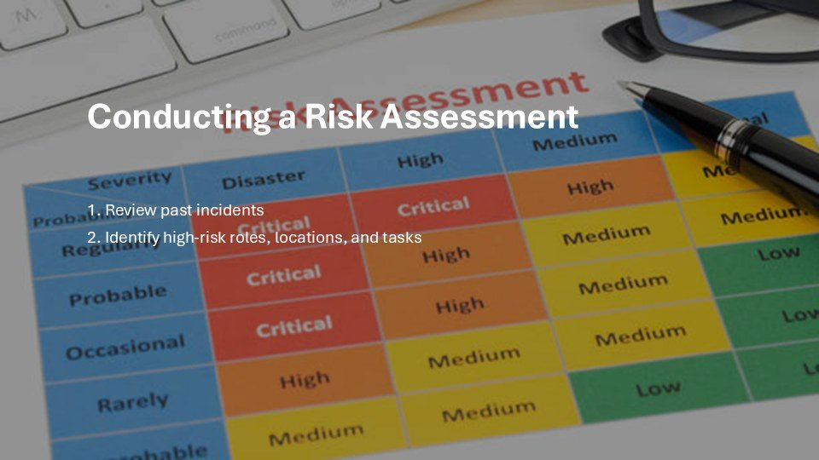  Notes __________________ | Conducting a Risk Assessment  assess job roles and work environments,  Assess the exposure, use the strongest practical controls, train workers, and review whether the controls work.  KEY POINTS  • 1. Review past incidents 2. Identify high-risk roles, locations, and tasks.  • Assess the exposure, use the strongest practical controls, train workers, and review whether the...

LESSON 02 • SLIDE 23 OF 43  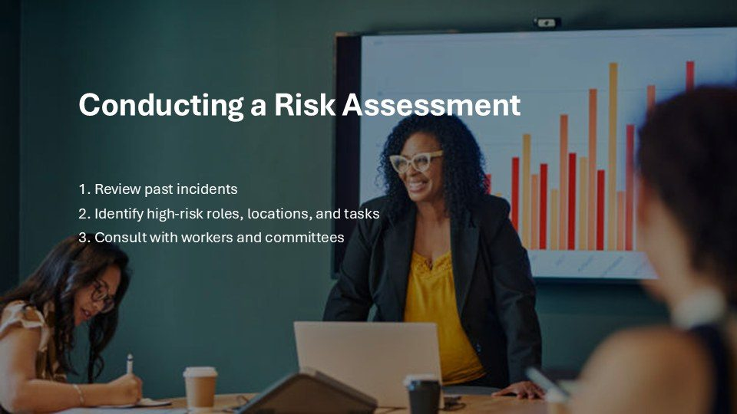  Notes __________________ | Conducting a Risk Assessment  consult with staff and Joint Health and Safety Committees.  Assess the exposure, use the strongest practical controls, train workers, and review whether the controls work.  KEY POINTS  • 1. Review past incidents 2. Identify high-risk roles, locations, and tasks 3. Consult with workers and...  • Assess the exposure, use the strongest practical controls, train workers, and review whether the...

LESSON 02 • SLIDE 24 OF 43  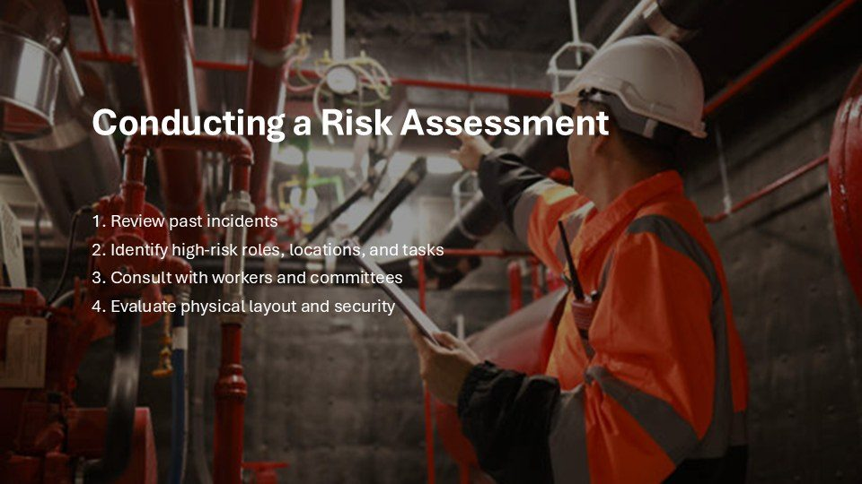  Notes __________________ | Conducting a Risk Assessment  Evaluate physical layout and security  Assess the exposure, use the strongest practical controls, train workers, and review whether the controls work.  KEY POINTS  • 1. Review past incidents 2. Identify high-risk roles, locations, and tasks 3. Consult with workers and...  • Assess the exposure, use the strongest practical controls, train workers, and review whether the...

GENERAL NOTES

LESSON 02 • SLIDE 25 OF 43  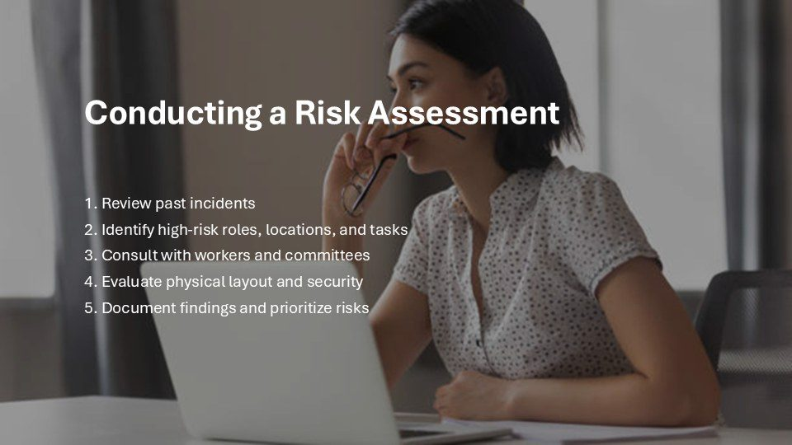  Notes __________________ | Conducting a Risk Assessment  Document findings and prioritize risks  Assess the exposure, use the strongest practical controls, train workers, and review whether the controls work.  KEY POINTS  • 1. Review past incidents 2. Identify high-risk roles, locations, and tasks 3. Consult with workers and...  • Assess the exposure, use the strongest practical controls, train workers, and review whether the...

LESSON 02 • SLIDE 26 OF 43  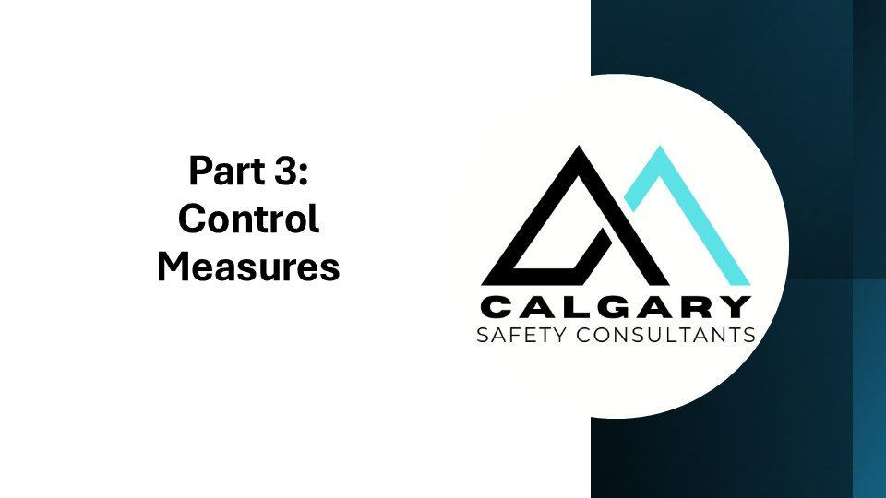  Notes __________________ | Part 3: ; Control Measures  Assess the exposure, use the strongest practical controls, train workers, and review whether the controls work.  Assess the exposure, use the strongest practical controls, train workers, and review whether the controls work.  KEY POINTS  • Part 3: ; Control Measures  • Assess the exposure, use the strongest practical controls, train workers, and review whether the...

LESSON 02 • SLIDE 27 OF 43  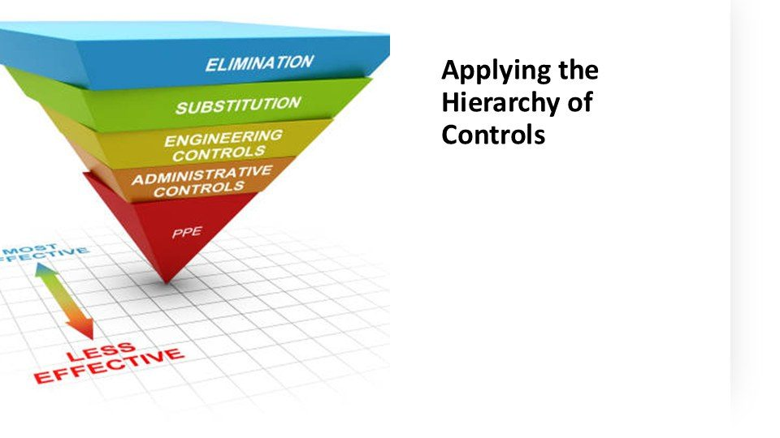  Notes __________________ | Applying the Hierarchy of Controls  Risk identification is followed by control implementation. Establishing due diligence requires implementing controls, which is done using the Hierarchy of Controls.  Assess the exposure, use the strongest practical controls, train workers, and review whether the controls work.  KEY POINTS  • Applying the Hierarchy of Controls  • Assess the exposure, use the strongest practical controls, train workers, and review whether the...

GENERAL NOTES

LESSON 02 • SLIDE 28 OF 43  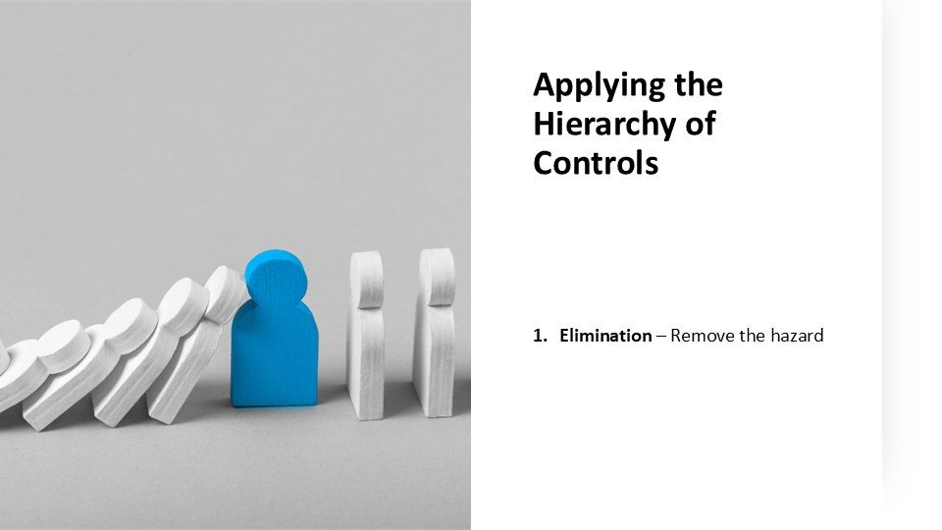  Notes __________________ | Applying the Hierarchy of Controls  Elimination is the most effective form of hazard control in the hierarchy. It is to physically remove the hazard from the workplace so there is no risk of exposure or harm to workers. In workplace violence, it could mean the termination of personnel who have a history of violence or who have displayed violent tendencies in the...  Assess the exposure, use the strongest practical controls, train workers, and review whether the controls work.  KEY POINTS  • Elimination – Remove the hazard.  • Assess the exposure, use the strongest practical controls, train workers, and review whether the...

LESSON 02 • SLIDE 29 OF 43  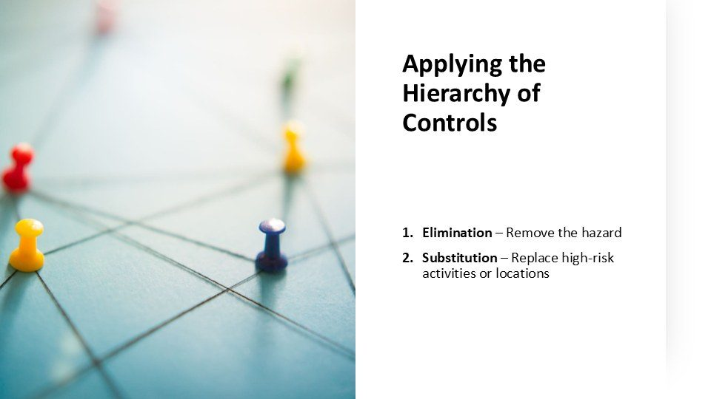  Notes __________________ | Applying the Hierarchy of Controls  Substitution is the next level. Such as replacing high-risk activities or moving locations to a safer area.  Assess the exposure, use the strongest practical controls, train workers, and review whether the controls work.  KEY POINTS  • Elimination – Remove the hazard Substitution – Replace high-risk activities or locations.  • Assess the exposure, use the strongest practical controls, train workers, and review whether the...

LESSON 02 • SLIDE 30 OF 43  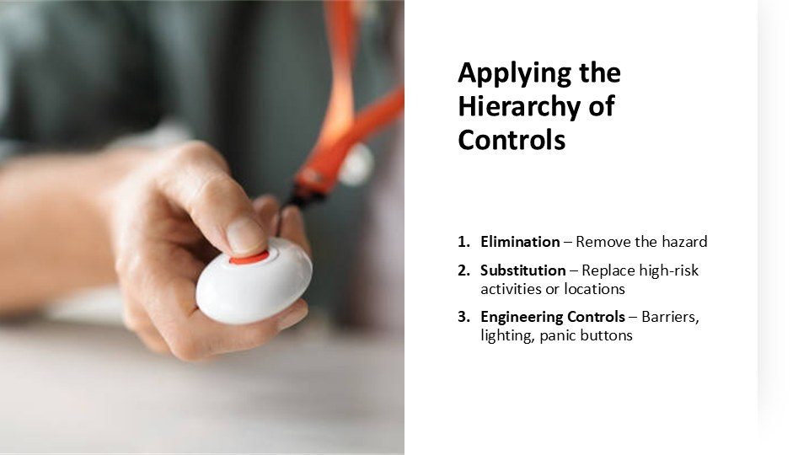  Notes __________________ | Applying the Hierarchy of Controls  Engineering controls are the third level in the hierarchy of hazard controls and focus on designing solutions to isolate workers from hazards. Instead of removing the hazard (like elimination or substitution), engineering controls aim to physically separate or shield workers from it.  A panic button is also a form of engineering control where help is summoned or an alarm is activated to alert others to the threat.  KEY POINTS  • Elimination – Remove the hazard Substitution – Replace high-risk activities or locations Engineering...  • Assess the exposure, use the strongest practical controls, train workers, and review whether the...

GENERAL NOTES

LESSON 02 • SLIDE 31 OF 43  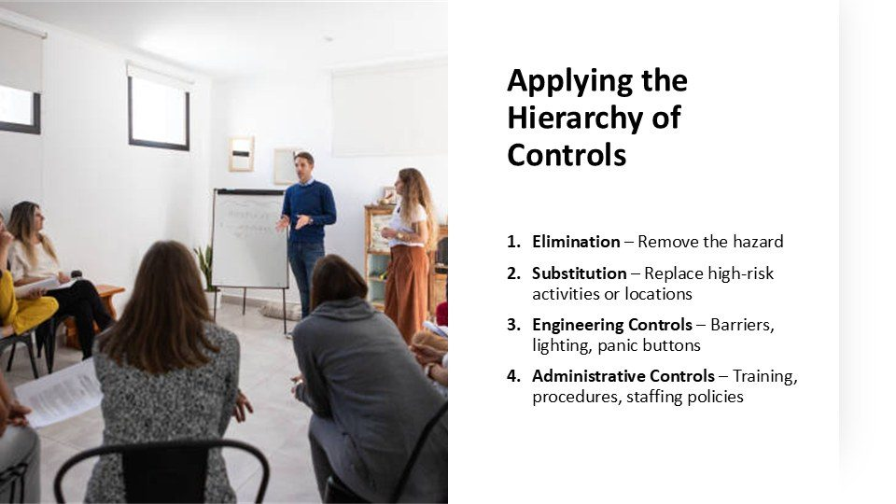  Notes __________________ | Applying the Hierarchy of Controls  Administrative controls are the fourth level in the hierarchy of hazard controls, and they focus on changing the way people work rather than removing the hazard itself. These controls aim to reduce exposure to hazards through policies, procedures, training, and scheduling.  Assess the exposure, use the strongest practical controls, train workers, and review whether the controls work.  KEY POINTS  • Elimination – Remove the hazard Substitution – Replace high-risk activities or locations Engineering...  • Assess the exposure, use the strongest practical controls, train workers, and review whether the...

LESSON 02 • SLIDE 32 OF 43  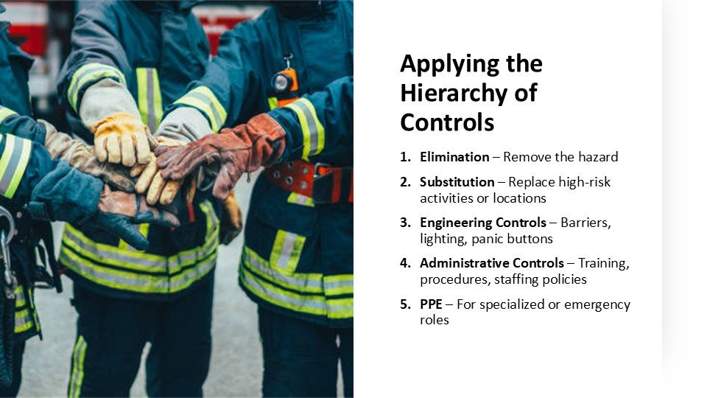  Notes __________________ | Applying the Hierarchy of Controls  Personal Protective Equipment (PPE) is the last line of defense in the hierarchy of hazard controls. It doesn’t eliminate or reduce the hazard itself. Instead, it provides a physical barrier between the worker and the hazard.  Workplace violence safety measures may include PPE for certain roles, such as what is given to police and security.  KEY POINTS  • Elimination – Remove the hazard Substitution – Replace high-risk activities or locations Engineering...  • Assess the exposure, use the strongest practical controls, train workers, and review whether the...

LESSON 02 • SLIDE 33 OF 43  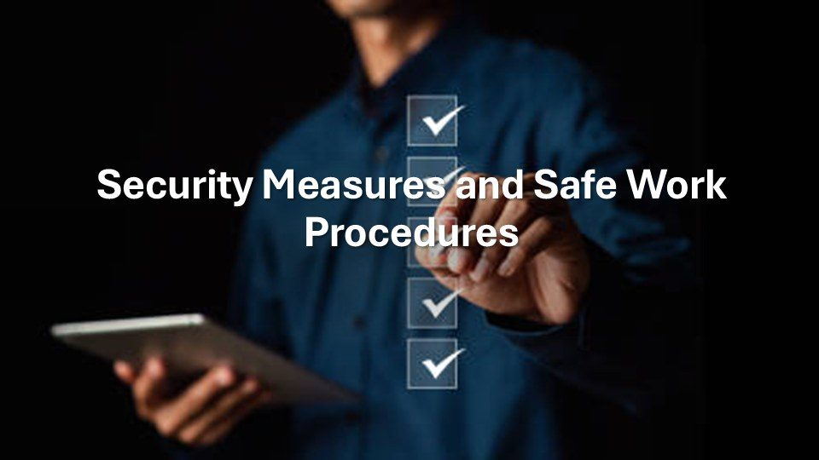  Notes __________________ | Security Measures and Safe Work Procedures  Security measures are a key part of prevention. These might include surveillance systems, alarms, or restricted access. For mobile or isolated workers, check-in protocols or GPS tracking may be used. Staff should also be trained in conflict de-escalation and safe practices for dealing with the public.  Assess the exposure, use the strongest practical controls, train workers, and review whether the controls work.  KEY POINTS  • Security Measures and Safe Work Procedures  • Assess the exposure, use the strongest practical controls, train workers, and review whether the...

GENERAL NOTES

LESSON 02 • SLIDE 34 OF 43  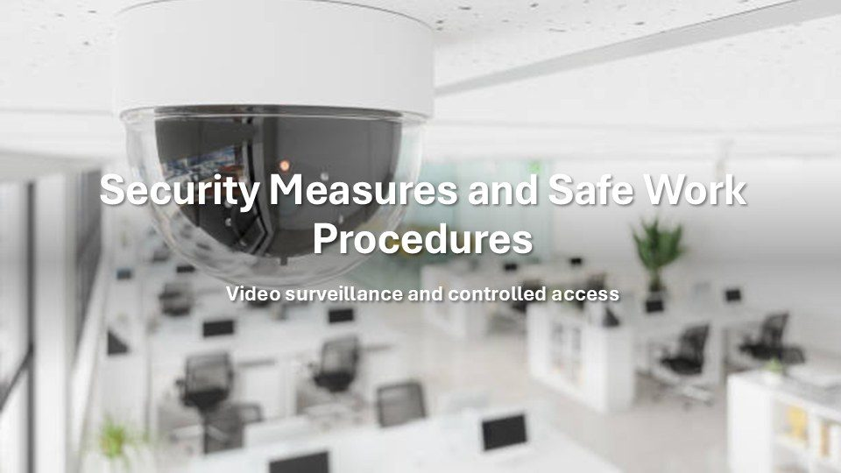  Notes __________________ | Security Measures and Safe Work Procedures  Video surveillance and controlled access are powerful tools in building a safer, more respectful workplace. When used properly, video surveillance serves two key roles; to act as a deterrent and a monitoring tool.  The presence of visible cameras in shared spaces like hallways, lobbies, and break rooms can discourage inappropriate or aggressive behavior by reminding everyone that their actions are being seen—and that accountability matters.  KEY POINTS  • Video surveillance and controlled access.  • Assess the exposure, use the strongest practical controls, train workers, and review whether the...

LESSON 02 • SLIDE 35 OF 43  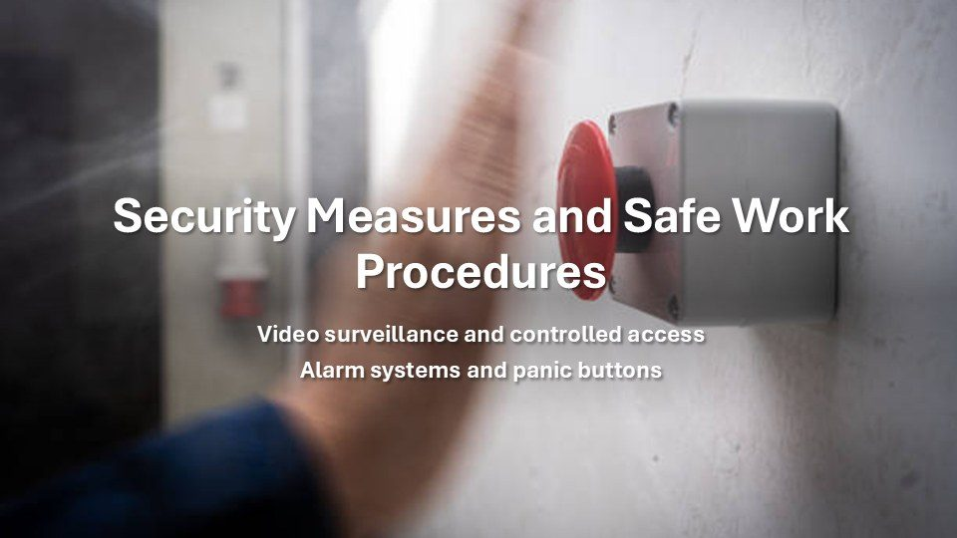  Notes __________________ | Security Measures and Safe Work Procedures  Alarm systems and panic buttons are essential components of a proactive approach to preventing workplace harassment and violence. These tools provide employees with a quick and discreet way to call for help in threatening or emergency situations.  Panic buttons can be installed under desks, in reception areas, or carried as personal devices. It allows workers to immediately alert security, supervisors, or emergency responders without escalating the situation.  KEY POINTS  • Video surveillance and controlled access Alarm systems and panic buttons.  • Assess the exposure, use the strongest practical controls, train workers, and review whether the...

LESSON 02 • SLIDE 36 OF 43  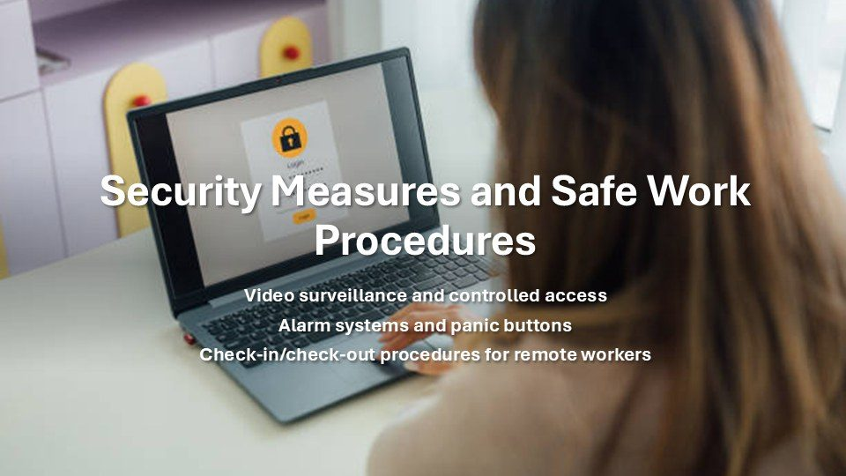  Notes __________________ | Security Measures and Safe Work Procedures  Check-in/check-out procedures for remote and lone workers are an important administrative control that helps prevent and respond to potential harassment and workplace violence.  These procedures involve having employees regularly report their location, work status, and well-being to a designated person or system—especially when working alone, off-site, or in potentially high-risk environments.  KEY POINTS  • Video surveillance and controlled access Alarm systems and panic buttons Check-in/check-out procedures...  • Assess the exposure, use the strongest practical controls, train workers, and review whether the...

GENERAL NOTES

LESSON 02 • SLIDE 37 OF 43  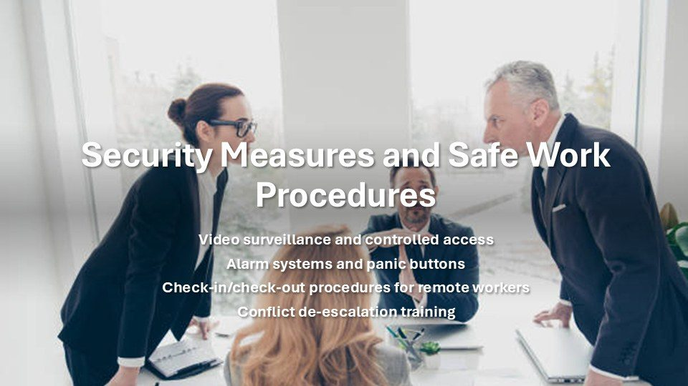  Notes __________________ | Security Measures and Safe Work Procedures  Conflict de-escalation training is a vital tool in preventing harassment and workplace violence by equipping employees with the skills to recognize, respond to, and defuse tense or potentially aggressive situations before they escalate.  This type of training teaches practical techniques such as active listening, non-threatening body language, maintaining a calm tone of voice, and setting respectful boundaries. It also helps individuals understand the early warning signs of conflict, including verbal cues, emotional triggers, and behavioral changes, allowing...  KEY POINTS  • Video surveillance and controlled access Alarm systems and panic buttons Check-in/check-out procedures...  • Assess the exposure, use the strongest practical controls, train workers, and review whether the...

LESSON 02 • SLIDE 38 OF 43  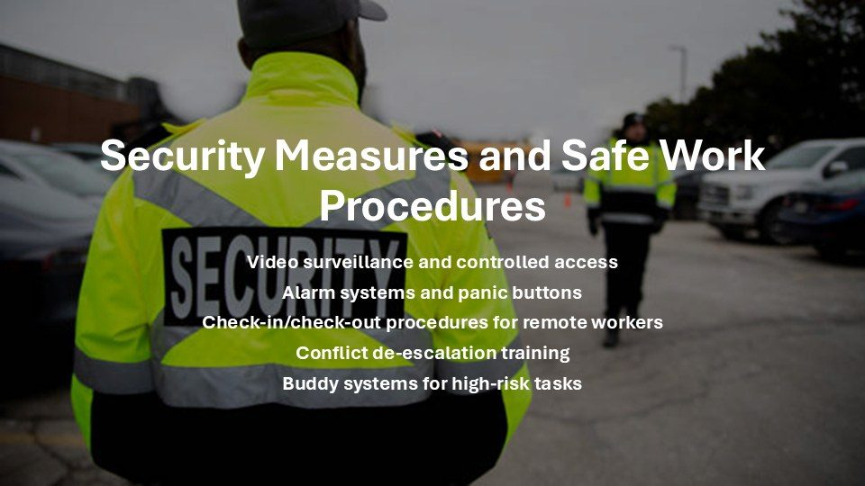  Notes __________________ | Security Measures and Safe Work Procedures  Buddy systems for high-risk tasks are an effective preventive measure against workplace harassment and violence, particularly in situations where employees may be more vulnerable due to isolation, location, or the nature of their work.  By pairing employees together, the buddy system ensures that no one is left alone in potentially risky environments—whether it's working in remote areas, dealing with the public, handling cash, or engaging in emotionally charged or unpredictable situations.  KEY POINTS  • Video surveillance and controlled access Alarm systems and panic buttons Check-in/check-out procedures...  • Assess the exposure, use the strongest practical controls, train workers, and review whether the...

LESSON 02 • SLIDE 39 OF 43    Notes __________________ | Part 4: ; Bringing it all Together  Assess the exposure, use the strongest practical controls, train workers, and review whether the controls work.  Assess the exposure, use the strongest practical controls, train workers, and review whether the controls work.  KEY POINTS  • Part 4: ; Bringing it all Together  • Assess the exposure, use the strongest practical controls, train workers, and review whether the...

GENERAL NOTES

LESSON 02 • SLIDE 40 OF 43  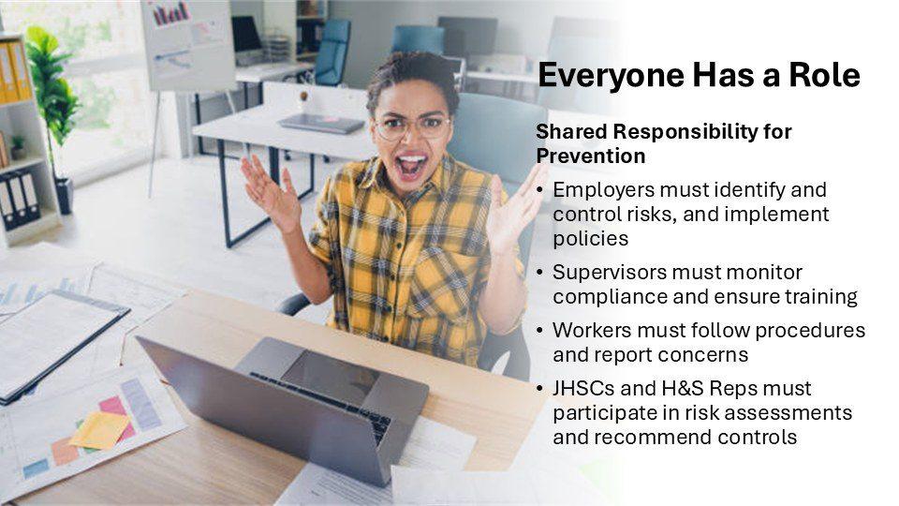  Notes __________________ | Everyone Has a Role;  Preventing violence is a shared responsibility. Employers must assess risks and implement controls. Supervisors are responsible for training and enforcement. Workers must follow safe work procedures and report hazards. Joint Health and Safety Committees play an important role in assessing and recommending prevention strategies.  Assess the exposure, use the strongest practical controls, train workers, and review whether the controls work.  KEY POINTS  • Shared Responsibility for Prevention Employers must identify and control risks, and implement policies...  • Assess the exposure, use the strongest practical controls, train workers, and review whether the...

LESSON 02 • SLIDE 41 OF 43  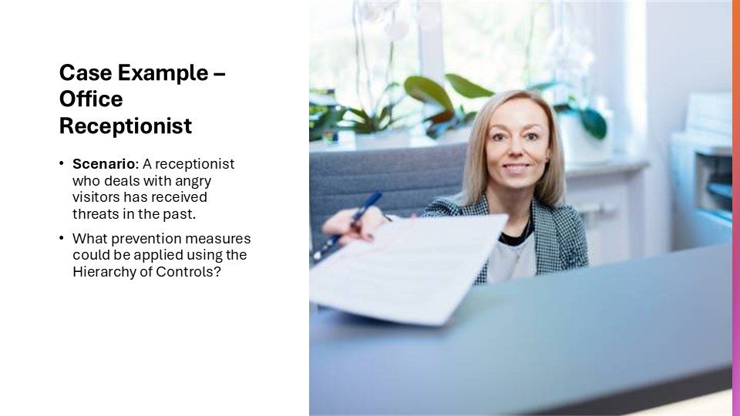  Notes __________________ | Case Example – Office Receptionist  Let’s apply what we’ve learned to a real-world example. A receptionist frequently handles confrontational individuals. What can we do to protect this worker? Consider options like installing a barrier, panic buttons, training in de-escalation, or staffing adjustments during peak hours.  Assess the exposure, use the strongest practical controls, train workers, and review whether the controls work.  KEY POINTS  • Scenario: A receptionist who deals with angry visitors has received threats in the past. What prevention...  • Assess the exposure, use the strongest practical controls, train workers, and review whether the...

LESSON 02 • SLIDE 42 OF 43  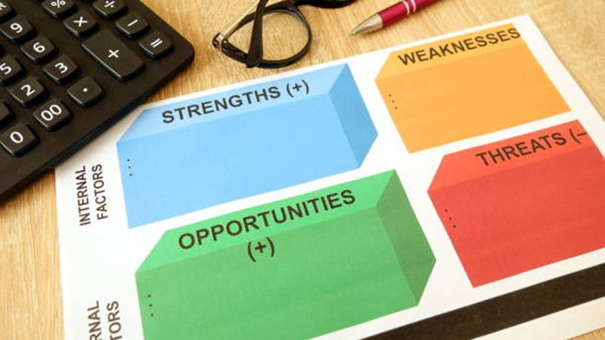  Notes __________________ | In this lesson, we looked at how to identify and assess the risk of violence, apply...  In this lesson, we looked at how to identify and assess the risk of violence, apply effective prevention strategies, and involve everyone in the solution.  Assess the exposure, use the strongest practical controls, train workers, and review whether the controls work.  KEY POINTS  • In this lesson, we looked at how to identify and assess the risk of violence, apply...  • Assess the exposure, use the strongest practical controls, train workers, and review whether the...

GENERAL NOTES

LESSON 02 • SLIDE 43 OF 43    Notes __________________ | Prevention isn’t just a legal requirement—it’s a key to building a safer, more respectful...  Prevention isn’t just a legal requirement—it’s a key to building a safer, more respectful workplace.  Assess the exposure, use the strongest practical controls, train workers, and review whether the controls work.  KEY POINTS  • Prevention isn’t just a legal requirement—it’s a key to building a safer, more respectful...  • Assess the exposure, use the strongest practical controls, train workers, and review whether the...

GENERAL NOTES

LESSON 02 SUMMARY
Preventing and Controlling Workplace Violence
The following points bring the lesson together. Use them to review the main prevention message and connect it to the procedures and expectations in your workplace.
01 | A violence risk assessment examines the work, environment, people, previous events, available information, and existing controls.
02 | Elimination and engineering controls should be considered before relying only on procedures, training, or personal protective measures.
03 | Effective controls may include access management, visibility, alarms, communication, staffing, scheduling, check in systems, and safe work procedures.
04 | Workers need practical training on the hazards, controls, reporting routes, emergency steps, and limits of their role.
05 | Controls should be monitored and reviewed after incidents, near misses, worker feedback, or changes in tasks, locations, staffing, or exposure.
Reflection and application
• Which violence controls in this workplace depend too heavily on individual behaviour?
• What task needs a clearer safe work procedure or check in system?
• How are workers involved when violence controls are reviewed?
________________________________________________________________________________
________________________________________________________________________________
GENERAL NOTES

MODULE THREE / LESSON 03

Violence Prevention Plans Policies and Procedures
Program design | Roles | Reporting | Emergency response | Review
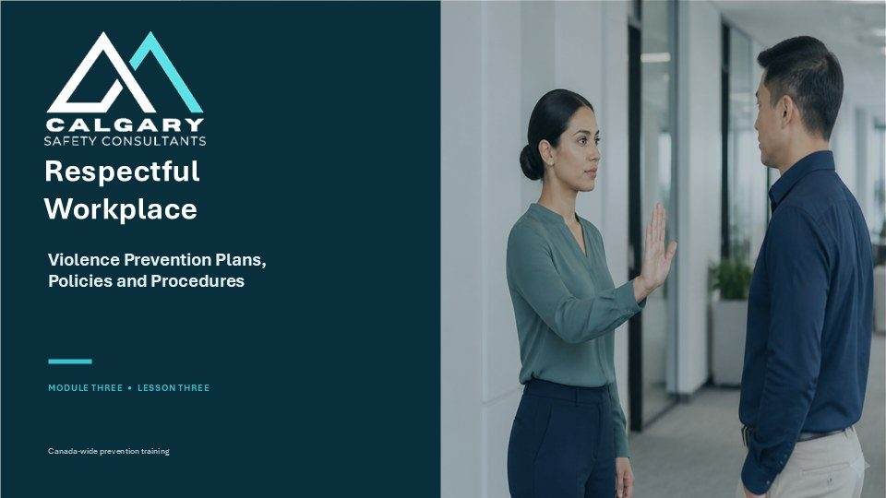
Lesson overview
A violence prevention plan turns the risk assessment into clear responsibilities, controls, reporting routes, emergency directions, training, records, and review. The plan must match the legal requirements and operating conditions of the workplace rather than remain a generic document.
This lesson explains the core elements of a usable policy and prevention program, including primary and alternate reporting routes, role clarity, privacy, support, emergency response, investigation, corrective action, communication, and scheduled review.
By the end of this lesson you should be able to
• Recognize the core elements of a workplace violence prevention policy and program.
• Connect identified risks with controls, procedures, training, and emergency arrangements.
• Identify employer, supervisor, worker, committee, representative, and designated recipient roles.
• Confirm primary, alternate, and emergency reporting routes and what happens after a report.
• Review the program when required and after incidents, control failures, or workplace changes.
GENERAL NOTES

LESSON 03 • SLIDE 01 OF 32  Notes __________________ | Violence Prevention Plans Policies and Procedures  Welcome to Module Three, Lesson Three: Violence Prevention Plans, Policies and Procedures. In this lesson, we will examine the workplace system used to prevent violence.  That system may be organized as a policy, program, plan or set of procedures, depending on the law that applies and the terminology used by your organization. Whatever it is called, it should connect risk assessment to practical controls, clear responsibilities, reporting routes, emergency action, response, support and review....  KEY POINTS  • Respectful Workplace.  • Violence Prevention Plans, Policies and Procedures.  • MODULE THREE • LESSON THREE.

LESSON 03 • SLIDE 02 OF 32  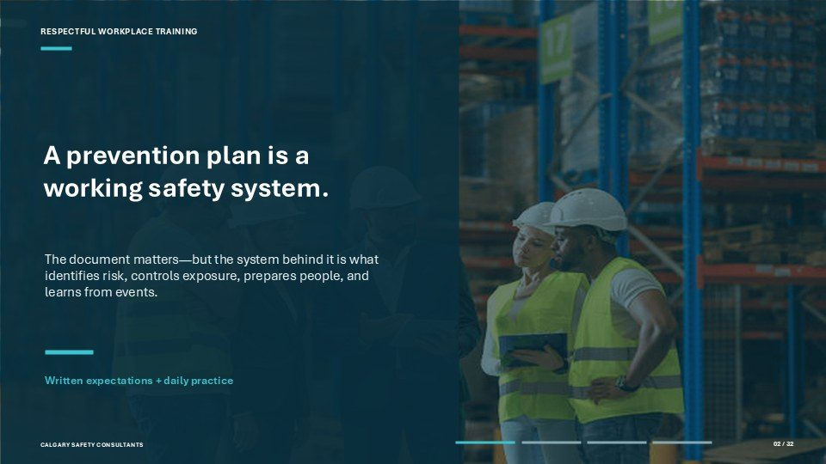  Notes __________________ | A prevention plan is a working safety system.  A prevention plan is a working safety system. The written document matters because it states expectations and describes the required procedures. However, the system behind the document is what actually identifies risk, controls exposure, prepares people and learns from events.  Written expectations become daily practice when workers can find the plan, understand the controls that apply to their work and use the correct reporting or emergency route. Leaders also need to recognize concerns, respond consistently and follow corrective actions through to completion. The key question is not simply...  KEY POINTS  • The document matters—but the system behind it is what identifies risk, controls exposure, prepares...  • Written expectations + daily practice.

LESSON 03 • SLIDE 03 OF 32  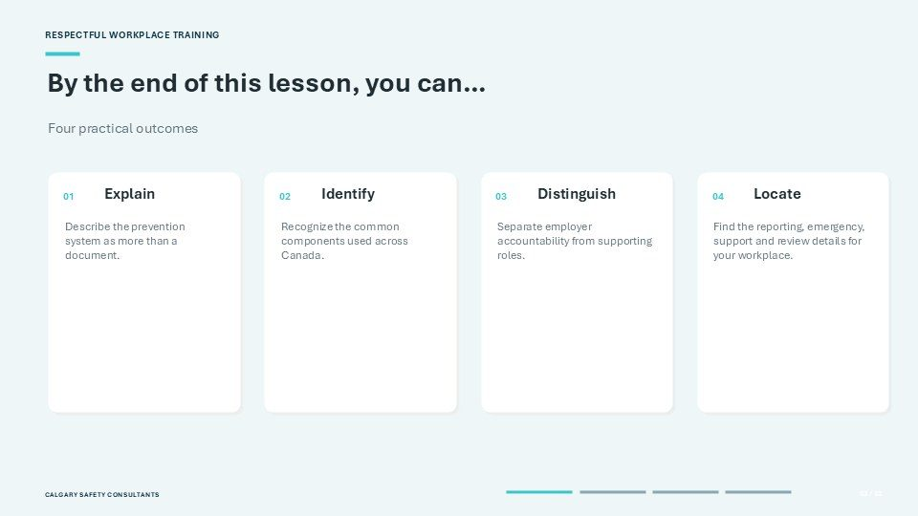  Notes __________________ | By the end of this lesson, you can…  By the end of this lesson, you should be able to achieve four practical outcomes. First, explain why violence prevention is a working system and not just a document. Second, identify the common components that connect policy to prevention across Canadian workplaces.  Third, distinguish employer accountability from the supporting responsibilities of leaders, workers, committees, representatives and unions. Fourth, locate the reporting, emergency, support and review information for your own workplace. As you learn, focus on what you would need to recognize, find or do. The purpose is not only...  KEY POINTS  • Four practical outcomes.  • Distinguish.  • Describe the prevention system as more than a document.

GENERAL NOTES

LESSON 03 • SLIDE 04 OF 32  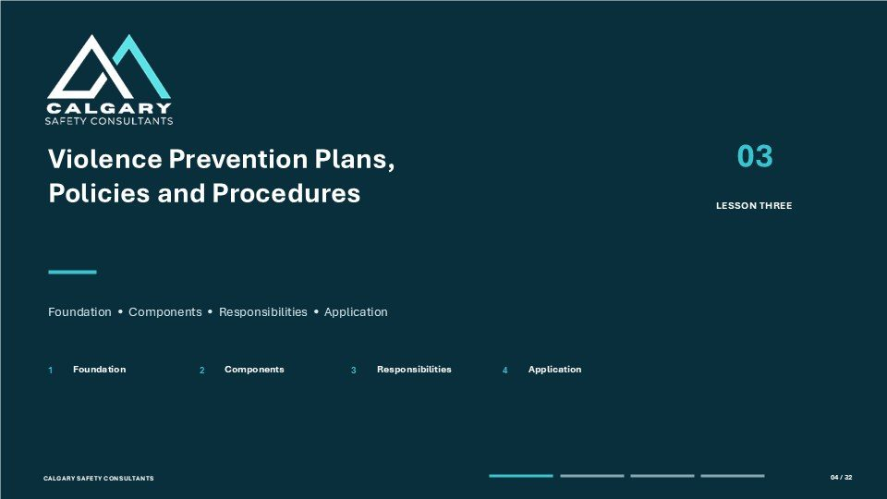  Notes __________________ | Violence Prevention Plans, Policies and Procedures  This lesson is organized into four connected parts. Foundation explains why prevention must operate as a working system and why legal structures differ across Canada. Components describes the elements that make the system usable, including assessment, controls, reporting, response, support, training and review.  Responsibilities clarifies who owns the system and how other workplace parties contribute. Application gives you an opportunity to use the concepts in a scenario, knowledge check and workplace-readiness review. Notice the progression: first understand the system, then examine its...  KEY POINTS  • Foundation • Components • Responsibilities • Application.  • Foundation.  • Components.

LESSON 03 • SLIDE 05 OF 32  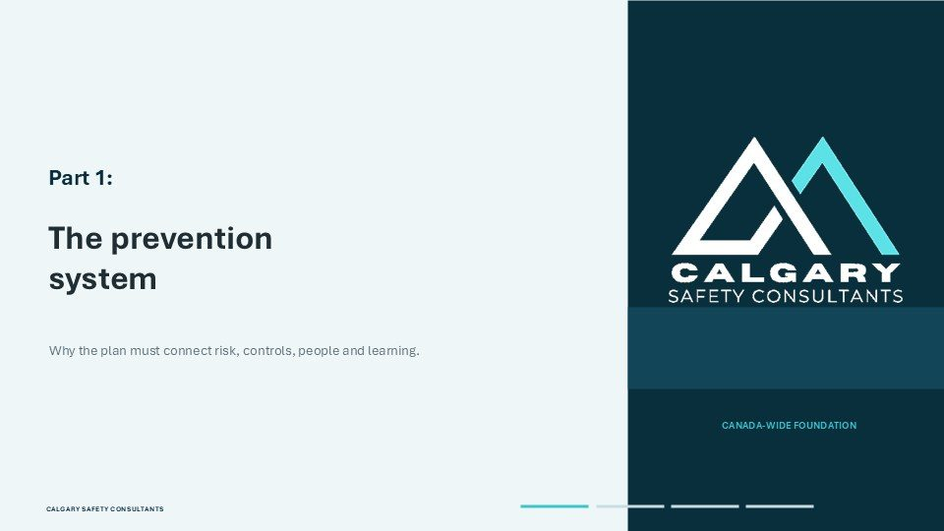  Notes __________________ | Part 1: The prevention system  Part One introduces the prevention system. A violence prevention plan should connect risk, controls, people and learning. Risk information identifies where exposure may occur. Controls change the work or environment to eliminate or reduce that exposure.  People need clear roles, accessible procedures and the ability to use them. Learning from incidents, near misses and feedback keeps the system current. If one of these connections is weak, the written plan may exist without producing safer decisions. As we examine the foundation, keep asking how the document is translated into...  KEY POINTS  • The prevention system.  • Why the plan must connect risk, controls, people and learning.

LESSON 03 • SLIDE 06 OF 32  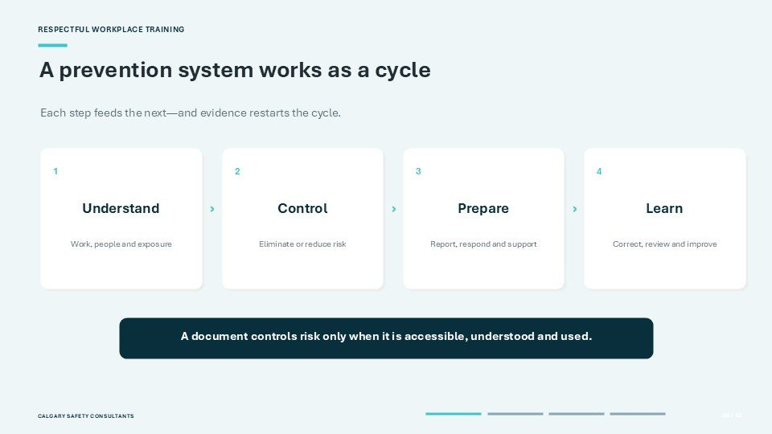  Notes __________________ | A prevention system works as a cycle  A prevention system works as a cycle. Step one is Understand: examine the work, the people who may be exposed and the situations in which violence could arise. Step two is Control: eliminate the hazard where possible or reduce the risk through safer design, equipment and work practices.  Step three is Prepare: make reporting, emergency response, investigation and support procedures clear before an event occurs. Step four is Learn: use incidents, near misses, worker feedback and corrective actions to decide what needs to improve. Each step feeds the next. When the work changes or evidence shows...  KEY POINTS  • Each step feeds the next—and evidence restarts the cycle.  • Understand.  • Work, people and exposure.

GENERAL NOTES

LESSON 03 • SLIDE 07 OF 32  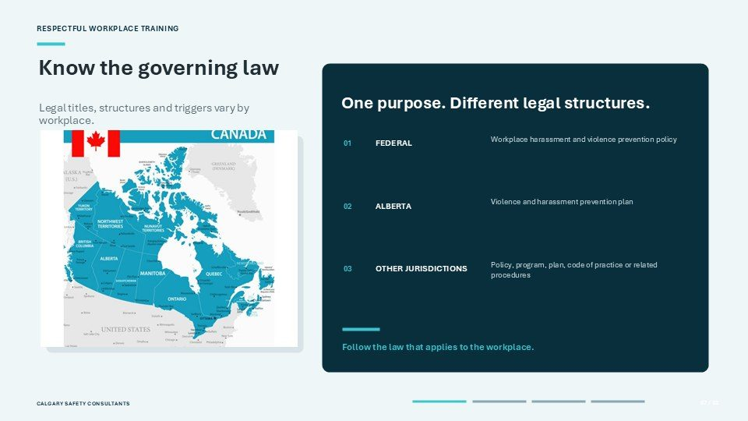  Notes __________________ | Know the governing law  The first legal step is to know the governing law. The prevention purpose is similar across Canada, but the required titles, structures, consultation processes and review triggers are not identical. Federally regulated workplaces use a workplace harassment and violence prevention policy under the federal regulations.  Alberta uses the term violence and harassment prevention plan. Other jurisdictions may require a policy, program, plan, code of practice or related procedures. Do not assume that one label or one set of rules applies everywhere. Identify the jurisdiction that governs the...  KEY POINTS  • One purpose. Different legal structures.  • Legal titles, structures and triggers vary by workplace.  • Workplace harassment and violence prevention policy.

LESSON 03 • SLIDE 08 OF 32  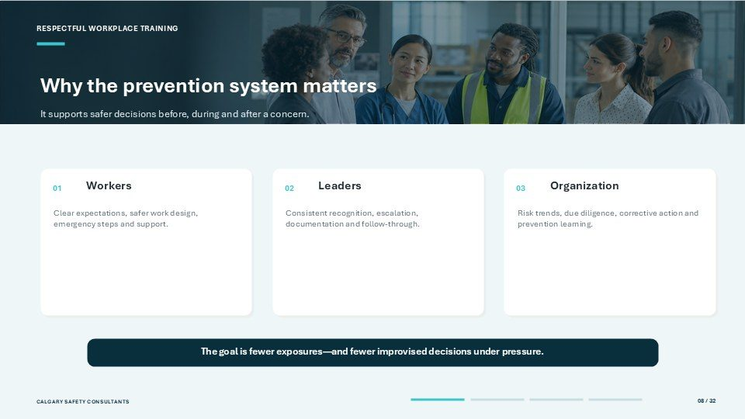  Notes __________________ | Why the prevention system matters  A strong prevention system supports safer decisions before, during and after a concern. For workers, it provides clear expectations, safer work design, understandable emergency steps and reliable access to reporting and support.  For leaders, it provides a consistent way to recognize concerns, escalate urgent situations, document initial information and follow the required process. For the organization, it provides evidence about risk trends, due diligence, control failures and corrective action. The goal is fewer exposures and fewer improvised...  KEY POINTS  • It supports safer decisions before, during and after a concern.  • Organization.  • Clear expectations, safer work design, emergency steps and support.

LESSON 03 • SLIDE 09 OF 32  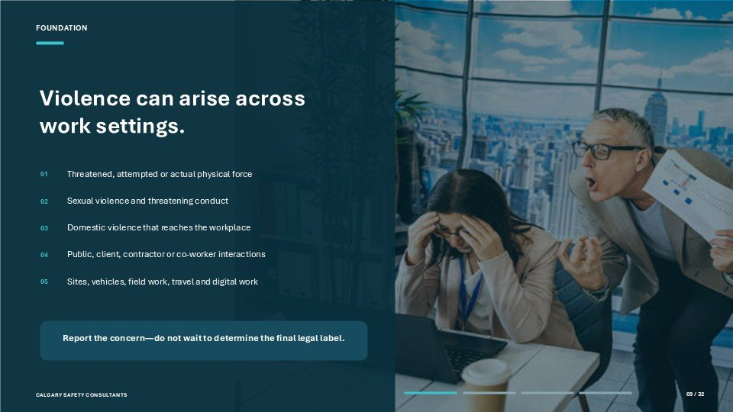  Notes __________________ | Violence can arise across work settings.  Violence can arise across work settings. It may involve threatened, attempted or actual physical force, sexual violence, threatening conduct or domestic violence that reaches the workplace, depending on the definition in the governing law.  The source may be a member of the public, a client, contractor, co-worker or another person connected to the work. Exposure can occur at a regular work site, in a vehicle, during field work or travel, at a work-connected event or through digital communication. If you experience or observe a concern, report it through the...  KEY POINTS  • Threatened, attempted or actual physical force.  • Sexual violence and threatening conduct.  • Domestic violence that reaches the workplace.

GENERAL NOTES

LESSON 03 • SLIDE 10 OF 32  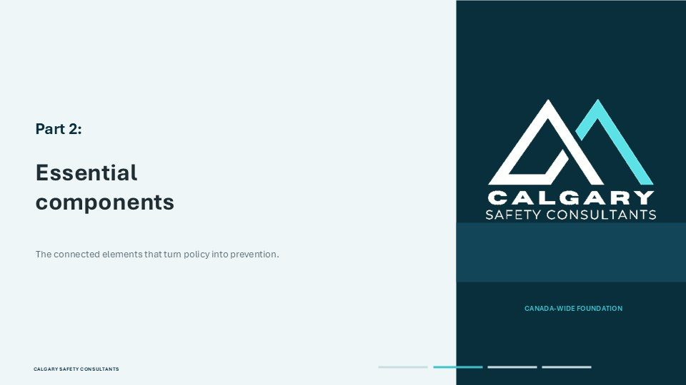  Notes __________________ | Part 2: Essential components  Part Two examines the essential components that turn policy into prevention. These components are connected. Clear definitions help people recognize what is covered. Risk assessment identifies exposure. Controls reduce the risk. Roles, reporting routes and emergency procedures guide action.  Response, privacy and support protect people after information is received. Training makes the system usable, while records and review create learning. The exact legal wording varies, but each component answers a practical question: what is covered, what can happen, what controls the risk, what should a...  KEY POINTS  • Essential components.  • The connected elements that turn policy into prevention.

LESSON 03 • SLIDE 11 OF 32  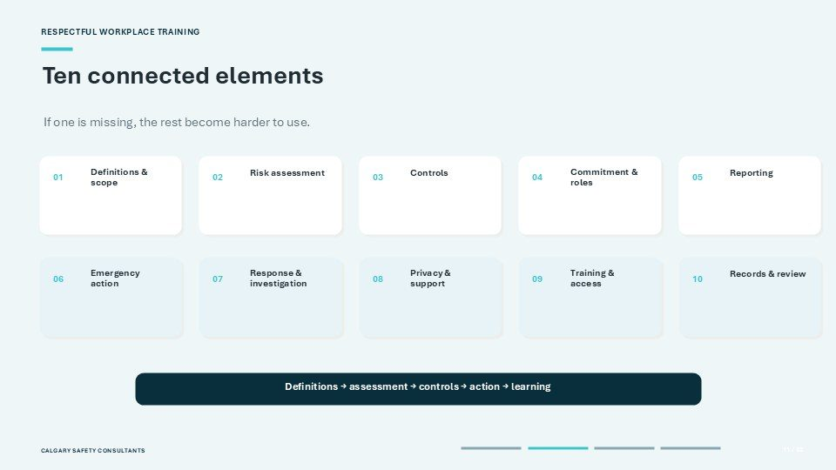  Notes __________________ | Ten connected elements  A practical prevention system contains ten connected elements. Definitions and scope establish what conduct, people and work situations are covered. Risk assessment identifies where and how violence may arise. Controls eliminate or reduce exposure.  Commitment and roles establish accountability and required consultation. Reporting gives people a safe route to raise a concern. Emergency action provides a different route when danger is immediate. Response and investigation explain what happens next. Privacy and support protect affected people. Training and access help...  KEY POINTS  • If one is missing, the rest become harder to use.  • Definitions & scope.  • Risk assessment.

LESSON 03 • SLIDE 12 OF 32  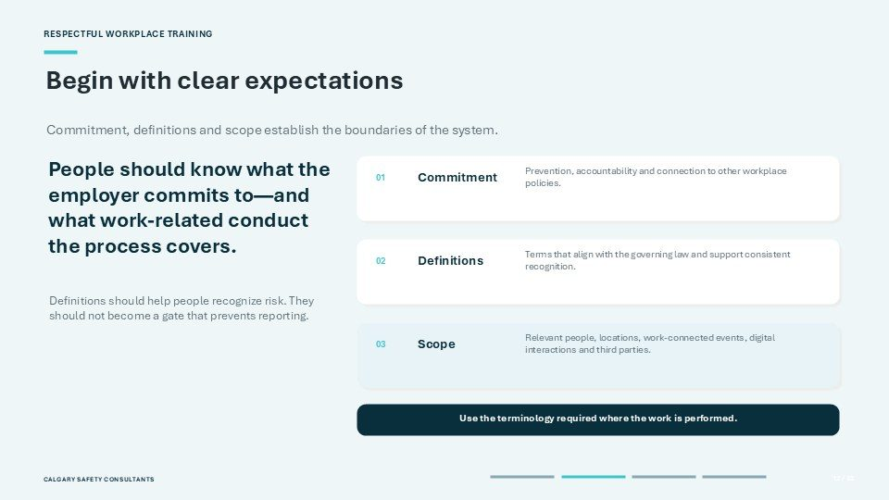  Notes __________________ | Begin with clear expectations  Begin with clear expectations. Commitment explains what the employer will do to prevent violence, provide a response and maintain accountability. Definitions should align with the governing law and help people recognize risk consistently. They should not become a barrier that prevents someone from reporting a concern.  Scope identifies the people, locations, work-connected events, digital interactions and third parties covered by the process. It should also explain how this plan connects with related policies and procedures. When reading your workplace documents, look for these three elements...  KEY POINTS  • Commitment, definitions and scope establish the boundaries of the system.  • People should know what the employer commits to—and what work-related conduct the process covers.  • Prevention, accountability and connection to other workplace policies.

GENERAL NOTES

LESSON 03 • SLIDE 13 OF 32  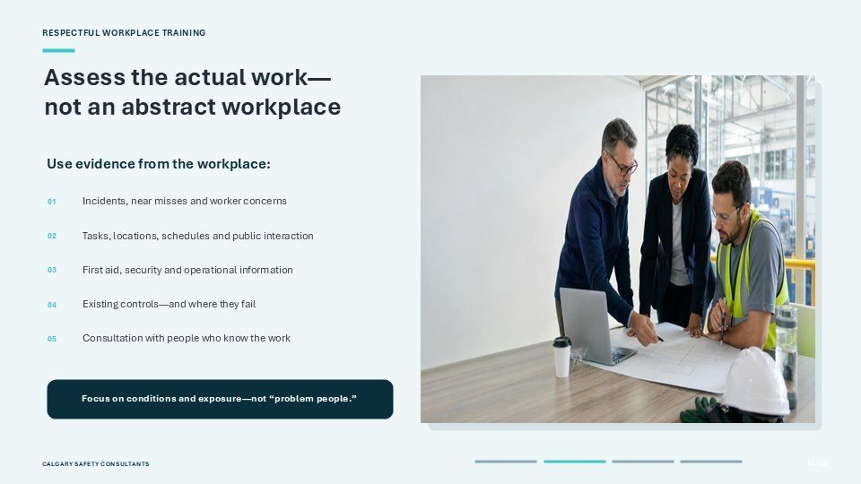  Notes __________________ | Assess the actual work— not an abstract workplace  Assess the actual work, not an abstract workplace. Start with evidence such as incidents, near misses and worker concerns. Examine tasks, locations, schedules, public interaction, first-aid information, security calls and operational changes.  Review the controls already in place and identify where they are difficult to use or have failed. Consultation with people who know the work can reveal exposure that does not appear in formal records. Ask who may be exposed, what the possible consequences are and how reliable the controls are under real conditions. Keep the...  KEY POINTS  • Use evidence from the workplace:  • Incidents, near misses and worker concerns.  • Tasks, locations, schedules and public interaction.

LESSON 03 • SLIDE 14 OF 32  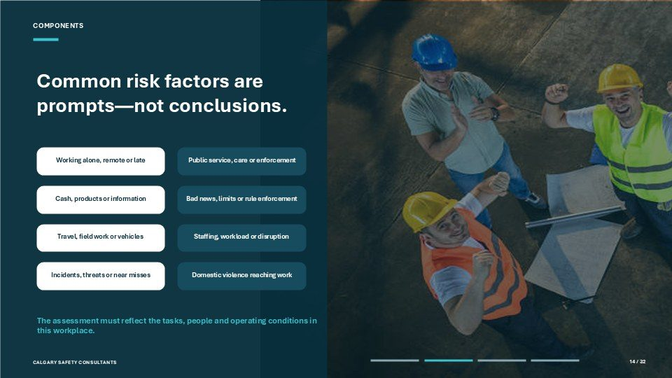  Notes __________________ | Common risk factors are prompts—not conclusions.  Common risk factors are prompts for assessment, not conclusions. Working alone, remotely or late may reduce access to assistance. Public service, care or enforcement work may involve conflict, distress or rule-setting. Handling cash, products or sensitive information can create a target.  Delivering bad news, setting limits or enforcing rules may increase tension. Travel, field work and vehicle-based work can change communication and emergency options. Staffing shortages, workload or organizational disruption may weaken existing controls. Previous incidents, threats, near misses and domestic...  KEY POINTS  • Working alone, remote or late.  • Public service, care or enforcement.  • Cash, products or information.

LESSON 03 • SLIDE 15 OF 32  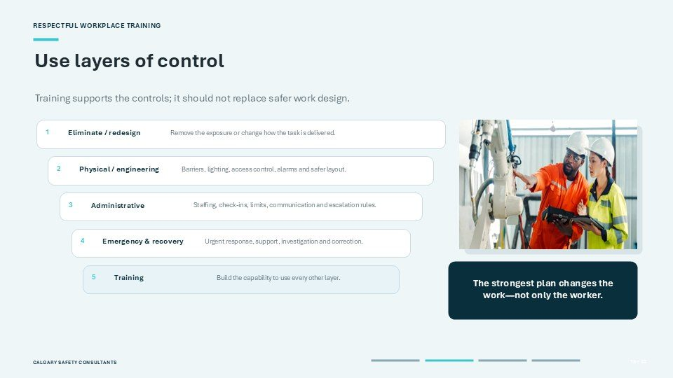  Notes __________________ | Use layers of control  Use layers of control. Begin with elimination or redesign by removing the exposure or changing how the task is delivered where reasonably practicable. Add physical or engineering controls such as barriers, lighting, access control, alarms and safer room layouts.  Use administrative controls such as staffing levels, check-in procedures, cash-handling limits, communication protocols and escalation rules. Prepare emergency and recovery measures, including urgent assistance, post-incident support, investigation and corrective action. Training builds the capability to use every other layer...  KEY POINTS  • Training supports the controls; it should not replace safer work design.  • Remove the exposure or change how the task is delivered.  • Eliminate / redesign.

GENERAL NOTES

LESSON 03 • SLIDE 16 OF 32  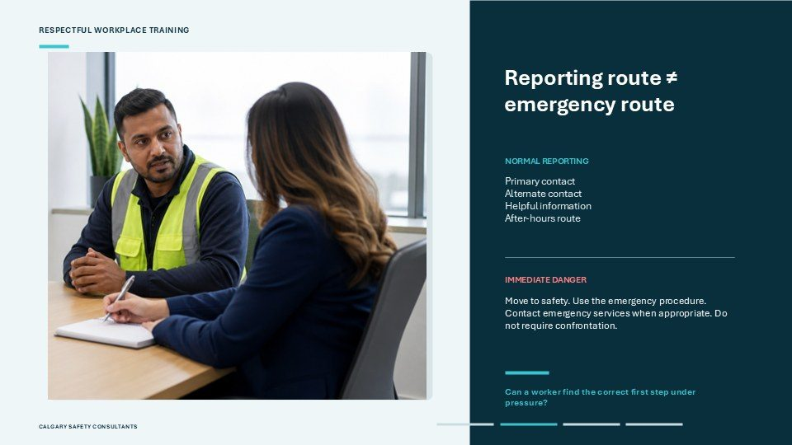  Notes __________________ | Reporting route ≠ emergency route  A normal reporting route is not the same as an emergency route. For normal reporting, workers should know the primary contact, the alternate contact, what information is helpful and how to report an after-hours concern.  When there is immediate danger, the priorities change: move to safety, follow the workplace emergency procedure and contact emergency services when appropriate. A worker should not be required to confront a potentially violent person before seeking help. Learn both routes before you need them. Ask yourself whether you could...  KEY POINTS  • Primary contact Alternate contact Helpful information After-hours route.  • Move to safety. Use the emergency procedure. Contact emergency services when appropriate. Do not require...  • Can a worker find the correct first step under pressure?

LESSON 03 • SLIDE 17 OF 32  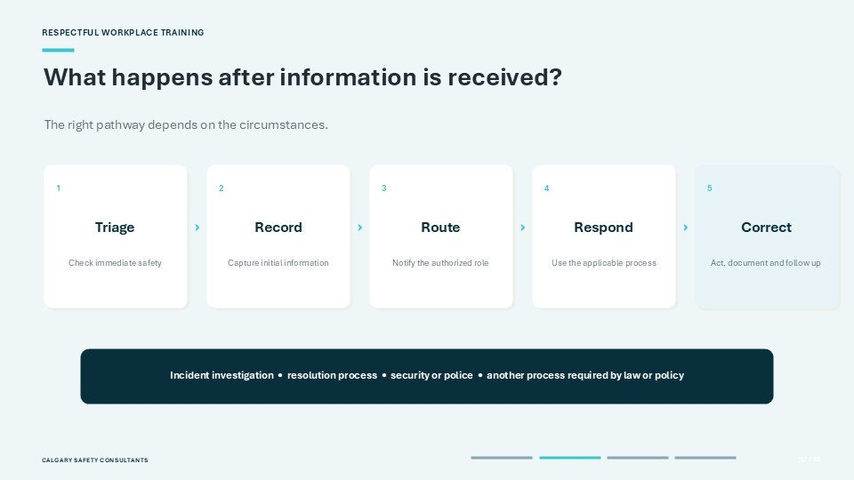  Notes __________________ | What happens after information is received?  The prevention system should explain what happens after information is received. Triage means checking immediate safety and arranging urgent protection or assistance. Record means capturing the initial information accurately without turning the first conversation into an unauthorized investigation.  Route means notifying the person or role authorized to respond. Respond means using the process that fits the circumstances, which may involve an incident investigation, a harassment and violence resolution process, security, police or another process required by law or policy. Correct means acting...  KEY POINTS  • The right pathway depends on the circumstances.  • Check immediate safety.  • Capture initial information.

LESSON 03 • SLIDE 18 OF 32  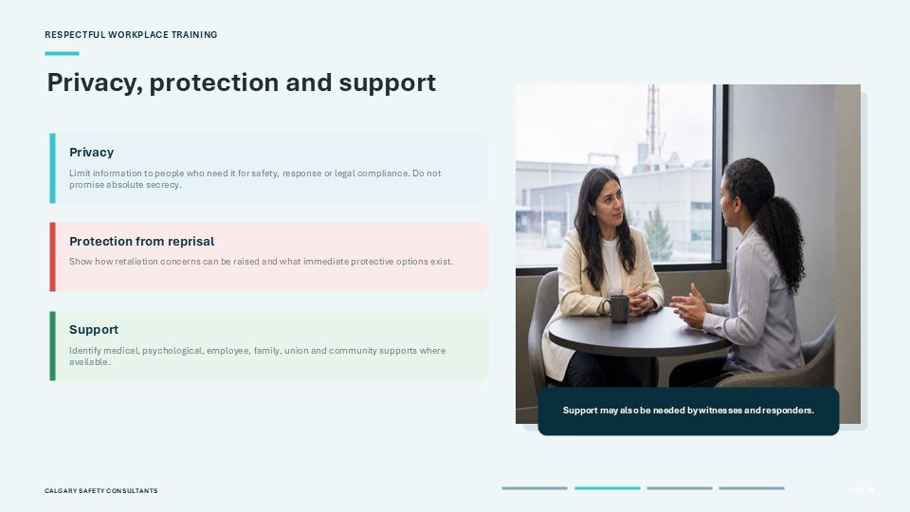  Notes __________________ | Privacy, protection and support  Privacy, protection from reprisal and support should be visible before an incident occurs. Privacy means limiting information to people who need it for safety, response or legal compliance. It does not mean promising absolute secrecy.  Protection from reprisal means the process should explain how retaliation concerns can be raised and what immediate protective options are available. Support may include medical or psychological care, employee and family assistance, union support or community resources, depending on what the workplace provides. Support may also...  KEY POINTS  • Limit information to people who need it for safety, response or legal compliance. Do not promise...  • Protection from reprisal.  • Show how retaliation concerns can be raised and what immediate protective options exist.

GENERAL NOTES

LESSON 03 • SLIDE 19 OF 32  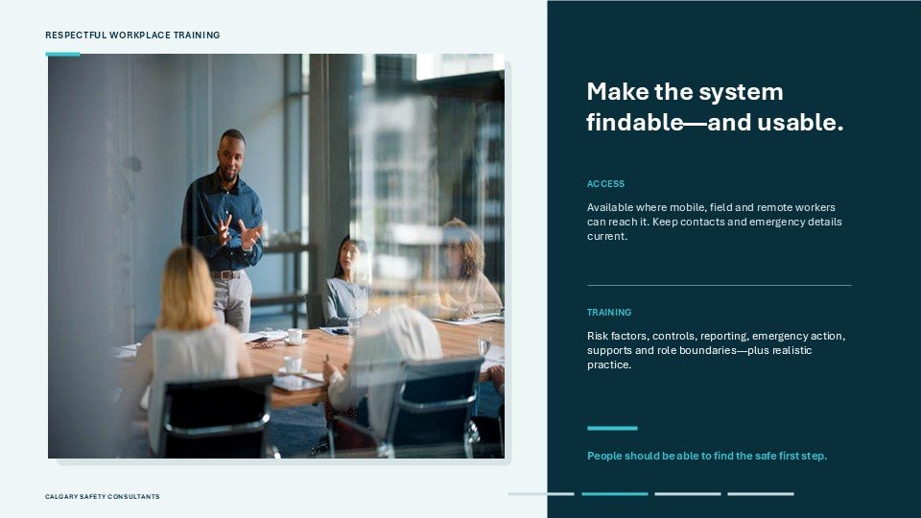  Notes __________________ | Make the system findable—and usable.  Make the system findable and usable. Access means the current policy, contacts and emergency information are available where mobile, remote and field workers can reach them. Outdated contact information can make a good procedure unusable, so those details must be maintained.  Training should explain risk factors, controls, reporting routes, emergency action, support options and role boundaries. People with specialized responsibilities need additional preparation for those responsibilities. Realistic scenarios and practice help confirm that workers can find the safe first step under pressure....  KEY POINTS  • Available where mobile, field and remote workers can reach it. Keep contacts and emergency details...  • Risk factors, controls, reporting, emergency action, supports and role boundaries—plus realistic...  • People should be able to find the safe first step.

LESSON 03 • SLIDE 20 OF 32  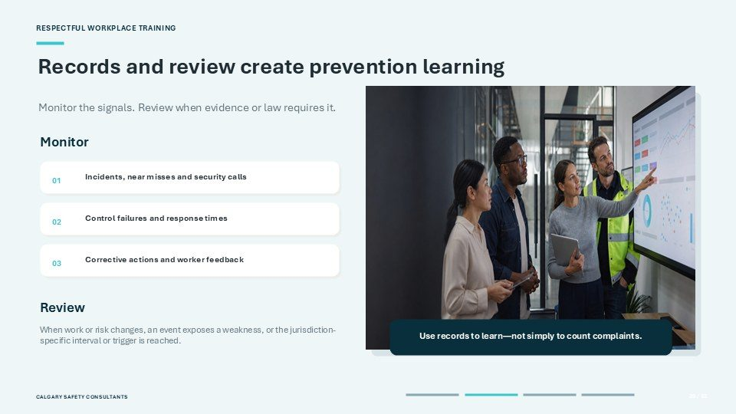  Notes __________________ | Records and review create prevention learning  Records and review create prevention learning. Monitoring looks for signals such as incidents, near misses, security calls, control failures, response times, corrective actions and worker feedback. Review uses those signals to decide whether the system or its controls must change.  A review may be triggered by a change in the work or work site, an event that exposes a weakness, a concern raised through the required consultation structure or the interval set by the governing law. Records should be protected and handled according to legal and workplace requirements. The purpose is to learn and...  KEY POINTS  • Monitor the signals. Review when evidence or law requires it.  • Incidents, near misses and security calls.  • Control failures and response times.

LESSON 03 • SLIDE 21 OF 32  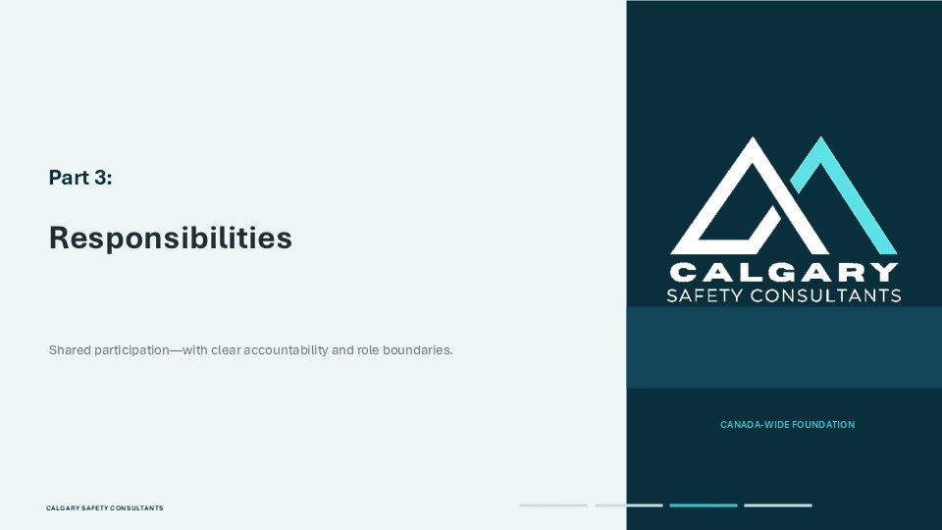  Notes __________________ | Part 3: Responsibilities  Part Three focuses on responsibilities. Participation is shared, but accountability and authority are not identical. The employer owns the prevention system and must establish, resource and maintain it. Supervisors and designated roles carry out assigned duties within their authority.  Workers follow controls, participate in training and report concerns. Committees, representatives and unions may contribute knowledge, consultation, review, representation and support. Effective prevention depends on each person knowing what they are expected to do, where their authority ends and when the...  KEY POINTS  • Responsibilities.  • Shared participation—with clear accountability and role boundaries.

GENERAL NOTES

LESSON 03 • SLIDE 22 OF 32  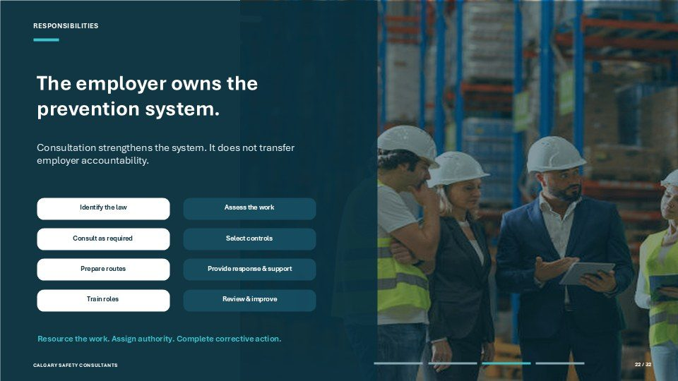  Notes __________________ | The employer owns the prevention system.  The employer owns the prevention system. This includes identifying the governing law, assessing the work, consulting as required, selecting and maintaining controls, establishing reporting and emergency routes and arranging an appropriate response.  The employer must provide training, access to support, required records and a process for review and improvement. Ownership also means resourcing the work, assigning enough authority and ensuring corrective actions are completed. A committee, representative, union, supervisor or outside specialist may make an important...  KEY POINTS  • Consultation strengthens the system. It does not transfer employer accountability.  • Identify the law.  • Assess the work.

LESSON 03 • SLIDE 23 OF 32  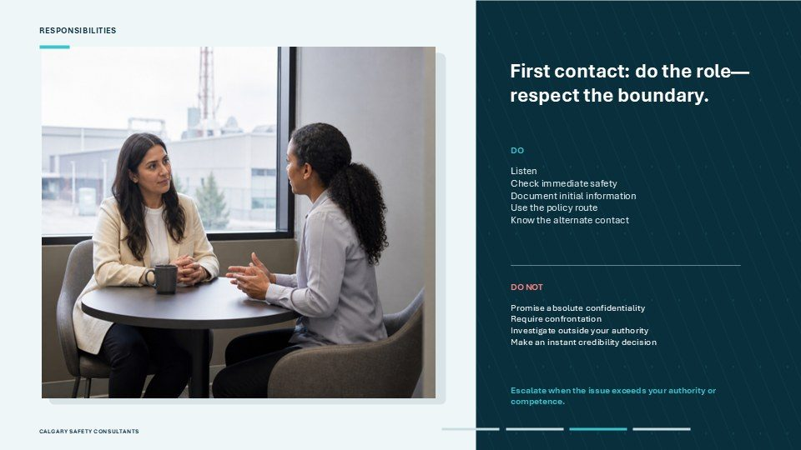  Notes __________________ | First contact: do the role— respect the boundary.  The first contact should do the role and respect the boundary. Do listen and check immediate safety. Do document the initial information and use the route set out in the workplace policy. Do know the alternate contact, emergency procedure and point at which specialized help is required.  Do not promise absolute confidentiality, because information may need to be shared for safety, response or legal compliance. Do not require confrontation, investigate outside your authority or make an instant credibility decision. The first contact's job is not to resolve every issue alone. When a concern...  KEY POINTS  • Listen Check immediate safety Document initial information Use the policy route Know the alternate...  • Promise absolute confidentiality Require confrontation Investigate outside your authority Make an...  • Escalate when the issue exceeds your authority or competence.

LESSON 03 • SLIDE 24 OF 32  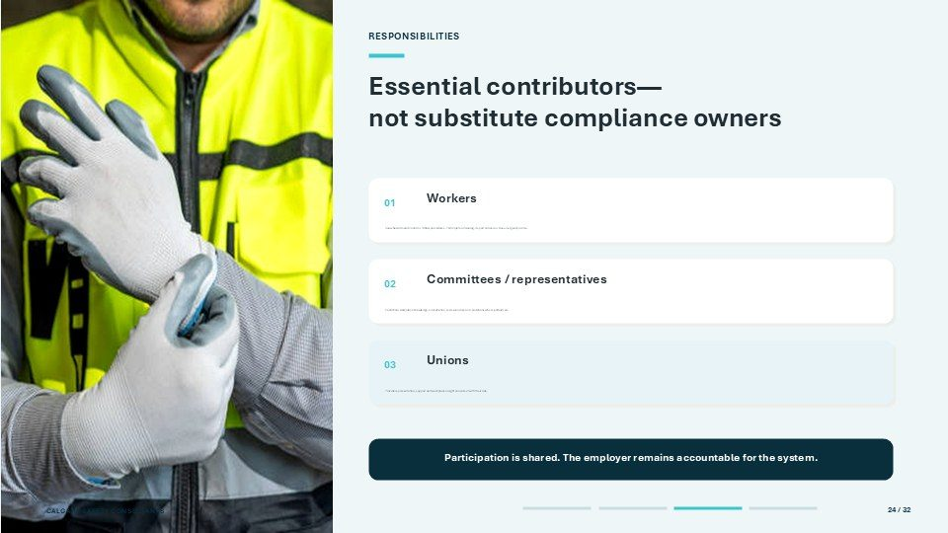  Notes __________________ | Essential contributors— not substitute compliance owners  Workers, committees, representatives and unions are essential contributors, but they are not substitute compliance owners. Workers should know the hazards and controls in their work, follow procedures, participate in training, report concerns and use emergency routes when needed.  Committees and health and safety representatives may contribute workplace knowledge, consultation, review and recommendations where authorized. Unions may provide representation, support and practical workplace insight consistent with their role. These contributions help the system reflect real work and real...  KEY POINTS  • Know hazards and controls. Follow procedures. Participate in training. Report concerns. Use emergency...  • Committees / representatives.  • Contribute workplace knowledge, consultation, review and recommendations where authorized.

GENERAL NOTES

LESSON 03 • SLIDE 25 OF 32  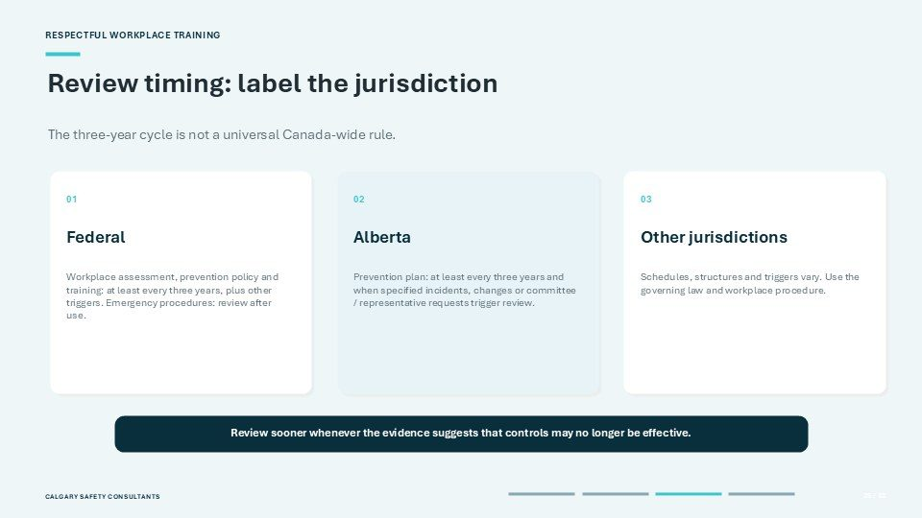  Notes __________________ | Review timing: label the jurisdiction  Review timing must be labelled by jurisdiction. The three-year cycle shown here is not a universal Canada-wide rule. Under the federal regulations, the workplace assessment, prevention policy and training are reviewed at least every three years, with additional triggers, and emergency procedures are reviewed after they  are used. In Alberta, the violence and harassment prevention plan must be reviewed at least every three years. A review is also required when an incident indicates a review is needed, when work or the work site changes in a way that could affect the potential for violence or...  KEY POINTS  • The three-year cycle is not a universal Canada-wide rule.  • Other jurisdictions.  • Workplace assessment, prevention policy and training: at least every three years, plus other triggers....

LESSON 03 • SLIDE 26 OF 32  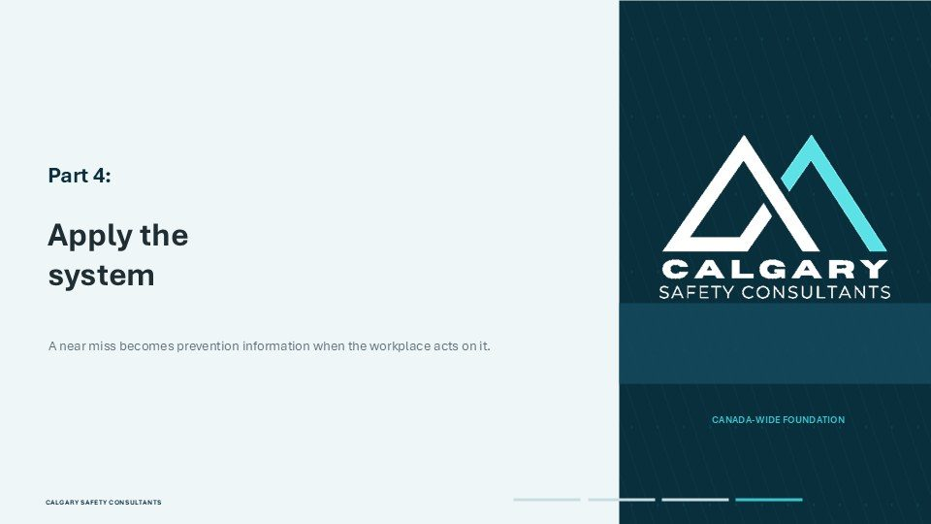  Notes __________________ | Part 4: Apply the system  Part Four applies the prevention system. The next scenario shows how a near miss becomes useful prevention information when the workplace acts on it. You will identify the best next step, then connect the answer to protection, reporting, assessment and corrective action.  A knowledge check will test the Canada-wide principles, and the local-readiness checklist will identify the workplace-specific details that must be confirmed. The final roadmap brings the lesson back to implementation. As you work through this section, focus on the decision a person should make and the system response that...  KEY POINTS  • Apply the system.  • A near miss becomes prevention information when the workplace acts on it.

LESSON 03 • SLIDE 27 OF 32  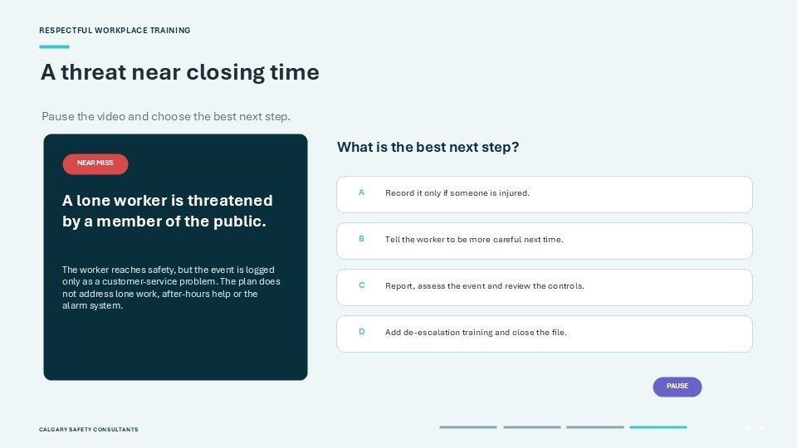  Notes __________________ | A threat near closing time  Consider this near-miss scenario. A lone worker is threatened by a member of the public near closing time. The worker reaches safety, but the event is recorded only as a customer-service problem. The plan does not address lone work, after-hours help or the alarm system.  What is the best next step? A: record the event only if someone is injured. B: tell the worker to be more careful next time. C: report and assess the event, then review the controls. Or D: add de-escalation training and close the file. Think about the prevention cycle and what the event reveals about the work. Pause the video...  KEY POINTS  • Pause the video and choose the best next step.  • What is the best next step?  • Record it only if someone is injured.

GENERAL NOTES

LESSON 03 • SLIDE 28 OF 32  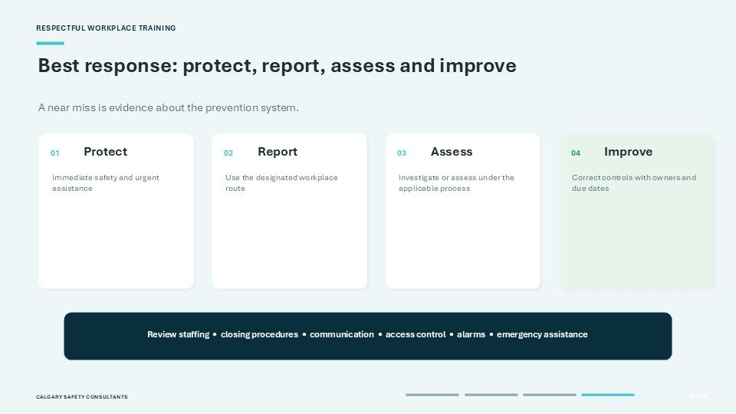  Notes __________________ | Best response: protect, report, assess and improve  The best response is C: protect, report, assess and improve. Protect means confirming immediate safety and obtaining urgent assistance if needed. Report means using the designated workplace route so the event enters the prevention system.  Assess means examining what happened under the applicable investigation or assessment process. Improve means correcting the controls, assigning owners and setting due dates. In this scenario, review staffing, closing procedures, communication, access control, alarms and emergency assistance. The answer is not to blame the...  KEY POINTS  • A near miss is evidence about the prevention system.  • Immediate safety and urgent assistance.  • Use the designated workplace route.

LESSON 03 • SLIDE 29 OF 32  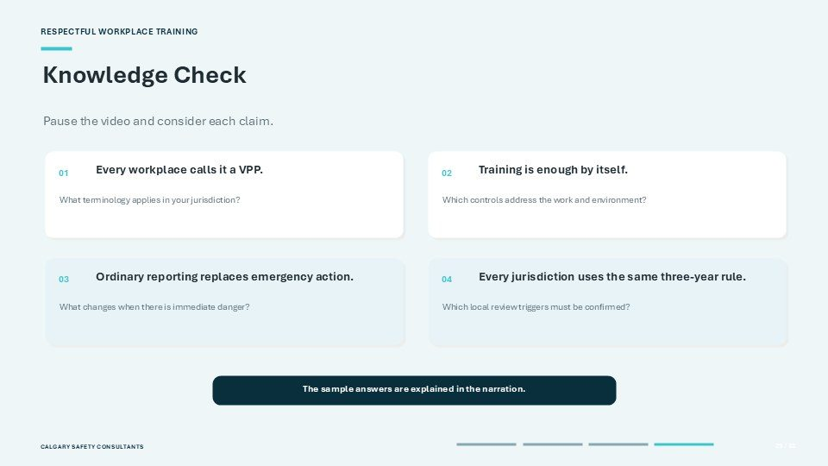  Notes __________________ | Knowledge Check  Check your understanding by considering each claim. First, every workplace calls the system a VPP. That is false. The terminology and detailed duties depend on the governing jurisdiction and workplace documents. Second, training is enough by itself. That is also false.  Training supports the controls, but safer work design, physical safeguards and effective procedures may also be required. Third, ordinary reporting replaces emergency action. False. Immediate danger requires the emergency route. Fourth, every jurisdiction uses the same three-year rule. False. Federal and Alberta requirements...  KEY POINTS  • Pause the video and consider each claim.  • Every workplace calls it a VPP.  • Training is enough by itself.

LESSON 03 • SLIDE 30 OF 32  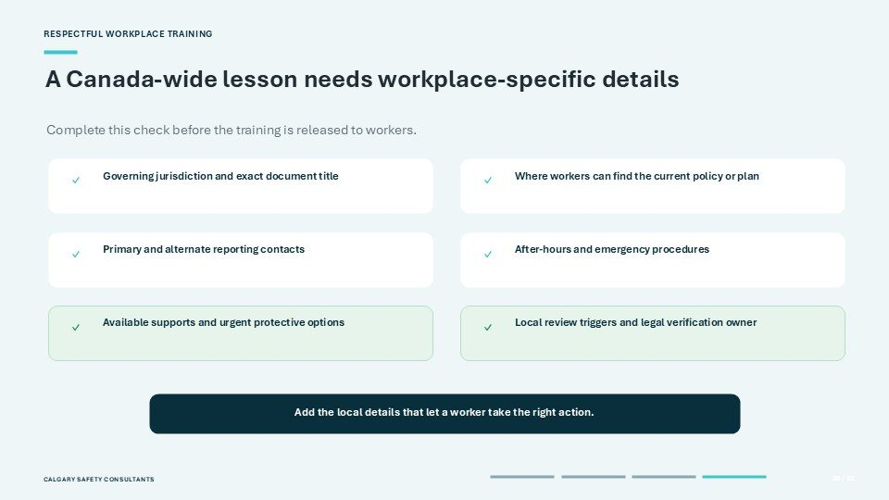  Notes __________________ | A Canada-wide lesson needs workplace-specific details  A Canada-wide lesson needs workplace-specific details before it is released to workers. Confirm the governing jurisdiction and the exact title of the policy, plan or program. Identify where workers can find the current version.  Provide the primary and alternate reporting contacts, including the route to use if the usual contact is involved or unavailable. Confirm the after-hours and emergency procedures, the available supports and any urgent protective options. Identify the local review triggers and the person responsible for verifying legal...  KEY POINTS  • Complete this check before the training is released to workers.  • Governing jurisdiction and exact document title.  • Where workers can find the current policy or plan.

GENERAL NOTES

LESSON 03 • SLIDE 31 OF 32  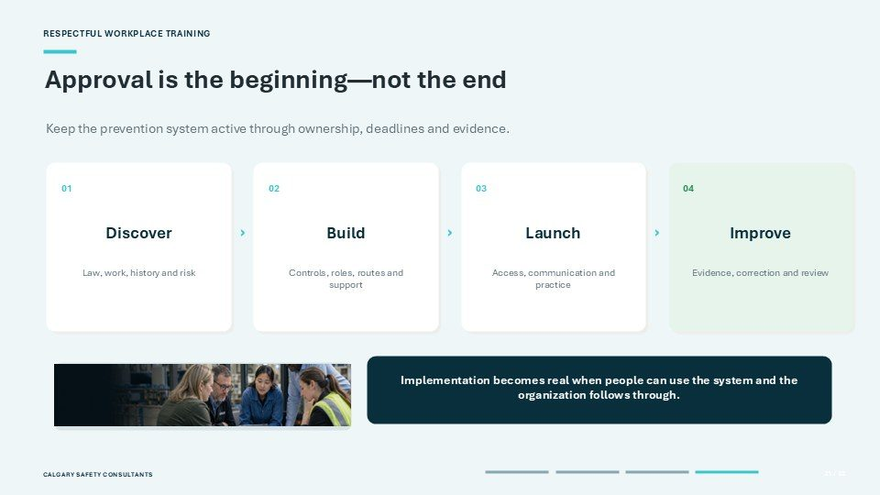  Notes __________________ | Approval is the beginning—not the end  Approval is the beginning, not the end. Use this four-step roadmap to keep the prevention system active. Discover the governing law, the work activities, incident history and current risk. Build the controls, roles, reporting routes, emergency procedures and supports through the consultation required for the workplace.  Launch the system by making it accessible, communicating responsibilities and providing realistic, role-specific training. Improve it by monitoring incidents, near misses, feedback, control failures and corrective actions, then completing scheduled and event-driven reviews....  KEY POINTS  • Keep the prevention system active through ownership, deadlines and evidence.  • Law, work, history and risk.  • Controls, roles, routes and support.

LESSON 03 • SLIDE 32 OF 32  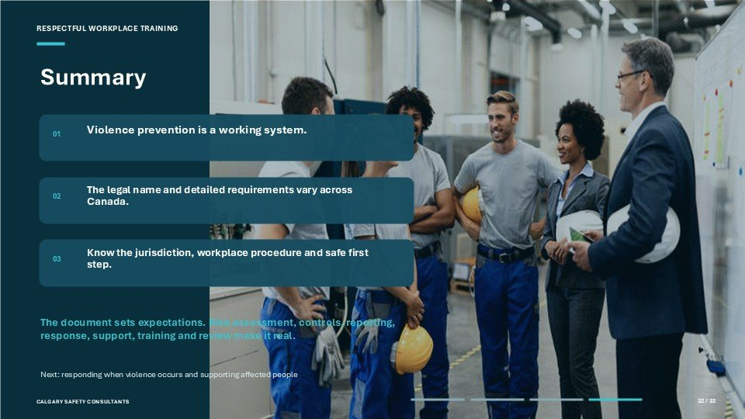  Notes __________________ | Summary  The main message from this lesson is that violence prevention is a working system. The document sets expectations, but risk assessment, controls, reporting, emergency action, response, support, training and review make the system real.  The legal name and detailed requirements vary across Canada, so know the jurisdiction that governs your workplace and use the terminology in your actual policy, plan or program. Most importantly, know the safe first step: where to report a concern, what to do in immediate danger and where to find support. In the next lesson, we...  KEY POINTS  • Violence prevention is a working system.  • The legal name and detailed requirements vary across Canada.  • Know the jurisdiction, workplace procedure and safe first step.

GENERAL NOTES

LESSON 03 SUMMARY
Violence Prevention Plans Policies and Procedures
The following points bring the lesson together. Use them to review the main prevention message and connect it to the procedures and expectations in your workplace.
01 | A usable prevention plan connects the workplace risk assessment with controls, procedures, training, reporting, response, records, and review.
02 | Policies should define scope, prohibited conduct, responsibilities, reporting routes, emergency directions, privacy limits, support, and follow through.
03 | Workers need a normal reporting route and an alternate route for conflicts of interest, access barriers, or concerns involving the usual recipient.
04 | Roles should be clear so people know who receives reports, assesses risk, investigates, communicates, implements controls, and monitors corrective action.
05 | The program should be reviewed on the required schedule and whenever incidents, near misses, worker feedback, or workplace changes show that improvement is needed.
Reflection and application
• Can a worker find the primary and alternate reporting routes quickly?
• Which role owns follow through after a corrective action is assigned?
• What event triggers an unscheduled review of the prevention plan?
________________________________________________________________________________
________________________________________________________________________________
GENERAL NOTES

MODULE THREE / LESSON 04

Responding to Workplace Violence
Immediate safety | Reporting | Investigation | Support | Follow through
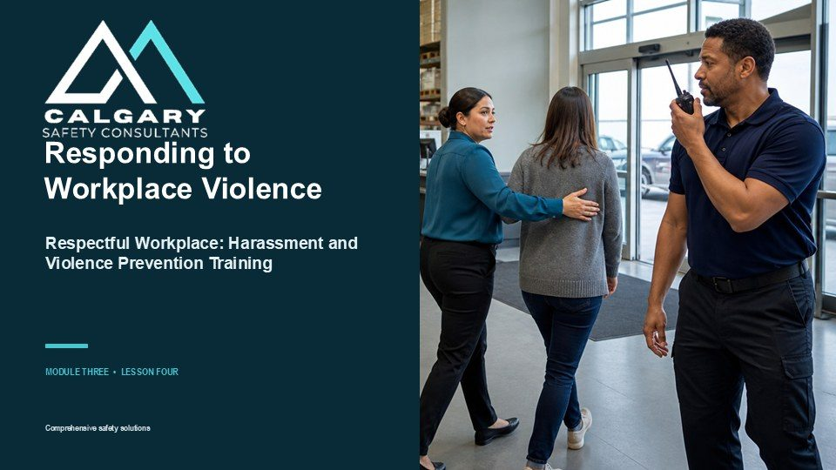
Lesson overview
A sound response begins with immediate safety. Workers should leave danger where possible, warn others when it is safe, use emergency or security procedures, and seek help. The ordinary workplace process follows once urgent risk has been addressed.
This lesson explains reporting, preservation of information, risk assessment, interim safeguards, investigation, communication, support, corrective action, monitoring, and protection from reprisal. It also reinforces the limits of each participant role.
By the end of this lesson you should be able to
• Choose emergency action, the primary reporting route, or the alternate route based on the situation.
• Report observable facts and preserve relevant information without investigating independently.
• Describe the main stages of a fair and proportionate workplace response.
• Recognize privacy, support, procedural fairness, and anti reprisal safeguards.
• Monitor corrective action and report continuing or changing risk.
GENERAL NOTES

LESSON 04 • SLIDE 01 OF 35  Notes __________________ | Responding to Workplace Violence  Welcome to Module Three, Lesson Four of Respectful Workplace: Harassment and Violence Prevention Training. This lesson focuses on the actions people take during an immediate threat and the steps that follow: emergency communication, reporting, investigation, support, corrective action and restoration.  No presentation can replace the site-specific emergency plan. Learners must know the alarms, emergency contacts, exits or secure locations, accountability procedure, reporting contacts and supports that apply to their work.  KEY POINTS  • Respectful Workplace: Harassment and Violence Prevention Training.  • MODULE THREE • LESSON FOUR.

LESSON 04 • SLIDE 02 OF 35  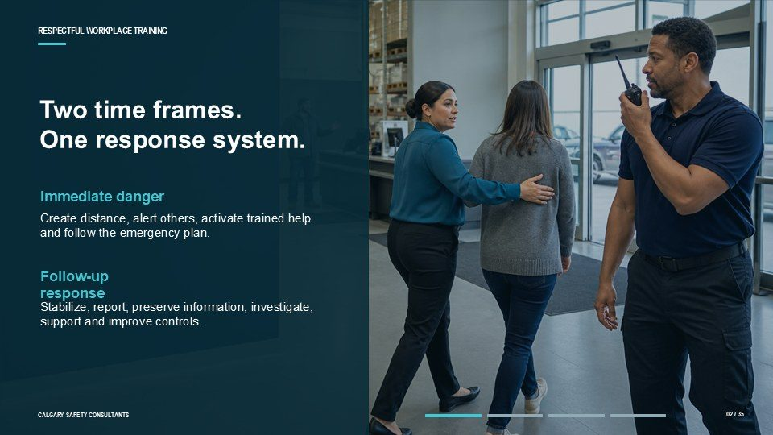  Notes __________________ | Two time frames. One response system.  Workplace violence response has two time frames. During immediate danger, the priority is life safety: create distance, summon trained help and follow the emergency plan.  After the danger is controlled, the organization stabilizes the workplace, obtains medical help, reports and preserves information, assesses continuing risk, investigates as required, supports people and improves controls. The exact legal duties and investigation processes vary across federal, provincial and territorial...  KEY POINTS  • Immediate danger.  • Create distance, alert others, activate trained help and follow the emergency plan.  • Follow-up response.

LESSON 04 • SLIDE 03 OF 35  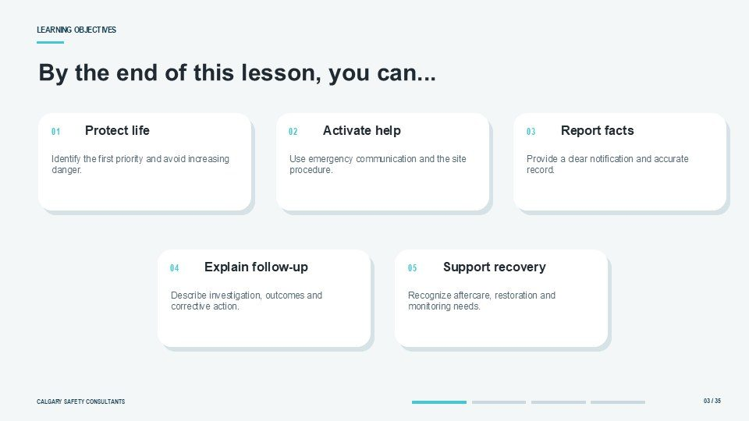  Notes __________________ | Learning Objectives  By the end of this lesson, you should be able to identify the first priority during a violent incident, select the correct emergency communication route, provide a clear factual report, describe the general stages of post-incident review or investigation, explain privacy and participation expectations, and identify  practical aftercare and restoration actions. Workers are not expected to physically intervene, prove misconduct or conduct their own investigation. Their role is to protect safety, report facts and cooperate with the assigned process.  KEY POINTS  • By the end of this lesson, you can...  • Protect life.  • Activate help.

GENERAL NOTES

LESSON 04 • SLIDE 04 OF 35  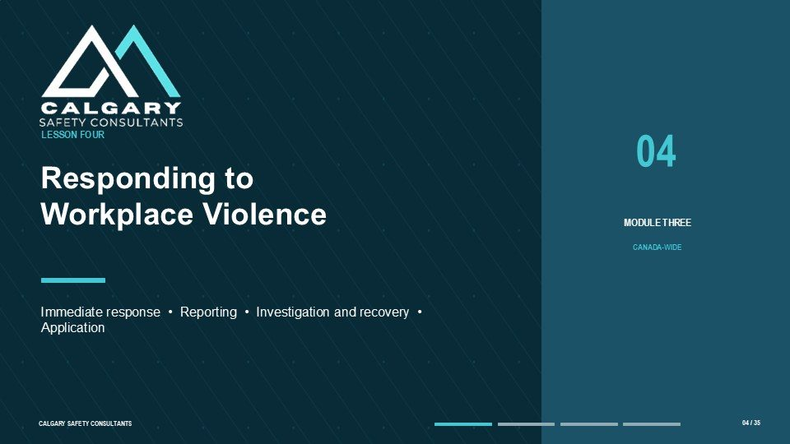  Notes __________________ | Responding to Workplace Violence  The lesson has four parts. Part One addresses the immediate response while danger may still be active. Part Two explains internal reporting after immediate safety is addressed. Part Three follows the investigation and recovery process, including findings, corrective actions, support and restoration.  Part Four applies the priorities in a customer-violence scenario and finishes with a knowledge check and local readiness review. The same sequence runs throughout: protect life, activate help, report facts, support people and improve prevention.  KEY POINTS  • Immediate response • Reporting • Investigation and recovery • Application.  • Protect immediate safety, report observable facts, preserve relevant information, and support the...

LESSON 04 • SLIDE 05 OF 35  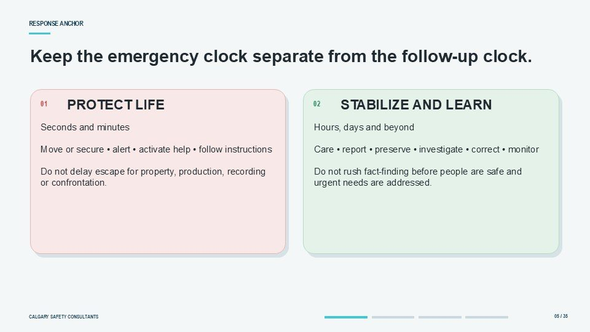  Notes __________________ | Keep the emergency clock separate from the follow-up clock.  Keep the two clocks separate. The emergency clock measures seconds and minutes. It asks how to create distance, alert others and obtain trained help without increasing exposure. The follow-up clock begins once immediate danger is controlled.  It asks who needs care, what risk remains, what must be reported or preserved, how the facts will be assessed, and which corrective actions will prevent recurrence. Confusing the clocks can delay emergency action or rush an investigation before people are safe.  KEY POINTS  • Seconds and minutes Move or secure • alert • activate help • follow instructions Do not delay escape for...  • Hours, days and beyond Care • report • preserve • investigate • correct • monitor Do not rush...

LESSON 04 • SLIDE 06 OF 35  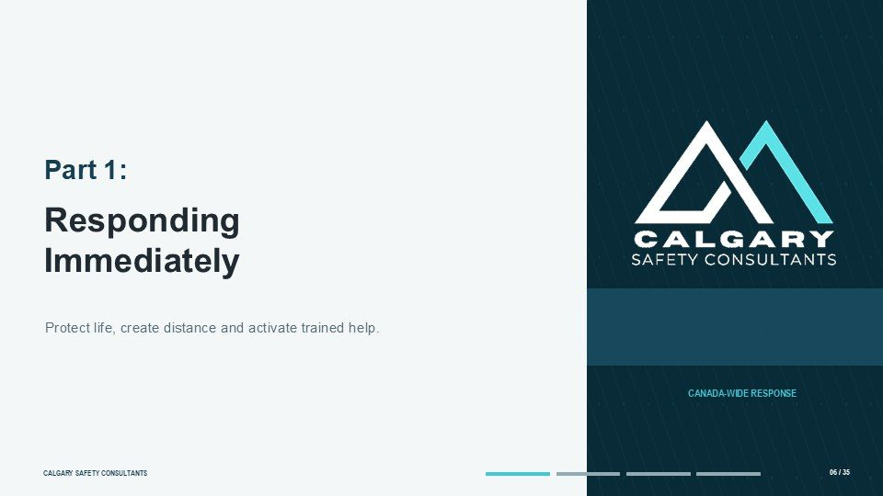  Notes __________________ | Part 1: Responding Immediately  Part One focuses on the moments during and immediately after a violent incident. The order of actions may change with the circumstances, but the governing principle is constant: protect life and avoid increasing the danger. Follow the workplace plan and instructions from emergency responders.  Do not take unnecessary risks to protect property, continue production, obtain a recording or physically confront a person. Preparation, drills and reliable communication systems make better decisions possible under pressure.  KEY POINTS  • Responding Immediately.  • Protect life, create distance and activate trained help.

GENERAL NOTES

LESSON 04 • SLIDE 07 OF 35  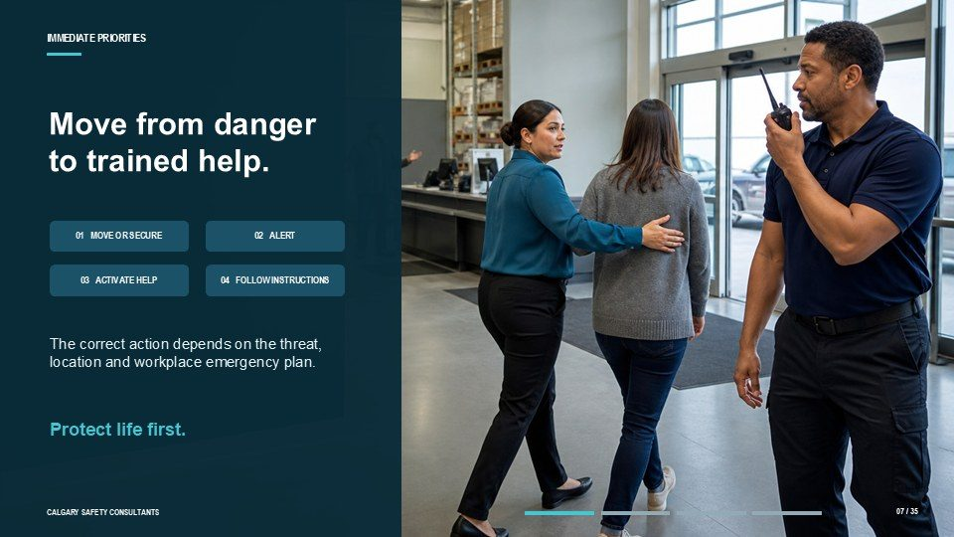  Notes __________________ | Move from danger to trained help.  Use a simple priority sequence. First, move away from danger or use the safe action in the site plan. Second, alert others when it can be done without delaying escape or exposing anyone. Third, summon trained help through emergency services, security, an alarm or another designated route.  Fourth, follow instructions and the accountability process. This is not a rigid universal script. The correct action depends on the threat, location and workplace emergency plan.  KEY POINTS  • The correct action depends on the threat, location and workplace emergency plan.  • Protect life first.

LESSON 04 • SLIDE 08 OF 35  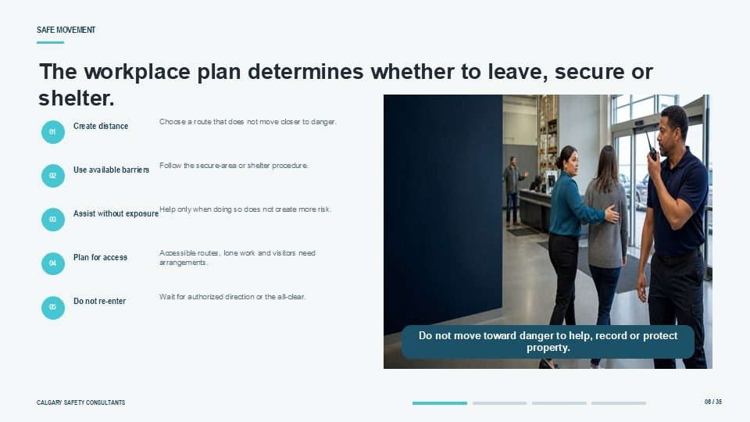  Notes __________________ | The workplace plan determines whether to leave, secure or shelter.  The workplace plan determines whether people evacuate, move to a secure area, shelter in place or take another action. Choose the safe route without moving closer to the threat. Help another person only when doing so does not create additional exposure. Do not re-enter a dangerous area or improvise a confrontation.  Workers with disabilities, lone workers, remote workers, visitors and contractors may need specific arrangements. Know the accessible alternative before an emergency occurs.  KEY POINTS  • Choose a route that does not move closer to danger.  • Create distance.  • Follow the secure-area or shelter procedure.

LESSON 04 • SLIDE 09 OF 35  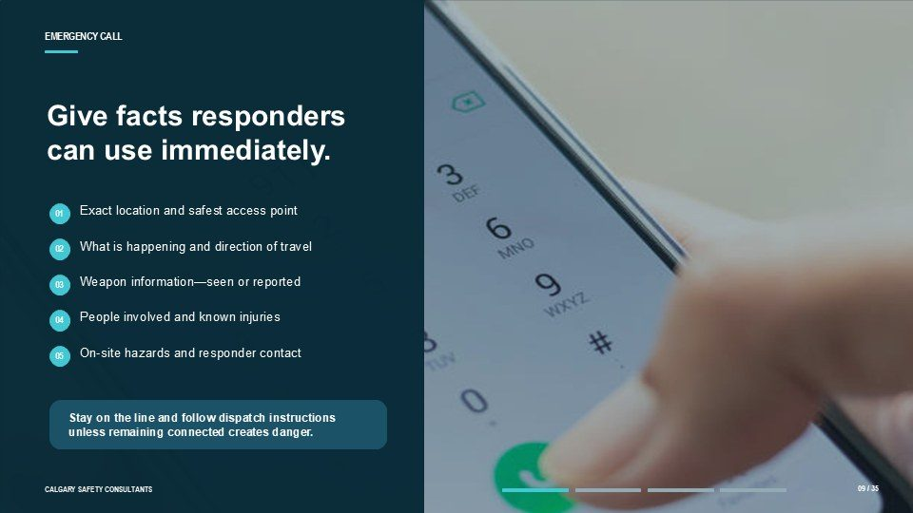  Notes __________________ | Give facts responders can use immediately.  Call 911 or the applicable emergency service when the incident involves immediate danger, serious injury, a weapon, a serious threat or another condition identified in the plan. Give the exact location, including the entrance or access point, and concise facts about what is occurring.  State whether a weapon is seen or reported, the number of people involved, known injuries and the safest responder access. Do not guess. Stay on the line and follow the dispatcher's instructions unless remaining connected creates danger.  KEY POINTS  • Exact location and safest access point.  • What is happening and direction of travel.  • Weapon information—seen or reported.

GENERAL NOTES

LESSON 04 • SLIDE 10 OF 35  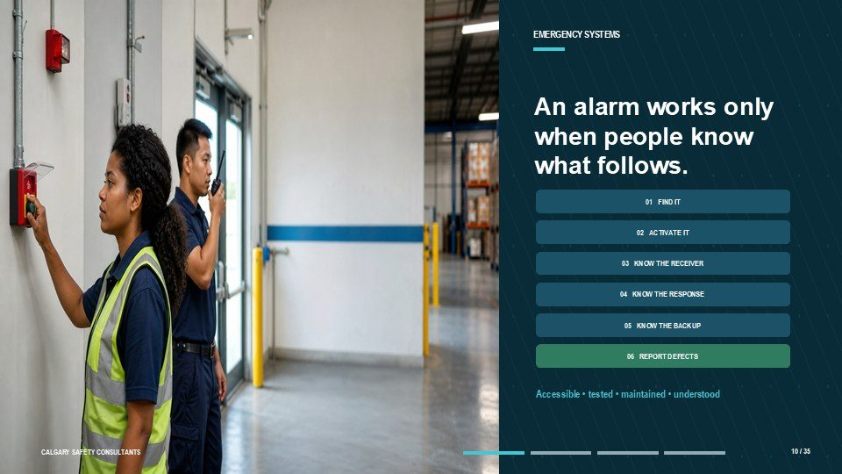  Notes __________________ | An alarm works only when people know what follows.  Emergency systems only work when people know how to use them. Training should cover alarms, panic buttons, radios, duress devices, emergency codes and backup methods. Learners need to know who receives the signal, whether it identifies a location, what action coworkers take and how failures are reported.  Devices should be accessible, tested and maintained through the workplace program. Do not test an alarm informally or assume someone else has already called for help.  KEY POINTS  • Accessible • tested • maintained • understood.  • Protect immediate safety, report observable facts, preserve relevant information, and support the...

LESSON 04 • SLIDE 11 OF 35  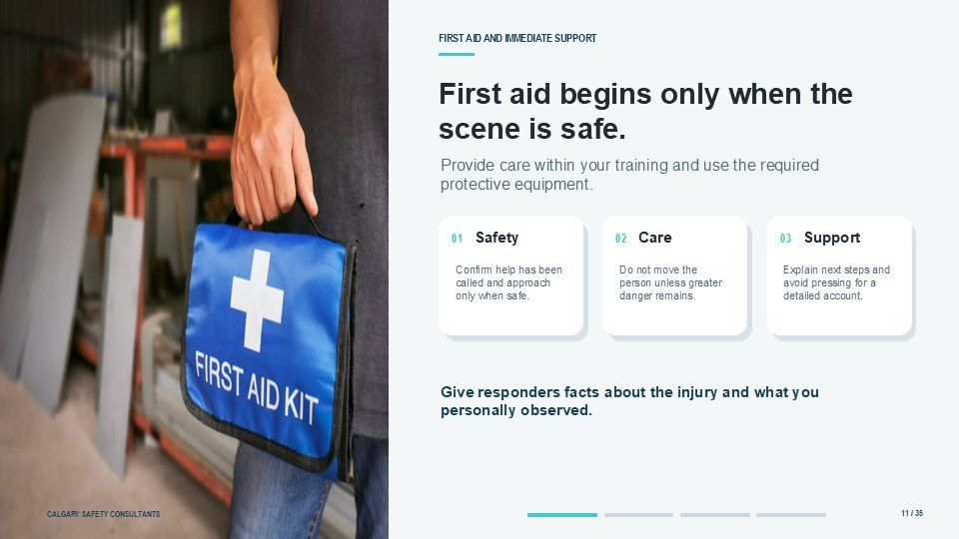  Notes __________________ | First aid begins only when the scene is safe.  Provide first aid only when the scene is safe and within your training. Confirm that emergency help has been called and use the required protective equipment. Do not move an injured person unless leaving them in place creates greater danger. Give responders facts about the injury and what you personally observed.  A person may also need immediate practical psychological support: move them to a quieter safe area, explain the next steps and avoid pressing for a detailed account before urgent health and safety needs are addressed.  KEY POINTS  • Provide care within your training and use the required protective equipment.  • Confirm help has been called and approach only when safe.  • Do not move the person unless greater danger remains.

LESSON 04 • SLIDE 12 OF 35  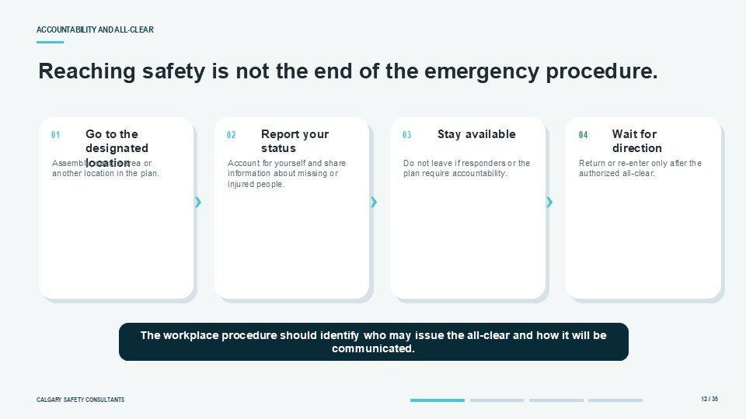  Notes __________________ | Reaching safety is not the end of the emergency procedure.  Accountability continues after people reach safety. Go to the assembly or secure location identified in the plan, report your status and provide information about missing or injured people. Do not leave or re-enter until the authorized person or emergency responder gives direction.  The workplace procedure should identify who may issue the all-clear and how it will be communicated. A vague message or informal return can expose people to a threat that has not been controlled.  KEY POINTS  • Go to the designated location.  • Report your status.  • Stay available.

GENERAL NOTES

LESSON 04 • SLIDE 13 OF 35  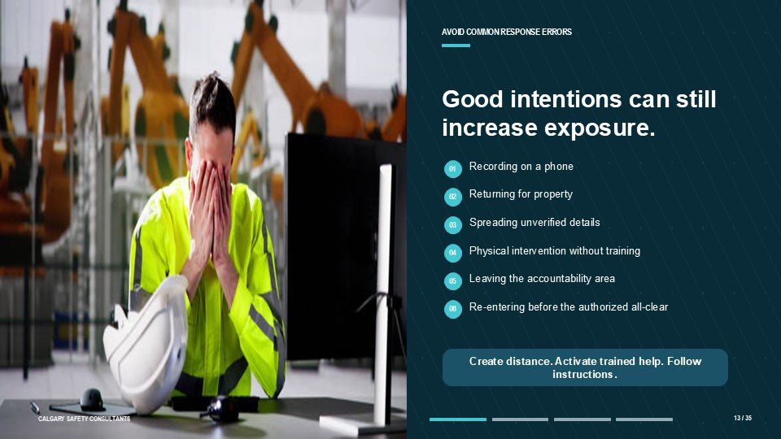  Notes __________________ | Good intentions can still increase exposure.  Common response errors increase risk. Recording on a phone can delay escape, distract the witness, provoke the person and create privacy concerns. Returning for property creates avoidable exposure. Spreading unverified information can cause panic. Physically intervening without training can escalate the incident.  Leaving the accountability area can complicate responder searches. The safer approach is to create distance, activate trained help, follow instructions and preserve information through the designated post-incident process.  KEY POINTS  • Recording on a phone.  • Returning for property.  • Spreading unverified details.

LESSON 04 • SLIDE 14 OF 35  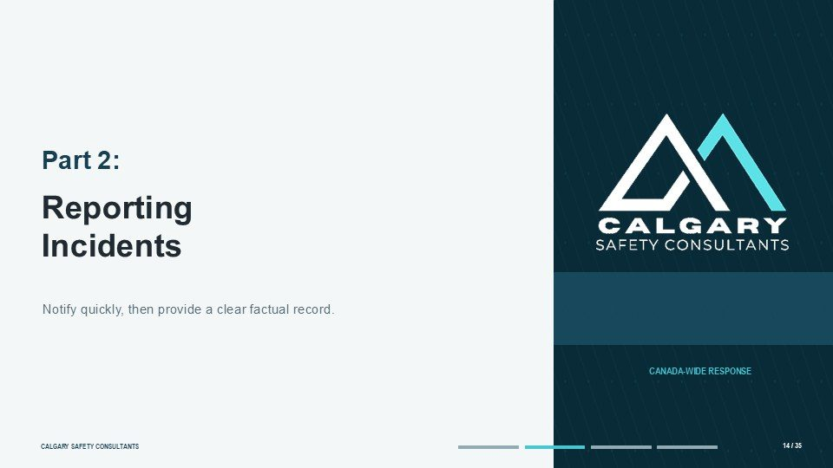  Notes __________________ | Part 2: Reporting Incidents  Part Two begins after immediate danger has been addressed. Prompt internal reporting allows the organization to assess continuing risk, arrange support, preserve evidence, notify external bodies when required and prevent recurrence. Reporting is not the same as proving misconduct.  The worker provides facts and current safety concerns. The designated workplace process determines what response, investigation or regulatory notification is required.  KEY POINTS  • Reporting Incidents.  • Notify quickly, then provide a clear factual record.

LESSON 04 • SLIDE 15 OF 35  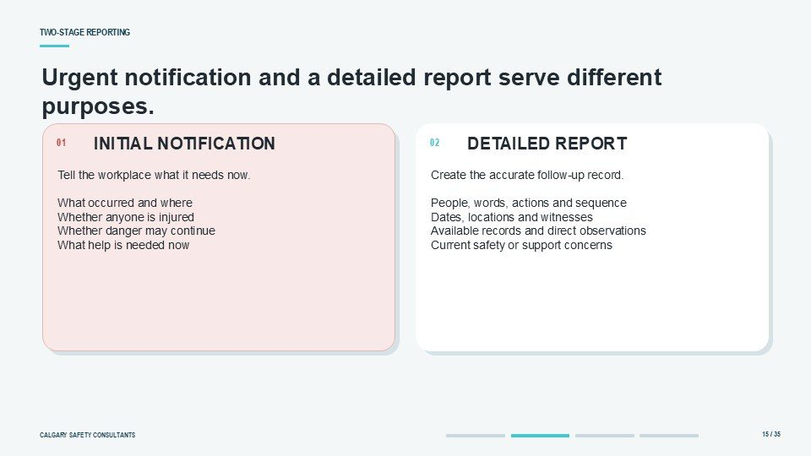  Notes __________________ | Urgent notification and a detailed report serve different purposes.  Separate the initial notification from the detailed report. The initial notification should quickly identify what happened, where it occurred, whether anyone is injured, whether the threat may continue and what help is needed. A fuller account can follow once the situation is stable.  The detailed report describes the people involved, words or actions, sequence, witnesses and available records. This staged approach prevents paperwork from delaying safety while still creating an accurate record.  KEY POINTS  • Tell the workplace what it needs now. What occurred and where Whether anyone is injured Whether danger...  • Create the accurate follow-up record. People, words, actions and sequence Dates, locations and witnesses...

GENERAL NOTES

LESSON 04 • SLIDE 16 OF 35  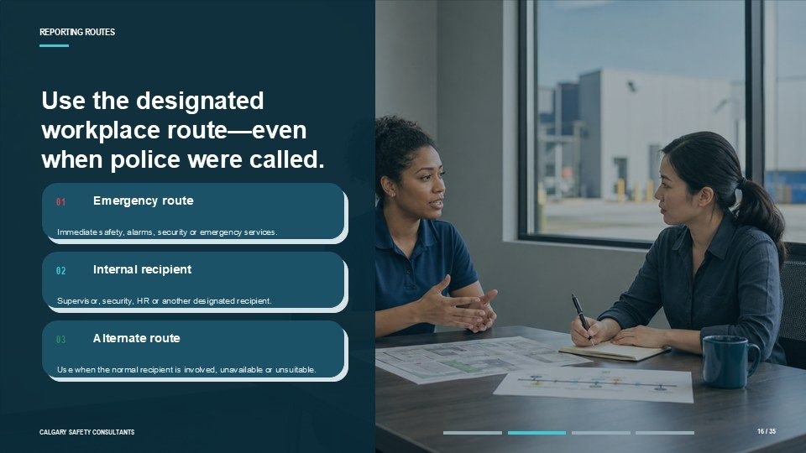  Notes __________________ | Use the designated workplace route—even when police were called.  Use the workplace's designated reporting routes even when emergency services or police were contacted. The primary route may be a supervisor, security team, human resources or another designated recipient. An alternate route is essential when the normal recipient is involved, unavailable or unsuitable.  The emergency route addresses immediate danger. The internal route addresses the employer's workplace safety, support, investigation and corrective-action responsibilities.  KEY POINTS  • Emergency route.  • Immediate safety, alarms, security or emergency services.  • Internal recipient.

LESSON 04 • SLIDE 17 OF 35  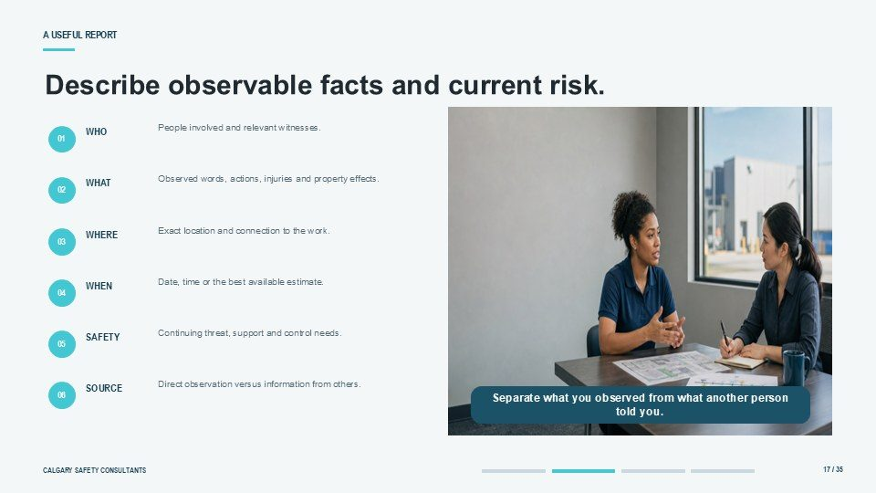  Notes __________________ | Describe observable facts and current risk.  A useful report answers who, what, where, when and current safety. Identify the people involved, the words or actions observed, the location, dates or approximate times, known injuries, witnesses and continuing risk. Separate what you directly observed from what another person told you.  Record uncertainty rather than guessing. Include only relevant information and correct significant errors promptly. The report should support decision-making, not read like a legal argument.  KEY POINTS  • People involved and relevant witnesses.  • Observed words, actions, injuries and property effects.  • Exact location and connection to the work.

LESSON 04 • SLIDE 18 OF 35  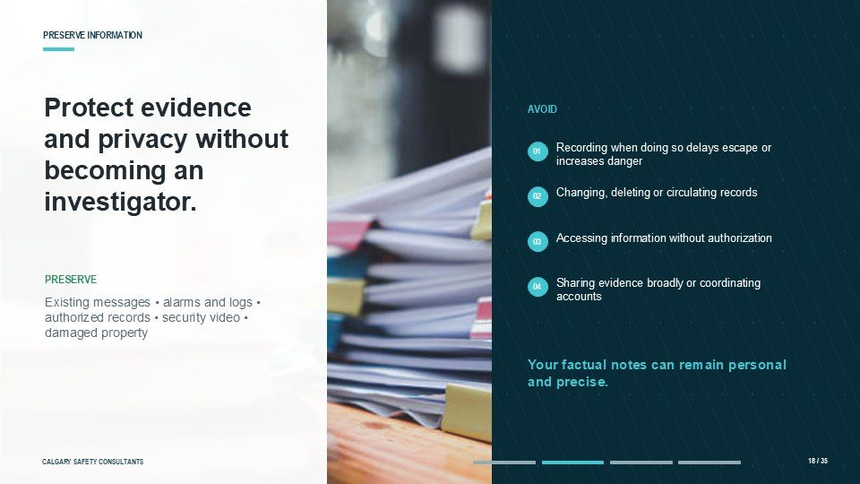  Notes __________________ | Protect evidence and privacy without becoming an investigator.  Preserve relevant information without conducting your own investigation. This may include messages, photographs, existing security video, access records, schedules, emergency logs or damaged property.  Do not alter records, access information without authorization, circulate private material or ask coworkers to coordinate accounts. Recordings created during danger can increase exposure. Safety comes first; the organization can preserve existing systems and obtain information through the proper process.  KEY POINTS  • Recording when doing so delays escape or increases danger.  • Changing, deleting or circulating records.  • Accessing information without authorization.

GENERAL NOTES

LESSON 04 • SLIDE 19 OF 35  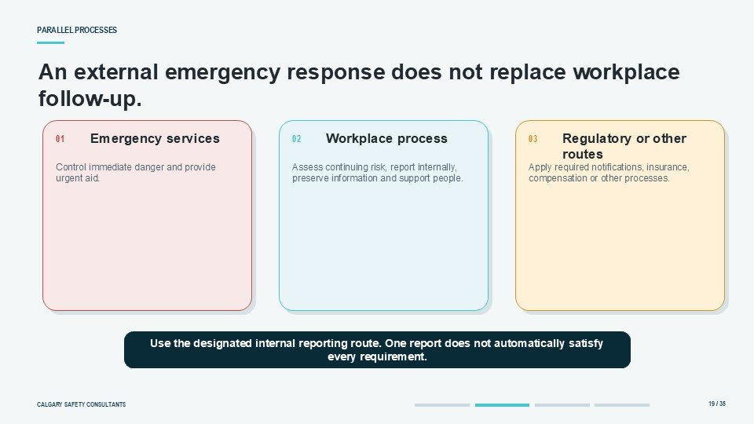  Notes __________________ | An external emergency response does not replace workplace follow-up.  External and internal processes may run at the same time. Calling police or emergency services does not replace the employer's duty to assess workplace risk and complete required internal follow-up.  The employer determines whether occupational health and safety, workers' compensation, insurance, a regulator or another body must be notified. Workers should use the designated internal route and provide factual information. Do not promise that one external report automatically satisfies every workplace requirement.  KEY POINTS  • Emergency services.  • Workplace process.  • Regulatory or other routes.

LESSON 04 • SLIDE 20 OF 35  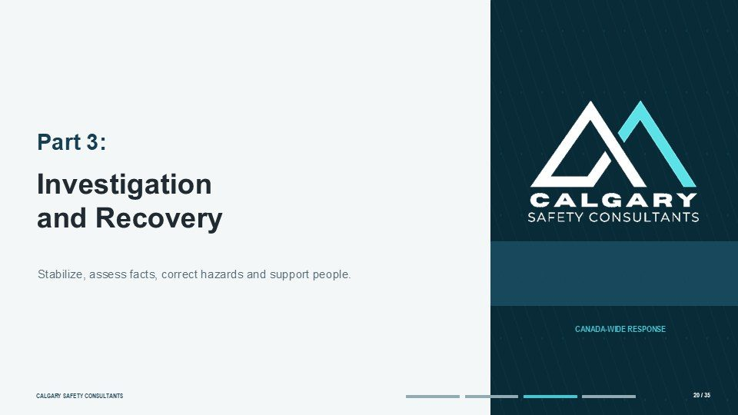  Notes __________________ | Part 3: Investigation and Recovery  Part Three follows the post-incident process. Not every violent event is handled through one identical investigation model. The scope may focus on safety hazards and corrective action, policy compliance, discipline, criminal conduct, human rights or another issue.  The organization should identify the applicable process, use competent and impartial people, protect privacy, provide a fair opportunity to be heard and implement actions that address continuing risk.  KEY POINTS  • Investigation and Recovery.  • Stabilize, assess facts, correct hazards and support people.

LESSON 04 • SLIDE 21 OF 35  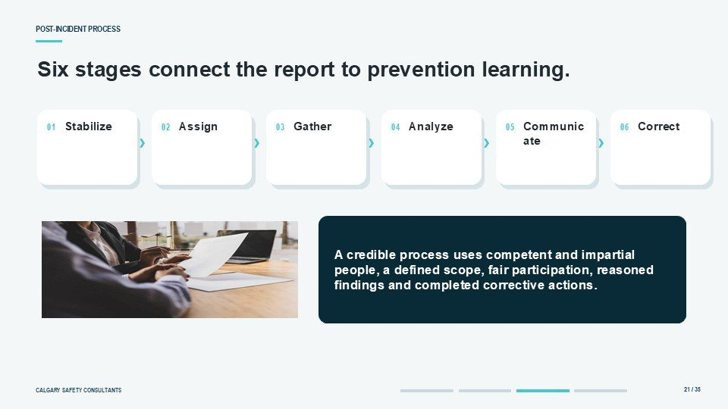  Notes __________________ | Six stages connect the report to prevention learning.  A credible post-incident process has six connected stages. It starts by acknowledging the report, stabilizing safety and arranging support. The organization then assigns the correct decision-maker or investigator and defines the scope. Relevant information is preserved and gathered.  Parties and witnesses are interviewed fairly. Evidence is analyzed using the applicable standard. Findings, permitted outcome information and corrective actions are communicated, implemented and monitored.  KEY POINTS  • Communicate.  • A credible process uses competent and impartial people, a defined scope, fair participation, reasoned...

GENERAL NOTES

LESSON 04 • SLIDE 22 OF 35  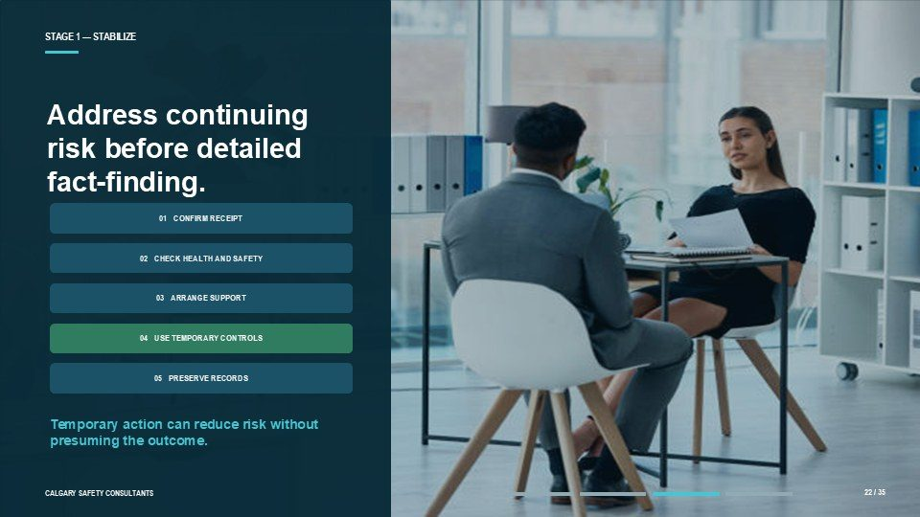  Notes __________________ | STAGE 1 — STABILIZE  The first response should confirm receipt, check injuries and continuing risk, arrange support and explain the next step. Temporary controls may be needed before the investigation is complete, such as access changes, schedule adjustments, security measures or separation that does not presume the outcome.  Preserve records that could be lost. Do not promise a finding, discipline or absolute confidentiality. Document when the report was received and use the timelines required by the applicable process.  KEY POINTS  • Address continuing risk before detailed fact-finding.  • Temporary action can reduce risk without presuming the outcome.

LESSON 04 • SLIDE 23 OF 35    Notes __________________ | STAGE 2 — ASSIGN AND SCOPE  Select an investigator or decision-maker with the competence, impartiality and authority required for the matter. Define the scope: what incident or allegation is being examined, which policy or legal requirements apply, what standard will be used, which decisions the investigator may make and who receives the report.  Internal investigators may be appropriate for some matters. External expertise may be needed for complexity, senior-party involvement, serious conflict, technical evidence or perceived independence.  KEY POINTS  • Match competence, impartiality and authority to the matter.  • Investigation skill and violence-response knowledge.  • No conflict that could reasonably undermine trust.

LESSON 04 • SLIDE 24 OF 35  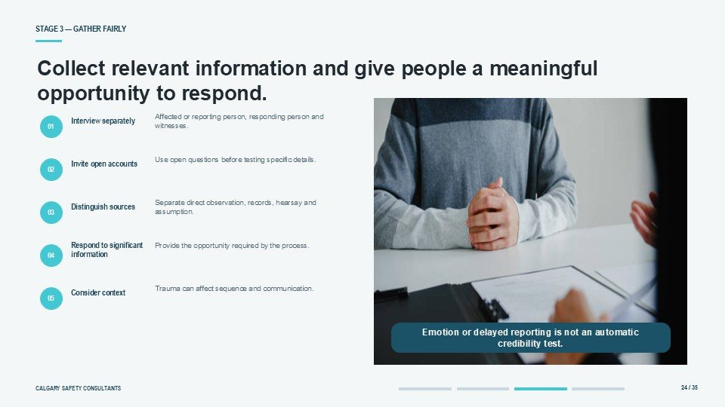  Notes __________________ | STAGE 3 — GATHER FAIRLY  Gather information proportionately. Interview the affected or reporting person, the responding person and relevant witnesses separately. Use open questions before testing details. Distinguish direct observation from hearsay or assumption.  Provide a meaningful opportunity to respond to significant information as required by the process. Evidence may include communications, security records, photographs, schedules, prior controls and emergency logs. Trauma can affect sequence and communication; emotion or delayed reporting is not an automatic credibility test.  KEY POINTS  • Collect relevant information and give people a meaningful opportunity to respond.  • Affected or reporting person, responding person and witnesses.  • Interview separately.

GENERAL NOTES

LESSON 04 • SLIDE 25 OF 35  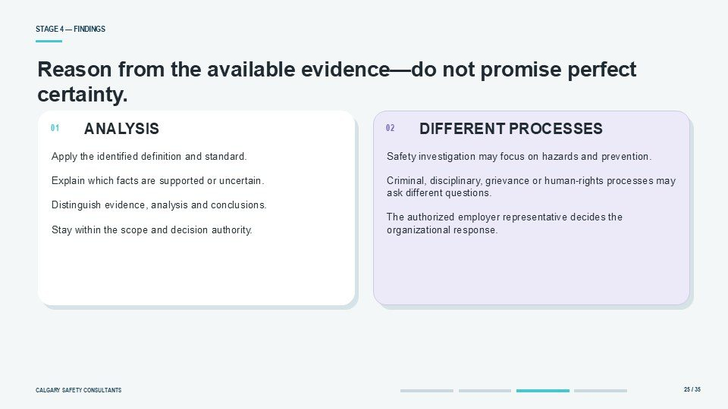  Notes __________________ | STAGE 4 — FINDINGS  Findings should be reasoned, not described as perfect certainty. The available evidence may be incomplete or conflicting. Apply the definition and standard identified in the mandate, explain which facts are supported or uncertain, and distinguish evidence, analysis and conclusions.  An occupational health and safety investigation may focus on circumstances, hazards and prevention, while a criminal, disciplinary, grievance or human rights process may ask different questions. The authorized employer representative decides the organizational response within the applicable process.  KEY POINTS  • Reason from the available evidence—do not promise perfect certainty.  • Apply the identified definition and standard. Explain which facts are supported or uncertain....  • Safety investigation may focus on hazards and prevention. Criminal, disciplinary, grievance or...

LESSON 04 • SLIDE 26 OF 35  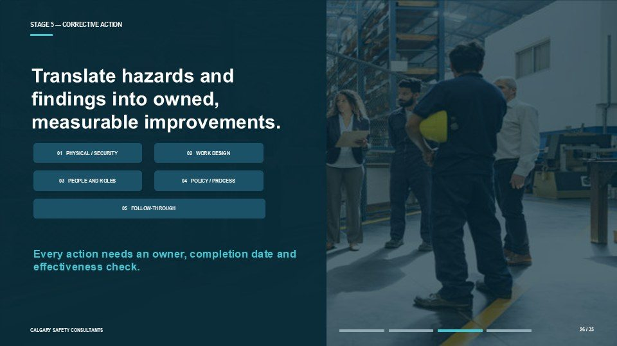  Notes __________________ | STAGE 5 — CORRECTIVE ACTION  Corrective action should address the hazards and contributing conditions identified. Examples include physical security, staffing or scheduling changes, safer client-contact procedures, emergency equipment, clearer reporting routes, supervision, training, policy revision or monitoring.  Personnel action may also be considered under the appropriate employment process. Each action should have an owner, completion date and effectiveness check. An unassigned recommendation does not reduce risk. Interim action may be appropriate before final findings when a clear safety gap already exists.  KEY POINTS  • Translate hazards and findings into owned, measurable improvements.  • Every action needs an owner, completion date and effectiveness check.

LESSON 04 • SLIDE 27 OF 35  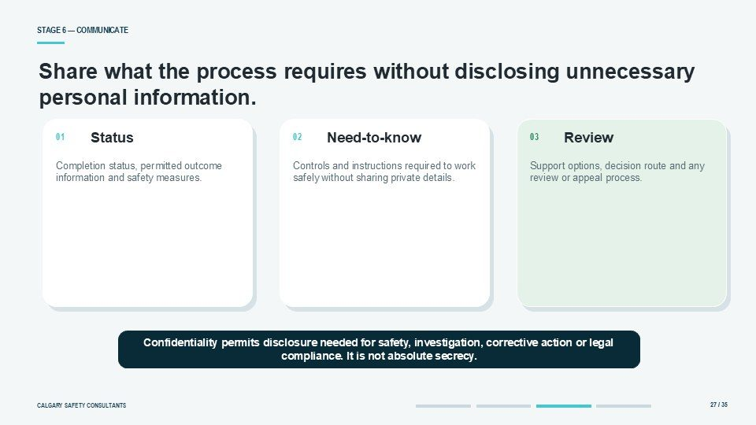  Notes __________________ | STAGE 6 — COMMUNICATE  Communicate the outcome required by law and policy while protecting private information. People may receive confirmation that the process is complete, the finding relevant to them, safety measures they need to know, support options and any review route.  They may not receive the full report or details of another person's personnel action. Confidentiality normally permits disclosure that is necessary for investigation, corrective action, safety or legal compliance. It is not a promise that no information will be shared.  KEY POINTS  • Share what the process requires without disclosing unnecessary personal information.  • Need-to-know.  • Completion status, permitted outcome information and safety measures.

GENERAL NOTES

LESSON 04 • SLIDE 28 OF 35  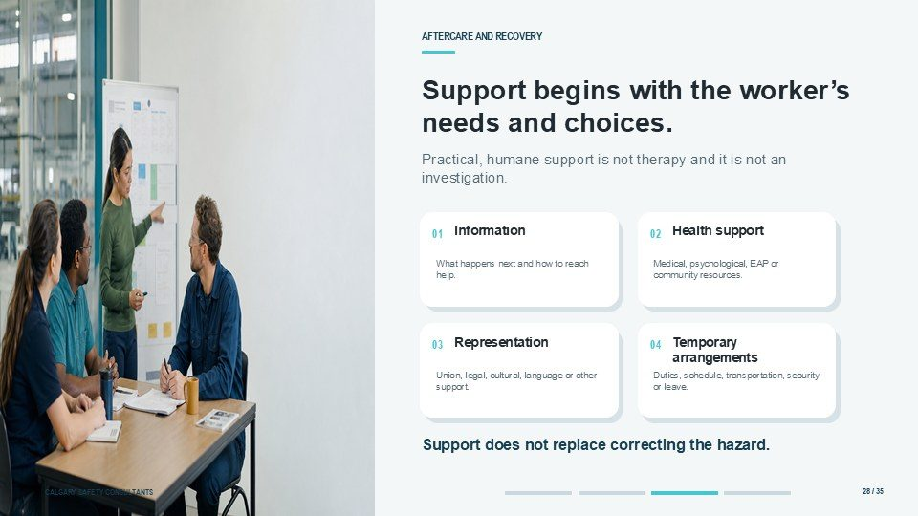  Notes __________________ | Support begins with the worker’s needs and choices.  Support should begin with the worker's immediate needs and choices. Psychological first aid is practical, humane support, not therapy or investigation. Help the person reach safety, provide clear information, reduce additional stressors and connect them with medical, psychological, employee, union or community  resources. Temporary modified duties, schedules, transportation, security or leave may help. Protect medical privacy and review arrangements with the worker. Support does not replace correcting the hazard.  KEY POINTS  • Practical, humane support is not therapy and it is not an investigation.  • Information.  • Health support.

LESSON 04 • SLIDE 29 OF 35  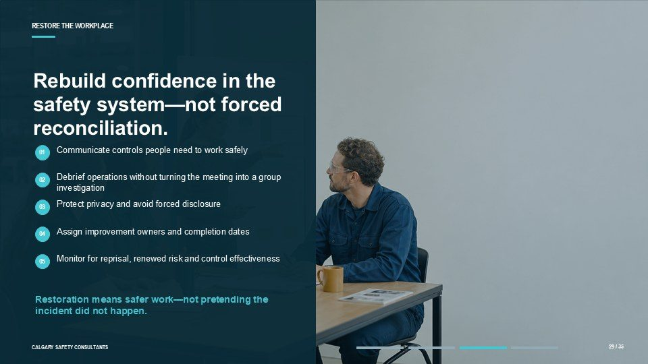  Notes __________________ | Rebuild confidence in the safety system—not forced reconciliation.  Restoration means rebuilding confidence in the safety system, not forcing reconciliation or disclosure. Tell workers what they need to work safely: changes to access, staffing, security, procedures, reporting routes or emergency controls.  An operational debrief examines what worked, what failed and what must change without turning the meeting into a group investigation or emotional disclosure session. Assign owners and dates to improvements, monitor for reprisal or renewed risk, and review the prevention plan when the incident reveals a gap.  KEY POINTS  • Communicate controls people need to work safely.  • Debrief operations without turning the meeting into a group investigation.  • Protect privacy and avoid forced disclosure.

LESSON 04 • SLIDE 30 OF 35  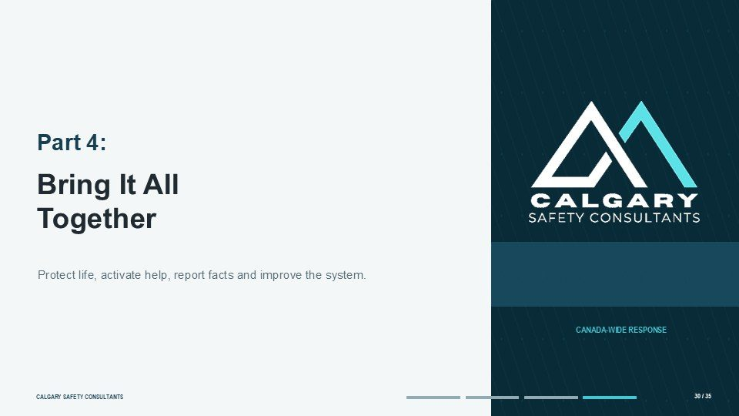  Notes __________________ | Part 4: Bring It All Together  Part Four applies the lesson. Use the same order of priorities: protect life, summon help, follow the emergency plan, report facts, cooperate with the process, support affected people and improve controls. The correct response depends on the actual risk and the site procedure.  The safest option reduces exposure and activates trained help without escalating the threat.  KEY POINTS  • Bring It All Together.  • Protect life, activate help, report facts and improve the system.

GENERAL NOTES

LESSON 04 • SLIDE 31 OF 35  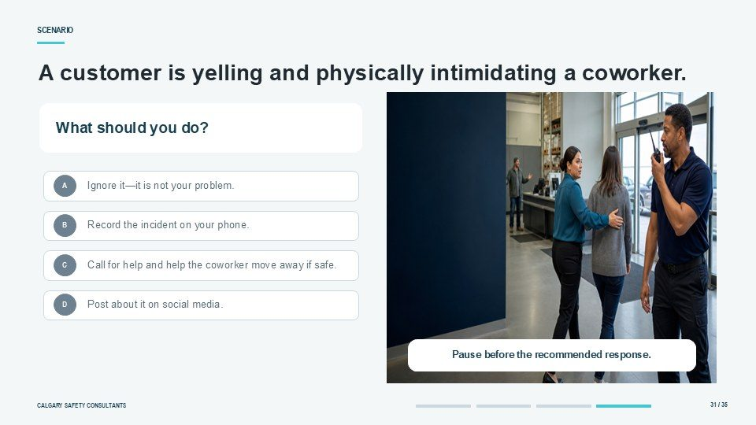  Notes __________________ | Scenario  Consider this scenario. A customer is yelling and physically intimidating a coworker. Which response is best? Option A is to ignore it. Option B is to record the incident on a phone. Option C is to call for help and help the coworker move away from danger when it can be done safely.  Option D is to post about it on social media. Pause and choose the response that prioritizes safety and the workplace plan.  KEY POINTS  • A customer is yelling and physically intimidating a coworker.  • What should you do?  • Ignore it—it is not your problem.

LESSON 04 • SLIDE 32 OF 35  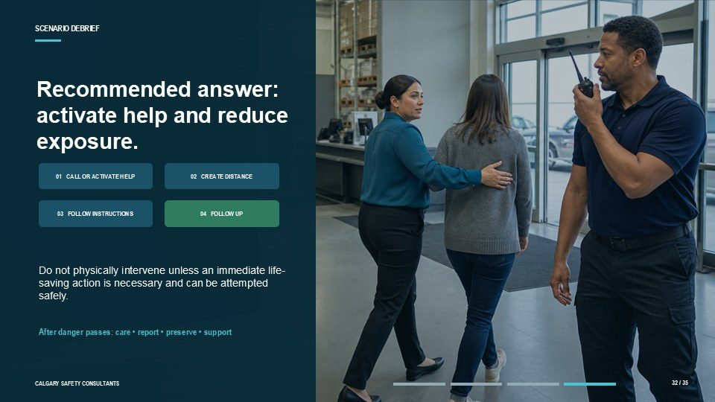  Notes __________________ | Recommended answer: activate help and reduce exposure.  The recommended answer is Option C. Activate the internal alarm or emergency route, contact 911 if there is immediate danger, create distance and follow instructions from trained responders. Help the coworker move only when it can be done without increasing exposure.  Do not physically intervene unless an immediate life-saving action is necessary and can be attempted safely. After danger passes, check for injury, provide first aid if safe and trained, report facts, preserve information and offer support.  KEY POINTS  • Do not physically intervene unless an immediate life-saving action is necessary and can be attempted...  • After danger passes: care • report • preserve • support.

LESSON 04 • SLIDE 33 OF 35  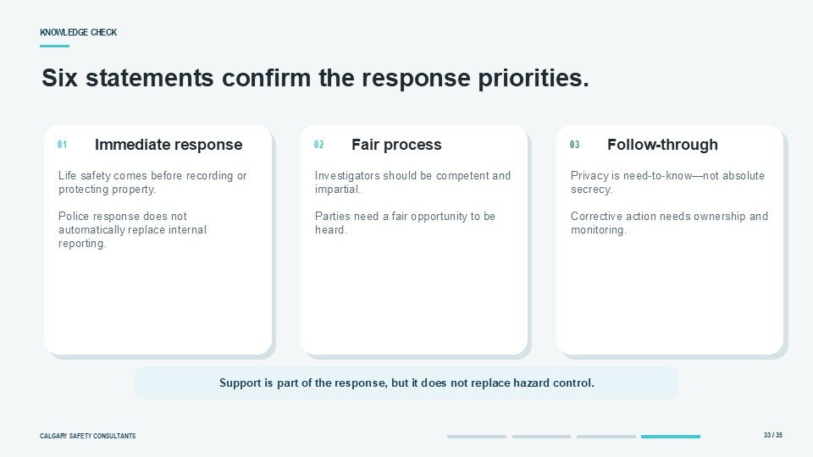  Notes __________________ | Six statements confirm the response priorities.  Check your understanding. During immediate danger, life safety comes before recording or protecting property. A police response does not automatically replace the internal workplace process. Investigations should use competent and impartial people and provide fair opportunities to be heard.  Privacy is need-to-know, not absolute secrecy. Corrective action requires ownership and monitoring. Finally, support is part of the response but does not replace hazard control.  KEY POINTS  • Immediate response.  • Fair process.  • Follow-through.

GENERAL NOTES

LESSON 04 • SLIDE 34 OF 35  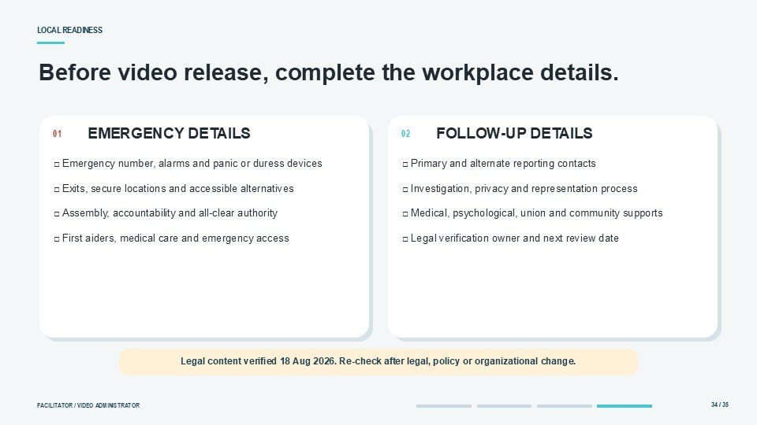  Notes __________________ | Before video release, complete the workplace details.  Before release, insert the local details that make the lesson usable. Confirm the emergency number, alarms, panic devices, exits, secure locations, accountability process and all-clear authority. Add primary and alternate reporting contacts, including after-hours access.  Identify first aid, medical and psychological supports. State the governing jurisdiction, investigation process, privacy limits, representation or accommodation options and external notification roles. Assign a legal verification owner and review date.  KEY POINTS  • □ Emergency number, alarms and panic or duress devices □ Exits, secure locations and accessible...  • □ Primary and alternate reporting contacts □ Investigation, privacy and representation process □...  • Legal content verified 18 Aug 2026. Re-check after legal, policy or organizational change.

LESSON 04 • SLIDE 35 OF 35  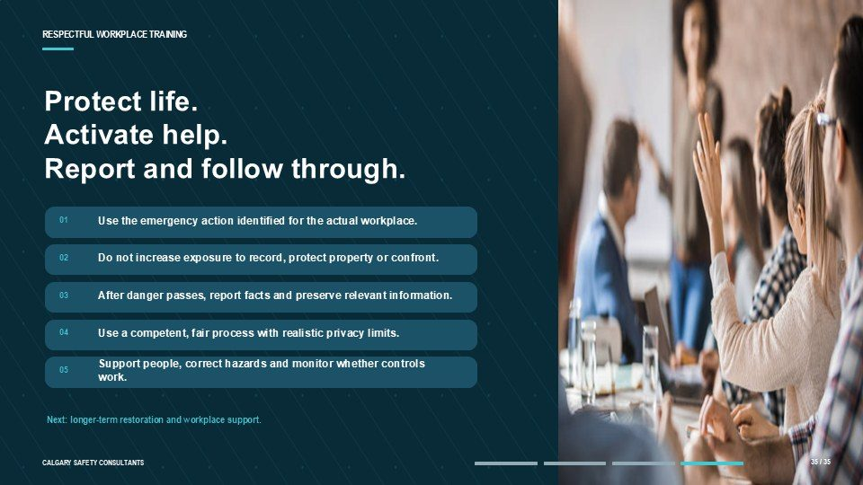  Notes __________________ | Protect life. Activate help. Report and follow through.  The key message is simple. During danger, protect life, create distance and activate trained help. Afterward, report facts, preserve relevant information, support people and use a fair process. The organization must correct hazards, communicate what can appropriately be shared and monitor whether controls work.  Take a moment now to locate the emergency procedure, primary and alternate contacts, safe locations, accountability process and support resources for your work area.  KEY POINTS  • Use the emergency action identified for the actual workplace.  • Do not increase exposure to record, protect property or confront.  • After danger passes, report facts and preserve relevant information.

GENERAL NOTES

LESSON 04 SUMMARY
Responding to Workplace Violence
The following points bring the lesson together. Use them to review the main prevention message and connect it to the procedures and expectations in your workplace.
01 | Immediate safety comes first. Leave danger where possible and use the emergency, security, or law enforcement response that applies.
02 | A useful report describes observable facts, current risk, timing, location, witnesses, immediate effects, and relevant preserved information.
03 | A fair response acknowledges the report, assesses risk, uses interim safeguards, assigns a competent and impartial process, gathers information, and reaches supported findings.
04 | Privacy should be protected on a need to know basis while participants receive enough information to understand their role, the process, available support, and expected conduct.
05 | Corrective action must be assigned, implemented, monitored, and reviewed. Reprisal or continuing risk requires prompt attention.
Reflection and application
• What is the first action if a violent situation creates immediate danger?
• What information would make a report useful without adding assumptions?
• How does this workplace monitor corrective action and continuing risk?
________________________________________________________________________________
MODULE REVIEW
Module Three complete
Workplace violence prevention depends on recognizing risk, applying practical controls, using clear reporting and emergency routes, responding fairly, and following through on corrective action.
☐ I know the primary, alternate, and emergency routes for workplace violence concerns.
☐ I can describe observable conduct and preserve useful information without investigating on my own.
☐ I can identify violence hazards and the controls used to reduce exposure.
☐ I can choose emergency action or the appropriate workplace reporting route based on the risk.
☐ I understand why corrective action, monitoring, communication, and follow through matter.
My most important takeaways
________________________________________________________________________________
________________________________________________________________________________
GENERAL NOTES

STUDENT REFERENCE GUIDE

Module Four
Respectful Workplace Harassment and Violence Prevention Training
How to use this guide
This portrait reference guide follows the original Module Four lesson and slide sequence. Each compact slide entry includes the PowerPoint visual, the lesson explanation, practical points to remember, and a line for notes. Every page also includes a general notes area.
Use the guide during training to record examples and questions. After training, return to the lesson overviews and summaries when you need to review recovery, support, communication, improvement, or workplace-specific follow-through.
Module roadmap
LESSON 01 | Restoring the Workplace After an Incident  Stabilize | Support | Communicate | Improve
LESSON 02 | Supporting Affected Persons  Safety | Trauma-informed response | Accommodation | Privacy
LESSON 03 | Supporting the Workplace as a Whole  Recovery | Communication | Facilitation | Culture
LESSON 04 | Sustaining Prevention and Moving Forward  Improve the system | Listen continuously | Reinforce respect | Apply and verify
Important: This guide supports the training. Follow the legislation, workplace policies, procedures, reporting routes, and emergency directions that apply to your workplace.
GENERAL NOTES

MODULE FOUR / LESSON 01

Restoring the Workplace After an Incident
Stabilize | Support | Communicate | Improve
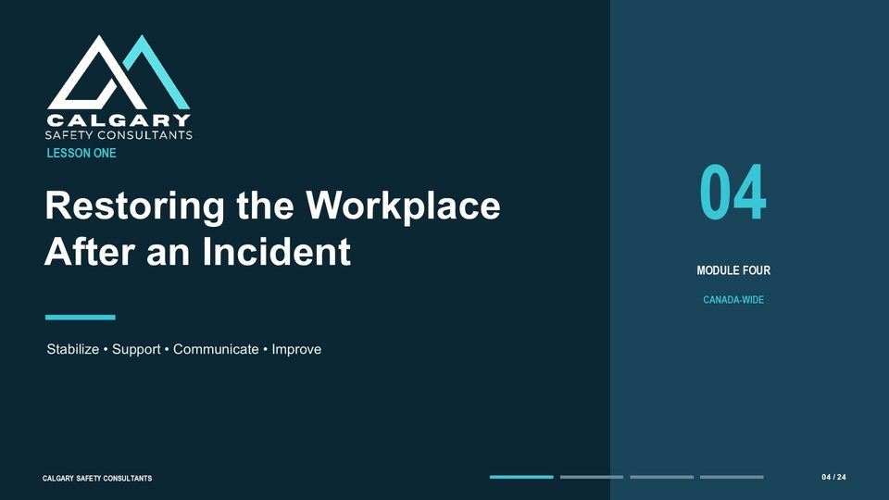
Lesson overview
Workplace recovery begins by controlling immediate risk and confirming what people need. Reporting, investigation, privacy, support, and return-to-work duties depend on the governing jurisdiction and the workplace process.
This lesson covers coordinated recovery after an incident, including physical and psychological safety, careful communication, practical support, planned return to work, corrective action, and follow-through.
By the end of this lesson you should be able to
• Stabilize safety and assess immediate and continuing risk.
• Communicate with care while protecting privacy.
• Coordinate practical supports and planned return-to-work measures.
• Rebuild confidence by completing corrective actions and monitoring conditions.
• Apply lessons from the incident to strengthen prevention.
GENERAL NOTES

LESSON 01 • SLIDE 01 OF 24    Notes __________________ | Restoring the Workplace After an Incident  This slide introduces restoring the workplace after an incident. Respectful Workplace: Restoring the Workplace after an Incident.  Respectful. Workplace.  KEY POINTS  • Respectful Workplace: Restoring the Workplace after an Incident.  • Respectful.  • Workplace.

LESSON 01 • SLIDE 02 OF 24    Notes __________________ | Recovery starts with safety, support and follow-through  Welcome to Module Four, Lesson One: Restoring the Workplace after an Incident. The key idea on this slide is that recovery starts with three connected commitments: safety, support, and follow-through.  After an incident, employees judge the response by what leaders do next - not by how quickly the workplace looks normal again. A calm, fair, and practical response restores confidence by controlling risk, supporting affected people, explaining the process, and carrying commitments through to completion.  KEY POINTS  • Recovery starts with.  • safety, support and follow-through.  • After an incident, people watch what leaders do next. A calm, fair and practical response helps restore confidence.

LESSON 01 • SLIDE 03 OF 24  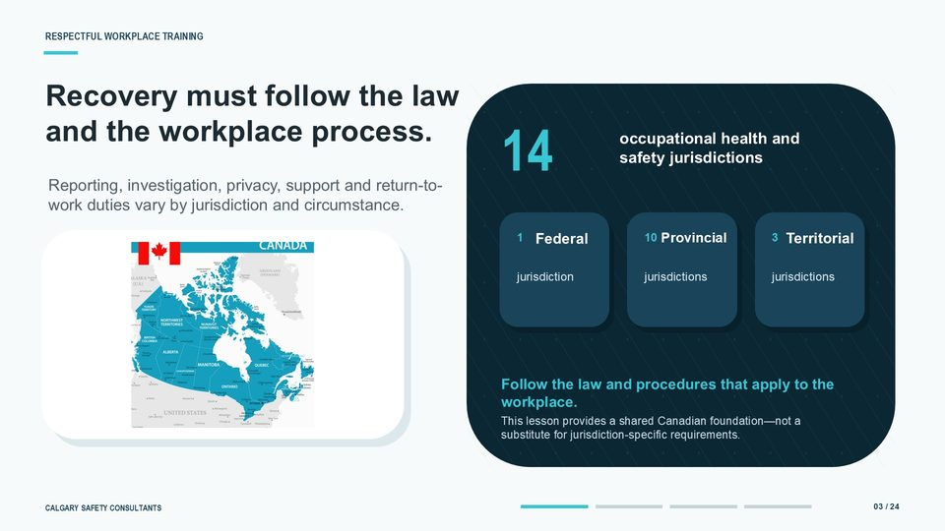  Notes __________________ | Recovery must follow the law and the workplace process  Recovery must follow the law and the workplace process that apply to the organization. Canada has fourteen occupational health and safety jurisdictions: one federal, ten provincial, and three territorial.  That distinction matters because reporting, investigation, privacy, support, and return-to-work requirements can vary by jurisdiction and circumstance. Begin by confirming which jurisdiction governs the workplace, then follow its requirements together with the organization's policies and procedures. Human rights, privacy, employment, labour relations, workers' compensation, and criminal law may also be relevant.  KEY POINTS  • Recovery must follow the law.  • and the workplace process.  • Reporting, investigation, privacy, support and return-to-work duties vary by jurisdiction and circumstance.

GENERAL NOTES

LESSON 01 • SLIDE 04 OF 24  Notes __________________ | Restoring the Workplace After an Incident  This lesson follows four connected themes: stabilize, support, communicate, and improve. First, we will look at how to control immediate risk and assess what people and the workplace need. Next, we will consider psychological safety and the support that may be helpful after an incident.  We will then focus on careful communication: what to say, what not to say, and how to protect privacy. Finally, we will look at the actions that rebuild trust, including corrective action, return-to-work planning, and follow-up. Each theme supports the others.  KEY POINTS  • LESSON ONE: Restoring the Workplace after an Incident.  • Restoring the Workplace.  • After an Incident.

LESSON 01 • SLIDE 05 OF 24  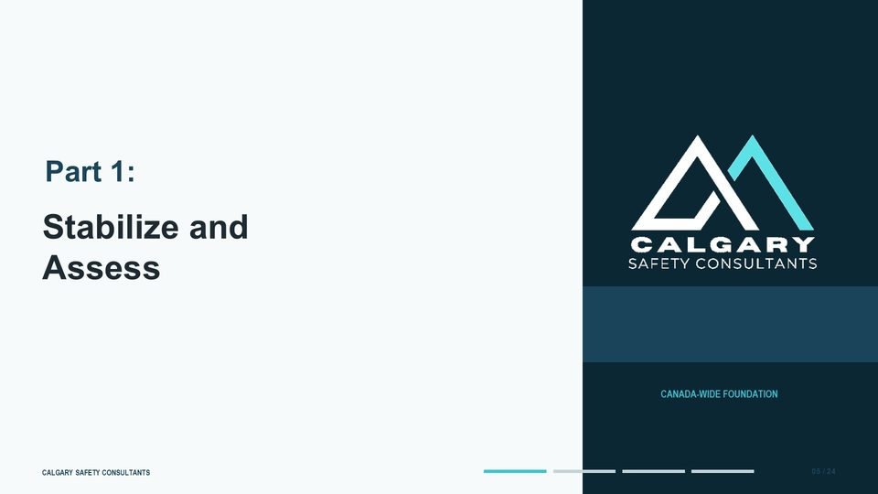  Notes __________________ | Stabilize and Assess  This slide introduces stabilize and assess. Stabilize and.  Assess. Review the workplace process related to stabilize and assess.  KEY POINTS  • Stabilize and.  • Assess.  • Review the workplace process related to stabilize and assess.

LESSON 01 • SLIDE 06 OF 24  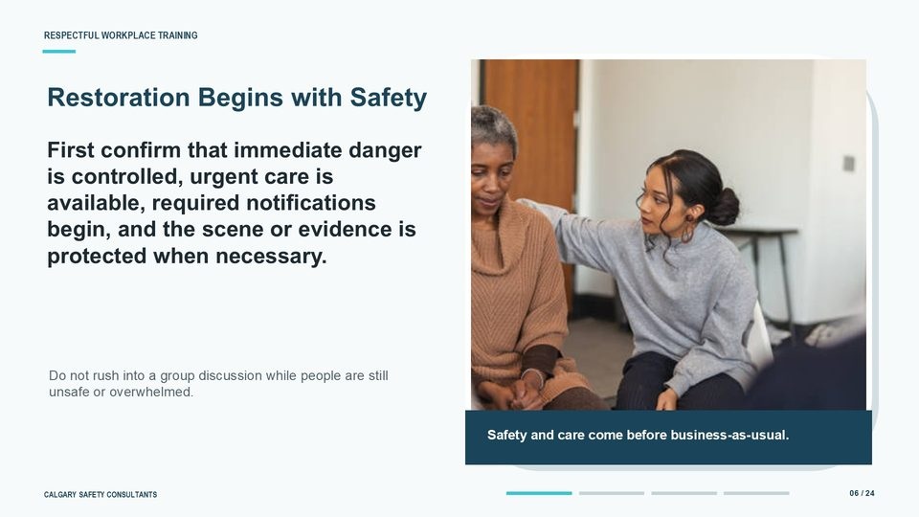  Notes __________________ | Restoration Begins with Safety  Restoration begins with safety. Stabilize the situation by controlling the immediate danger and following the workplace emergency procedure. Support affected people by arranging medical or emergency assistance when needed and checking on urgent practical needs.  Notify the appropriate internal and external contacts, and protect the scene, records, or other evidence when the applicable process requires it. Do not pressure anyone for a detailed account before urgent needs have been addressed, and do not rush into a group discussion while people are still unsafe or overwhelmed. The priority is clear: safety and care come before business as usual.  KEY POINTS  • First confirm that immediate danger is controlled, urgent care is available, required notifications begin, and the scene or evidence is protected when necessary.  • STABILIZE.  • SUPPORT.

GENERAL NOTES

LESSON 01 • SLIDE 07 OF 24  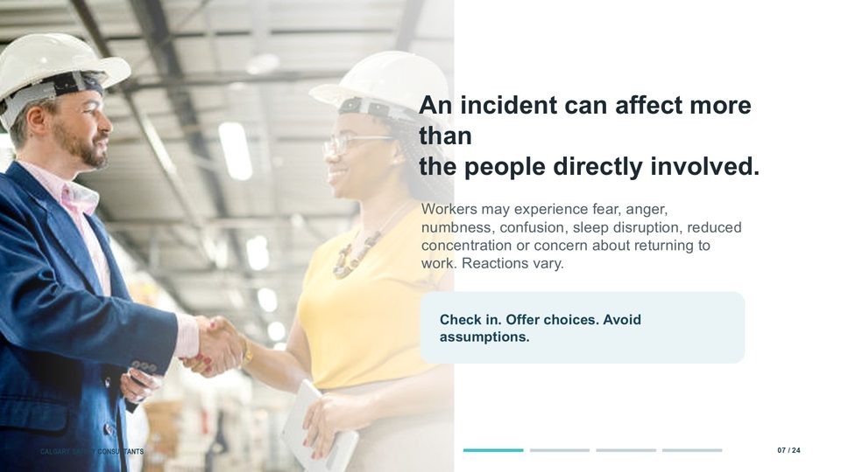  Notes __________________ | An incident can affect more than the people directly involved  An incident can affect more than the people who were directly involved. The person targeted, witnesses, responders, supervisors, co-workers, and family members may all experience an impact. Reactions can include fear, anger, numbness, confusion, disrupted sleep, reduced concentration, or concern about returning to work.  These reactions vary from person to person and may change over time. Check in privately, offer practical choices, and explain how support can be accessed now or later. Avoid diagnosing, labelling, or assuming that everyone needs the same response.  KEY POINTS  • An incident can affect more than.  • the people directly involved.  • Workers may experience fear, anger, numbness, confusion, sleep disruption, reduced concentration or concern about returning to work. Reactions vary.

LESSON 01 • SLIDE 08 OF 24  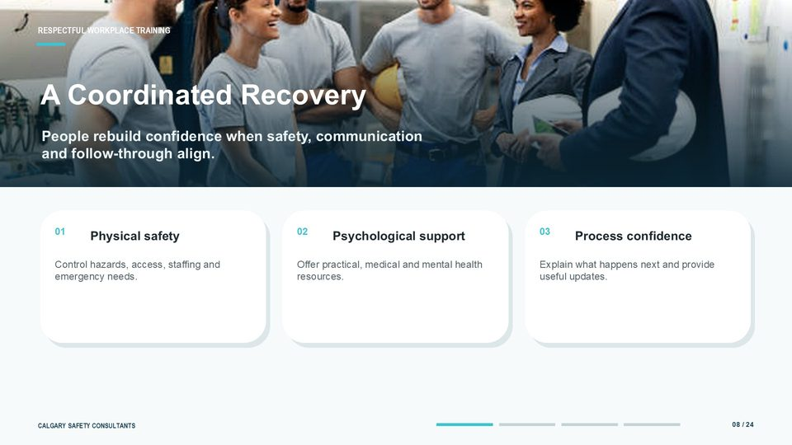  Notes __________________ | A Coordinated Recovery  A coordinated recovery brings together the three elements shown on this slide. Physical safety means controlling hazards, access, staffing, security, equipment, and emergency needs. Psychological support means offering practical help and access to appropriate medical or mental health resources.  Process confidence comes from explaining what happens next, who is responsible, and when people can expect another update. These elements are interdependent. Support does not replace correcting a hazard, and a corrected hazard does not remove the need to communicate and follow through.  KEY POINTS  • Safety, support and follow-through need to work together.  • People rebuild confidence when safety, communication and follow-through align.  • Physical safety.

LESSON 01 • SLIDE 09 OF 24    Notes __________________ | Reactions are not performance failures  Reactions after a serious event are not performance failures. Stress can temporarily affect concentration, memory, sleep, confidence, and decision-making. Start with a private check-in and ask what would help the person work safely.  Depending on the situation, this may include clearer information, time away, a temporary change in duties or schedule, a safer location, medical care, counselling, or another form of support. Focus on functional needs and safe work rather than labels or assumptions about a diagnosis. Explain the available process, involve the appropriate workplace or health professionals when required, and review any adjustment as needs change.  KEY POINTS  • Reactions are not.  • performance failures.  • Concentration, memory, sleep or confidence may be affected after a serious event. Support safe work and avoid labelling normal reactions.

GENERAL NOTES

LESSON 01 • SLIDE 10 OF 24  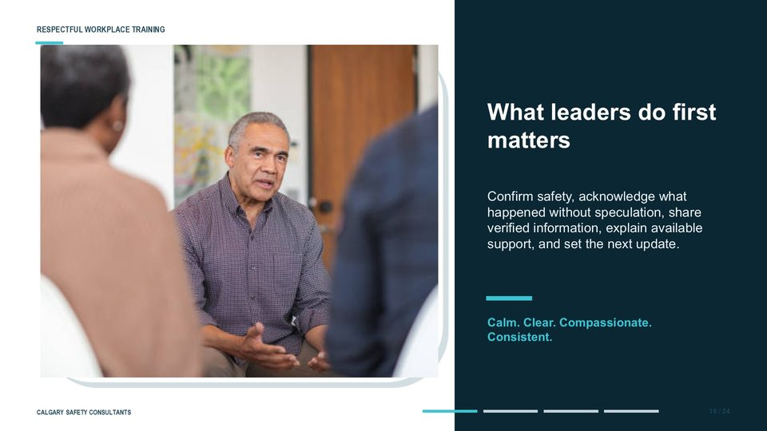  Notes __________________ | What leaders do first matters  What leaders do first matters. Begin by confirming safety and acknowledging that something significant has occurred without speculating about causes or responsibility. Share only information that has been verified and can appropriately be disclosed.  Explain the support that is available, describe the reporting, investigation, or resolution process, and identify who will provide the next update and when. Keep the message calm, clear, compassionate, and consistent. Avoid blame, promises about outcomes, or language that minimizes the event.  KEY POINTS  • Confirm safety, acknowledge what happened without speculation, share verified information, explain available support, and set the next update.  • Calm. Clear. Compassionate. Consistent.  • Begin by confirming safety and acknowledging that something significant has occurred without speculating about causes or responsibility.

LESSON 01 • SLIDE 11 OF 24  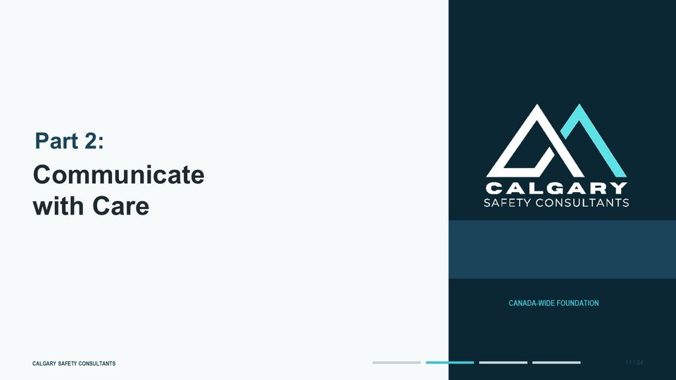  Notes __________________ | Communicate with Care  This slide introduces communicate with care.  Communicate. with Care. Review the workplace process related to communicate with care.  KEY POINTS  • Communicate.  • with Care.  • Review the workplace process related to communicate with care.

LESSON 01 • SLIDE 12 OF 24  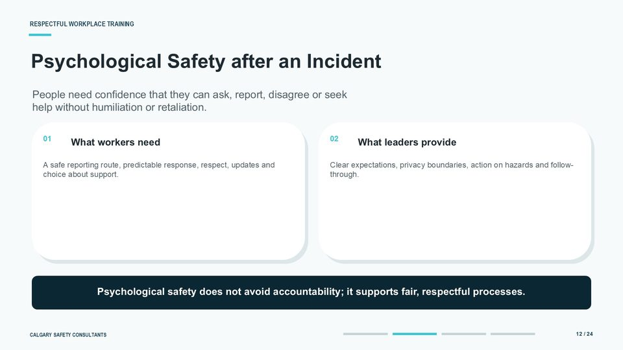  Notes __________________ | Psychological Safety after an Incident  Psychological safety after an incident means people can ask questions, report concerns, disagree respectfully, or seek help without humiliation or retaliation. It does not remove accountability; it supports a fair and respectful process. Workers need a safe reporting route, a predictable response, respectful treatment, useful updates, and meaningful choice about support.  Leaders provide clear expectations, explain privacy boundaries, act on hazards, and follow through on commitments. Pay attention to signs that people are staying silent because they fear blame or reprisal. Confidence grows when the stated process is actually used consistently.  KEY POINTS  • People need confidence that they can ask, report, disagree or seek help without humiliation or retaliation.  • What workers need.  • A safe reporting route, predictable response, respect, updates and choice about support.

GENERAL NOTES

LESSON 01 • SLIDE 13 OF 24  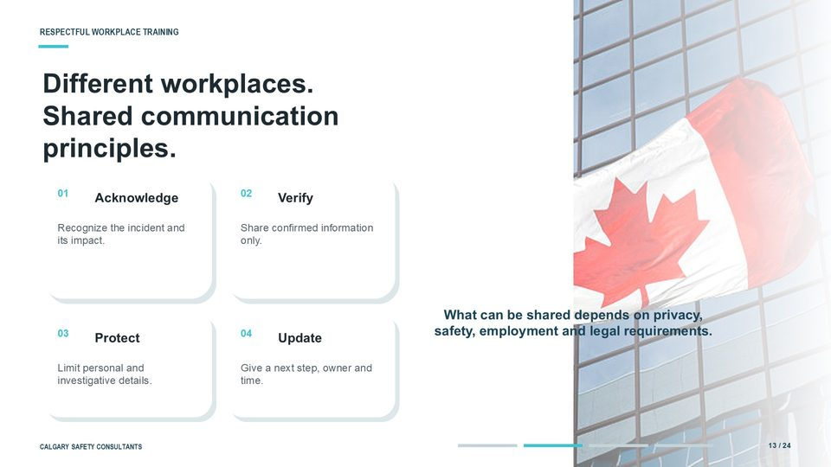  Notes __________________ | Different workplaces. Shared communication principles  Different workplaces can use the same four communication principles. First, acknowledge the incident and its impact without announcing conclusions. Second, verify information before sharing it.  Third, protect personal, medical, employment, and investigative details by limiting information to those who need it for the response. Fourth, provide an update with a clear next step, a responsible role, and a reasonable time for more information. Even when details are limited, a useful message can explain immediate safety actions, available support, the general process, and when people will hear more.  KEY POINTS  • Different workplaces.  • Shared communication principles.  • Acknowledge.

LESSON 01 • SLIDE 14 OF 24  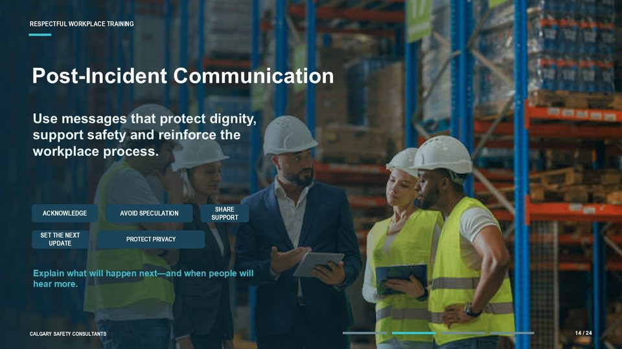  Notes __________________ | Post-Incident Communication  Post-incident communication should protect dignity, support safety, and reinforce confidence in the workplace process. Acknowledge the event at an appropriate level, share any immediate safety direction, explain available support, and state what will happen next. Avoid speculation, blame, graphic details, and premature conclusions.  Protect privacy by sharing only what is necessary and appropriate. Consistency also matters: use confirmed information, direct questions to the appropriate contact, and give a clear time for the next update. If earlier information turns out to be wrong, correct it openly and promptly.  KEY POINTS  • Use messages that protect dignity, support safety and reinforce the workplace process.  • ACKNOWLEDGE.  • AVOID SPECULATION.

LESSON 01 • SLIDE 15 OF 24  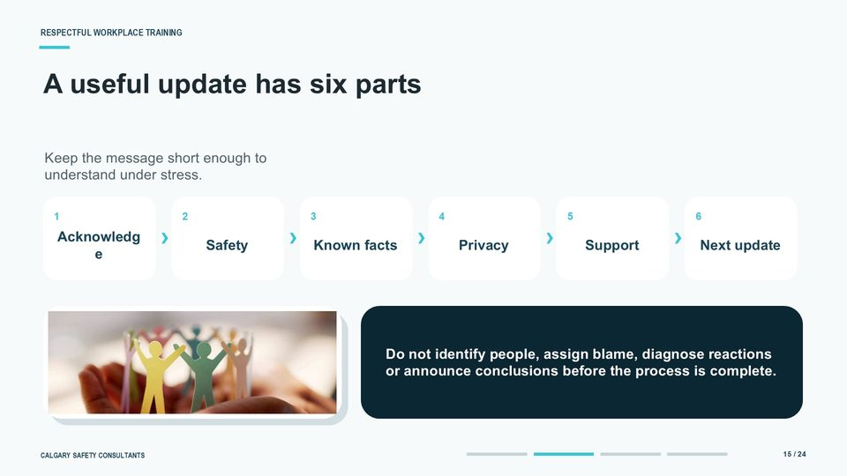  Notes __________________ | A useful update has six parts  A useful post-incident update has the six parts shown on the slide: acknowledge the event, give immediate safety information, share appropriate known facts, explain the privacy boundary, identify available support, and set the next update. Keep the message short enough to understand under stress. For example: "An incident occurred today.  The immediate hazard is controlled, and a review is underway. We will protect the privacy of those involved. Support is available through the usual workplace contacts.  KEY POINTS  • Keep the message short enough to understand under stress.  • Acknowledge.  • Safety.

GENERAL NOTES

LESSON 01 • SLIDE 16 OF 24  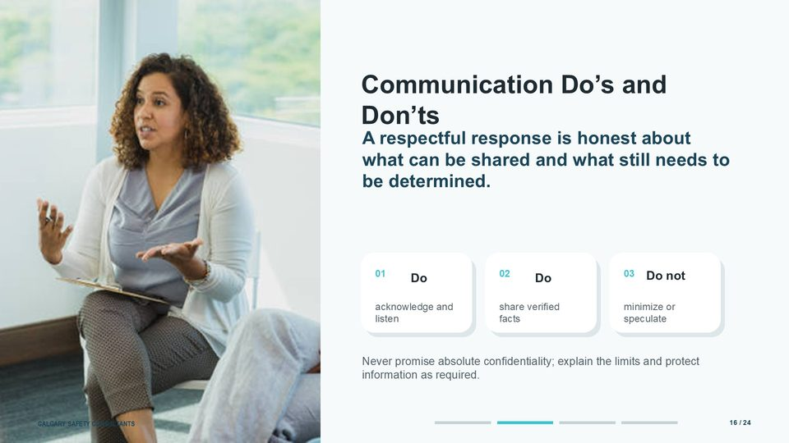  Notes __________________ | Communication Do's and Don'ts  Use these do's and don'ts as a quick leader checklist. Do acknowledge what happened and listen to concerns. Do share verified facts, practical safety information, available support, and the next step.  Do not minimize the incident, speculate, pressure people to speak publicly, or promise a particular outcome. Be careful with the word confidential. Absolute secrecy may not be possible because information may need to be shared for safety, legal compliance, or a fair investigation.  KEY POINTS  • A respectful response is honest about what can be shared and what still needs to be determined.  • acknowledge and listen.  • share verified facts.

LESSON 01 • SLIDE 17 OF 24  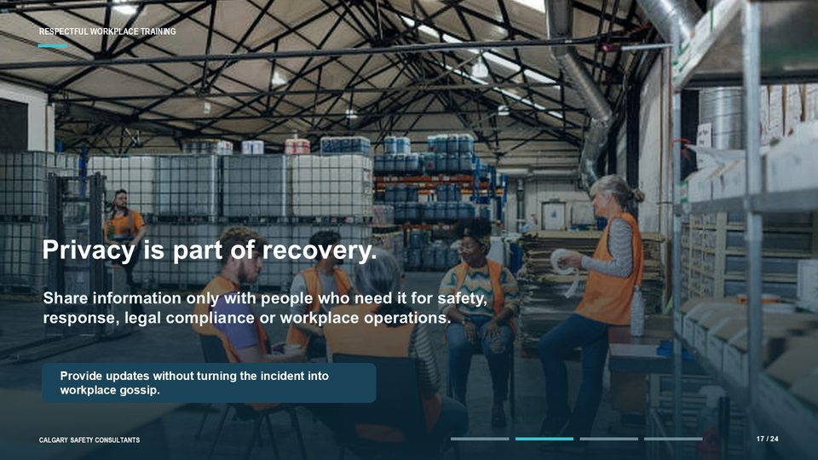  Notes __________________ | Privacy is part of recovery  Privacy is part of recovery. Share information only with people who need it for safety, the response process, legal compliance, or workplace operations. The broader workforce can still receive useful updates without personal or investigative details.  For example, explain that a safety review is underway, identify interim controls, list available supports, and provide the timing of the next update. Discourage gossip and direct questions through the appropriate workplace contact. Protecting privacy preserves dignity, reduces further harm, and supports the fairness of the response.  KEY POINTS  • Share information only with people who need it for safety, response, legal compliance or workplace operations.  • Provide updates without turning the incident into workplace gossip.  • Share information only with people who need it for safety, the response process, legal compliance, or workplace operations.

LESSON 01 • SLIDE 18 OF 24  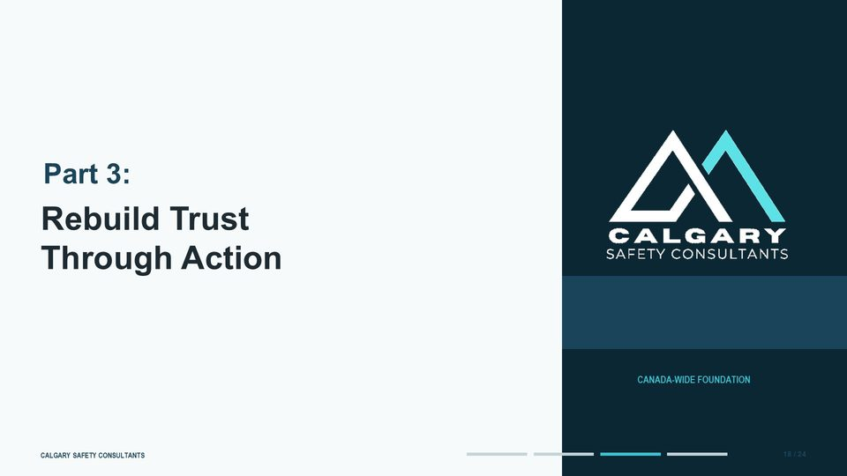  Notes __________________ | Rebuild Trust Through Action  This slide introduces rebuild trust through action. Rebuild Trust.  Through Action. Review the workplace process related to rebuild trust through action.  KEY POINTS  • Rebuild Trust.  • Through Action.  • Review the workplace process related to rebuild trust through action.

GENERAL NOTES

LESSON 01 • SLIDE 19 OF 24  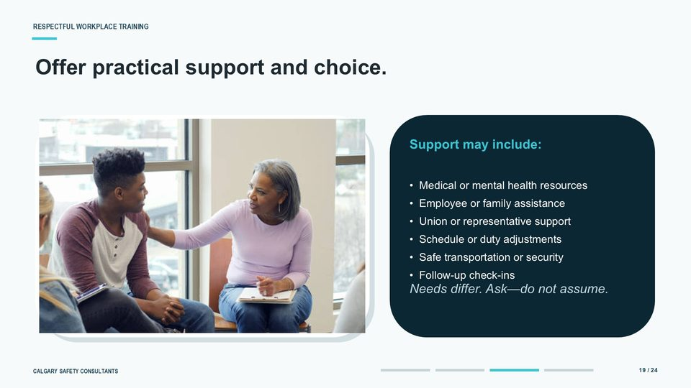  Notes __________________ | Offer practical support and choice  Offer practical support and meaningful choice. Depending on the circumstances, support may include medical or mental health resources, employee or family assistance, union or representative support, schedule or duty adjustments, safe transportation, security measures, and planned check-ins. Needs differ, so ask what would be useful rather than assuming.  Support may also be appropriate for witnesses, supervisors, and responders. Do not force someone to take part in counselling, a group discussion, or a debrief. Explain the available options, follow the duties and workplace processes that apply, and revisit the conversation because needs can change over time.  KEY POINTS  • Support may include:.  • • Medical or mental health resources.  • • Employee or family assistance.

LESSON 01 • SLIDE 20 OF 24  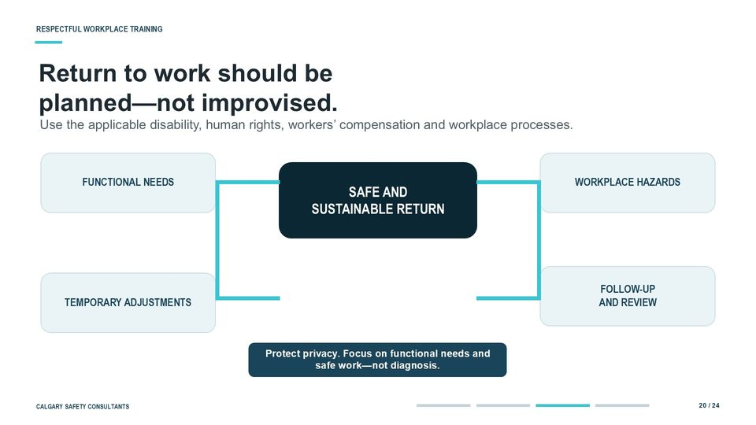  Notes __________________ | Return to work should be planned - not improvised  A safe and sustainable return to work should be planned, not improvised. Consider the four connected areas on this slide: the worker's functional needs, the hazards in the workplace, any temporary adjustments, and a schedule for follow-up and review.  Use the applicable disability management, human rights, workers' compensation, employment, and workplace safety processes. Focus on what the person can safely do and what barriers need to be addressed, rather than seeking unnecessary diagnostic details.  KEY POINTS  • Use the applicable disability, human rights, workers' compensation and workplace processes.  • SAFE AND.  • SUSTAINABLE RETURN.

LESSON 01 • SLIDE 21 OF 24  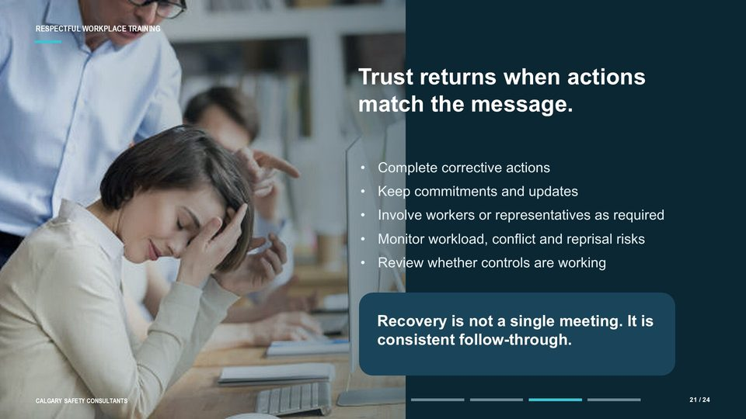  Notes __________________ | Trust returns when actions match the message  Trust returns when actions match the message. Complete corrective actions and communicate when they are finished. Keep the commitments made during check-ins and updates.  Involve workers, committees, representatives, or unions when the law or workplace process requires it. Monitor workload, conflict, reprisal risk, and any other condition that could create further harm. Then confirm that the controls are working by using worker feedback, incident and near-miss trends, response times, and completion records.  KEY POINTS  • Trust returns when actions.  • match the message.  • Complete corrective actions.

GENERAL NOTES

LESSON 01 • SLIDE 22 OF 24  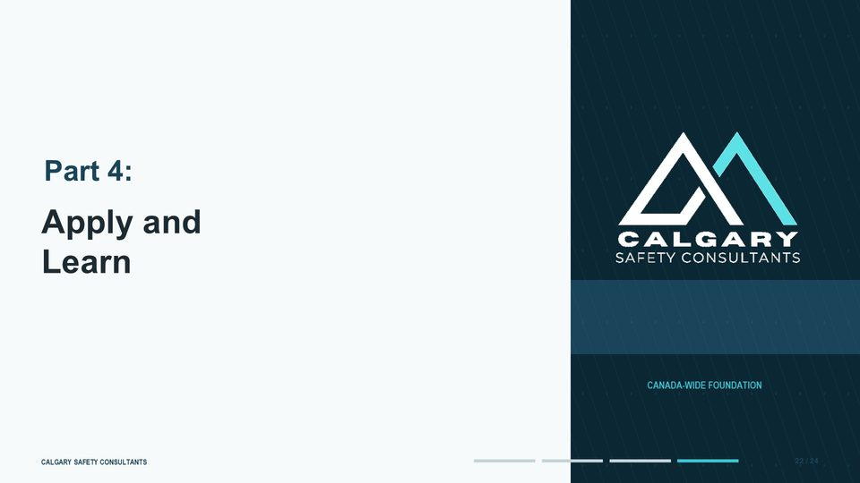  Notes __________________ | Apply and Learn  This slide introduces apply and learn. Apply and.  Learn. Review the workplace process related to apply and learn.  KEY POINTS  • Apply and.  • Learn.  • Review the workplace process related to apply and learn.

LESSON 01 • SLIDE 23 OF 24  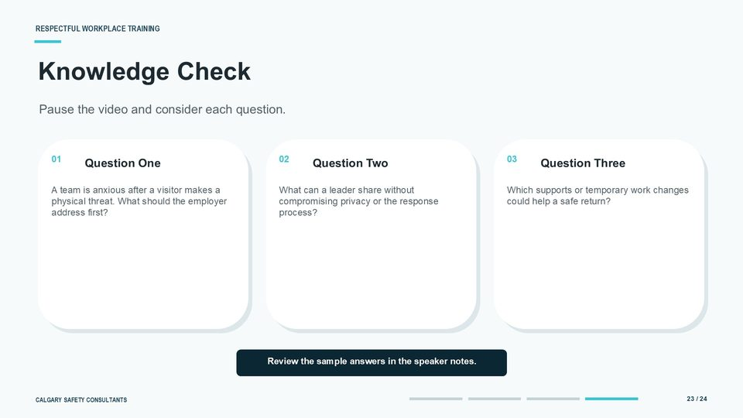  Notes __________________ | Knowledge Check  Pause the video and consider each question before reviewing these sample responses. 1. Address immediate safety first.  Control the threat, follow emergency and reporting procedures, check on affected people, and put any necessary interim controls in place before work resumes. 2. A leader can share verified safety information, interim controls, available support, the general response process, and the timing of the next update.  KEY POINTS  • How should the workplace support recovery after a physical threat?  • Pause the video and consider each question.  • Question One.

LESSON 01 • SLIDE 24 OF 24  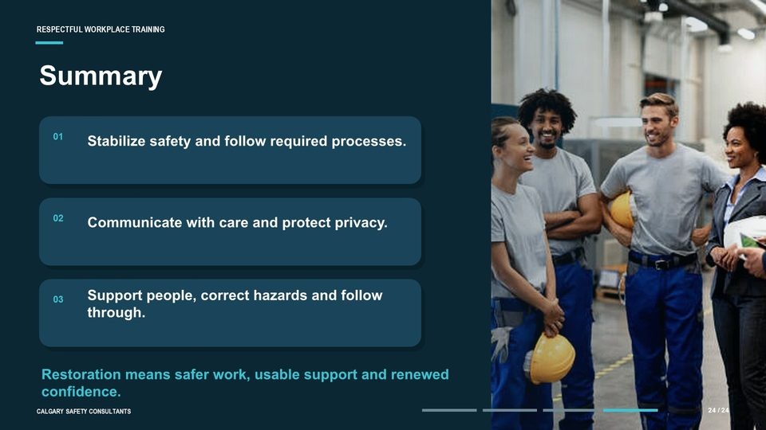  Notes __________________ | Summary  To summarize, restoration begins by stabilizing safety and following the required emergency, reporting, and response processes. Communicate with care by acknowledging the event, sharing verified information, protecting privacy, explaining support, and setting the next update.  Support people and improve the work through practical choices, safe return-to-work planning, corrective action, and meaningful follow-through. Restoration is measured by safer work, usable support, and renewed confidence - not by how quickly the workplace appears normal. This concludes Module Four, Lesson One: Restoring the Workplace after an Incident.  KEY POINTS  • Stabilize safety. Communicate with care. Support people. Improve the work.  • Stabilize safety and follow required processes.  • Communicate with care and protect privacy.

GENERAL NOTES

LESSON 01 SUMMARY
Restoring the Workplace After an Incident
The following points bring the lesson together. Use them to review the main recovery and prevention message and connect it to the procedures and expectations in your workplace.
01 | Stabilize immediate safety and begin the reporting, notification, and response processes required for the workplace.
02 | Assess physical and psychological effects without treating normal reactions as performance failures.
03 | Communicate known facts, privacy limits, available support, and the timing of the next update.
04 | Offer practical support and plan any return to work around functional needs, hazards, and follow-up.
05 | Complete corrective action, monitor continuing risk, and use the incident to improve prevention.
Reflection and application
• What must happen first when an incident creates immediate or continuing danger?
• What information can be shared to support safe work while protecting privacy?
• How will this workplace confirm that corrective actions and supports are working?
________________________________________________________________________________
________________________________________________________________________________
GENERAL NOTES

MODULE FOUR / LESSON 02

Supporting Affected Persons
Safety | Trauma-informed response | Accommodation | Privacy
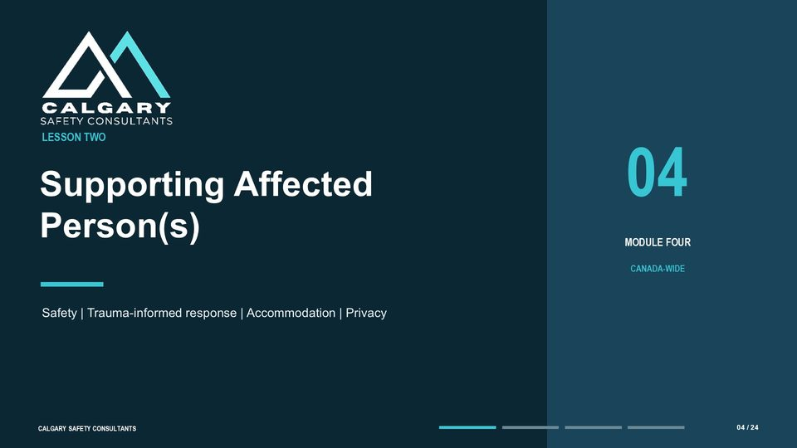
Lesson overview
An occurrence can affect physical safety, emotional and psychological well-being, social relationships, trust, and participation at work. A useful first response is calm, respectful, and focused on immediate safety and choice.
This lesson explains trauma-informed support, supervisor role boundaries, practical accommodation, privacy, follow-up, and access to workplace, health, union, and community resources.
By the end of this lesson you should be able to
• Recognize that people may experience and describe effects differently.
• Respond with safety, respect, choice, and clear role boundaries.
• Coordinate practical supports and individualized accommodations.
• Protect privacy while sharing information needed for safe work.
• Connect affected people with appropriate workplace and external resources.
GENERAL NOTES

LESSON 02 • SLIDE 01 OF 24    Notes __________________ | Supporting Affected Persons  Welcome to Module Four, Lesson Two: Supporting Affected Persons. In this lesson, we move from prevention and reporting to a question that matters just as much: what does a respectful workplace do after someone has been affected by harassment, violence, or another harmful occurrence?  We will look at immediate safety, trauma-informed communication, practical workplace support, accommodation, privacy, resources, and follow-up. The aim is not to turn supervisors into counsellors or investigators. It is to help everyone understand how to respond calmly, preserve dignity, and connect the person with the right help and process.  KEY POINTS  • Supporting Affected Person(s).  • Trauma-Informed Response and Recovery at Work.  • Welcome to Module Four, Lesson Two: Supporting Affected Persons.

LESSON 02 • SLIDE 02 OF 24    Notes __________________ | Support begins with safety, choice, and respect  Welcome to Module Four, Lesson Two: Supporting Affected Persons. This topic can connect with personal experiences. Participate in a way that supports your well-being, and use the workplace's designated support or emergency resources if the content raises an immediate concern.  Support begins with safety, choice, and respect. Those three ideas should shape every interaction with an affected person. The first response can influence whether someone feels safe enough to remain at work, seek help, or participate in the workplace process.  KEY POINTS  • How the workplace responds can shape trust, recovery, and continued participation at work.  • Welcome to Module Four, Lesson Two: Supporting Affected Persons.  • This topic can connect with personal experiences.

LESSON 02 • SLIDE 03 OF 24  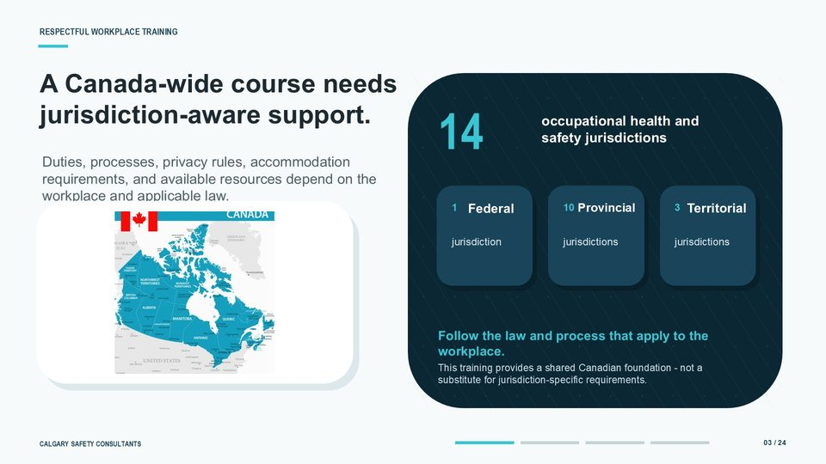  Notes __________________ | A Canada-wide course needs jurisdiction-aware support  A Canada-wide approach must also be jurisdiction-aware. Canada has federal, provincial, and territorial occupational health and safety jurisdictions, and the exact duties and processes are not identical in every workplace.  The applicable rules may depend on where the work takes place, whether the employer is federally regulated, and which employment, human rights, privacy, and workers' compensation requirements apply. Available support services and reporting routes may also differ. The practical message is simple: use the common support principles in this lesson, then confirm the local requirements.  KEY POINTS  • Duties, processes, privacy rules, accommodation requirements, and available resources depend on the workplace and applicable law.  • occupational health and safety jurisdictions.  • Federal.

GENERAL NOTES

LESSON 02 • SLIDE 04 OF 24  Notes __________________ | Supporting Affected Persons  This lesson is organized into four parts. First, we will look at why individual support matters and how an occurrence can affect people in different ways. Second, we will practise a caring, trauma-informed first response.  Third, we will examine accommodation, privacy, and support resources. Finally, we will bring the pieces together with a short knowledge check and summary. As you move through the lesson, think about your own role.  KEY POINTS  • LESSON TWO: Supporting Affected Person(s).  • Foundations of a Respectful Workplace.  • Supporting Affected Person(s).

LESSON 02 • SLIDE 05 OF 24  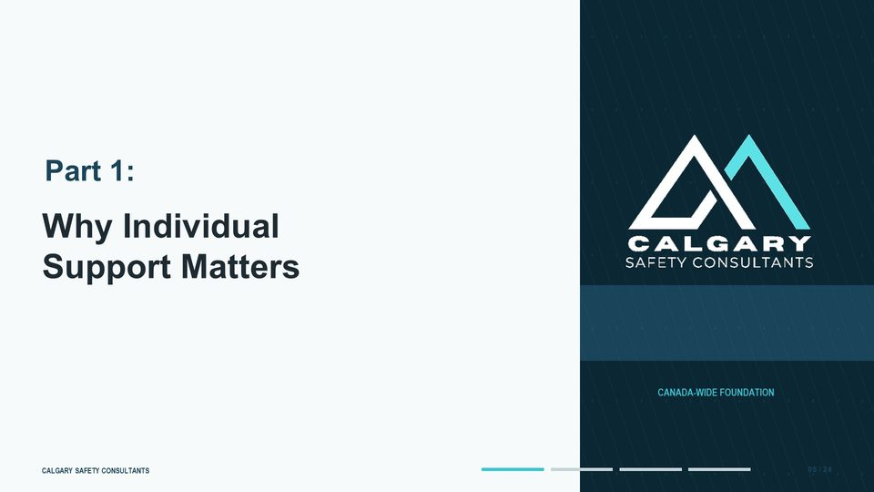  Notes __________________ | Why Individual Support Matters  This slide introduces why individual support matters. Review the workplace process related to why individual support matters.  Review the workplace process related to why individual support matters. Review the workplace process related to why individual support matters.  KEY POINTS  • Review the workplace process related to why individual support matters.  • Review the workplace process related to why individual support matters.  • Review the workplace process related to why individual support matters.

LESSON 02 • SLIDE 06 OF 24  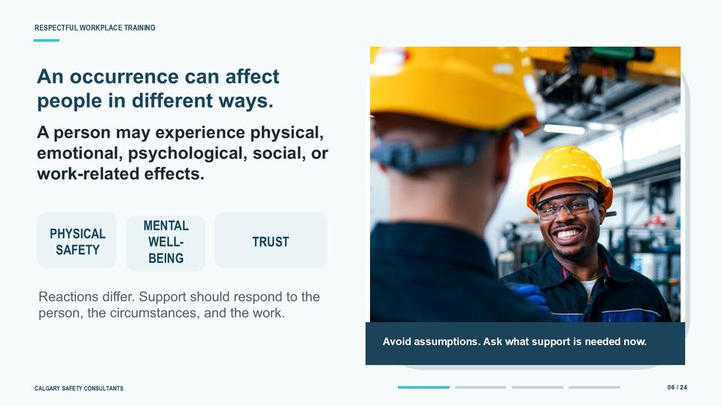  Notes __________________ | An occurrence can affect people in different ways  People can respond to the same kind of occurrence in very different ways. One person may appear visibly upset. Another may seem calm, become very task-focused, or need time before the impact becomes clear.  Reactions can include fear, anger, numbness, confusion, embarrassment, sleep disruption, difficulty concentrating, or no obvious distress at all. Do not use a person's appearance or communication style to judge how serious the experience was. Avoid diagnosing trauma, labelling the reaction, or asking for personal details that are not needed for safety, reporting, or accommodation.  KEY POINTS  • A person may experience physical, emotional, psychological, social, or work-related effects.  • PHYSICAL SAFETY.  • MENTAL WELL-BEING.

GENERAL NOTES

LESSON 02 • SLIDE 07 OF 24  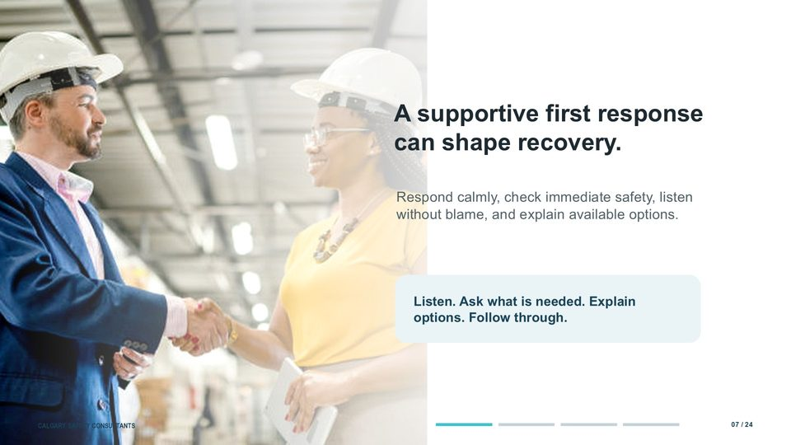  Notes __________________ | A supportive first response can shape recovery  A supportive first response is calm, respectful, and practical. Begin by acknowledging the conversation: Thank you for telling me. Then check whether anyone is in immediate danger, needs medical attention, or requires urgent help.  Listen without blame or disbelief. You do not need every detail in the first conversation. Ask what the person needs right now, explain your role, and describe the available reporting, resolution, representation, and support options.  KEY POINTS  • Respond calmly, check immediate safety, listen without blame, and explain available options.  • Listen. Ask what is needed. Explain options. Follow through.  • A supportive first response is calm, respectful, and practical.

LESSON 02 • SLIDE 08 OF 24  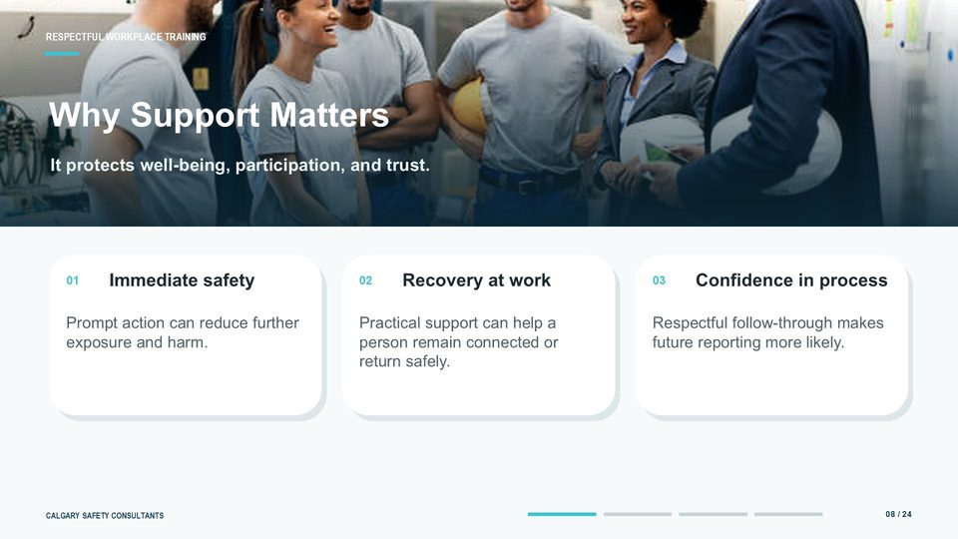  Notes __________________ | Why Support Matters  Support matters for three connected reasons. First, prompt action can protect immediate physical and psychological safety and reduce the chance of further exposure. That may require an emergency response, a temporary separation, a safe way to leave, or another immediate control.  Second, practical support can help a person remain connected to work or return safely. Small, flexible changes can reduce barriers while the workplace addresses risk and the person recovers. Third, respectful follow-through builds confidence in the workplace process.  KEY POINTS  • It protects well-being, participation, and trust.  • Immediate safety.  • Prompt action can reduce further exposure and harm.

LESSON 02 • SLIDE 09 OF 24    Notes __________________ | Support helps people remain connected to work  When someone is affected by a workplace concern, injury, or difficult experience, the right support can help them remain connected to work - or return safely when they are ready. The goal is not to rush recovery or overlook workplace risks. Safety comes first.  At the same time, practical measures - such as temporary modified duties, flexible scheduling, regular check-ins, or access to appropriate resources - can reduce barriers. Support should be confidential, respectful, and tailored to the individual. The plan should be reviewed regularly and adjusted as the person recovers and workplace risks are addressed.  KEY POINTS  • Flexible, practical measures can reduce barriers while the person recovers and the workplace addresses risk.  • SAFETY FIRST.  • PRACTICAL SUPPORT.

GENERAL NOTES

LESSON 02 • SLIDE 10 OF 24  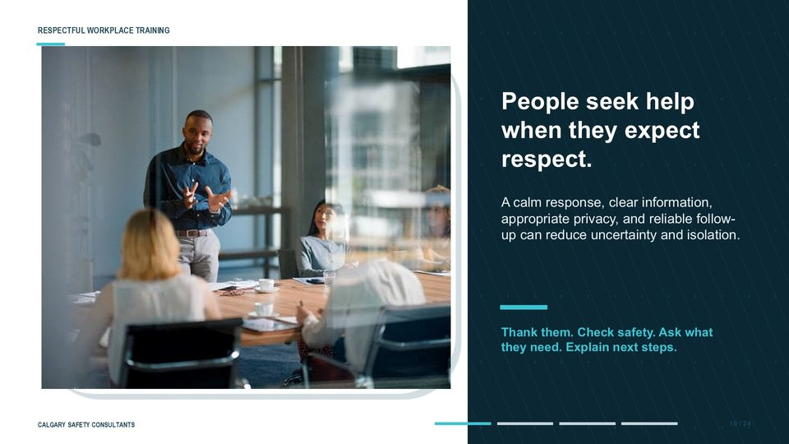  Notes __________________ | People seek help when they expect respect  People are more likely to seek help when they expect respect, clear information, and reliable follow-up. The opposite is also true. Gossip, inconsistent messages, pressure to disclose, or silence after a report can increase uncertainty and isolation.  Communicate within your role. Tell the person what you know, what you do not yet know, who owns the next step, and when an update can reasonably be expected. If another role will contact them, explain who that person is and how to reach them.  KEY POINTS  • A calm response, clear information, appropriate privacy, and reliable follow-up can reduce uncertainty and isolation.  • Thank them. Check safety. Ask what they need. Explain next steps.  • People are more likely to seek help when they expect respect, clear information, and reliable follow-up.

LESSON 02 • SLIDE 11 OF 24  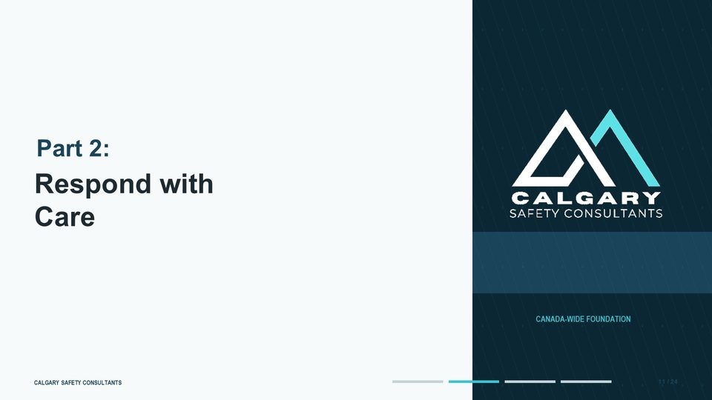  Notes __________________ | Respond with Care  This slide introduces respond with care. Review the workplace process related to respond with care.  Review the workplace process related to respond with care. Review the workplace process related to respond with care.  KEY POINTS  • Review the workplace process related to respond with care.  • Review the workplace process related to respond with care.  • Review the workplace process related to respond with care.

LESSON 02 • SLIDE 12 OF 24  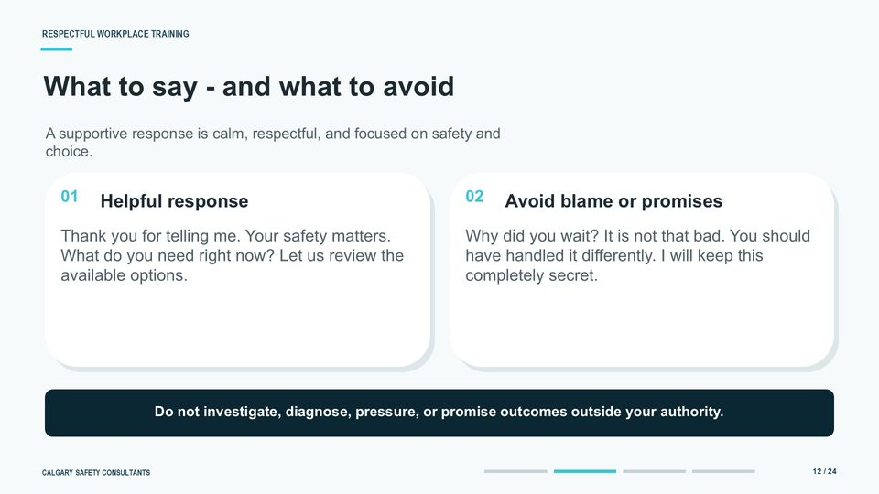  Notes __________________ | What to say - and what to avoid  Words matter in the first conversation. Helpful language is simple and grounded: Thank you for telling me. Your safety matters.  What do you need right now? Would you like a support person? Let us review the available options.  KEY POINTS  • A supportive response is calm, respectful, and focused on safety and choice.  • Helpful response.  • Thank you for telling me. Your safety matters. What do you need right now? Let us review the available options.

GENERAL NOTES

LESSON 02 • SLIDE 13 OF 24  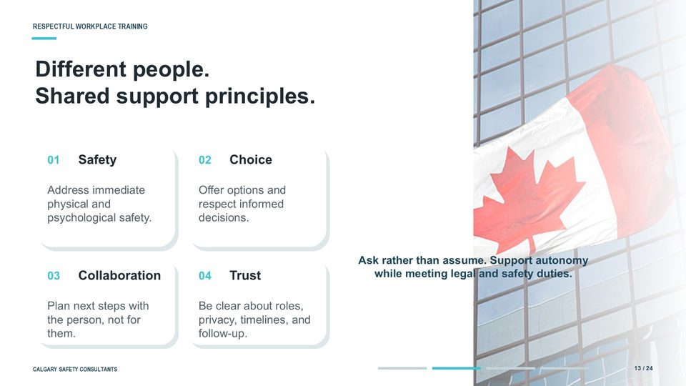  Notes __________________ | Different people. Shared support principles  Four shared principles can guide a supportive response. The first is safety: address urgent physical and psychological needs before moving into routine process steps. The second is choice: offer realistic options and respect informed decisions wherever the process allows.  The third is collaboration: plan next steps with the person, not simply for them. The fourth is trust: be clear about your role, privacy limits, timelines, documentation, and follow-up. These principles should be applied with cultural humility and accessibility in mind.  KEY POINTS  • Safety.  • Address immediate physical and psychological safety.  • Choice.

LESSON 02 • SLIDE 14 OF 24  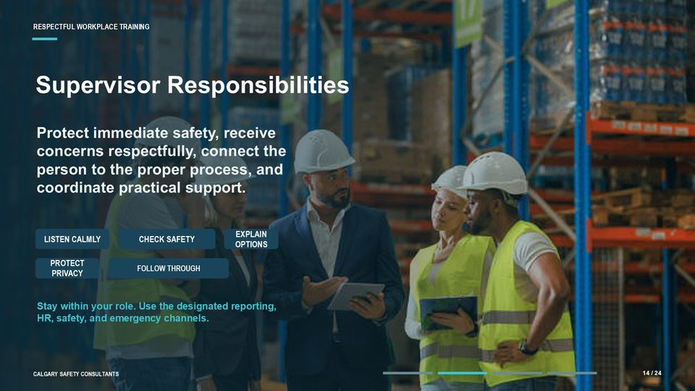  Notes __________________ | Supervisor Responsibilities  A supervisor has an important role, but it is a defined role. The supervisor should listen calmly, check immediate safety, receive the concern respectfully, explain the available channels, protect privacy, and help coordinate practical workplace support. The supervisor should also know when to involve others.  Depending on the workplace procedure, that may include the designated recipient, human resources, health and safety, disability management, security, emergency responders, union representation, or another qualified resource. Stay within your authority and competence. Do not conduct an investigation unless you are assigned and qualified to do so.  KEY POINTS  • Protect immediate safety, receive concerns respectfully, connect the person to the proper process, and coordinate practical support.  • LISTEN CALMLY.  • CHECK SAFETY.

LESSON 02 • SLIDE 15 OF 24  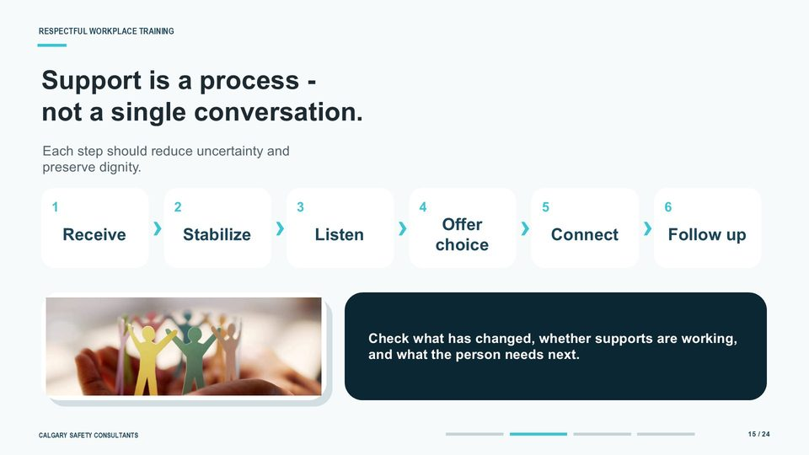  Notes __________________ | Support is a process - not a single conversation  Support is a process, not a single conversation. A useful sequence has six steps. First, receive the concern without blame.  Second, stabilize urgent safety and practical needs. Third, listen without pressing for unnecessary detail. Fourth, offer meaningful choices within the limits of the process.  KEY POINTS  • Each step should reduce uncertainty and preserve dignity.  • Receive.  • Stabilize.

GENERAL NOTES

LESSON 02 • SLIDE 16 OF 24  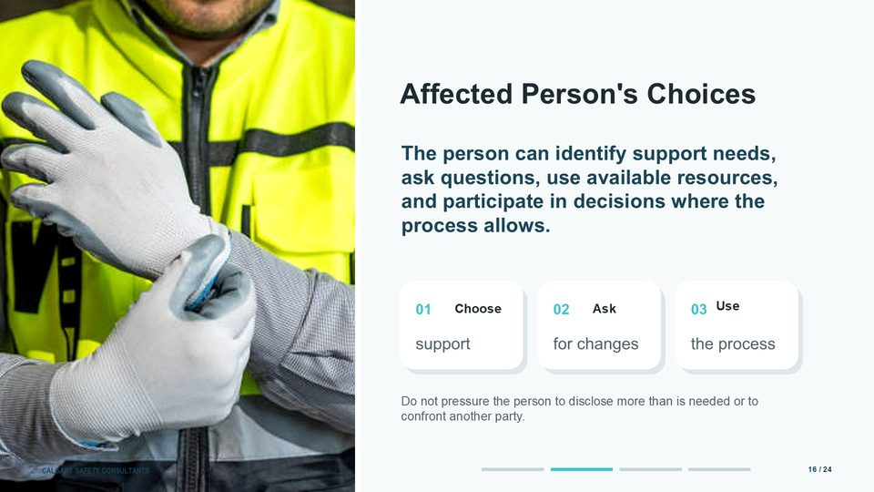  Notes __________________ | Affected Person's Choices  An affected person should be able to identify support needs, ask questions, request changes, use available resources, and participate in decisions where the process allows. They may also be able to involve a support person, representative, or union, depending on the applicable rules and workplace process.  Choice does not mean that every option is available or that the employer can ignore a serious safety or legal duty. It means explaining the realistic options, the consequences, and any limits so the person can participate in an informed way.  KEY POINTS  • The person can identify support needs, ask questions, use available resources, and participate in decisions where the process allows.  • Choose.  • support.

LESSON 02 • SLIDE 17 OF 24  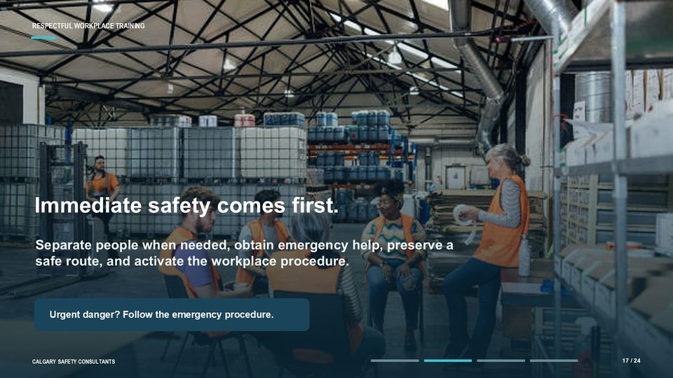  Notes __________________ | Immediate safety comes first  Immediate safety comes first. If there is an urgent threat, serious injury, or another emergency, pause the normal conversation and activate the workplace emergency procedure. Contact emergency services or security when appropriate, move people to safety, arrange medical attention, and preserve a safe way to leave or obtain help.  Do not ask the person to manage the danger themselves or to confront the other party. Avoid leaving someone alone if doing so would create additional risk. At the same time, do not make promises about actions outside your authority; involve the roles responsible for emergency and security decisions.  KEY POINTS  • Separate people when needed, obtain emergency help, preserve a safe route, and activate the workplace procedure.  • Urgent danger? Follow the emergency procedure.  • If there is an urgent threat, serious injury, or another emergency, pause the normal conversation and activate the workplace emergency procedure.

LESSON 02 • SLIDE 18 OF 24  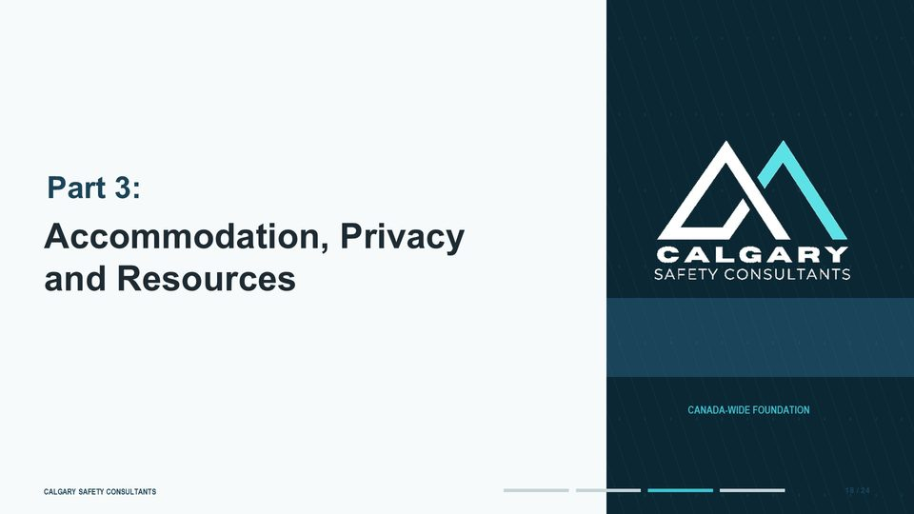  Notes __________________ | Accommodation, Privacy and Resources  This slide introduces accommodation, privacy and resources. Review the workplace process related to accommodation, privacy and resources.  Review the workplace process related to accommodation, privacy and resources. Review the workplace process related to accommodation, privacy and resources.  KEY POINTS  • Review the workplace process related to accommodation, privacy and resources.  • Review the workplace process related to accommodation, privacy and resources.  • Review the workplace process related to accommodation, privacy and resources.

GENERAL NOTES

LESSON 02 • SLIDE 19 OF 24  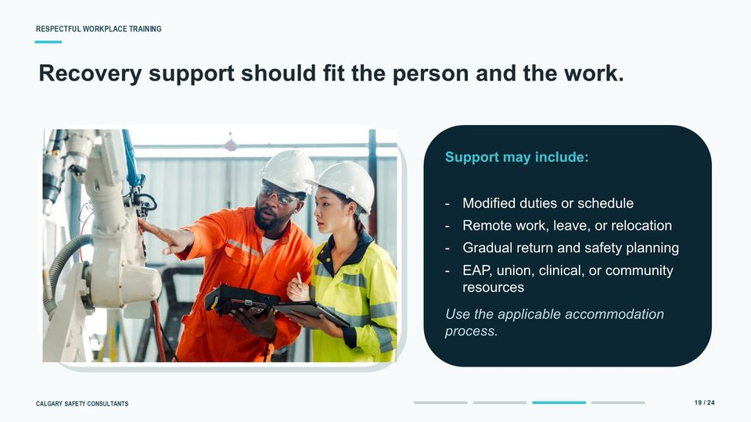  Notes __________________ | Recovery support should fit the person and the work  Recovery support should fit both the person and the work. Possible measures include modified duties or hours, remote work, leave, relocation, a gradual return, a safety plan, communication changes, or a designated contact person.  Support may also come from an employee assistance program, a union or representative, occupational health, medical or psychological services, workers' compensation resources, or community organizations. Offer options without treating any single resource as the complete response.  KEY POINTS  • Support may include:.  • Modified duties or schedule.  • Remote work, leave, or relocation.

LESSON 02 • SLIDE 20 OF 24  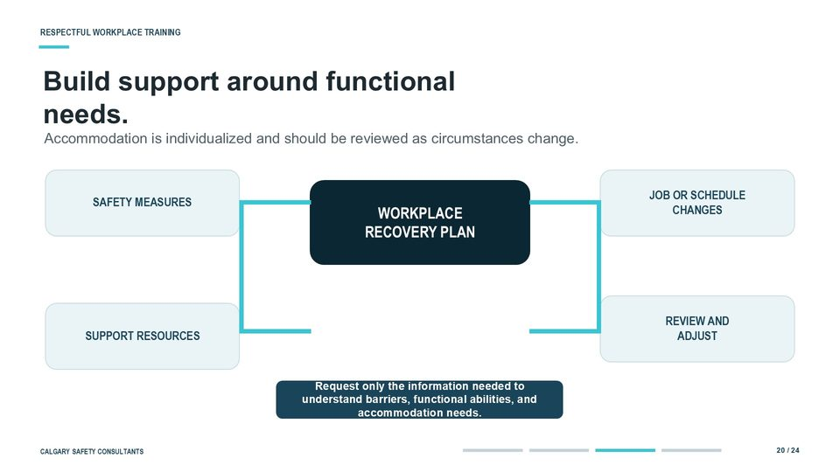  Notes __________________ | Build support around functional needs  Accommodation is individualized. Start with the barrier to safe and meaningful participation at work: what task, schedule, location, interaction, or condition is creating difficulty, and what change could reduce that barrier?  Focus on functional abilities, restrictions, and accommodation needs. Request only information that is necessary for the decision, using the least intrusive method available. Detailed diagnoses, treatment histories, or unrelated personal information are generally not what a supervisor needs to implement a workplace measure.  KEY POINTS  • Accommodation is individualized and should be reviewed as circumstances change.  • WORKPLACE RECOVERY PLAN.  • SAFETY MEASURES.

LESSON 02 • SLIDE 21 OF 24  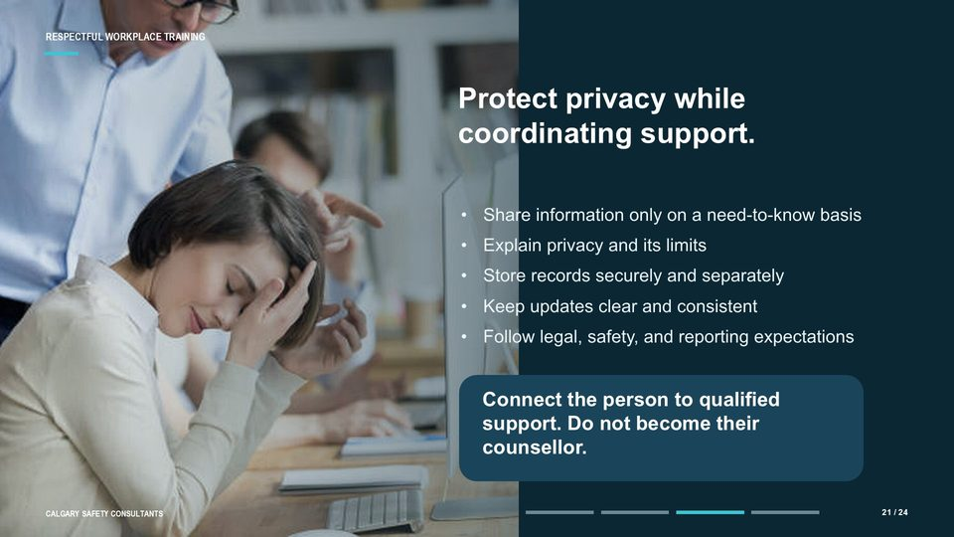  Notes __________________ | Protect privacy while coordinating support  Privacy is essential to trust, but it should be explained accurately. Tell the person what information will be documented, who may need to receive it, why it may be shared, and what legal or safety exceptions could apply. Use a need-to-know approach.  A manager arranging a schedule change may need to know the approved measure and its duration, but not the full allegation, diagnosis, or treatment history. Also distinguish privacy from silence. A person may be entitled to process updates even when the workplace cannot share details about another employee.  KEY POINTS  • Share information only on a need-to-know basis.  • Explain privacy and its limits.  • Store records securely and separately.

GENERAL NOTES

LESSON 02 • SLIDE 22 OF 24    Notes __________________ | Bringing it all Together  This slide introduces bringing it all together. Review the workplace process related to bringing it all together.  Review the workplace process related to bringing it all together. Review the workplace process related to bringing it all together.  KEY POINTS  • Review the workplace process related to bringing it all together.  • Review the workplace process related to bringing it all together.  • Review the workplace process related to bringing it all together.

LESSON 02 • SLIDE 23 OF 24  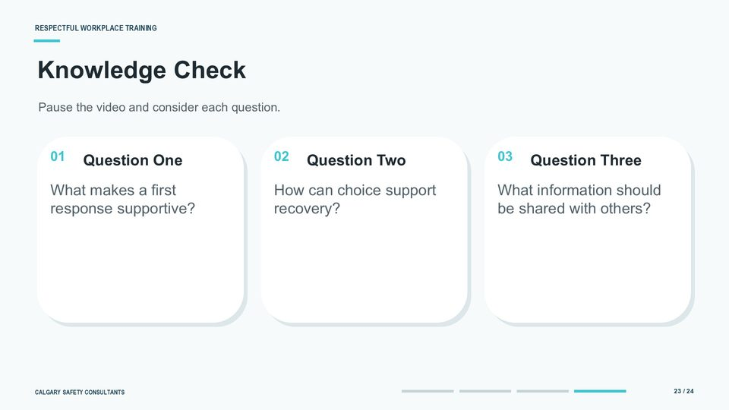  Notes __________________ | Knowledge Check  Here's a quick knowledge check of what we learned so far. Consider each question and feel free to pause the video to contemplate your answers. What makes a first response supportive?  A supportive response is calm and non-blaming. It checks immediate safety, explains roles and privacy limits, asks what the person needs, and creates a clear next step. How can choice support recovery?  KEY POINTS  • What makes a first response supportive?  • How can choice support recovery?  • What information should be shared with others?

LESSON 02 • SLIDE 24 OF 24  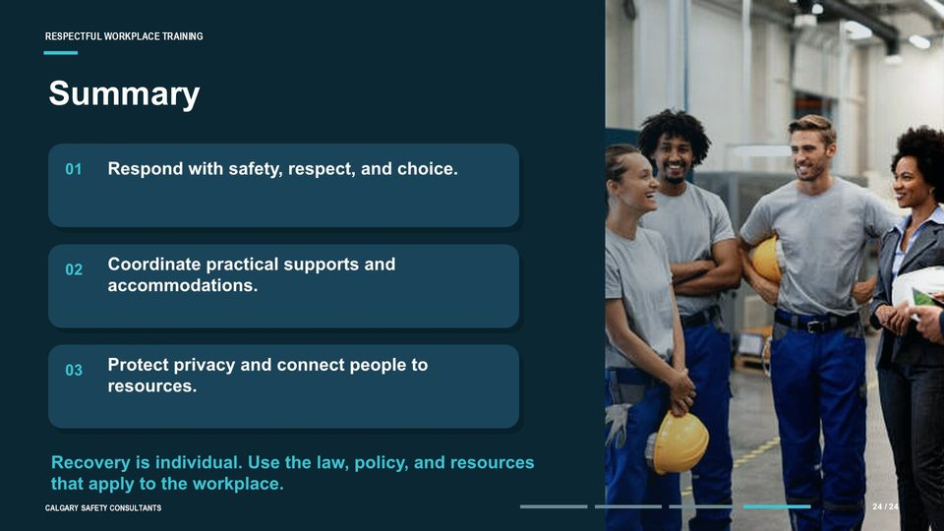  Notes __________________ | Summary  Let's summarize the lesson. Begin with safety, respect, and meaningful choice. Coordinate practical supports and accommodations through the correct workplace roles.  Protect privacy, explain its limits, connect the person with qualified resources, and follow up to confirm that the measures are working. Remember that recovery is individual. Avoid assumptions, unnecessary disclosure, pressure, or promises outside your authority.  KEY POINTS  • Respond with safety, respect, and choice.  • Coordinate practical supports and accommodations.  • Protect privacy and connect people to resources.

GENERAL NOTES

LESSON 02 SUMMARY
Supporting Affected Persons
The following points bring the lesson together. Use them to review the main recovery and prevention message and connect it to the procedures and expectations in your workplace.
01 | Begin with immediate safety, a calm response, and respect for the person's choices.
02 | Ask what support is needed instead of making assumptions or pressing for unnecessary details.
03 | Use the designated reporting and response process without investigating or promising outcomes outside your authority.
04 | Build accommodation and recovery support around functional needs and review it as circumstances change.
05 | Protect privacy, explain its limits, follow up, and connect the person with qualified resources.
Reflection and application
• What makes a first response supportive in this workplace?
• Which practical supports or accommodations may help a person stay connected to work?
• Who needs information for safety or process reasons, and what should remain private?
________________________________________________________________________________
________________________________________________________________________________
GENERAL NOTES

MODULE FOUR / LESSON 03

Supporting the Workplace as a Whole
Recovery | Communication | Facilitation | Culture

Lesson overview
An incident can affect safety, trust, communication, and culture across the wider team. Employees watch how the workplace responds, so recovery requires credible information, visible follow-through, and support that does not expose the people directly involved.
This lesson covers team-level effects, facilitated help, privacy boundaries, manager follow-through, workplace resources, employee participation, and prevention improvements that rebuild confidence over time.
By the end of this lesson you should be able to
• Recognize common team-level effects after an occurrence.
• Communicate credible updates without disclosing protected case details.
• Choose voluntary and appropriate formats for workplace support.
• Maintain privacy, choice, authority, and role boundaries.
• Turn worker insight and organizational learning into prevention improvements.
GENERAL NOTES

LESSON 03 • SLIDE 01 OF 32    Notes __________________ | Supporting the Workplace as a Whole  This slide introduces supporting the workplace as a whole.  Respectful. Workplace. as a Whole.  KEY POINTS  • Respectful.  • Workplace.  • as a Whole.

LESSON 03 • SLIDE 02 OF 32  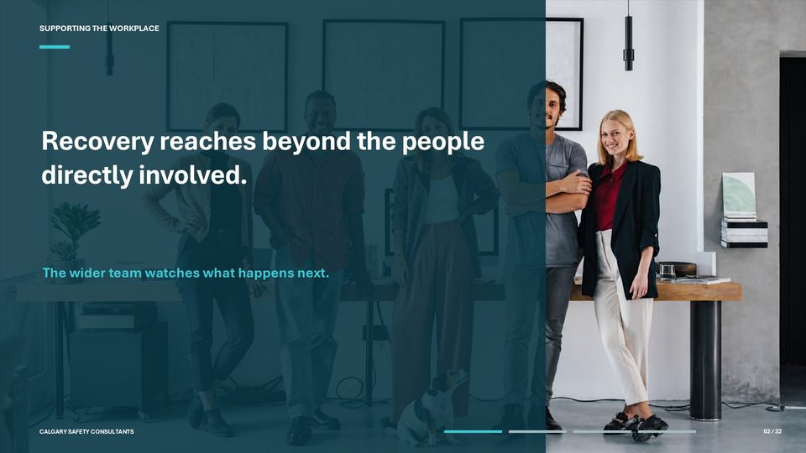  Notes __________________ | Recovery reaches beyond the people directly involved  Welcome to Module Four, Lesson Three: Supporting the Workplace as a Whole. In this lesson, we look beyond the people directly involved in a harassment or violence occurrence and consider what the wider workplace may need in order to recover.  Coworkers may be unsettled, routines may be disrupted, and people may be watching closely to see whether the organization responds fairly and consistently. Recovery reaches beyond the people who are formally involved in an occurrence. Members of the wider team may have witnessed behaviour, heard incomplete information, taken on extra work, or simply noticed that normal routines and relationships have changed.  KEY POINTS  • The wider team watches what happens next.  • Welcome to Module Four, Lesson Three: Supporting the Workplace as a Whole.  • Coworkers may be unsettled, routines may be disrupted, and people may be watching closely to see whether the organization responds fairly and consistently.

LESSON 03 • SLIDE 03 OF 32  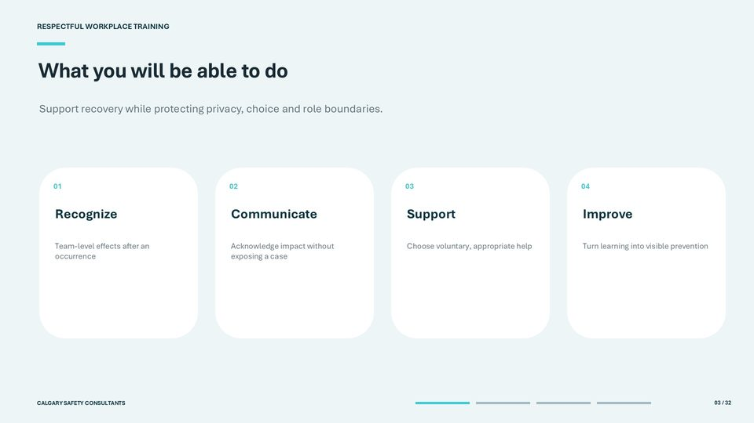  Notes __________________ | What you will be able to do  By the end of this lesson, you should be able to do four things. First, recognize common team-level effects after an occurrence, including changes in perceived safety, trust, communication, and willingness to report concerns.  Second, communicate in a way that acknowledges workplace impact without disclosing allegations, evidence, medical information, or personal outcomes. Third, you will be able to select support options that are voluntary, accessible, and appropriate to the level of need. This includes knowing when a manager or facilitator can help and when a qualified health, trauma, or emergency professional is required.  KEY POINTS  • Support recovery while protecting privacy, choice and role boundaries.  • Recognize.  • Team-level effects after an occurrence.

GENERAL NOTES

LESSON 03 • SLIDE 04 OF 32  Notes __________________ | Supporting the Workplace as a Whole  This lesson follows the path of organizational recovery. We will begin with the immediate ripple effect on the team, then examine facilitated support, cultural repair, and the prevention work that should continue after the formal process has moved forward or concluded. Three principles run through every section: restore safety, rebuild trust, and strengthen prevention.  Restoring safety may involve both physical and psychological considerations. Rebuilding trust requires predictable communication and follow-through. Strengthening prevention means identifying workplace conditions that can be improved, rather than focusing only on individual blame.  KEY POINTS  • Supporting the.  • Workplace as a Whole.  • Restore safety. Rebuild trust. Strengthen prevention.

LESSON 03 • SLIDE 05 OF 32  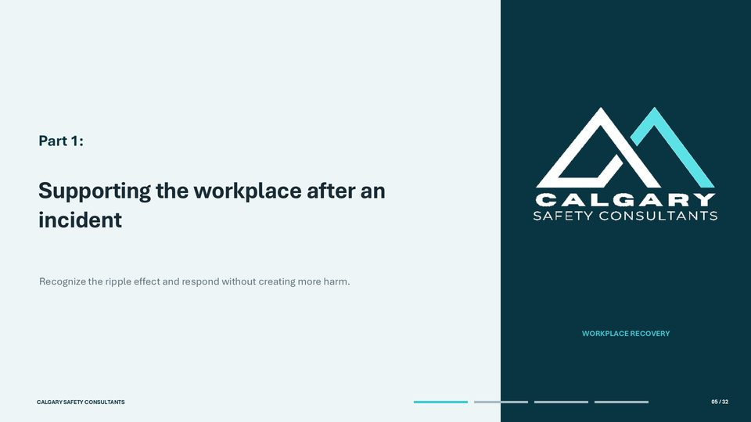  Notes __________________ | Supporting the workplace after an incident  This slide introduces supporting the workplace after an incident. Recognize the ripple effect and respond without creating more harm.  Review the workplace process related to supporting the workplace after an incident. Review the workplace process related to supporting the workplace after an incident.  KEY POINTS  • Recognize the ripple effect and respond without creating more harm.  • Review the workplace process related to supporting the workplace after an incident.  • Review the workplace process related to supporting the workplace after an incident.

LESSON 03 • SLIDE 06 OF 32  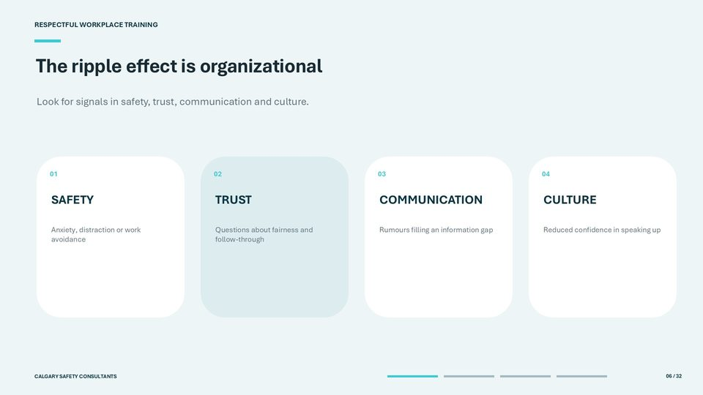  Notes __________________ | The ripple effect is organizational  The ripple effect often appears in four areas. Under safety, workers may report anxiety, distraction, avoidance of a location or person, or difficulty concentrating on tasks. Under trust, they may question whether expectations are applied consistently or whether leadership will follow through.  Under communication, an information gap may be filled by rumours or competing versions of events. Under culture, people may become less willing to speak up or intervene. Treat these as signals, not diagnoses or proof.  KEY POINTS  • Look for signals in safety, trust, communication and culture.  • SAFETY.  • Anxiety, distraction or work avoidance.

GENERAL NOTES

LESSON 03 • SLIDE 07 OF 32  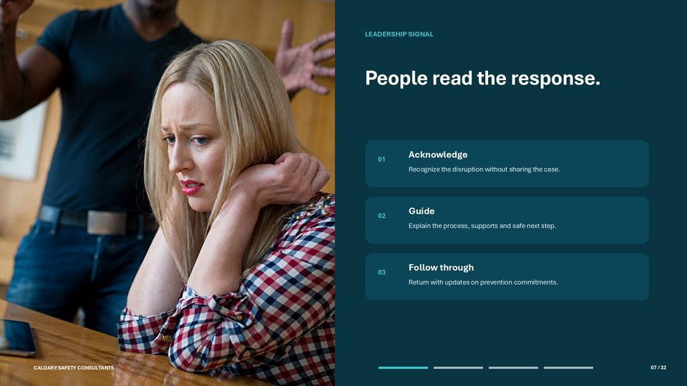  Notes __________________ | People read the response  People read the leadership response for clues about the organization's real values. Silence may be interpreted as indifference or avoidance, while an impulsive or overly detailed response can expose private information and cause further harm. Credibility sits between those two risks.  Acknowledge the disruption by recognizing that people may have questions or concerns. Guide the team by explaining the process at a general level, identifying available supports, and stating the safest route for new concerns. Then follow through.  KEY POINTS  • LEADERSHIP SIGNAL.  • Acknowledge.  • Recognize the disruption without sharing the case.

LESSON 03 • SLIDE 08 OF 32  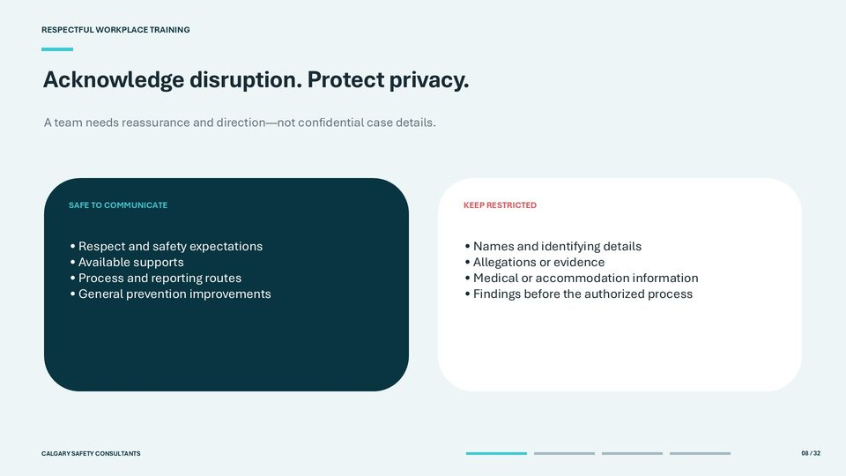  Notes __________________ | Acknowledge disruption. Protect privacy  Acknowledging disruption is not the same as disclosing a case. It is generally appropriate to restate expectations for respect and safety, identify reporting and support routes, explain the process in broad terms, and communicate general prevention improvements that workers need in order to do their jobs safely.  Keep names, identifying clues, allegations, evidence, interview information, medical or accommodation information, and unapproved findings restricted to people with an authorized need to know. Be alert to indirect identification. In a small team, a job title, shift, location, or timeline may reveal a person even when no name is used.  KEY POINTS  • A team needs reassurance and direction - not confidential case details.  • SAFE TO COMMUNICATE.  • • Respect and safety expectations.

LESSON 03 • SLIDE 09 OF 32  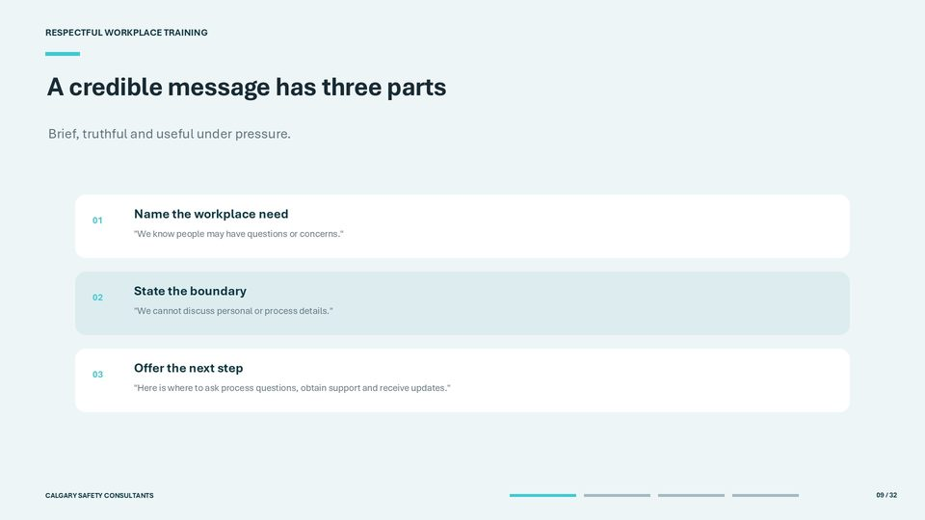  Notes __________________ | A credible message has three parts  A credible team message is brief, truthful, and useful. First, name the workplace need: 'We know people may have questions or concerns.' This acknowledges the situation without confirming rumours.  Second, state the boundary: 'We cannot discuss personal information or the details of an active process.' A clear reason for the boundary often feels more respectful than saying only, 'No comment.' Third, offer a practical next step. Tell people where they can ask process questions, report a new safety concern, request support, or receive a general update.  KEY POINTS  • Brief, truthful and useful under pressure.  • Name the workplace need.  • "We know people may have questions or concerns.".

GENERAL NOTES

LESSON 03 • SLIDE 10 OF 32  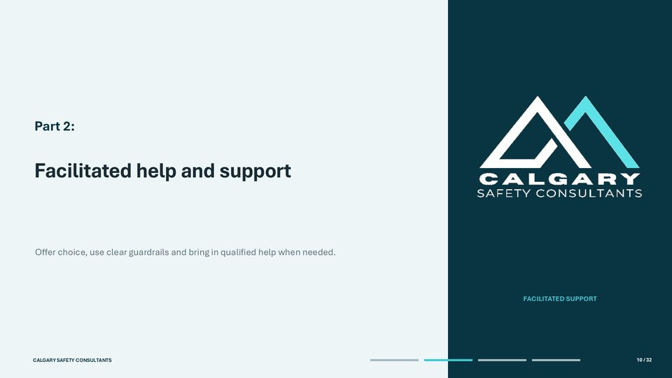  Notes __________________ | Facilitated help and support  This slide introduces facilitated help and support. Offer choice, use clear guardrails and bring in qualified help when needed.  FACILITATED SUPPORT. Review the workplace process related to facilitated help and support.  KEY POINTS  • Offer choice, use clear guardrails and bring in qualified help when needed.  • FACILITATED SUPPORT.  • Review the workplace process related to facilitated help and support.

LESSON 03 • SLIDE 11 OF 32  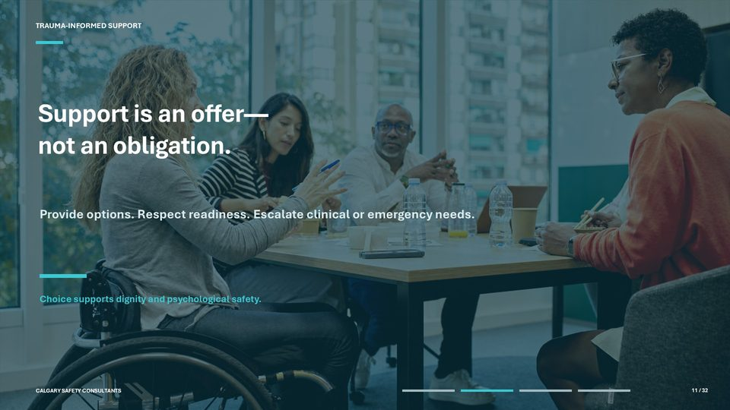  Notes __________________ | Support is an offer - not an obligation  Trauma-informed support begins with an offer, not an obligation. People respond to difficult experiences differently, and readiness may change over time.  Provide more than one option and allow the worker to decide whether, when, and how to participate within the requirements of safe work and the applicable process. Useful options may include a private check-in, a voluntary team session, an employee or family assistance resource, medical or counselling support, union or association representation, a chosen support person, or a culturally appropriate service. Do not require someone to tell their story in order to receive general information or access an available support.  KEY POINTS  • TRAUMA-INFORMED SUPPORT.  • Support is an offer -.  • not an obligation.

LESSON 03 • SLIDE 12 OF 32  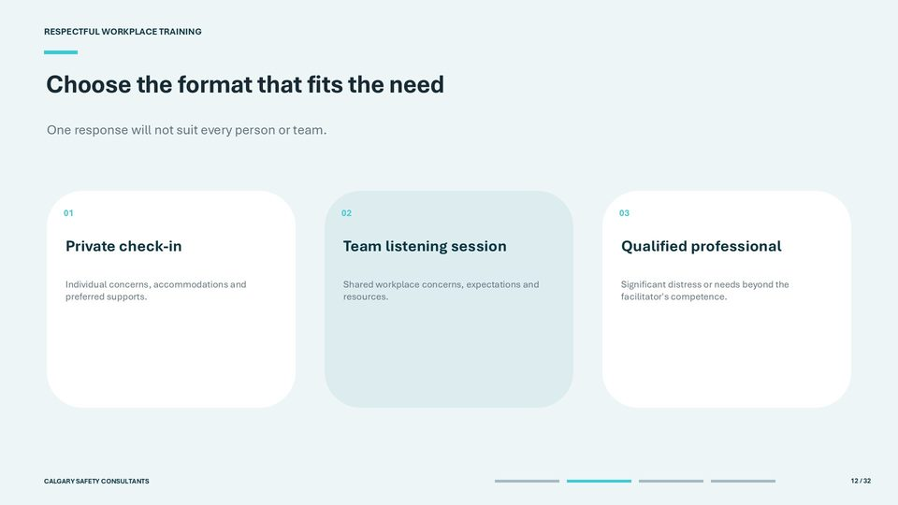  Notes __________________ | Choose the format that fits the need  Choose the support format according to the need rather than using the same response for everyone. A private check-in is often the best place to discuss an individual's concerns, work limitations, accommodation request, communication preference, or desired support route.  It also reduces the pressure to speak in front of coworkers. A voluntary team listening session can address shared concerns about work, expectations, resources, or prevention. It should remain focused on the work environment, not the facts of an individual case.  KEY POINTS  • One response will not suit every person or team.  • Private check-in.  • Individual concerns, accommodations and preferred supports.

GENERAL NOTES

LESSON 03 • SLIDE 13 OF 32  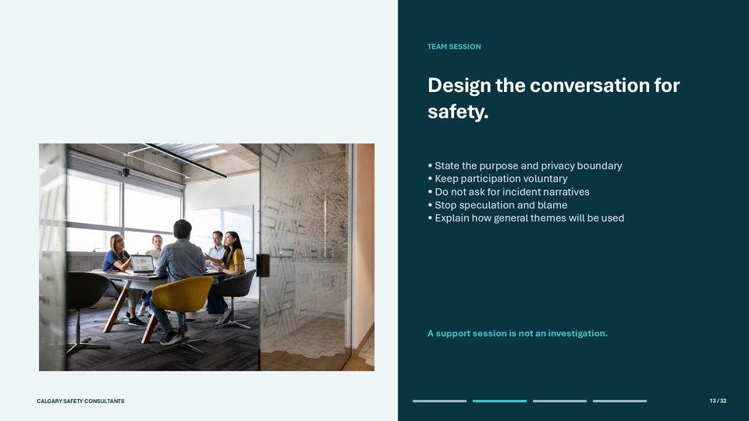  Notes __________________ | Design the conversation for safety  A safe team conversation needs guardrails that are explained at the beginning and reinforced throughout. State that the purpose is to discuss general workplace impact, supports, respectful expectations, and prevention needs. Explain what the session can and cannot address, how privacy will be handled, and what information may need to be escalated for safety or legal reasons.  Keep participation voluntary and provide alternatives, such as a private meeting or written feedback. Do not invite incident narratives or ask the group to determine who is right. Stop speculation, blame, retaliation, or attempts to identify parties.  KEY POINTS  • TEAM SESSION.  • • State the purpose and privacy boundary.  • • Keep participation voluntary.

LESSON 03 • SLIDE 14 OF 32  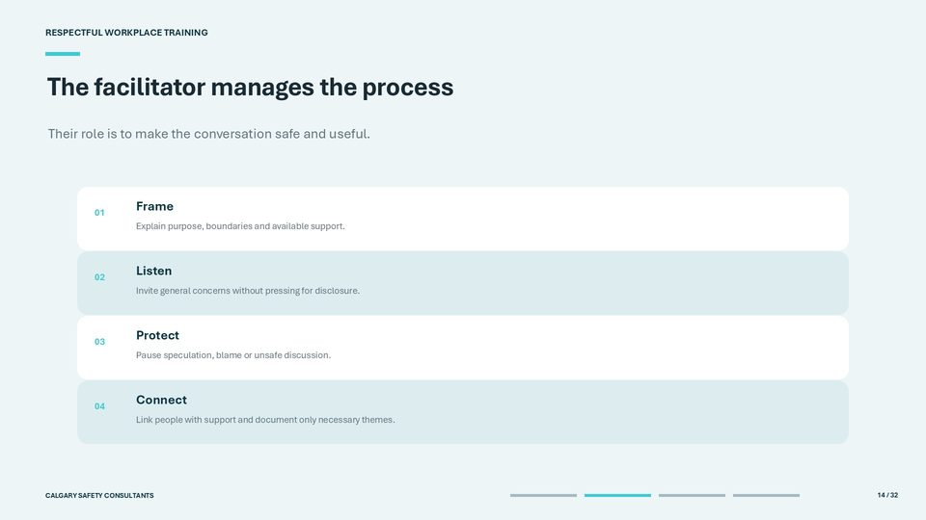  Notes __________________ | The facilitator manages the process  The facilitator manages the safety and usefulness of the conversation. They frame the purpose and boundaries, invite workplace-level concerns without pressing for disclosure, and make space for different reactions. They should monitor tone and participation, interrupt speculation or blame, and pause or end the session if the discussion becomes unsafe.  A competent facilitator knows what is outside their role. They do not assess credibility, promise an outcome, provide therapy unless professionally qualified to do so, or collect evidence for an investigation. They connect people with the correct reporting, representation, health, or emergency resource when a need emerges.  KEY POINTS  • Their role is to make the conversation safe and useful.  • Frame.  • Explain purpose, boundaries and available support.

LESSON 03 • SLIDE 15 OF 32  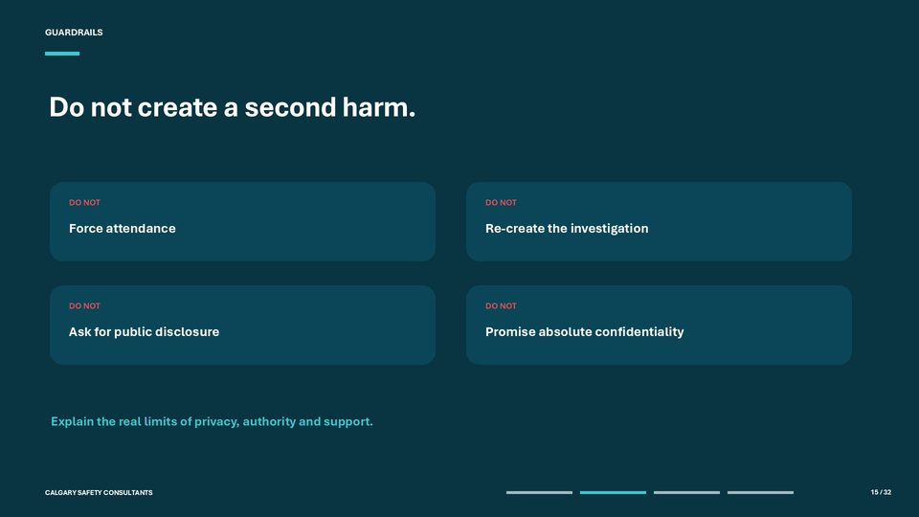  Notes __________________ | Do not create a second harm  Four common mistakes can create a second harm. First, forcing attendance may remove choice and place people in a room before they are ready. Second, recreating the investigation in a group setting can spread allegations, contaminate evidence, and place unauthorized people in decision-making roles.  Third, asking for public disclosure may pressure workers to share personal experiences or emotions in front of coworkers. Participation can be meaningful without speaking. Fourth, promising absolute confidentiality can be misleading.  KEY POINTS  • GUARDRAILS.  • DO NOT.  • Force attendance.

GENERAL NOTES

LESSON 03 • SLIDE 16 OF 32  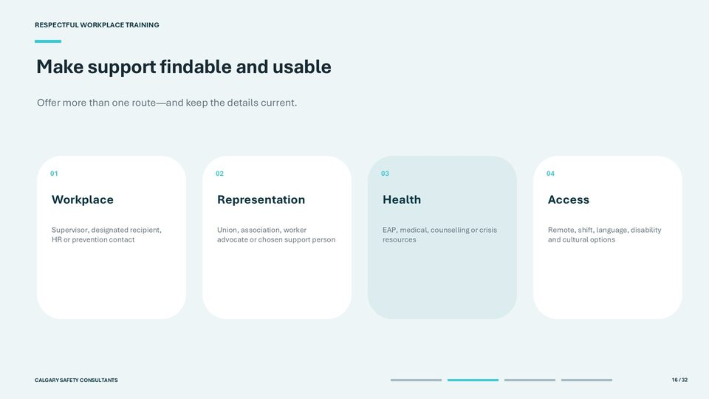  Notes __________________ | Make support findable and usable  Support is effective only when people can find it, understand it, and use it. Provide current names, phone numbers, links, operating hours, eligibility information, and after-hours instructions. Avoid telling workers simply to 'contact HR' if they do not know who that is or if HR is part of their concern.  Offer more than one route. Workplace contacts may include a supervisor, designated recipient, human resources advisor, or prevention lead. Representation may include a union, association, worker advocate, or chosen support person where permitted.  KEY POINTS  • Offer more than one route - and keep the details current.  • Workplace.  • Supervisor, designated recipient, HR or prevention contact.

LESSON 03 • SLIDE 17 OF 32  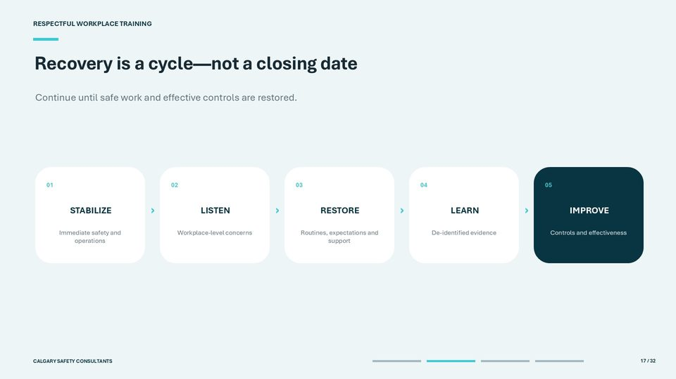  Notes __________________ | Recovery is a cycle - not a closing date  Recovery is a cycle, not a date on which a file is marked closed. Begin by stabilizing immediate safety and essential operations. Next, listen for workplace-level concerns using appropriate, privacy-protective channels.  Restore predictable routines, respectful expectations, work supports, and access to help. Then learn from de-identified evidence. Look for contributing conditions in the work environment, systems, supervision, communication, staffing, or procedures.  KEY POINTS  • Continue until safe work and effective controls are restored.  • STABILIZE.  • Immediate safety and operations.

LESSON 03 • SLIDE 18 OF 32  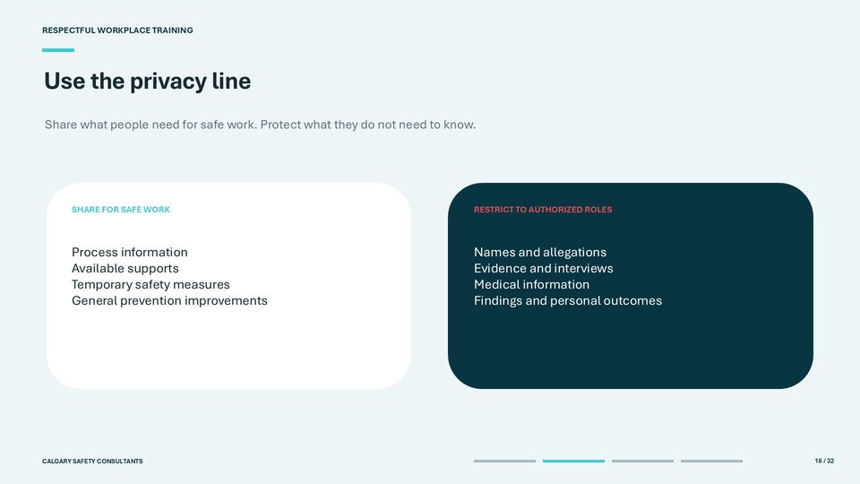  Notes __________________ | Use the privacy line  Use the privacy line as a practical decision test: share what people need for safe work, and protect what they do not need to know. Information about the reporting process, available supports, temporary safety measures, and general prevention improvements can often help the team without revealing the case.  Names, allegations, evidence, interview content, medical information, findings, and personal consequences stay with authorized roles. Temporary measures should be described in neutral terms where possible. Their purpose is risk management, not proof of wrongdoing or a signal about the final outcome.  KEY POINTS  • Share what people need for safe work. Protect what they do not need to know.  • SHARE FOR SAFE WORK.  • Process information.

GENERAL NOTES

LESSON 03 • SLIDE 19 OF 32  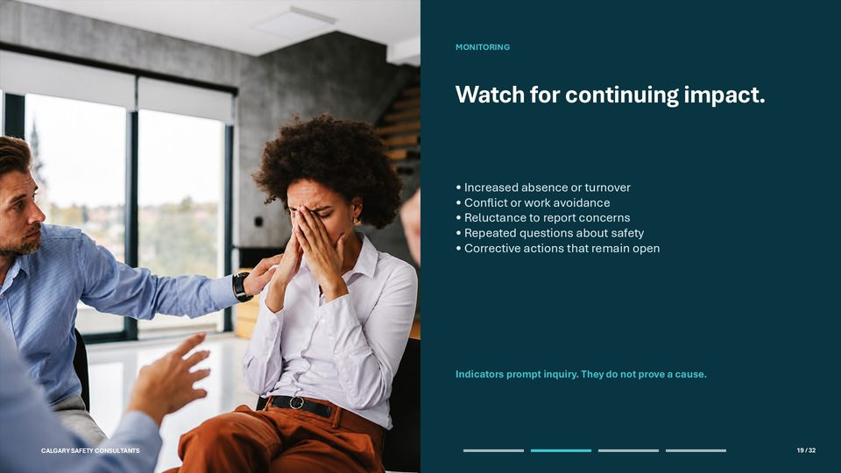  Notes __________________ | Watch for continuing impact  Continue monitoring for workplace impact after the immediate response. Possible indicators include increased absence or turnover, conflict, work avoidance, reluctance to report concerns, repeated questions about safety, or corrective actions that remain overdue. Use several sources rather than relying on a single comment or number.  These indicators prompt inquiry; they do not prove a cause. An absence trend may relate to many factors, and silence may reflect privacy, uncertainty, fatigue, or a lack of confidence. Check in using neutral questions, review the risk assessment and controls, and consult qualified support where the pattern warrants it.  KEY POINTS  • MONITORING.  • • Increased absence or turnover.  • • Conflict or work avoidance.

LESSON 03 • SLIDE 20 OF 32  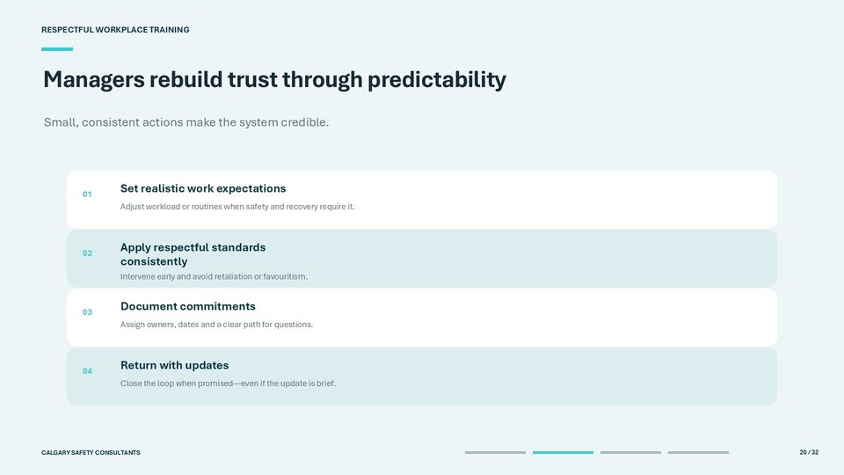  Notes __________________ | Managers rebuild trust through predictability  Managers rebuild trust through predictable, everyday actions. Set realistic work expectations and adjust workload, schedules, reporting lines, or routines when an authorized safety or accommodation plan requires it. Avoid making workers repeatedly explain private circumstances to multiple people.  Apply respectful conduct standards consistently, regardless of role, seniority, performance, or personal relationships. Intervene early when behaviour crosses a boundary and watch for retaliation, exclusion, gossip, or favouritism after a concern is raised. Consistency does not mean every situation has the same outcome; it means the same principles and fair process are used.  KEY POINTS  • Small, consistent actions make the system credible.  • Set realistic work expectations.  • Adjust workload or routines when safety and recovery require it.

LESSON 03 • SLIDE 21 OF 32  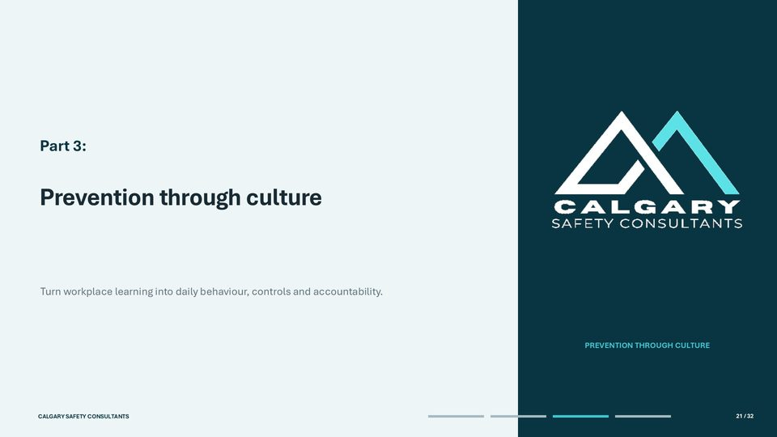  Notes __________________ | Prevention through culture  This slide introduces prevention through culture. Turn workplace learning into daily behaviour, controls and accountability.  Review the workplace process related to prevention through culture. Review the workplace process related to prevention through culture.  KEY POINTS  • Turn workplace learning into daily behaviour, controls and accountability.  • Review the workplace process related to prevention through culture.  • Review the workplace process related to prevention through culture.

GENERAL NOTES

LESSON 03 • SLIDE 22 OF 32  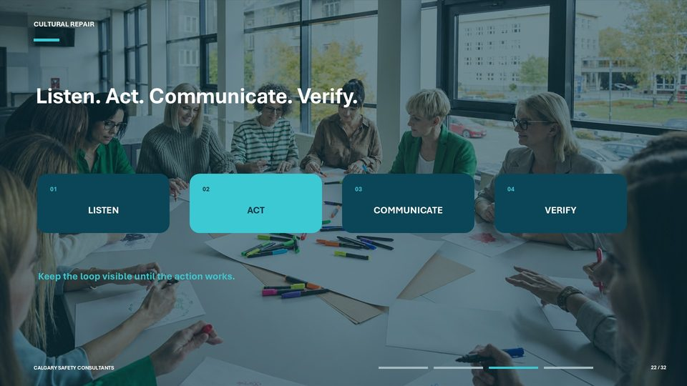  Notes __________________ | Listen. Act. Communicate. Verify  Cultural repair connects four steps. Listen for de-identified themes about the work environment, barriers, and risk factors. Act by selecting proportionate controls and assigning accountability.  Communicate the improvement in a way workers can understand and use. Verify whether the change reduced risk or improved confidence. Each step matters.  KEY POINTS  • CULTURAL REPAIR.  • LISTEN.  • COMMUNICATE.

LESSON 03 • SLIDE 23 OF 32  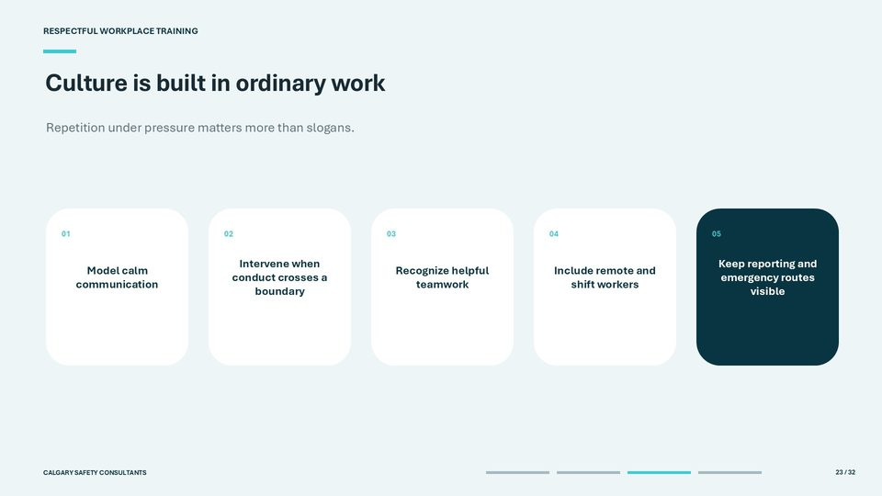  Notes __________________ | Culture is built in ordinary work  Culture is built in ordinary work, especially when people are busy or under pressure. Leaders model calm, direct communication and correct disrespect without humiliation. Supervisors intervene when conduct crosses a boundary rather than waiting for a formal complaint.  Teams recognize cooperation, respectful disagreement, and people who help maintain safe work. Inclusion must be practical. Remote workers, night shifts, temporary staff, contractors, new employees, and people who communicate differently should have access to the same expectations, reporting routes, and support information.  KEY POINTS  • Repetition under pressure matters more than slogans.  • Model calm communication.  • Intervene when conduct crosses a boundary.

LESSON 03 • SLIDE 24 OF 32  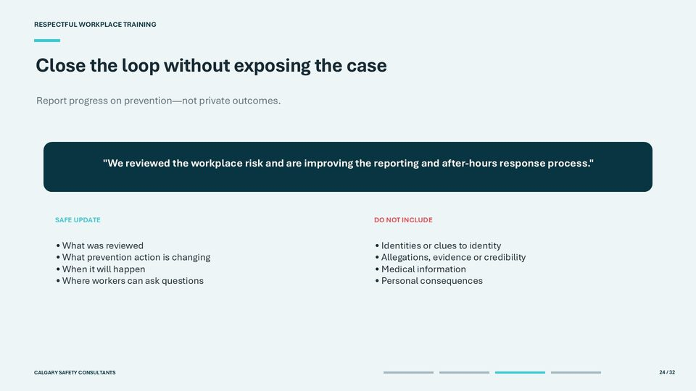  Notes __________________ | Close the loop without exposing the case  Closing the loop means reporting progress on prevention, not exposing the case.  A safe update can say what workplace risk or process was reviewed, what general improvement is being made, when it will occur, and where workers can ask questions or raise additional concerns. For example: 'We reviewed the workplace risk and are improving the reporting and after-hours response process.  KEY POINTS  • Report progress on prevention - not private outcomes.  • "We reviewed the workplace risk and are improving the reporting and after-hours response process.".  • SAFE UPDATE.

GENERAL NOTES

LESSON 03 • SLIDE 25 OF 32  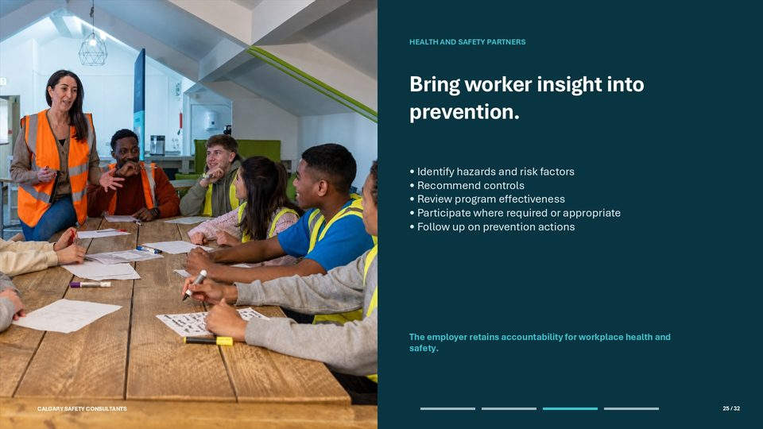  Notes __________________ | Bring worker insight into prevention  Health and safety committees or representatives can bring valuable worker insight into prevention. Depending on the governing rules, they may help identify hazards and risk factors, recommend controls, review the effectiveness of a prevention program, participate in certain inquiries or investigations, and follow up on outstanding actions.  Their focus should remain on workplace health and safety functions within their authority. Committee membership does not automatically create access to names, allegations, medical information, interview evidence, or personal outcomes.  KEY POINTS  • HEALTH AND SAFETY PARTNERS.  • • Identify hazards and risk factors.  • • Recommend controls.

LESSON 03 • SLIDE 26 OF 32  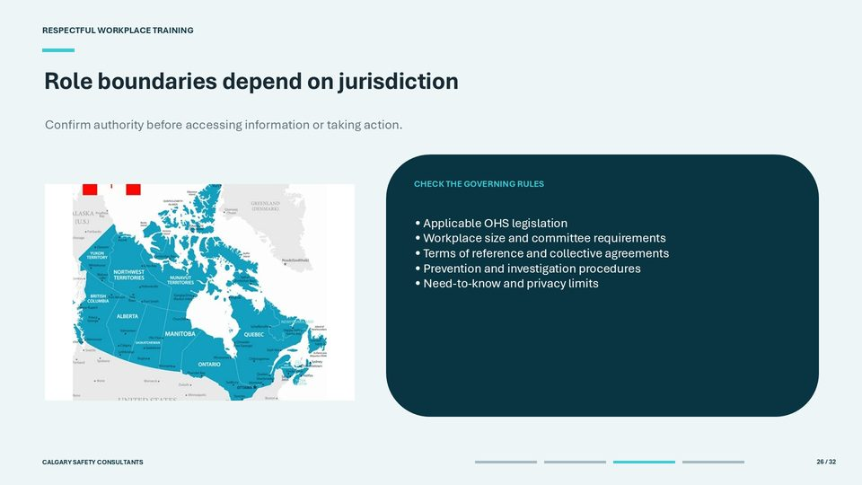  Notes __________________ | Role boundaries depend on jurisdiction  Role boundaries depend on jurisdiction, workplace size, sector, and the authority assigned by law and workplace procedure. Before requesting information or taking action, confirm the applicable occupational health and safety legislation, committee or representative requirements, terms of reference, collective agreements, prevention procedure, investigation process, and privacy rules.  Do not assume that a committee member, manager, union representative, or prevention partner is entitled to the full case file. Access should be tied to an authorized function and limited to what is needed for that function.  KEY POINTS  • Confirm authority before accessing information or taking action.  • CHECK THE GOVERNING RULES.  • • Applicable OHS legislation.

LESSON 03 • SLIDE 27 OF 32  Notes __________________ | Turn lessons into controls  Turn workplace learning into controls. Begin by identifying contributing conditions rather than stopping at the immediate behaviour.  Relevant conditions may include work design, staffing, supervision, unclear authority, isolated work, after-hours communication, reporting barriers, physical layout, workload, or gaps in procedures and training. Select controls that match the risk and are within the organization's authority. Assign each action to a named role, set a realistic completion date, provide the required resources, and explain the improvement to the people who must use it.  KEY POINTS  • Prevention requires ownership, dates and effectiveness checks.  • Identify.  • Contributing workplace conditions.

GENERAL NOTES

LESSON 03 • SLIDE 28 OF 32  Notes __________________ | Measure climate - not gossip  Measure workplace climate, not rumours about an individual case. Useful indicators include whether people know the reporting and support routes, whether they believe concerns will be addressed fairly, whether prevention actions are completed, and whether similar workplace risk factors continue to appear.  Possible methods include anonymous pulse surveys, focus groups with clear privacy boundaries, training and action-completion records, risk-assessment follow-up, and aggregate trends. Choose measures that can lead to a decision. A high number of reports does not automatically mean culture is worse; it may reflect increased awareness or confidence.  KEY POINTS  • Use aggregate indicators and protect anonymity.  • Awareness.  • Do people know the reporting and support routes?

LESSON 03 • SLIDE 29 OF 32  Notes __________________ | Bringing it all together  This slide introduces bringing it all together. Apply acknowledgement, privacy, choice and prevention to a workplace scenario.  BRINGING IT TOGETHER. Review the workplace process related to bringing it all together.  KEY POINTS  • Apply acknowledgement, privacy, choice and prevention to a workplace scenario.  • BRINGING IT TOGETHER.  • Review the workplace process related to bringing it all together.

LESSON 03 • SLIDE 30 OF 32  Notes __________________ | A team goes quiet after an occurrence  In this scenario, a reported occurrence has left the team quiet and disconnected. Rumours are spreading, and workers are unsure whether leadership is responding. Pause here and ask participants to choose the safest next step before discussing the answer.  Option A - saying nothing until the case is finished - protects information but ignores the workplace impact and allows uncertainty to grow. Option B - sharing investigation details - breaches the privacy boundary and may compromise the process. Option D - requiring everyone to describe the impact - removes choice and may pressure people into public disclosure.  KEY POINTS  • Pause and choose the best organizational next step.  • SCENARIO.  • Rumours are spreading. Workers are unsure whether leadership is responding.

GENERAL NOTES

LESSON 03 • SLIDE 31 OF 32  Notes __________________ | Best response: acknowledge, protect and act  The best response is C, but the quality of the session determines whether it helps. Begin by acknowledging that the workplace has been affected and people may have questions. Do not validate rumours or confirm details.  Protect the process by setting clear privacy and participation boundaries and redirecting case-specific information to the authorized private route. Offer choice through several support and feedback options: the voluntary session, a private check-in, written information, representation, or a qualified health resource. Gather only de-identified workplace themes needed for safe work and prevention.  KEY POINTS  • The answer is C - but the quality of the session matters.  • C Hold a voluntary, facilitated session focused on general concerns, supports and prevention.  • Acknowledge.

LESSON 03 • SLIDE 32 OF 32  Notes __________________ | Summary  Supporting the workplace as a whole means restoring safe work, trust, and prevention while protecting the people involved. First, acknowledge the wider impact without exposing the case. Second, offer support that is voluntary, appropriate, accessible, and connected to qualified help when needed.  Third, respect jurisdiction, authority, privacy, and role boundaries. Share information according to need and authorized responsibility, not curiosity or status. Fourth, close the loop on prevention: identify workplace conditions, assign controls, communicate the improvement, and verify that it works.  KEY POINTS  • Support the wider workplace without exposing the case.  • Offer voluntary, appropriate and accessible help.  • Respect jurisdiction, authority and privacy boundaries.

GENERAL NOTES

LESSON 03 SUMMARY
Supporting the Workplace as a Whole
The following points bring the lesson together. Use them to review the main recovery and prevention message and connect it to the procedures and expectations in your workplace.
01 | Support the wider workplace without exposing the people or confidential details involved in the case.
02 | Use credible messages that acknowledge the need, state the boundary, and explain the next step.
03 | Offer voluntary, appropriate, and accessible support through formats that fit the workplace need.
04 | Managers rebuild trust through predictable action, practical updates, and documented follow-through.
05 | Bring worker insight into prevention and close the loop on visible improvements.
Reflection and application
• What signs would show that an occurrence is affecting the wider team?
• What can the workplace communicate without exposing confidential case information?
• How will employees see that their concerns led to prevention improvements?
________________________________________________________________________________
________________________________________________________________________________
GENERAL NOTES

MODULE FOUR / LESSON 04

Sustaining Prevention and Moving Forward
Improve the system | Listen continuously | Reinforce respect | Apply and verify
Lesson overview
Reports, investigations, feedback, observations, and changes in the workplace can reveal where prevention needs to improve. Sustained prevention uses a repeatable cycle to listen, learn, decide, act, communicate, and verify.
This lesson covers review triggers, evidence sources, implementation ownership, clear communication, employee participation, psychological safety, recognition of positive behaviour, local readiness, and verification that improvements work in practice.
By the end of this lesson you should be able to
• Use a continuous-improvement cycle to turn learning into action.
• Recognize scheduled and event-driven review triggers.
• Invite meaningful participation through safe and realistic channels.
• Reinforce respectful behaviour without rewarding silence or low reporting.
• Assign owners, communicate changes, and verify implementation.
GENERAL NOTES

LESSON 04 • SLIDE 01 OF 37  Notes __________________ | Sustaining Prevention and Moving Forward  This slide introduces sustaining prevention and moving forward.  Sustaining Prevention. and Moving Forward. Respectful Workplace: Harassment and Violence Prevention Training.  KEY POINTS  • Sustaining Prevention.  • and Moving Forward.  • Respectful Workplace: Harassment and Violence Prevention Training.

LESSON 04 • SLIDE 02 OF 37  Notes __________________ | Recovery becomes resilience when learning leads to action  Welcome to Module Four, Lesson Four: Sustaining Prevention and Moving Forward. This lesson is about what happens after information reaches the organization. Reports, investigations, feedback, training questions and everyday observations can all reveal where prevention needs to improve.  The objective is to turn that learning into decisions, assigned action, clear communication and an effectiveness check. Remind learners that the exact legal duties for review, consultation, training and documentation depend on the jurisdiction and workplace. The consistent principle is simple: prevention becomes sustainable when the organization learns, acts and verifies the result.  KEY POINTS  • Reports, investigations, feedback and observations can reveal where prevention needs to improve.  • Learn • decide • act • communicate • verify.  • Welcome to Module Four, Lesson Four: Sustaining Prevention and Moving Forward.

LESSON 04 • SLIDE 03 OF 37  Notes __________________ | By the end of this lesson, you can  Review the five learning objectives. By the end of the lesson, learners should be able to use a continuous-improvement cycle, recognize scheduled and event-driven review triggers, invite meaningful participation, reinforce respectful behaviour without discouraging reporting, and identify the workplace-specific details that must be confirmed before implementation.  Encourage learners to connect each objective to their role. They may not own every step, but they should know how to contribute, where to raise concerns and how to recognize whether follow-through has occurred.  KEY POINTS  • Use the cycle.  • Turn learning into owned and verified improvements.  • Review intelligently.

GENERAL NOTES

LESSON 04 • SLIDE 04 OF 37  Notes __________________ | Sustaining Prevention and Moving Forward  Introduce the four parts of the lesson. Part One turns incident learning and workplace change into stronger prevention. Part Two focuses on employee voice, safe feedback channels and visible follow-through.  Part Three examines recognition and performance practices that reinforce respect. Part Four applies the principles to a policy-update scenario and identifies the local details required before delivery. Set the expectation that this lesson is practical: the focus is not simply revising a document, but making sure people can use the change and that the organization checks whether it works.  KEY POINTS  • Sustaining Prevention.  • and Moving Forward.  • Improve the system • Listen continuously • Reinforce respect • Apply and verify.

LESSON 04 • SLIDE 05 OF 37  Notes __________________ | Sustained prevention is a cycle - not a one-time announcement  Walk through the improvement cycle from left to right. Listen for reports, concerns, near misses, feedback and observations. Learn by examining causes, patterns and control performance.  Decide what change is proportionate and appropriate. Act by assigning an owner, resources and a completion date. Communicate what people need to know.  KEY POINTS  • CONTINUOUS IMPROVEMENT.  • Listen.  • Learn.

LESSON 04 • SLIDE 06 OF 37  Notes __________________ | Sustaining Prevention and Moving Forward  This slide introduces sustaining prevention and moving forward.  Sustaining Prevention. and Moving Forward. Turn incident learning and workplace change into stronger prevention.  KEY POINTS  • Sustaining Prevention.  • and Moving Forward.  • Turn incident learning and workplace change into stronger prevention.

GENERAL NOTES

LESSON 04 • SLIDE 07 OF 37  Notes __________________ | Look beyond the event to the prevention system  Every incident or concern can reveal something about the prevention system. Look beyond the immediate event to the conditions that shaped exposure and response. Were reporting routes understood?  Did people know how to obtain help? Did staffing, supervision, scheduling or work design increase risk? Did the written procedure match the work as performed?  KEY POINTS  • LEARNING FROM EVERY INCIDENT.  • Were reporting routes understood?  • Did people know how to obtain help?

LESSON 04 • SLIDE 08 OF 37  Notes __________________ | Use several sources to understand how prevention works in practice  Use several relevant sources rather than relying on one report or impression. Sources may include occurrence and near-miss information, operational debriefs, worker and supervisor experience, committee input, training questions and evidence about control performance.  Workplace indicators can also help when they are relevant to the risk being assessed. Protect privacy, use only information that is lawfully available and distinguish evidence from assumptions. A single data point may raise a useful question, but it rarely provides a complete explanation by itself.  KEY POINTS  • SOURCES OF LEARNING.  • Occurrence information.  • Reports, near misses, investigations and operational debriefs.

LESSON 04 • SLIDE 09 OF 37  Notes __________________ | Patterns can reveal gaps in work design, communication and control  Patterns can show where prevention needs attention. Consider severity and frequency, the task or location involved, the shift, public or client interaction, reporting delays and the performance of controls or emergency equipment. Look for repeated conditions, not labels about individuals or groups.  Small numbers require caution because one or two events can make a rate appear dramatic. The purpose is to identify useful risk information and test possible explanations. Facilitator prompt: ask what additional information would be needed before acting on an apparent pattern.  KEY POINTS  • LOOK FOR PATTERNS.  • SEVERITY AND FREQUENCY.  • LOCATION, TASK AND SHIFT.

GENERAL NOTES

LESSON 04 • SLIDE 10 OF 37  Notes __________________ | People closest to the work help identify practical gaps and unintended consequences  People closest to the work often see practical gaps and unintended consequences that are not obvious from a written procedure. Involve the committee, health and safety representative, affected workers, supervisors and subject-matter expertise as required by the governing law and workplace process.  Clarify each participant's role, provide the information they are entitled to receive, protect personal information and record recommendations. Participation should be early enough to influence the decision, not a ceremonial step after the outcome is fixed.  KEY POINTS  • PARTICIPATION IN REVIEW.  • INVOLVE AS APPLICABLE.  • Workplace or policy committee.

LESSON 04 • SLIDE 11 OF 37  Notes __________________ | An improvement needs an owner, a date and an effectiveness check  Turn each finding into an action that can be managed and checked. Record the hazard or gap, the required change, the accountable owner, the completion date, the resources needed and the measure of effectiveness.  Choose controls that address the source of risk through work design, staffing, equipment, access, authority, communication or procedure. Training may support a control, but it should not be used as the only response when the underlying problem is equipment, workload, staffing or process design. An action is not complete until its effectiveness has been reviewed.  KEY POINTS  • FROM FINDINGS TO ACTION.  • HAZARD OR GAP.  • REQUIRED CHANGE.

LESSON 04 • SLIDE 12 OF 37  Notes __________________ | Visibility connects policy to everyday work  Prevention remains credible when people can see how it connects to everyday work. Use practical reminders about how to obtain immediate help, how and where to report, what has changed, where the current procedure is located and who can answer questions.  Visibility is more than posters or slogans. Messages should be tied to real tasks, risks and decisions. Keep emergency information easy to find, repeat key information across shifts and update or remove obsolete material so workers are not asked to choose between conflicting instructions.  KEY POINTS  • KEEPING SAFETY VISIBLE.  • Use regular, practical reminders about:.  • How to obtain immediate help.

GENERAL NOTES

LESSON 04 • SLIDE 13 OF 37  Notes __________________ | Use several channels so the message reaches every part of the workplace  Use more than one communication channel because workers do not all receive information in the same place or format. Briefings and supervisor conversations allow questions. Written reminders provide a reference.  Orientation and training help people practise expectations. Digital options can reach remote teams, alternate shifts and workers who missed the first announcement. Plan for contractors, new workers, changed roles and accessibility needs.  KEY POINTS  • ONGOING COMMUNICATION.  • Briefings.  • Toolbox talks, huddles and supervisor conversations.

LESSON 04 • SLIDE 14 OF 37  Notes __________________ | Make safety messages clear, accessible and actionable  Effective safety messages are clear, accessible and actionable. Use plain language and familiar terms. Provide translation, interpretation or accommodation when needed.  Use examples that reflect the actual tasks, shifts and locations in the workplace. State what changed, when it takes effect, what action is required and where support is available. Protect privacy by excluding unnecessary incident details.  KEY POINTS  • MESSAGE DESIGN.  • People should be able to understand what changed and what to do next.  • Plain language.

LESSON 04 • SLIDE 15 OF 37  Notes __________________ | Refresh when the law, work or evidence requires it  Refresher training should respond to the law and to the needs revealed by the work. Refresh when procedures or hazards change, when an occurrence or review identifies a gap, when people move into new roles or locations, when the required interval arrives, or when understanding and practical ability need reinforcement.  Confirm competence through discussion, demonstration, scenarios or another appropriate method; attendance alone does not show that people can apply the procedure. Keep the records required by law and workplace policy.  KEY POINTS  • REFRESHER TRAINING.  • Procedure or hazard changes.  • An occurrence or review reveals a gap.

GENERAL NOTES

LESSON 04 • SLIDE 16 OF 37  Notes __________________ | Review can be scheduled - and triggered by change or evidence  Program and policy review may be scheduled, and it may also be triggered by change or evidence. Common triggers include an occurrence that exposes a gap, changes to tasks, staffing, location, technology or public interaction, new legal or hazard information, a control failure, a participation request or the arrival of a required review date.  The exact triggers, participants and frequency are jurisdiction-specific. Before delivery, the facilitator should confirm which local document defines the review cycle, who must participate and how decisions are recorded.  KEY POINTS  • PROGRAM AND POLICY REVIEW.  • Incident learning.  • An occurrence indicates the plan or control needs review.

LESSON 04 • SLIDE 17 OF 37  Notes __________________ | Review frequency is jurisdiction-specific - not one Canada-wide annual rule  Emphasize that there is no single Canada-wide annual review rule for every workplace. The slide gives three examples. Ontario requires the workplace violence policy to be reviewed at least annually.  Federal requirements use three-year review cycles for the policy, training and workplace assessment, with additional change or occurrence-based triggers. Alberta requires review of the violence and harassment prevention plan after specified triggers and at least every three years. These examples are not a substitute for identifying the law that governs the workplace.  KEY POINTS  • CANADA-WIDE LEGAL FRAME.  • Ontario example.  • The workplace violence policy must be reviewed at least annually.

LESSON 04 • SLIDE 18 OF 37  Notes __________________ | A disciplined review connects requirements, evidence and implementation  A disciplined review connects requirements, evidence and implementation. First confirm the scope, governing requirements and required participants. Gather relevant reports, feedback, workplace changes and information about control performance.  Compare the written program with the work as performed. Revise the parts that need to change, assign implementation responsibilities, communicate and train as required, and then verify effectiveness. Keep a clear record of why the review occurred, who participated, what changed, who owns implementation and when the next check will occur.  KEY POINTS  • REVIEW PROCESS.  • Confirm scope.  • Gather.

GENERAL NOTES

LESSON 04 • SLIDE 19 OF 37  Notes __________________ | Approval is not implementation  Approval is not the same as implementation. Remove or clearly archive obsolete versions. Update linked forms, contacts, emergency information and digital references.  Communicate the effective date and the action expected from each affected role. Train workers and supervisors who must apply the change, and check that they can find and use the current procedure. Keep the decision and consultation record required by the applicable process.  KEY POINTS  • IMPLEMENT THE REVISION.  • Archive or remove obsolete versions.  • Update linked forms, contacts and emergency information.

LESSON 04 • SLIDE 20 OF 37  Notes __________________ | Fostering a Culture of Continuous Feedback  This slide introduces fostering a culture of continuous feedback.  Fostering a Culture. of Continuous Feedback. Make worker voice practical, trusted and visible in prevention decisions.  KEY POINTS  • Fostering a Culture.  • of Continuous Feedback.  • Make worker voice practical, trusted and visible in prevention decisions.

LESSON 04 • SLIDE 21 OF 37  Notes __________________ | Ask about the work people actually experience  Ask about the work people actually experience. Useful questions focus on practical conditions: What makes reporting difficult? Where do interactions feel unsafe?  Which controls fail during busy periods, lone work or remote work? What would make training more useful? What change would reduce exposure?  KEY POINTS  • EMPLOYEE VOICE AND PARTICIPATION.  • What makes reporting difficult?  • Where do interactions feel unsafe?

GENERAL NOTES

LESSON 04 • SLIDE 22 OF 37  Notes __________________ | Offer more than one safe and realistic way to speak up  Offer more than one safe and realistic feedback route. Options may include a conversation with a supervisor or designated contact, a committee or representative, a facilitated discussion, a survey, a written suggestion process, an anonymous form, a training evaluation or an operational debrief.  Explain the purpose of each route, who receives the information and the limits of privacy. Anonymous options can surface concerns, but limited detail may restrict follow-up. Keep emergency assistance and formal occurrence-reporting routes clearly identified and distinct from general feedback.  KEY POINTS  • FEEDBACK CHANNELS.  • Conversation.  • Supervisor, manager or designated contact.

LESSON 04 • SLIDE 23 OF 37  Notes __________________ | People should be able to raise concerns without unreasonable fear of humiliation or punishment  Psychological safety means people can raise concerns, questions and mistakes without unreasonable fear of humiliation or punishment. It does not remove accountability, guarantee agreement or excuse harmful conduct.  Leaders support psychological safety by listening respectfully, asking before assuming, explaining decisions, protecting against reprisal and responding consistently. When people expect to be dismissed or blamed, the organization loses information it needs to prevent harm. Facilitator prompt: ask learners what a respectful first response sounds like when a coworker raises a concern.  KEY POINTS  • PSYCHOLOGICAL SAFETY.  • LISTEN RESPECTFULLY.  • ASK BEFORE ASSUMING.

LESSON 04 • SLIDE 24 OF 37  Notes __________________ | Participation builds trust when people can see the follow-through  Close the feedback loop so participation produces visible follow-through. Acknowledge the input and identify any immediate safety step. Assess the issue through the appropriate process.  Decide and act, or explain why another response is required. Update workers on what changed, what remains under review and how effectiveness will be checked. Then verify the result.  KEY POINTS  • CLOSE THE FEEDBACK LOOP.  • Acknowledge.  • Assess.

GENERAL NOTES

LESSON 04 • SLIDE 25 OF 37  Notes __________________ | Measure whether participation is useful, inclusive and trusted  Measure whether participation is useful, inclusive and trusted, not only how many comments were received. Indicators can include awareness of reporting routes, participation across roles, shifts and locations, response time, recurring themes, completed actions, communicated follow-through and confidence that concerns will be handled fairly.  Interpret trends carefully. A rise in reporting may indicate worsening conditions, but it may also reflect stronger awareness and trust. Use several indicators together and investigate the context before drawing conclusions.  KEY POINTS  • PARTICIPATION INDICATORS.  • Awareness.  • Workers know where and how to raise a concern.

LESSON 04 • SLIDE 26 OF 37  Notes __________________ | A feedback system needs clear protections and realistic privacy limits  A credible feedback system needs clear protections and realistic privacy limits. State that reprisal is prohibited under the applicable law and policy. Provide an alternate route when the usual contact is involved.  Share information only with people who need it for safety, assessment, resolution, corrective action or legal compliance. Monitor for negative treatment after someone participates. Do not promise absolute confidentiality; explain what may need to be shared and why.  KEY POINTS  • SAFEGUARD PARTICIPATION.  • Prohibit reprisal under the applicable law and policy.  • Provide an alternate route when the usual contact is involved.

LESSON 04 • SLIDE 27 OF 37  Notes __________________ | Recognize and Celebrate Positive Behaviour  This slide introduces recognize and celebrate positive behaviour. Recognize and Celebrate.  Positive Behaviour. Reinforce visible actions that support respect, safety and early reporting.  KEY POINTS  • Recognize and Celebrate.  • Positive Behaviour.  • Reinforce visible actions that support respect, safety and early reporting.

GENERAL NOTES

LESSON 04 • SLIDE 28 OF 37  Notes __________________ | Recognize behaviours that others can understand and repeat  Make respect visible by recognizing actions that others can understand and repeat.  Examples include making room for questions, raising a safety issue early, helping a coworker find the correct process, protecting privacy and completing a corrective action. Describe the specific behaviour and its impact: for example, "You raised the equipment concern before the shift, which gave the team time to correct it safely." Avoid vague praise, popularity-based recognition or any disclosure that identifies a reporter or private occurrence.  KEY POINTS  • MAKE RESPECT VISIBLE.  • Listen.  • Make room for questions and concerns.

LESSON 04 • SLIDE 29 OF 37  Notes __________________ | Recognition should be credible, fair and safe  Recognition should be specific, fair, proportionate, private when needed and aligned with workplace values and safety duties. Include contributions from different roles, shifts and locations rather than recognizing only the most visible people. Match the level of recognition to the contribution.  Timely verbal thanks may be appropriate; a team acknowledgement may fit a larger improvement. Consistency matters. If recognition appears arbitrary, unsafe or tied to keeping incident numbers low, it can undermine trust and discourage reporting.  KEY POINTS  • RECOGNITION PRINCIPLES.  • Specific.  • Name the action and why it helped.

LESSON 04 • SLIDE 30 OF 37  Notes __________________ | Celebrate prevention results - not the fact that harm occurred  Team recognition is useful when prevention depends on coordinated work. Recognize the team that identified an emerging hazard, tested a safer procedure, improved access or emergency communication, maintained a critical control or helped implement a change.  Explain the prevention result so others can learn from it, while protecting personal and occurrence information. Celebrate the action that reduced risk, not the fact that harm occurred. The goal is to reinforce practical behaviours that other teams can repeat.  KEY POINTS  • RECOGNIZE TEAM CONTRIBUTIONS.  • Recognize the team that:.  • Identified an emerging hazard.

GENERAL NOTES

LESSON 04 • SLIDE 31 OF 37  Notes __________________ | Performance systems should consider how results are achieved  Performance systems should consider how results are achieved, not only the final numbers. Reinforce respectful supervision, timely response to concerns, participation in training and review, protection of privacy and completion of corrective actions.  Avoid rewards based on artificially low incident numbers, pressure to stay silent, popularity-based recognition, forced positivity after harm or inconsistent accountability. Apply expectations consistently. Recognition does not replace a fair process for addressing misconduct, and accountability should not be used to punish good-faith reporting or participation.  KEY POINTS  • RESPECT AND PERFORMANCE.  • REINFORCE.  • Respectful supervision.

LESSON 04 • SLIDE 32 OF 37  Notes __________________ | Bringing It All Together  This slide introduces bringing it all together. Bringing It.  All Together. Apply the cycle to a policy revision and prepare the local implementation details.  KEY POINTS  • Bringing It.  • All Together.  • Apply the cycle to a policy revision and prepare the local implementation details.

LESSON 04 • SLIDE 33 OF 37  Notes __________________ | A policy update needs follow-through  Present the scenario without revealing the answer. The workplace has updated its violence prevention policy after an incident. Ask learners which next step best supports sustained prevention.  Read the four options, then pause long enough for a response. If facilitating live, invite learners to choose privately or discuss with a partner before debriefing. Listen for the idea that updating the document is only one step; communication, role-appropriate training, worker feedback and an effectiveness check are needed to put the revision into practice.  KEY POINTS  • SCENARIO ACTIVITY.  • Which next step best supports sustained prevention?  • Archive the old policy and move on.

GENERAL NOTES

LESSON 04 • SLIDE 34 OF 37  Notes __________________ | Recommended answer: C  The recommended answer is C. Communicate what changed and when it takes effect, train everyone whose work or responsibilities are affected, and invite feedback about how the change works in practice.  Replace or archive obsolete versions, update linked forms and contacts, assign implementation owners and schedule an effectiveness check. Explain why the other answers are incomplete: archiving alone does not implement the change, training only those involved misses other affected roles, and waiting for another incident leaves a known gap unaddressed.  KEY POINTS  • SCENARIO DEBRIEF.  • Communicate the update, train affected people and invite feedback on how the change works in practice.  • REPLACE OBSOLETE VERSIONS.

LESSON 04 • SLIDE 35 OF 37  Notes __________________ | Five statements confirm the lesson priorities  Use the five statements as a final knowledge check. Ask learners to explain one statement in their own words.  The expected points are: learning should lead to owned action and verification; review frequency and triggers depend on the jurisdiction and workplace program; worker input should influence decisions and receive follow-through; recognition should reinforce specific respectful actions without discouraging reporting; and a revised document is implemented only when affected people can find, understand and use it. Correct any uncertainty before moving to local readiness.  KEY POINTS  • LEARN.  • Incident learning should lead to owned action and an effectiveness check.  • REVIEW.

LESSON 04 • SLIDE 36 OF 37  Notes __________________ | Before delivery, complete the workplace-specific details  This is a facilitator and administrator readiness check. Before delivery, confirm the governing jurisdiction, review frequency, event-based triggers, required participants, consultation route, recordkeeping duties and the person responsible for legal verification.  Complete the implementation details: training triggers and affected roles, reporting and feedback contacts, alternate routes, communication channels, accessible formats, the action owner and the next effectiveness review date. Replace generic examples with approved workplace information. Recheck the legal and policy content after any legislative, organizational or process change.  KEY POINTS  • LOCAL READINESS.  • LEGAL AND PARTICIPATION.  • □ Governing jurisdiction and review frequency.

GENERAL NOTES

LESSON 04 • SLIDE 37 OF 37  Notes __________________ | Learn. Improve. Listen. Reinforce. Verify  Close by returning to the improvement cycle. Learn from reports, incidents, feedback and everyday observations. Review the program when the law, workplace or evidence requires it.  Communicate clearly, refresh training and invite meaningful participation. Recognize behaviours that support respect, safety and early reporting. Most importantly, assign each improvement and check whether it works in practice.  KEY POINTS  • Learn. Improve.  • Listen. Reinforce.  • Verify.

GENERAL NOTES

LESSON 04 SUMMARY
Sustaining Prevention and Moving Forward
The following points bring the lesson together. Use them to review the main recovery and prevention message and connect it to the procedures and expectations in your workplace.
01 | Use reports, incidents, near misses, feedback, and workplace observations as prevention information.
02 | Review the program when the law, workplace, or available evidence requires it.
03 | Assign each improvement to an owner with authority, a due date, and an effectiveness check.
04 | Communicate changes clearly, refresh training, and offer safe ways for workers to participate.
05 | Recognize conduct that supports respect and verify that policy changes work in everyday practice.
Reflection and application
• What events or changes trigger a review in this workplace?
• How can workers raise concerns or offer feedback through safe and realistic channels?
• Who owns each improvement, and how will the workplace verify that it works?
________________________________________________________________________________
MODULE REVIEW
Module Four complete
A strong recovery process protects safety, supports affected people and the wider workplace, applies incident learning, and verifies that prevention improvements work in practice.
☐ I know how this workplace stabilizes safety and begins recovery after an incident.
☐ I can respond to affected people with respect, choice, practical support, and clear role boundaries.
☐ I understand how communication and follow-through can rebuild trust across the wider workplace.
☐ I can identify the reporting, privacy, accommodation, and support processes that apply locally.
☐ I understand how worker feedback, review, corrective action, and verification sustain prevention.
My most important takeaways
________________________________________________________________________________
________________________________________________________________________________
GENERAL NOTES

Appendix Handouts and Templates
These handouts and templates are arranged in the same sequence as the four course modules. Use them for review, workplace discussion, planning, reporting, and post incident support.
Module One Foundations and Shared Responsibility
Appendix A IRS Quick Guide for Respectful Workplaces
Appendix B Shared Responsibility Chart for Employer Supervisor and Worker Roles
Appendix C Psychological Safety Self Assessment
Appendix D Emotional Intelligence for Safer Workplaces
Appendix E Responding to Behaviour That Causes Discomfort
Module Two Harassment Prevention and Response
Appendix F Harassment What It Is and Is Not
Appendix G Workplace Rights and Reporting Channels
Appendix H Employee Disclosure Response Checklist
Appendix I Federal Harassment Prevention Plan Template
Module Three Workplace Violence Prevention and Controls
Appendix J Understanding Workplace Violence
Appendix K Hierarchy of Controls for Respectful Workplaces
Appendix L Violence Prevention Plan Handout
Module Four Recovery and Continuous Improvement
Appendix M Team Debriefing Guide for Managers
Appendix N Team Debrief Post Incident Handout
Appendix O Post Incident Recovery Plan Checklist
Appendix P Return to Work After Incident Protocol Template

APPENDIX A
IRS Quick Guide for Respectful Workplaces
Supporting Health, Safety & Respect – Canada-Wide
💡 What is the IRS?
The Internal Responsibility System (IRS) is a fundamental principle in Canadian occupational health and safety law. It means everyone in the workplace shares responsibility for health, safety, and a respectful environment. Whether you're a worker, supervisor, or employer, you have a role to play in preventing harassment, violence, and unsafe conditions.
👷‍♂️ Worker Responsibilities
Follow all safety and respect-related policies and procedures
Report hazards, unsafe behaviours, or disrespectful conduct
Use personal protective equipment (PPE) as required
Cooperate in investigations and prevention initiatives
Speak up—respectfully—when something doesn’t seem right
👩‍💼 Supervisor Responsibilities
Monitor day-to-day behaviours and safety practices
Take immediate action on reports of harassment or violence
Model respectful communication and conflict resolution
Support workers and foster open dialogue
Ensure workers are trained and understand expectations
🏢 Employer Responsibilities
Establish and maintain respectful workplace policies
Conduct hazard and violence risk assessments
Provide training on harassment, violence, and psychological safety
Investigate reports thoroughly and confidentially
Support affected workers through accommodations or referrals
🔄 How the IRS Promotes Respect
Encourages early reporting of concerns
Builds trust and communication between all parties
Strengthens psychological and physical safety
Supports a culture of mutual accountability and fairness
📌 Quick Tips for a Respectful Workplace
Think before you speak or act—tone, timing, and intent matter
Ask questions and listen actively
Don’t tolerate bullying, discrimination, or gossip
Speak up early—before small issues escalate
Support your coworkers—we all share responsibility
This guide was created by Calgary Safety Consultants to promote proactive, respectful safety practices in Canadian workplaces.
📧 info@calgarysafetyconsultants.ca
🌐 www.calgarysafetyconsultants.ca

APPENDIX B
Shared Responsibility Chart: Employer, Supervisor, Worker Roles
Creating a respectful, harassment-free, and safe workplace is a shared responsibility. Each group—employers, supervisors, and workers—has a vital role to play in fostering a positive work environment.
Employer Responsibilities
Key Duties | Examples
Establish and maintain policies | Develop violence and harassment prevention policies and make them accessible to all staff.
Provide training and information | Offer regular training on respectful workplace practices and legal rights/responsibilities.
Conduct risk assessments | Identify potential sources of violence or harassment and take corrective action.
Respond to complaints and incidents | Investigate reports promptly and fairly, ensuring confidentiality and protection from retaliation.
Support reporting and resolution systems | Implement a clear complaint process and ensure workers feel safe to use it.
Engage Joint Health and Safety Committees (JHSCs) | Involve safety representatives in prevention planning and post-incident reviews.

Supervisor Responsibilities
Key Duties | Examples
Model respectful behavior | Demonstrate professionalism, fairness, and courtesy at all times.
Monitor team dynamics | Be alert to signs of conflict, discomfort, or misconduct among team members.
Address concerns early | Intervene promptly in inappropriate behavior or escalating situations.
Communicate policies clearly | Ensure workers understand their rights and the process for reporting concerns.
Support workers during incidents | Provide assistance and follow appropriate reporting and response procedures.
Participate in training and policy reviews | Stay informed and involved in ongoing safety efforts.

Worker Responsibilities
Key Duties | Examples
Treat others with respect | Avoid harassment, bullying, or discriminatory language or actions.
Know and follow policies | Understand workplace policies related to violence and harassment prevention.
Report incidents or concerns | Speak up if you experience or witness concerning behavior. Use available channels.
Support a positive workplace culture | Encourage open communication, inclusion, and support among peers.
Participate in training | Attend mandatory sessions and apply what you learn on the job.
Collaborate with supervisors and safety reps | Share concerns, suggestions, and feedback to improve the work environment.

A respectful workplace starts with all of us.
For questions or support, speak with your supervisor, Human Resources, or a Health and Safety Representative.

APPENDIX C
Psychological Safety Self-Assessment
Purpose:
This self-assessment helps you reflect on how safe, supported, and respected you feel in your workplace. Honest responses can guide personal reflection and contribute to discussions about improving workplace culture.
Instructions:
For each statement below, rate your agreement on the following scale:
1 – Strongly Disagree
2 – Disagree
3 – Neutral
4 – Agree
5 – Strongly Agree
SECTION 1: Respect & Inclusion
Statement | Rating (1–5)
I feel respected by my coworkers. | ☐ 1 ☐ 2 ☐ 3 ☐ 4 ☐ 5
My ideas and opinions are valued, even if they differ from others. | ☐ 1 ☐ 2 ☐ 3 ☐ 4 ☐ 5
I can be myself at work without fear of judgment. | ☐ 1 ☐ 2 ☐ 3 ☐ 4 ☐ 5
I feel included in team discussions and decisions. | ☐ 1 ☐ 2 ☐ 3 ☐ 4 ☐ 5

SECTION 2: Communication & Feedback
Statement | Rating (1–5)
I feel safe speaking up about mistakes or concerns. | ☐ 1 ☐ 2 ☐ 3 ☐ 4 ☐ 5
I can give feedback to colleagues respectfully and constructively. | ☐ 1 ☐ 2 ☐ 3 ☐ 4 ☐ 5
My supervisor is open to feedback and differing opinions. | ☐ 1 ☐ 2 ☐ 3 ☐ 4 ☐ 5
Concerns are taken seriously and addressed promptly. | ☐ 1 ☐ 2 ☐ 3 ☐ 4 ☐ 5

SECTION 3: Trust & Support
Statement | Rating (1–5)
I trust my team to support me if I face challenges at work. | ☐ 1 ☐ 2 ☐ 3 ☐ 4 ☐ 5
I feel comfortable admitting when I don’t know something. | ☐ 1 ☐ 2 ☐ 3 ☐ 4 ☐ 5
Mistakes are treated as learning opportunities, not failures. | ☐ 1 ☐ 2 ☐ 3 ☐ 4 ☐ 5
I believe leadership genuinely cares about employee well-being. | ☐ 1 ☐ 2 ☐ 3 ☐ 4 ☐ 5

Scoring (Optional)
Add up your scores for a general sense of your current environment:
45–60: High Psychological Safety – You likely feel safe, respected, and supported.
30–44: Moderate Psychological Safety – Some areas are strong, but improvements could help.
Below 30: Low Psychological Safety – Consider discussing changes with leadership or HR.
Reflection Questions (Optional)
What does psychological safety mean to you?
What are one or two areas where you’d like to see improvement?
What can you personally do to support a more psychologically safe workplace?

APPENDIX D
Tip Sheet: Emotional Intelligence for Safer Workplaces
Emotional intelligence (EI) is the ability to recognize, understand, and manage our own emotions while also being able to recognize, understand, and influence the emotions of others. In the workplace, strong emotional intelligence supports better communication, decision-making, and team relationships — all of which contribute to a safer and more respectful work environment.
Key Components of Emotional Intelligence
- Self-Awareness: Recognize your emotions and how they affect your behavior and decisions.
- Self-Regulation: Manage your emotional reactions to situations and people.
- Motivation: Stay focused on goals despite obstacles and setbacks.
- Empathy: Understand and consider the feelings and perspectives of others.
- Social Skills: Communicate clearly, manage conflict, and build healthy workplace relationships.
Why It Matters for Safety
- Promotes respectful communication and reduces conflicts.
- Supports early resolution of workplace tensions or misunderstandings.
- Encourages collaborative problem-solving and team cohesion.
- Helps supervisors and team members recognize signs of stress or distress in others.
Tips for Building Emotional Intelligence at Work
- Take a moment before reacting to emotionally charged situations.
- Ask for feedback to improve self-awareness.
- Practice active listening in conversations.
- Recognize your emotional triggers and prepare healthy responses.
- Show appreciation and acknowledgment to team members.
Resources
- Consider EI training or workshops as part of professional development.
- Access Employee Assistance Programs (EAPs) for additional support.
- Encourage open conversations about mental health and wellness.

APPENDIX E
Have You Witnessed or Experienced Behavior That Made You Uncomfortable?
Recognizing and responding to disrespectful or harmful behavior is a key part of maintaining a safe and inclusive workplace. Whether you’re a bystander or directly affected, you have the right to speak up and take respectful action.
Examples of Discomforting Situations
- Hearing a joke or comment that targets someone's identity or personal characteristics.
- Witnessing aggressive or threatening language or body language.
- Noticing someone being excluded or ignored during meetings or group discussions.
- Observing repeated interruptions or dismissive treatment of a colleague.
What Could a Respectful Response Look Like?
- Check in privately with the person affected: “Are you okay? That didn’t sit right with me.”
- Speak up respectfully in the moment: “I’m not sure that comment was appropriate.”
- Ask for clarification in a neutral tone: “Can you explain what you meant by that?”
- Redirect the conversation: “Let’s keep things professional and respectful.”
- Report the concern if needed using your organization’s reporting channels.
Why This Matters
Responding to uncomfortable behavior helps set a tone of respect and accountability. It encourages open communication, supports those affected, and reinforces a culture where everyone feels safe and included.
What You Can Do:
Ensure Immediate Safety: If the situation poses a threat to your safety or others, remove yourself from the area and call emergency services (911) immediately.
Document the Incident: Record what happened, including dates, times, locations, individuals involved, and any witnesses. Keep copies of messages or other evidence if applicable.
Report the Behavior: Report the incident to your supervisor, Human Resources, or your Joint Health and Safety Committee (JHSC) or Health and Safety Representative. Respectful workplaces require accountability, and reporting is a vital step toward resolution and prevention.
Support Others: If you're a bystander, offer support to the individual affected. A respectful response may include checking in privately, listening without judgment, and encouraging them to seek help.
Use Your Internal Complaint Process: Most employers have a violence and harassment policy with clear steps for resolving issues. Ask HR or your safety rep for guidance.
Seek External Help If Needed: If internal processes are not effective or the issue involves your employer, you can contact a relevant agency for support or to file a formal complaint.
Canadian Resources for Support and Reporting:
Here are national and provincial contacts that can help if you need to escalate concerns or seek outside assistance:
National Support
Canada Labour Code (for federally regulated workplaces)
Toll-Free: 1-800-641-4049
Canada.ca – Labour Program
Mental Health Support (Talk Suicide Canada)
Call or Text: 988 (24/7 support)
Canadian Centre for Occupational Health and Safety (CCOHS)
InfoLine: 1-800-668-4284
www.ccohs.ca
Provincial and Territorial Contacts
Alberta OHS Contact Centre
Phone: 1-866-415-8690
www.alberta.ca/ohs
British Columbia – WorkSafeBC
Phone: 1-888-621-7233
www.worksafebc.com
Manitoba – Workplace Safety and Health
Phone: 1-855-957-7233
www.gov.mb.ca/labour/safety
New Brunswick – WorkSafeNB
Phone: 1-800-999-9775
www.worksafenb.ca
Newfoundland and Labrador – OHS Division
Phone: 1-800-563-5471
www.gov.nl.ca/dgsnl/ohs
Nova Scotia – Labour Standards
Phone: 1-888-315-0110
www.novascotia.ca/lae
Ontario – Ministry of Labour, Immigration, Training and Skills Development
Phone: 1-877-202-0008
www.ontario.ca/page/health-and-safety
Prince Edward Island – Workers Compensation Board
Phone: 1-800-237-5049
www.wcb.pe.ca
Québec – CNESST (Labour Standards, Pay Equity and Occupational Health and Safety)
Phone: 1-844-838-0808
www.cnesst.gouv.qc.ca
Saskatchewan – Occupational Health and Safety Division
Phone: 1-800-567-7233
www.saskatchewan.ca/ohs
Northwest Territories & Nunavut – WSCC (Workers' Safety and Compensation Commission)
Phone: 1-800-661-0792
www.wscc.nt.ca
Yukon – Workers’ Safety and Compensation Board
Phone: 1-800-661-0443
www.wcb.yk.ca
A Respectful Response Looks Like:
Listening without judgment
Supporting confidentiality
Encouraging use of reporting channels
Refusing to tolerate gossip or retaliation
Taking action based on policies and values
Would you like this turned into a printable or shareable resource for employees?

APPENDIX F
Harassment: What It Is and Isn’t
Understanding what constitutes harassment is essential for maintaining a respectful and legally compliant workplace. This guide helps distinguish between inappropriate behaviour and actions that may not meet the legal threshold for harassment.
What Harassment IS
Repeated and unwelcome conduct, comment, or action that is known or ought reasonably to be known to cause offense, humiliation, or physical or psychological harm.
Insults, name-calling, or derogatory remarks based on race, gender, religion, age, disability, sexual orientation, etc.
Spreading harmful gossip or rumors.
Intimidation, threats, or aggressive behaviour.
Unwanted touching or sexual advances.
Displaying offensive or graphic materials in the workplace.
What Harassment ISN’T
Reasonable management actions carried out in a fair way.
Assigning tasks or performance evaluations.
Constructive feedback, even if critical, given respectfully.
Enforcing workplace rules and policies.
Scheduling or workload decisions made without bias.
Single incidents that are not repeated or threatening (though these should still be addressed).
Why It Matters
Recognizing the difference between harassment and other workplace interactions helps ensure complaints are treated seriously and fairly. Clear understanding supports respectful workplace culture, encourages early resolution, and ensures compliance with Canadian OH&S legislation.

APPENDIX G
Workplace Rights and Reporting Channels
Canada-wide Guide to Addressing Workplace Violence and Harassment
Your Rights at Work
Every worker in Canada has the right to a workplace that is safe and free from violence and harassment. This includes psychological, physical, sexual, and verbal forms of harm.
Under federal and provincial/territorial Occupational Health and Safety (OH&S) legislation, you have the right to:
✅ Be treated with dignity and respect at work
✅ Work in an environment free from violence, bullying, and harassment
✅ Report unsafe or disrespectful behaviour without fear of retaliation
✅ Receive training and information on workplace harassment and violence
✅ Be part of solutions through Joint Health and Safety Committees (JHSCs) or Health & Safety Representatives (HSRs)
Employer Responsibilities
Across Canada, employers must:
🔹 Create and maintain a Violence and Harassment Prevention Policy
🔹 Conduct risk assessments to identify hazards including violence or harassment
🔹 Provide training to all workers and supervisors
🔹 Establish clear, confidential reporting procedures
🔹 Respond to and investigate complaints promptly and fairly
🔹 Take steps to protect workers from reprisals
🔹 Provide support to affected individuals (e.g., accommodations, EAPs)
How to Report an Incident
If you experience or witness harassment or violence at work:
Document the incident: Note dates, times, witnesses, and details.
Report through your workplace channels:
Supervisor or manager
Human Resources department
Joint Health and Safety Committee (JHSC) or Health and Safety Rep (HSR)
Use any internal reporting tool (anonymous hotline, online portal, etc.)
External Reporting (if internal channels fail):
Provincial/Territorial OH&S Regulator
Federal Labour Program (for federally regulated industries)
Human Rights Commission or Tribunal (for discrimination/harassment related to protected grounds)
Support Resources
🔹 Employee Assistance Program (EAP) – Confidential counselling & referrals
🔹 Mental Health Helplines – Available in each province and territory
🔹 Legal Aid – For guidance on your rights and legal process
🔹 Workplace Safety Committees – For support, consultation, and prevention planning
Remember
Reporting is a protected right. Retaliation for raising a concern is illegal.
If you're unsure where to begin, start with your workplace policy or safety contact. You are not alone—support is available.
🛡️ This handout was prepared by Calgary Safety Consultants to support a respectful and safe work environment for all.
📧 info@calgarysafetyconsultants.ca
🌐 www.calgarysafetyconsultants.ca

APPENDIX H
Checklist: What to Do When an Employee Discloses Harassment or Violence
This checklist is designed to help supervisors, managers, and HR professionals respond appropriately when an employee discloses an incident of harassment or violence in the workplace. Following these steps can support a respectful, safe, and legally compliant process.
1. Remain Calm and Supportive:
- Thank the employee for coming forward.
- Listen without judgment or interruption.
- Avoid expressing doubt or minimizing their experience.
2. Ensure Immediate Safety:
- Assess whether the employee or others are in immediate danger.
- Contact emergency services if needed.
- Take appropriate steps to ensure a safe environment.
3. Maintain Confidentiality:
- Reassure the employee that the information will be handled as confidentially as possible.
- Share details only with those who are legally or operationally required to know.
4. Document the Disclosure:
- Take clear, objective notes about the incident as described.
- Include date, time, people involved, and specific concerns raised.
- Do not record personal opinions or assumptions.
5. Explain the Next Steps:
- Outline the investigation process, including timelines and what to expect.
- Inform them about support options such as EAP, counselling, or legal services.
- Clarify that retaliation is prohibited.
6. Report to the Appropriate Internal Authority:
- Follow your workplace’s harassment and violence prevention plan.
- Notify HR, Safety Officer, or designated contact as per policy.
7. Offer Continued Support:
- Check in regularly with the employee to ensure they are safe and supported.
- Modify duties or schedules if needed during the recovery period.
- Keep lines of communication open.
8. Monitor and Review:
- Ensure the case is managed according to workplace policy and legal requirements.
- Participate in follow-up evaluations to improve future responses and support systems.

APPENDIX I
Harassment Prevention Plan Template
Federally Compliant (Canada Labour Code, Part II & Workplace Harassment and Violence Prevention Regulations)
NOTE: This is a template only. Modification will be required for your workplace.
1. Introduction
This Harassment Prevention Plan outlines the commitment, procedures, and responsibilities required to prevent and address workplace harassment and violence, in accordance with the Canada Labour Code, Part II and the Workplace Harassment and Violence Prevention Regulations.
2. Policy Statement
Our organization is committed to providing a safe, healthy, and respectful work environment free from harassment and violence. Harassment of any kind will not be tolerated. All employees have the right to work in an environment where they are treated with dignity and respect.
3. Risk Assessment
In consultation with the workplace health and safety committee or representative, the employer will identify risk factors for harassment and violence in the workplace. This includes reviewing job functions, locations, interpersonal dynamics, and past occurrences.
4. Prevention Measures
Prevention strategies include policies, training, environmental design, administrative controls, and behavior guidelines. Managers and workers are expected to adhere to all implemented measures.
5. Reporting Procedures
Employees who experience or witness harassment or violence must report the incident through the designated reporting channels. Reports can be submitted to [Name or Title] in person, via email, or through a confidential reporting system.
6. Resolution and Investigation Process
All reports will be assessed and investigated promptly, impartially, and confidentially. The resolution process will adhere to the timelines and requirements set out in the federal regulations. All parties involved will be informed of the outcome.
7. Support and Protection
Support measures for affected individuals may include Employee Assistance Programs (EAP), accommodations, and leave options. There will be no reprisal against any person who reports harassment or participates in an investigation.
8. Training and Education
All employees must receive training on harassment and violence prevention, including reporting procedures and rights under the Canada Labour Code. Training will be renewed every 3 years or as required.
9. Review and Updates
This plan will be reviewed every 3 years, or sooner if new risks are identified or following an incident. Revisions will be made in consultation with the health and safety committee or representative.
10. Sign-Off
Employer Representative: ___________________________
Date: ___________________

APPENDIX J
Understanding Workplace Violence
Workplace violence is any act in which a person is abused, threatened, intimidated, or assaulted in their place of work. It can include both physical and psychological harm and may come from coworkers, clients, customers, or others. Understanding what constitutes workplace violence is the first step in preventing it and creating a safer work environment for everyone.
What is Workplace Violence?
According to Canadian Occupational Health and Safety legislation, workplace violence is defined as any act or threat of violence, harassment, or other threatening disruptive behavior that occurs at the work site. This can include physical attacks, verbal abuse, threats, intimidation, or any behavior that makes a person feel unsafe.
Types of Workplace Violence
Workplace violence is commonly categorized into four types:
Type I – Criminal Intent
This type of violence involves a perpetrator with no legitimate relationship to the business or employees. It usually occurs during the commission of a crime such as robbery, trespassing, or vandalism. Example: An individual enters a store to commit theft and assaults an employee in the process.
Type II – Customer or Client
This type involves a person who has a legitimate relationship with the business and becomes violent during their interaction. This is common in service industries, healthcare, and customer service roles. Example: A patient becomes aggressive and strikes a nurse during treatment.
Type III – Worker-on-Worker
This type refers to violence or threats between coworkers. It can occur between employees, managers, or supervisors. Example: A disagreement between coworkers escalates to physical confrontation.
Type IV – Domestic Violence
This involves a person who has a personal relationship with an employee—such as a spouse or partner—who brings violence or threats into the workplace. Example: An ex-partner comes to the workplace and harasses or threatens an employee.
Key Takeaway
Workplace violence can affect anyone, in any job, and at any time. Being aware of the different types and warning signs helps create a safer and more supportive environment. Reporting, responding appropriately, and fostering a respectful workplace culture are essential steps in prevention.

APPENDIX K
Applying the Hierarchy of Controls
Respectful Workplace: Harassment and Violence Prevention
Creating a respectful and safe workplace requires a layered approach to managing risks—just like we do with physical hazards. The Hierarchy of Controls helps us apply structured prevention strategies, from the most effective to the least. Here's how each level can be adapted to address harassment and workplace violence.
1. Elimination (Most Effective)
Remove the hazard entirely.
- Do not hire individuals with known histories of violent behavior (when legally appropriate and supported by background checks).
- Eliminate high-risk interactions where possible (e.g., avoid having staff work alone in volatile environments).
- Reassign or terminate individuals who engage in verified acts of violence or harassment.
2. Substitution
Replace the hazard with a less risky alternative.
- Replace in-person conflict-prone interactions with virtual meetings when possible.
- Assign staff with advanced de-escalation skills to handle high-risk clients or situations.
- Shift schedules to avoid staff working in isolation or in unsafe pairings.
3. Engineering Controls
Physically separate people from the hazard.
- Install video surveillance in public/common areas.
- Implement controlled access systems (e.g., keycards, secured doors).
- Provide panic buttons or personal alarms for at-risk employees.
- Set up reception barriers or safe rooms in client-facing environments.
4. Administrative Controls
Change the way people work.
- Establish clear respectful workplace policies and zero-tolerance procedures.
- Implement check-in/check-out protocols for lone or remote workers.
- Offer conflict de-escalation training to all staff.
- Use buddy systems for high-risk tasks or locations.
- Schedule workers to minimize isolation or exposure to potentially unsafe environments.
- Regularly conduct violence risk assessments.
5. Personal Protective Equipment (PPE) (Least Effective)
Use protective gear only when other controls aren’t enough.
- While PPE is limited in preventing harassment or violence, it may be necessary for:
- Body-worn panic alarms
- Protective clothing in high-risk service industries
- Communication devices (e.g., radios, lone worker apps)
Best Practices
- Combine multiple levels of controls for stronger protection.
- Review and update controls regularly based on incidents, risk assessments, and worker feedback.
- Engage all levels of staff in developing and supporting a culture of respect and safety.
Remember: Preventing harassment and violence isn’t just about reacting to incidents—it’s about building systems that prevent them in the first place.

APPENDIX L
Violence Prevention Plans (VPPs)
NOTE: This is an outline to creating a VPP, and will require modification to your workplace.
A Violence Prevention Plan (VPP) is a written policy and procedure framework that outlines how an organization identifies, prevents, responds to, and monitors risks related to workplace violence. VPPs are required under both federal and provincial Occupational Health and Safety (OH&S) legislation across Canada.
What is Workplace Violence?
Workplace violence includes any act in which a person is abused, threatened, intimidated, or assaulted in their employment. This can include physical acts, verbal threats, or psychological intimidation.
Purpose of a Violence Prevention Plan
The purpose of a VPP is to ensure the safety and well-being of all workers by preventing and responding to violence in the workplace. It demonstrates an employer’s commitment to providing a respectful and secure work environment.
Key Elements of a VPP
1. Identification of Risks Related to Violence in the Workplace
Employers must assess the specific conditions of their workplace to identify potential sources of violence. This includes:
Reviewing past incident reports and near-misses
Consulting with workers and Joint Health and Safety Committees (JHSCs) or Health and Safety Representatives
Identifying roles or locations at higher risk (e.g., working alone, public interaction, handling cash or enforcement duties)
Evaluating both internal and external threats, including domestic violence that could enter the workplace
2. Procedures and Measures to Prevent and Control These Risks
Once risks are identified, employers must implement measures to eliminate or minimize them using the Hierarchy of Controls. This may include:
Installing physical barriers, access control systems, and panic buttons
Adjusting work practices (e.g., buddy systems, staffing during high-risk hours)
Establishing safe work procedures for dealing with aggressive individuals
Modifying job duties or environments to reduce exposure
3. Worker Training and Education on Workplace Violence
All workers must receive training appropriate to their role, including:
How to recognize the warning signs of potential violence
How to respond to incidents safely
How to report concerns and use the workplace’s VPP Training must be provided during onboarding and refreshed regularly, especially if risks or roles change.
4. Procedures for Reporting and Investigating Violent Incidents
The VPP must clearly outline:
How and where to report workplace violence (verbally or in writing)
Who receives the reports (e.g., supervisor, HR, safety representative)
The process for conducting timely, fair, and confidential investigations
The responsibilities of involved parties throughout the investigation process
5. Emergency Response Protocols
Preparedness for violent incidents is critical. The plan must include:
Step-by-step procedures to follow in emergencies (e.g., evacuation, lockdown, contacting emergency services)
Roles and responsibilities during emergencies
Communication plans for informing staff and coordinating with authorities
6. Confidentiality Measures and Protection from Reprisal
To encourage reporting and protect those involved, the plan must:
Ensure the confidentiality of all reports and investigation records
Clearly state that retaliation or reprisal against anyone who reports violence or participates in an investigation is strictly prohibited
Outline consequences for breaches of confidentiality or acts of reprisal
7. Procedures for Regularly Reviewing and Updating the Plan
The VPP must be treated as a living document and reviewed:
At least once every three years
Immediately after a violent incident or a significant change in workplace conditions
In consultation with workers and JHSCs or Health and Safety Representatives The review should assess the plan’s effectiveness, update procedures, and incorporate lessons learned.
Roles and Responsibilities
Employers: Develop and implement the VPP, consult with workers or representatives, provide training, and ensure follow-through on prevention and response measures.
Supervisors: Support implementation of the VPP, monitor compliance, and report or respond to concerns appropriately.
Workers: Participate in training, follow safe work procedures, report concerns, and cooperate in investigations.
Joint Health and Safety Committees or Representatives: Consulted during development, implementation, and review of the plan.
Accessing Your VPP
Workers should be informed about where to find the Violence Prevention Plan. It may be available on internal portals, posted on safety boards, or available through your supervisor or HR department.

APPENDIX M
Team Debriefing Guide for Managers
This guide is designed to support managers in conducting respectful and effective team debriefings after a workplace incident involving harassment or violence. The goal of a debriefing is to promote psychological safety, rebuild trust, and create space for open dialogue while respecting confidentiality and emotional wellbeing.
When to Hold a Debrief
- After a workplace incident involving violence, harassment, or a traumatic event
- When team morale or psychological safety has been impacted
- After the conclusion of an investigation or resolution process
- As part of a return-to-work or recovery plan
Goals of a Team Debrief
- Acknowledge the impact of the incident on the team
- Re-establish a sense of safety and normalcy
- Provide general updates without breaching confidentiality
- Reinforce values of respect, inclusion, and accountability
- Invite questions, feedback, and suggestions for moving forward
Preparing for the Debrief
- Choose a private, neutral, and comfortable location
- Consider having an HR representative or facilitator present
- Establish ground rules (e.g., respectful listening, no blaming)
- Prepare general talking points and follow-up resources
Sample Debrief Agenda
1. Welcome and purpose of the meeting
2. Acknowledge the incident and its potential impact
3. Share general updates and next steps (avoid details)
4. Reinforce safety measures and support options
5. Invite questions and respectful dialogue
6. Provide follow-up resources and contact information
Tips for Facilitating the Conversation
- Stay calm, empathetic, and non-judgmental
- Avoid assigning blame or sharing confidential details
- Encourage participation but respect those who prefer not to speak
- Listen actively and thank team members for their input
- Document key takeaways and follow up as needed
Post-Debrief Follow-Up
- Check in with individual team members as needed
- Share resources (EAP, HR contacts, policy links)
- Summarize action steps or improvements discussed
- Continue fostering an environment of open communication

APPENDIX N
Team Debrief: Post-Incident Support and Reflection
This debriefing handout is intended to guide team discussions following a workplace harassment or violence incident. Its purpose is to ensure employees feel supported, to clarify next steps, and to provide an opportunity for collective reflection. Participation is voluntary, and this is not an investigation or disciplinary meeting.
1. Acknowledgement and Safety
- The incident that occurred on [Insert Date] has impacted our team. It is important to recognize this event and give space for concerns.
- Everyone’s safety—physical and psychological—is our priority.
- If anyone is feeling unsafe, please inform HR, your supervisor, or a safety representative immediately.
2. Support Resources
- Confidential support is available to all employees through:
• Employee Assistance Program (EAP)
• Counselling or wellness services (internal/external)
• HR representatives
• Health and Safety representatives or the JHSC
- You are encouraged to use whichever option feels most appropriate for your needs.
3. What Happens Next
- The situation is being addressed according to our workplace policies on harassment and violence.
- Investigations or follow-ups will be handled confidentially and respectfully.
- Any necessary changes to improve safety or prevent recurrence will be communicated to the team.
4. Reflection and Moving Forward
- If you’d like to share how the incident has affected you or suggest changes, you can do so anonymously or in person.
- We encourage open dialogue, empathy, and mutual support during this time.
- Maintaining respect in our work environment is a shared responsibility.
5. Optional Notes or Feedback
____________________________________________________________________________
____________________________________________________________________________
____________________________________________________________________________
____________________________________________________________________________
Date: March 31, 2025
Facilitator: _________________________
Location: ____________________________

APPENDIX O
Post-Incident Workplace Recovery Plan Checklist
This checklist is designed to guide employers, supervisors, and Joint Health and Safety Committees (JHSCs) in planning and implementing effective post-incident recovery strategies. It helps ensure that steps are taken to support affected individuals, rebuild workplace trust, and restore a respectful and psychologically safe environment.
Acknowledge the incident with staff in a respectful and non-disclosing manner.
Communicate the steps being taken to ensure safety and address concerns.
Ensure access to support services such as Employee Assistance Programs (EAP) or counseling.
Offer individual check-ins with affected employees to assess their needs and well-being.
Consider temporary adjustments to duties, schedules, or workspaces as needed.
Conduct team debriefs or facilitated discussions to address collective concerns.
Reaffirm workplace values around respect, safety, and inclusion.
Review and update workplace policies and Violence and Harassment Prevention Plans.
Provide refresher training on respectful workplace behavior and reporting procedures.
Engage the JHSC or Health and Safety Representative in reviewing the recovery process and recommending improvements.
Monitor morale, communication, and workplace culture post-incident through anonymous feedback or surveys.
Document all recovery actions taken and ensure they align with legal and organizational responsibilities.

APPENDIX P
Return to Work After Incident – Protocol Template
This template provides a structured protocol to support employees returning to work after experiencing or witnessing a workplace harassment or violence incident. The goal is to ensure a safe, respectful, and psychologically supportive reintegration process.
1. Initial Assessment and Planning
Conduct a confidential meeting with the affected employee.
Assess readiness to return to work (psychological and physical).
Involve relevant personnel (e.g., HR, manager, EAP counselor) as appropriate.
Discuss any accommodations or support needed.
2. Workplace Accommodations
Temporary or modified duties.
Adjusted schedule or reduced hours.
Remote work options (if feasible).
Workspace relocation (if needed for safety or comfort).
3. Communication and Confidentiality
- Determine what, if any, information will be shared with coworkers.
- Reinforce expectations around confidentiality.
- Designate a point of contact for follow-up support.
4. Support Resources
- Offer Psychological First Aid or EAP referral.
- Provide written resources and contacts for mental health support.
- Schedule regular check-ins with the employee during the transition period.
5. Follow-Up and Review
- Monitor employee well-being and workplace reintegration.
- Reassess accommodations after 2–4 weeks.
- Solicit feedback from the returning employee.
- Document follow-up actions taken.
Note: This template should be customized based on organizational policies and the specific needs of the returning employee.

